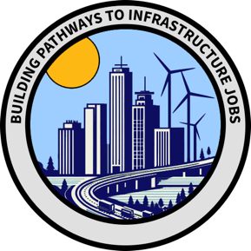
Building Pathways to Infrastructure Jobs
Quarterly Peer Learning Call
Thursday, June 27, 2024 | 1:00 pm to 2:00 pm ET

Overview
On June 27, 2024, the technical assistance team hosted the first Building Pathways quarterly peer learning call. Grantees have consistently expressed interest in understanding how their peer organizations, such as workforce boards, community-based organizations, and universities/colleges, approach foundational grant execution topics. The goals of the session were to:
- Facilitate relationship-building among grantees.
- Promote cross-sharing of approaches to program areas such as partnership development and employer/participant engagement.
- Identify adaptable strategies for local contexts.
Grantees shared questions and ideas via a group Miro board ahead of the session, and these topics were further explored during the call.

Themes
Workforce Boards/ Community-based Organizations (CBOs)
The conversation in the workforce boards and CBOs breakout group centered on participant recruitment, worker voice, and data collection. The key takeaways are as follows:
- Participant Recruitment: Grantees are at different stages of recruitment, with some already filling initial cohorts and others planning to start after Labor Day. Surveys are being used to understand participant needs and barriers.
  - One example from The Workplace is linked below in Tools and Resources.
- Labor Partnerships: Many grantees face difficulties partnering with labor unions and worker organizations, especially in new sectors like clean energy, where unions are less established. This is partially due to the time and trust required to build new relationships and partially from a lack of infrastructure to support new and emerging sectors. For example, grantees focusing on clean energy are working around the lack of solar energy-focused unions in many places.
- Data Collection: With the first quarterly performance reports due in November, grantees are streamlining data collection processes, avoiding dual entry, and developing automated solutions.
  - Examples shared include avoiding dual entry for co-enrolled participants, working with vendors to automate reporting, and developing solutions allowing participants to enter their own information.

Colleges/ Universities
Similar to the first group, the college and university discussion focused on data collection and employer engagement. The key takeaways are as follows:
- Data Collection: Grantees are exploring e-forms, software crosswalks for internal databases to the PIRL requirements, and participant incentives for data entry to prepare for performance reporting and eligibility determination.
- Employer Engagement: Grantees discussed strategies for supporting employer engagement, including hiring dedicated staff to shepherd industry relationships, diversifying employer partnerships, and streamlining requests to minimize employers' workload and increase employer buy-in. Grantees are working to navigate employers' hesitation, including resistance to allowing workers to take time off from work to complete training.

Tools and Resources
- Pre-enrollment Participant Survey (shared by The Workplace) – Survey Link https://c4uojvcdzd4.typeform.com/energyworks

Next Steps
- The next peer learning call will take place in September 2024.

