Oklahoma Office of Workforce Development



PY17 WIOA Monitoring Tool
Section 4: Financial Management Systems

Area: | South Central Oklahoma Workforce Board
Dates: | February 18-22, 2019
Completed by:

State Monitor | Date
LWDB Rep | Date
Fiscal Agent Rep | Date

§ 4 FINANCIAL MANAGEMENT SYSTEMS

Financial management systems are part of the overall organizational administrative systems that support grant functions or are those activities necessary for the operation of a project but not related to the direct provision of services. The standards for financial management systems are in 2 CFR 200.302.

GENERAL INSTRUCTIONS

Local area fiscal agent representatives are to follow the “Local Area Guidance” instructions shaded in gray throughout this document and complete electronically. After completing, return this document, along with all other documentation requested for desk review, to OOWD prior to the due date identified in the desk review e-mail.

State Monitor Guidance: The purpose of the financial management component is to evaluate the grantee’s capacity to perform the financial management functions that are required when operating federally funded workforce development grants and assure the proper safeguards are in place to protect grant assets. During this phase of monitoring, the focus will specifically be on the financial management systems that relate to budgets, cash management, program income, cost allocation, allowable costs, internal controls, and financial reporting.

The Summary of Review table below is a synopsis of the annual monitoring review. During desk review document the details of the area (i.e. number and names of service providers, fiscal agent, board staff employer of record, etc.) in the “Summary” box below. Document the potential risk areas for this section (from previous findings, the expenditure level review, etc.) in the “Factors of Review” box. A brief overview of best practices, particular areas of concern, potential findings, etc. identified during the monitoring process should be documented in the “Notes” box.

Summary of Review
(to be completed by State monitor)
Summary
Factors for Review

Notes

OBJECTIVE I: BUDGET CONTROLS

Budget Controls: The organization has a method for tracking planned expenditures that allows it to compare actual expenditures or outlays to planned or estimated expenditures [2 CFR 200. 302; current State WIOA Roles and Responsibilities policy].

Indicator #1: Budget

The organization has a CLEO approved LWDB developed budget that is compared to actual expenditures on a regular basis (i.e., monthly, quarterly) to determine expenditures are in line with the LWDB plan.

Local Area Guidance: Complete each item below.
 | Budget Controls
 | Does your organization have a copy of the current CLEO approved LWDB budget? If yes, what is the date of CLEO approval? Submit a copy with your desk review documents. |  | Local Area Response:
 | Is the budget in a line item format? |  | Local Area Response:
 | If not, what are the amounts budgeted for the following line items and how did your organization obtain these amounts:
 | Fiscal Agent | Admin |  | Program: N/A
 | Board | Admin |  | Program
 | One-Stop Operator | Admin |  | Program
 | Service Provider | Admin: N/A |  | Program
 | One-Stop System | Admin: N/A |  | Program
 | Direct Client Costs | Admin: N/A |  | Program
 | What is your organization’s process to compare actual costs to budgeted costs to ensure that the program operates within the approved budget? |  | Local Area Response:
 | When was the last actual versus budget analysis completed? Submit a copy with your desk review documents. |  | Local Area Response:
 | How is information regarding available funds transferred to appropriate staff in order to avoid over-obligating or when additional funds become available? |  | Local Area Response:
 | How is information regarding additional funds transferred to the LWDB when these funds become available, in order for the LWDB to modify their budget? |  | Local Area Response:
 | What does your organization include as obligations reported to the state on the Monthly Expenditure report? |  | Local Area Response:

State Monitor Guidance: Interview the staff primarily responsible for comparing budgeted to actual expenditures. Review the organization’s current CLEO approved LWDB budget and the most recent actual versus budget analysis. Technical assistance given regarding this indicator or any other pertinent information should be identified within the notes for this indicator.
 | Budget Controls
 | Is the LWDB providing the fiscal agent with a line item budget? If not, is there documentation to support the LWDB provided other documentation to the fiscal agent that supports the line item amounts the fiscal agent is using in its budgeting? | State Monitor Response:
 | State Monitor Notes for Indicator #1:

Indicator #2: Grant Spending

Grant spending is occurring at a rate consistent with the amounts budgeted.

Local Area Guidance: Complete each item below.
 | Grant Spending
 | WIOA grants have a 10% administrative cost limit and special grants may have other cost minimums or maximums, utilizing the figures from your organization’s actual versus budget analysis, project whether the current rate of spending will result in actual expenditures remaining within those cost limits. Note any exceptions. | Local Area Response:
 | Are there any variances in current or projected expenditures that are +/-10 percent of the LWDB’s budget? If yes, has the LWDB been notified? | Local Area Response:
 | For personnel and fringe benefit line items, all variances that exceed the budget amount require a budget modification. Using the current actual versus budget analysis and the projected figures from item 1, are there any significant variances in the rate of expenditures for personnel and fringe benefits? If yes, what caused the variances? Has the LWDB been notified? | Local Area Response:
 | Utilizing the figures from item 1, do the current and projected levels of spending indicate that 30% or more of youth funds will be spent on out-of-school youth by the end of the grant period for each youth grant? [WIOA §129(c)(4)(A)]. Explain any discrepancies. | Local Area Response:

State Monitor Guidance: Review the organization’s actual versus budget analysis and review the data from the Excel spreadsheet “PY16 Expenditure level review Sec4Tool.xls” that was completed in desk review, to assist in the completion of this indicator. Technical assistance given regarding this indicator or any other pertinent information should be identified within the notes for this indicator.

 | Grant Spending
 | Are there instances where actual or projected figures exceed the LWDB budget? If yes, has the LWDB been notified? What action is being taken? | State Monitor Response:
 | Is the area expending funds at a rate comparable with the completion timing of the contracts? Document any discrepancies.
 | What is the percentage of admin spent on all current contracts compared to total expenditures?
 | State Monitor Notes for Indicator #2:

OBJECTIVE II: CASH MANAGEMENT

Cash Management: The organization’s cash draws are necessary and reasonable, and the timing and amount of such draws appear to be as close as possible to the actual disbursement of grant funds for the payment of allowable and allocable costs incurred by the grant [2 CFR 200.302].

Indicator #3: Cash Management

Grant recipients have a mechanism in place, including policies and procedures, to minimize the time between the transfer of funds from the U.S. Treasury and disbursement of funds to pay allowable costs. The grantee draws cash as close to the time of making disbursements as possible. If applicable, grantees monitor the cash management activities of their sub-recipients to ensure that the sub-recipients conform to the same standards of timing and amount that apply to the grantees.

Local Area Guidance: Complete items 1 through 8. Submit with your desk review documents, a copy of your cash management policy if it is new or has been revised. Submit copies of your organization’s check registers and AP registers for the months being reviewed. Have available for inspection during the onsite visit, your organization’s cashdraw documentation and bank reconciliations for the months being reviewed.
 | Cash Management
 | How often does your organization draw down cash and how does it determine when and how much cash to draw down? | Local Area Response:
 | Does your organization have policies in place for payment of non-sufficient funds, overdraft fees, and other penalties which cannot be paid using Federal funds?
Does your organization have policy on bank reconciliation?
If yes, submit a copy with your desk review documents.
 | Does your organization’s bank reconciliation procedures provide direction for:
 | Identifying outstanding checks?
 | Investigating/Voiding outstanding checks after a reasonable time?
 | Adequate explanation and justification of out of sequence check numbers?
 | Comparing the cash balance in the bank reconciliation with the general ledger?
 | Comparing checks, including voided ones with the check register to verify date, number, amount and payee?
 | Verifying all voided checks are accounted for?
 | Funds insured by the FDIC?
Interest earned?
(This would indicate program income and should be reported as such, see indicator #4)
 | Are your organization’s bank statements reconciled to “cash” in the book of accounts?
 | Does your organization have policy regarding notifying the bank with changes of signatories?
Does your organization use Credit/Debit cards?
Fiscal Agent? LWDB?
 | Does your organization have written policy regarding credit card use?

State Monitor Guidance: Review the organization’s policies and procedures on cash management and bank reconciliation. Compare the organization’s drawdowns to their expenditures for the months being reviewed. Document the organization’s responses to your inquiries, the extent to which they are in compliance with this indicator, and the results of your review of their expenditures in relation to their draws. Keep in mind that drawdowns should lag behind reported accrued expenditures. If the grantee has a sub-recipient, request evidence that the grantee is monitoring the cash management activities of their sub-recipients.

Obtain organization’s check register for months in review. Use check registers, drawdown documents, and bank statements to complete Worksheet 4.3. Technical assistance given regarding this indicator or any other pertinent information should be identified within the notes for this indicator.
 | Cash Management
 | Review source documents used by the grantee to substantiate each drawdown requested. Does it appear that each amount requested is sufficiently substantiated? List any discrepancies. | State Monitor Response:
 | Review Worksheet 4.3, does it appear there are instances of excess cash-on-hand? Explain. | State Monitor Response:
 | Does the organization follow its policies and procedures on cash management? If no, explain. | State Monitor Response:
 | Compare cash drawdowns with the organization’s bank deposits. Does the Grantee’s internal cash request record reconcile with the bank deposits? List any discrepancies. | State Monitor Response:
 | State Monitor Notes for Indicator #3:

Worksheet 4.3 (to be completed by state monitor)

§4 CASH ON HAND ANALYSIS
State Monitor Guidance: The reviewer should complete the Cash Management Worksheet on the next page to calculate estimated excess cash then use this information to complete the Excess Cash Calculation below:

Instructions for Cash Management Worksheet (a):

- Column 2 should be completed prior to the review. (Adjustments may be necessary while on site to include refunds, rebates and/or credits.)
- Item 1: Ending Balance of Previous Month. Enter the actual cash balance for the previous month as contained in the entity's bank statement or cash receipt/disbursement ledger (for example, if the review is being conducted for the month of January, enter the cash balance as of the last working day in December).
- Column 3: Funds Disbursed. Enter the total amount of Federal funds disbursed on each day. For days where no disbursement occurred, enter 0. (Disbursement is made on date check is issued.)
- Column 4: Funds on Hand: Enter the amount of Federal funds on hand as of the close of business each day. This column is calculated as follows:
Previous Day Column 4
+ Current Day Column 2
– Current Day Column 3
Current Day Column 4
(To account for weekends, enter Friday's "Federal Funds on Hand" figure on the lines for both Saturday and Sunday.)
- Items 5-7: Total. Add the figures in columns 2-4.

Worksheet 4.3 continued
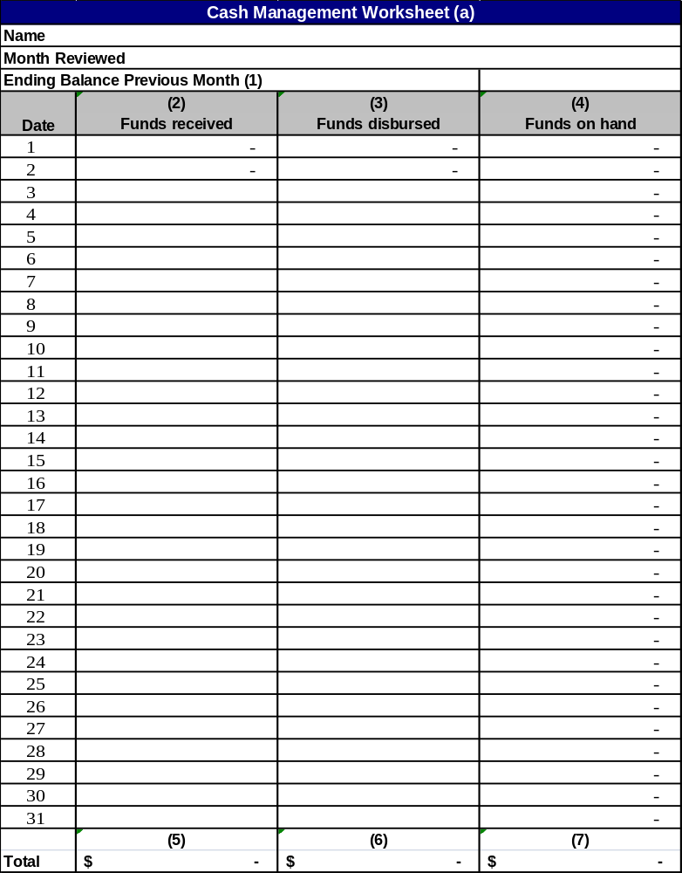

Instructions for Excess Cash Calculation Worksheet (b):
Section A
Line 1 - Record the total of item 7 of the Cash Management Worksheet. (Note: Be sure that each Friday’s balance was added two more times to account for the weekend.)
Line 2 - Record the number of calendar days for the month.
Line 3 - Divide Line 1 by Line 2. This will give you the “average daily cash balance.”
Section B
Line 1 - Record the total of item 6 of the Cash Management Worksheet.
Line 2 - Record the number of work days for the month.
Line 3 - Divide Line 1 by Line 2. This is the “average daily disbursement” which provides an indicator of the “average daily cash needs.”
Section C
Line 1 - Record the dollar figure of Line A.3 above.
Line 2 - Record the dollar figure of Line B.3 above.
Line 3 - Subtract Line 2 from Line 1. The remainder is the “average amount of excess cash on hand” beyond one day’s average need.
Line 4 - Record the dollar figure of Line B.3.
Line 5 - Divide Line C.3 by Line C.4. This will provide the “average number of workdays of excess cash on hand.”
Section D
Line 1 - If Line c.5 is more than five, add two additional days for every five full workdays to account for weekends. Enter the number of additional days.
Line 2 - Total Line C.5 and D.1. The result is the average number of calendar days of excess cash on hand.

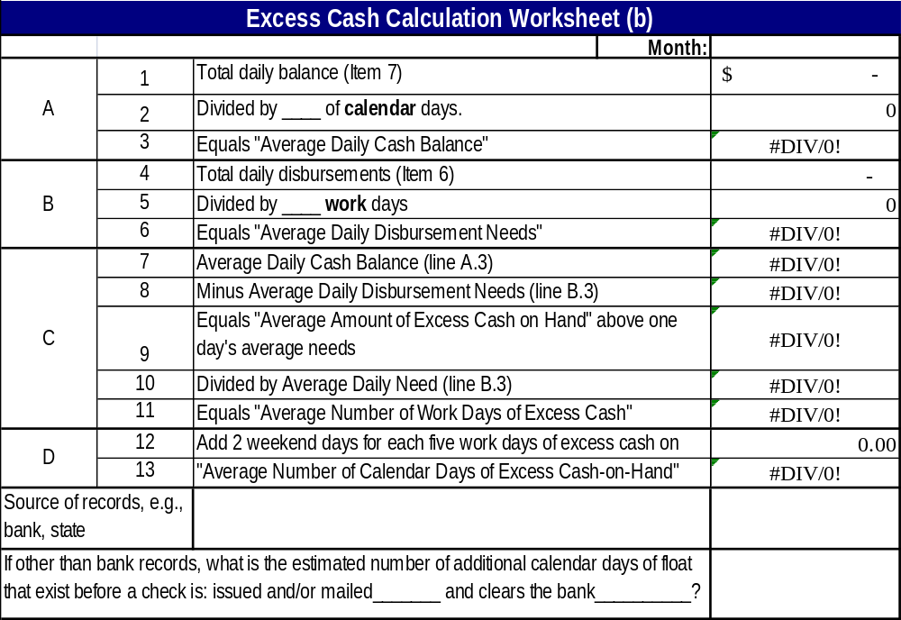

OBJECTIVE III: PROGRAM INCOME

Program Income: The organization is aware of the requirements for earning, spending, and reporting program income [2 CFR 200.307].

Indicator #4: Program Income

The organization understands the definition of program income, knows whether it is earning program income, and if earning program income, is properly documenting and using it to provide additional services under the grant prior to drawing grant funds.

Local Area Guidance: Complete each item below.
 | Program Income
 | Does your organization know whether it is earning program income? | Local Area Response:
 | According to your organization’s policy and procedures, what is the definition of program income as it relates to your activities? | Local Area Response:
 | How does your organization ensure that program income earned is being documented correctly and used to provide additional services under the grant in which it was earned? | Local Area Response:
 | Is your organization reporting program income with the submission of a Monthly Accrued Expenditure Report to OOWD? | Local Area Response:
 | Does your organization use cash from program income activities before requesting additional grant funds (cash draw)? | Local Area Response:
 | How does your organization ensure its sub-recipient(s) use cash from program income activities before requesting additional grant funds (cash draw)? | Local Area Response:

State Monitor Guidance: Review the grantee’s records to determine if it is earning, using, and reporting program income. Based on your review, if the organization does not appear to be earning, using, and reporting program income, determine if the organization is earning program income but has failed to use, document, and report it. Technical assistance given regarding this indicator or any other pertinent information should be identified within the notes for this indicator.
 | Program Income
 | If program income is being reported, is it tracked within the area’s financial records? If no, explain. | State Monitor Response:
 | Do the accounting records match the amounts reported on the monthly expenditure reports?
 | State Monitor Notes for Indicator #4:

OBJECTIVE IV: COST ALLOCATION

Cost Allocation: The organization only allocates costs to the grants (WIOA, BRAC, etc.) to the extent that a benefit was received [2 CFR Part 220 Appendix A; 2 CFR Part 225 Appendix A; 2 CFR Part 230 Appendix A; current State Cost Allocation Plan policy].

Indicator #5: Cost Allocation Evidence

There is written evidence, such as a timesheet, that costs being allocated to the grant are being treated consistently over time and within the accounting system, are necessary and reasonable, and are allocated to the grant based on the benefit received.

Local Area Guidance: Complete each item below.
 | Cost Allocation
 | How many funding sources does your organization have? | Local Area Response:
 | Does your organization-wide budget identify all sources of funds?
 | Does your organization receive funds from more than one source or administer more than one grant program and have staff that work on more than one funding source or grant? How do you allocate their time among the various funding streams and grant programs they work on?
 | Does the answer to 3 differ from the allocation process described for staff time in your organization’s cost allocation plan?
 | Does your organization maintain written policies and procedures for distributing program costs, staff time, and general and administrative costs among programs?
 | Does your organization allocate WIOA Administrative/Program costs appropriately? [20 CFR Part 652. 667.20] Explain.

State Monitor Guidance: Allocability is the extent to which a cost benefits the grant. Allocation of costs and the charging of costs to specific cost categories applies to all funding streams, which should also be documented in the organization’s Cost Allocation Plan. A common allocation issue arises when personnel compensation costs are charged to a grant.

If the organization receives funds from more than one source or administers more than one grant program, obtain copies of the timesheets of two or more staff who work on more than one grant to determine how they are allocating their time among the grant programs. Use these timesheets to complete Worksheet 4.5. Technical assistance given regarding this indicator or any other pertinent information should be identified within the notes for this indicator.

 | Cost Allocation
 | Describe any discrepancies found in Worksheet 4.5. | State Monitor Response:
 | State Monitor Notes for Indicator #5:

Worksheet 4.5

§4 Payroll and Time Distribution Worksheet
State Monitor Guidance: This worksheet will allow the reviewer to attest to the accuracy, reasonableness, and allowability of personnel expenses charged to the grants.

Directions: For one or more pay periods, obtain the staffing chart (organizational chart), time sheets, individual staff time activity sheets, payroll register, spreadsheet of actual personnel expenses to be allocated, organization time activity reports, and (if needed) personnel records or expense reports from the third party payroll processing company hired by the organization. Select a sample of employees and complete the following table.

Payroll and Time Distribution Testing
Checkpoints | Yes or No | Comments
Is the time sheet used to account for vacation and sick leave along with activity reporting? | Y N
If not, is there a time activity or distribution sheet that is completed and coincides with the payroll period? | Y N
Internal Controls
Examine the time sheet or the time activity/distribution sheet to attest to the following requirements:
Signed by the employee? | Y N
Certified or approved by supervisor? | Y N
Accounts for 100% of time worked? | Y N
Is the time distribution system reviewed periodically and certified for accuracy? | Y N
Cost Classification
Are there sufficient activity codes to prevent the lumping of general or all other activities in a single code? | Y N
If the organization is using an “other” code to combine multiple activities, does it exclude non-allowable and/or non-allocable activities? For example, if the organization provides economic development, marketing, fee for service to local businesses that is lumped into an activity code called “Other,” is such a code also used to record time for organization fundraising drives or other unallowable activities? If so, activity codes need to be expanded to include a code for non-allowable activities. | Y N
Cost Allocation
Reconcile or compare the time activity reports to the payroll register, the spreadsheet of actual personnel, and the third party allocation or expense report to assure consistency with allocation. | Y N
Allowable Costs
For allowability, look at the organization’s staffing chart and compare it to the individuals charging time to the grants. If discrepancies arise, look to the personnel records for recent job description or duties changes or modifications. | Y N
Look at the general ledger postings of personnel and fringe benefits expenses to ensure consistency with the actual time charged on individual activity reports. | Y N
Salary Limitations
Are directly charged or allocated salaries within the Executive Level II threshold as stated in TEGL 5-06? | Y N
If a salary exceeds the threshold, does the amount in excess of the threshold derive from a non-federal funding source? | Y N
Additional comments by state monitor:

Indicator #6: Cost Allocation Plan

The organization has a cost allocation plan.

Local Area Guidance: Complete each item below.
 | Cost Allocation Plan
 | Does your organization use cost pools? If yes, what are the methods/bases for allocating each pool? | Local Area Response:
 | Does your fiscal system separate WIOA activity by grant/cost category? If no, explain how monthly expenditure reports are compiled | Local Area Response:
 | Does your organization have separate cost pools for administrative and program expenditures? If no, how does your organization ensure that administrative costs are not charged against program cost categories? | Local Area Response:

State Monitor Guidance: Review the organization’s cost allocation plan and determine if it is compliant then review the answers to the above questions.

Determine if the grantee is allocating costs in accordance to its plan by completing the following activity: Review the cost allocation plan for methods of allocation for each type of cost and then from the accounting records pull a sample of allocated expenses to test for compliance. Trace back from the allocated expense to the original paid invoice and calculate the percent to be charged to each grant to determine if the expense was allocated in accordance to the grantee’s cost allocation plan. Complete the following table with the results.

Cost pool or shared cost items | Allocation method is appropriate for the type of cost pool or cost item allocated | Payments were appropriately allocated according to the CAP? | Final allocations appear to reflect the benefit received by cost objectives?
 | Y N | Y N | Y N
 | Y N | Y N | Y N
 | Y N | Y N | Y N
 | Y N | Y N | Y N
 | Y N | Y N | Y N
 | Y N | Y N | Y N
 | Y N | Y N | Y N
 | Y N | Y N | Y N
 | Y N | Y N | Y N

State Monitor Guidance: Complete each item below.
 | Cost Allocation Plan
 | Are the bases for allocation allowable and reasonable? | State Monitor Response:
 | Are overhead costs being allocated across all funding streams in a manner that is equitable? | State Monitor Response:
 | State Monitor Notes for Indicator #6:

Indicator #7: Indirect Cost Rate

The organization has an approved indirect cost rate.

Local Area Guidance: Complete each item below.
 | Indirect Cost Rate
 | Does your organization charge indirect costs using an indirect cost rate? | Local Area Response:
 | If no indirect cost rate, proceed to the next indicator.
 | Does your organization have an approved indirect cost rate or a provisional indirect rate? If an approved rate, by which agency?  Submit the most recent approval or copy of provisional rate with your desk review documents. | Local Area Response:
 | Does your organization apply this rate against the appropriate bases in accordance with the terms of the approved indirect cost rate agreement? | Local Area Response:
 | What is your organization’s process to ensure the costs included in the indirect cost rate are allowable? | Local Area Response:
 | Are the individual costs in the indirect rate being charged to the correct cost categories? (Admin / program) Explain the process for doing this. | Local Area Response:

State Monitor Guidance: Obtain a copy of the organization’s indirect cost rate approval or provisional indirect cost rate.
 | Policy Compliance
 | Is the organization charging indirect costs according to their approved or provisional rate? | State Monitor Response:
 | Is the provisional rate finalized within 6 months from the end of the organization’s fiscal year? | State Monitor Response:
 | Once finalized, are corrections made in the accounting records to reflect the finalized figures? | State Monitor Response:
 | State Monitor Notes for Indicator #7:

Indicator #8: One-Stop Operator / Service Provider

The organization has a contracted One-Stop Operator or service provider(s) with an approved indirect cost rate or provisional indirect rate.

Local Area Guidance: Complete each item below.
 | One-Stop Operator
 | Does your organization’s contracted One-Stop Operator and/or service provider(s) charge indirect costs using an indirect cost rate? | Local Area Response:
 | If no contracted One-Stop Operator or service provider with an indirect cost rate, proceed to the next indicator.
 | Does the contracted One-Stop Operator and/or service provider(s) have an approved indirect cost rate or a provisional indirect rate? If an approved rate, by which agency?  Submit the most recent approval letter or copy of provisional rate and documentation of most recent finalized rate with your desk review documents. | Local Area Response:
 | Does the contracted One-Stop Operator and/or service provider(s) apply this rate against the appropriate bases in accordance with the terms of the approved indirect cost rate agreement or provisional indirect cost rate? How does your organization ensure the rate is applied correctly? | Local Area Response:
 | What is your organization’s process to ensure the costs included in the indirect cost rate/provisional indirect rate are allowable? | Local Area Response:
 | Are the costs in the contracted One-Stop Operator’s indirect rate being charged to the correct cost categories? (Admin / program) Explain how your organization ensures these costs are charged correctly. | Local Area Response:

State Monitor Guidance: Obtain a copy of the contracted One-Stop Operator and/or service provider organizations’ indirect cost rate approval or provisional indirect cost rate.

 | One-Stop Operator
 | Is the organization ensuring the contracted One-Stop Operator and service provider(s) are charging indirect costs according to their approved or provisional indirect cost rate? | State Monitor Response:
 | Is the organization ensuring that a provisional rate is finalized within 6 months of the end of the organization’s fiscal year?
 | Once finalized, are corrections made in the service provider invoices to reflect the finalized figures?
 | State Monitor Notes for Indicator #8:

Indicator #9: Resource Sharing Agreement

The organization has entered into a resource sharing agreement or financial contract in accordance with the local One-Stop MOU.

Local Area Guidance: Complete each item below.
 | MOU & Resource Sharing
 | Does your local area MOU contain a resource sharing agreement? If no, explain why.  If yes, submit a copy of the MOU including the resource sharing agreement with your desk review documents. | Local Area Response:
 | If no resource sharing agreement, proceed to next indicator.
 | Is the MOU and/or financial contract detailed to provide the following information: Identification of the costs that benefit more than one program.  Are the costs classified as system and center? | Local Area Response:
 | Are the partners co-located? If yes, then the cost allocation section of the MOU must include shared system costs and shared costs of co-location, does the MOU contain these costs? | Local Area Response:
 | Are any of the following bases used for the cost allocation of the Center costs?  - Participants Served  - Direct Cost  - Space Allocation  - Full Time Equivalents (FTE)  - Allowable Survey Methods  Explain when each measure is used. | Local Area Response:
 | How was each partner’s fair share determined? | Local Area Response:

State Monitor Guidance: Obtain a copy of the agreement and/or contract that was entered into as a result of the local MOU. Complete Worksheet 4.9. Make note of any issues in state monitor notes for this indicator.

MOU & Resource Sharing
State Monitor Notes for Indicator #9:

Worksheet 4.9

§4 Resource Sharing Worksheet
State Monitor Guidance: This worksheet’s purpose is to gather documentation to assist in determining if the local area’s MOU funding document or Resource Sharing Document contains the appropriate elements and meets requirements.
Checkpoints | Y/N or Date | Adequacy | Comments
Does the agreement contain:
- The parties to the agreement?
- Identification of the shared costs?
- The methods of allocating costs?
- The methods used to pay for shared costs?
- Any modification and reconciliation procedures?
- Authority and signatures?
Is the agreement for the current period?
Has the agreement been modified, e.g., partner or funding changes? If yes, enter date.
Is a reconciliation performed?
Do they operate in accordance with their plan?
In your judgment, is the process adequate and reasonable?

OBJECTIVE V: ALLOWABLE COSTS

Allowable Costs: The organization has a system in place to ensure the program is incurring necessary and reasonable costs and is only charging allowable and allocable costs to the grants [2 CFR Part 220 Appendix A; 2 CFR Part 225 Appendix A; 2 CFR Part 230 Appendix A; 48 CFR Subchapter E, Part 31 (FAR)]

Indicator #10: Allowable Costs

The grantee only charges allowable costs in accordance with its applicable cost principles and is aware of which costs are allowable, allowable under certain conditions, or unallowable.

Local Area Guidance: Complete each item below.
 | Allowable Costs
 | Does your organization have a written allowable cost policy for internal use that addresses cost principles, program statutory and regulatory requirements? If no, how does your organization ensure compliance? | Local Area Response:
 | If your organization has sub-recipients, how do you ensure that the sub-recipients are following appropriate cost guidelines and policies? Has your organization issued written cost policies to the sub-recipients? | Local Area Response:
 | Does your organization have a system in place to ensure that amounts charged to the grants for grantee owned facilities and capital improvement projects are limited to the cost recovery using the use allowance or depreciation methods (based upon the percentage of program occupancy)? Explain.  Note: the use allowance for buildings and improvements should be computed at an annual rate not exceeding 2 percent of the acquisition costs. The use allowance for equipment should be computed at an annual rate not exceeding 6 2/3 percent of acquisition cost. | Local Area Response:
 | Does your organization’s financial system allow for the tracing of transactions to supporting documents? Explain. | Local Area Response:
 | Has the area had an approval from OOWD to transfer funds to/from Adult and Dislocated Worker funds?  If yes, print a detailed accounting of the expenditures that fall under the transfer approval and have available for onsite review. | Local Area Response:

State Monitor Guidance: Complete each item below.
 | Allowable Costs
 | Select a sample of expenses from the grantee’s accounting records by grant and for a specific period and use Worksheet 4.10 to help determine compliance and whether the costs are reported within the period of availability. Ensure that costs of one grant are not paid for by funds of another grant (e.g., adult expenses being paid with DLW funds). (For file purposes, attach the completed copy of Worksheet 4.10 and the copies made of sample expenditure with issues identified) | State Monitor Response:
 | Based on analysis of the results of the Transaction Testing Worksheet 4.10, do the costs of the organization meet the allowable cost standards? Explain. | State Monitor Response:
 | Is there evidence the expenditures identified in item #5 are allowable under State and Federal transfer of funds policies and regulations? Explain. | State Monitor Response:
 | State Monitor Notes for Indicator #10:
Worksheet 4.10

§4 Transaction Testing Worksheet
Monitor Guidance: Select a variety of non-payroll transactions from the detailed accounting records. Complete a worksheet for each transaction selected.

OOWD Financial and Administrative Compliance Review
Working Papers
Sample Item
Pulled from Grant # or Cost Pool
Date |  | Participant Name/OSL ID
Payee
Amount |  | Check #
Approval Received | Yes No
Is supporting documentation sufficient. | Yes No | PO Voucher Travel Claim  Inv. Ck stub/copy SS request  Training request  Other _____________
Purchase made consistent with financial policies? | Yes No
Competition used? | Yes No N/A
Basis of benefit reasonable? (on shared or allocated costs) | Yes No N/A
Allowable? | Yes No
Comments:
Need Additional Explanation/Documents:
Questioned costs:

OBJECTIVE VI: COST CLASSIFICATION

Cost Classification: The organization maintains a system to ensure that grant costs are charged to the appropriate cost category [20 CFR 667.220; OOWDI #10-2017].

Indicator #11: Cost Classification Methodology

The organization has a methodology for accounting separately for administrative and program costs in accordance with the WIOA Administrative cost definition.

Local Area Guidance: Complete each item below.
 | Cost Classification
 | Does your organization’s Chart of Accounts provide for a method to track the cost by administration and program categories? Describe. | Local Area Response:
 | Does your organization track administrative expenditures against the administrative limit to ensure that you will not exceed the allowable administrative cap? Describe. | Local Area Response:
 | If your organization has an indirect cost rate, do you charge all indirect costs as administrative? | Local Area Response:
 | If not, has your organization performed an analysis of the costs in the pool to determine what proportion of the indirect costs are properly chargeable to program?  What is the date of the last analysis? Submit a copy of this analysis with your desk review documents. | Local Area Response:
 | If the administrative costs exceed the administrative limit for the grant, does your organization have a process to charge the excess to non-Federal funds? Describe. | Local Area Response:
 | If your organization has directly charged staff (i.e. not in the indirect pool) who perform activities that are chargeable to both administration and program, does your organization maintain adequate actual activity report records to document the split of these staff costs? Describe. | Local Area Response:

State Monitor Guidance: The organization must maintain a system for tracking and reporting its administrative expenditures as well as its program expenditures. Codes should be established in the organization’s Chart of Accounts for appropriately charging costs defined as administrative in accordance with the WIOA definition at 20 CFR 667.220, or other required categories, in its accounting records.

 | Cost Classification
 | Are there issues of administrative activities improperly classified as program activities? If yes, explain. | State Monitor Response:
 | If the organization does not charge all indirect costs as administrative costs, review the organization’s most recent analysis and determine if the appropriate proportion of costs are being charged as administrative and program. Explain your findings. | State Monitor Response:
 | State Monitor Notes for Indicator #11:

Indicator #12: Subrecipient Cost

If there are subrecipients, the grantee has a system in place to ensure the subrecipient is properly charging costs to cost categories. Administrative costs are to be reported by State and local boards, direct recipients (i.e., the State), the local grant recipient or subrecipient (i.e., the LWIOA / Local Elected Officials), the fiscal agent, and the One-Stop operator.

Local Area Guidance: Complete each item below.
 | Cost Classification
 | Has your organization identified that your subrecipient/s must classify costs in both program and administrative cost categories? If yes, explain. | Local Area Response:
 | Does your organization require subrecipients who must classify costs in both administrative and program categories to record their costs by category in their books of account? If yes, explain. | Local Area Response:

State Monitor Guidance: Review the subrecipients to determine whether the subrecipient costs are being classified appropriately.
 | Policy Compliance
 | Does the local area have a contracted One-Stop Operator? | State Monitor Response:
 | Does the One-Stop Operator classify administrative costs correctly? Explain.
 | State Monitor Notes for Indicator #12:

OBJECTIVE VII: INTERNAL CONTROLS

Internal Controls: Effective control, integrity, and accountability are maintained for all grant and sub-recipient cash, personal property, and other grant assets. [2 CFR 200.303]

Indicator #13: Internal Controls

Grant recipient adequately safeguards all grant property and ensures that it is used solely for authorized purposes; has mechanisms in place to prevent unauthorized purchases and disbursements of grant funds; and safeguards its cash and other assets so no one person controls the order, receipt, payment, and reconciliation of an asset.

Local Area Guidance: The Separation of Duties Worksheet 4.13 includes a comprehensive list of required internal controls. Complete the worksheet then use the information and your knowledge of the everyday functions in your organization to answer questions 1 and 2.

Local Area Guidance: Complete each item below.
 | Internal Controls
 | Review the results of your organization’s separation of duties as indicated in Worksheet 4.13 and then identify if the following are in place, communicated to appropriate staff, and followed:
 | Duties are separated adequately to ensure that one single person is not requesting, authorizing and issuing payment or checks? | Local Area Response:
 | Transactions are appropriately authorized? | Local Area Response:
 | Assets are safeguarded? | Local Area Response:
 | Budgetary controls are in place? | Local Area Response:
 | IT systems are secure? | Local Area Response:
 | Internal controls are periodically tested and modified when necessary? Explain the process. | Local Area Response:
 | Does your organization maintain a payroll system that provides for the following:
 | Staff/participants paid only by check or direct deposit? | Local Area Response:
 | The preparation of the payroll entirely separate from and independent of the delivery of paychecks? | Local Area Response:

State Monitor Guidance: Ask the organization’s financial staff for evidence, including written policies and procedures, of separation of duties or other safeguards that they have in place to prevent unauthorized purchases and disbursements of grant assets. Observe the activities of staff to determine the extent to which they have implemented their internal control policies and procedures. Inquire about how the organization manages its assets so no one person has complete control over all aspects of a financial transaction. Document their responses to your inquiries, the extent to which they are in compliance with the indicator, and your observations.

Internal controls must be present in a number of areas to safeguard grant assets appropriately. Prior to conducting your analysis, review the organization’s single audit report on internal controls to identify noted deficiencies.
 | Internal Controls
 | Are there weaknesses identified in the area of internal controls? Explain | State Monitor Response:
 | State Monitor Notes for Indicator #13:

Worksheet 4.13

§4 Separation of Duties Worksheet
Local Area Guidance: Enter in the top row the names of staff who have any of the responsibilities listed in the table. Place a checkmark below a name if that person has responsibility for that function.

Internal Control Activity | Individual with Responsibility for Internal Controls
Approves Purchase Orders
Verifies Receipt of Order
Prepares Request for Funds
Authorizes Disbursements
Prepares Checks
Signs Checks -- Manual
-- Machine
Custodian of Check Signing Device
Custodian of Blank Checks
Compares Checks with Vouchers
Distributes Checks
Posts Disbursements
Computes Cost Allocations
Receives “Cash”
Posts Receipts
Deposits Receipts
Custodian of Petty Cash
Petty Cash Replenishment
Audits Petty Cash
Bank Reconciliation
Maintains General Ledger
Prepares Financial Reports
Approves Financial Reports
Other -

OBJECTIVE VIII: FINANCIAL REPORTING

Financial Reporting: The organization has an accounting system that allows it to maintain accurate and complete disclosure of the financial results of its grant activities and those of its sub-recipients according to the financial reporting requirements of the grant [2 CFR 200.327].

Indicator #14: Accrual Data

If the organization maintains its books of account on a cash basis, it develops and reports accrual data on the financial status report.

Local Area Guidance: Complete each item below.
 | Financial Reporting
 | Does your organization maintain its books of account on a cash or accrual basis? | Local Area Response:
 | Is the financial data included in the costs reported to OOWD on an accrued basis? | Local Area Response:
 | What evidence can you provide to support accruals (spreadsheets, MIS reports, etc.)? | Local Area Response:

State Monitor Guidance: If the organization keeps its books on a cash basis, ask the organization for evidence that the financial data included in its Monthly Expenditure Report submitted to OOWD are on an accrual basis. This may be in the form of a spreadsheet or another type of document that will link to the accounting records. Obtain copies of the grantee’s accounting records used to develop the monthly expenditure reports for the months in review.
 | Financial Reporting
 | Do the total expenditures on the Grantee’s accounting records match its total expenditures reported to the State? If No, explain. | State Monitor Response:
 | What documentation did the Grantee provide to support accruals? | State Monitor Response:
 | State Monitor Notes for Indicator #14:

Indicator #15: Sub-recipient Financial Reporting

If there are sub-recipients, the grantee has a system in place to ensure the sub-recipient is reporting the financial results of its grant activities on an accrual basis and in a timely manner.

Local Area Guidance: Complete each item below.
 | Financial Monitoring
 | Has your organization issued reporting instructions and formats to your subrecipients? If No, explain.  If yes, submit a copy with your desk review documentation. | Local Area Response:
 | Are there policies or contract clauses concerning financial reporting? Describe. | Local Area Response:
 | Is your organization receiving timely data from your sub-recipients? If No, explain. | Local Area Response:
 | Does your organization require subrecipients to identify and report expenditures on an accrual basis? If No, explain. | Local Area Response:

State Monitor Guidance: If applicable, determine if the organization is receiving financial data from its sub-recipients in a timely manner so that it can include this data in its reports to OOWD. Ask for copies of any policies or contract clauses related to sub-recipient reporting.
Financial Reporting
State Monitor Notes for Indicator #15:

OBJECTIVE IX: PARTICIPANT TRAINING RESOURCE MANAGEMENT

Participant Training Resource Management: The grantee has an accounting system that allows it to maintain accurate tracking of Individual Training Accounts (ITA), On-the-Job Training (OJT), and Customized Training for each grant [20 CFR Part 652.663; current State policies]

Indicator #16: Training Resource Management

The grantee has procedures in place for the management of ITAs, OJTs, and Customized Training.

Local Area Guidance: Complete each item below.
 | Participant Training Resource Management
 | Does your organization or your area’s subrecipient have a financial system (e.g., record or ledger) that tracks the overall and per participant training balances, obligations, and expenditures? Explain. | Local Area Response:
 | Does your organization have procedures to ensure timely deobligation of funds? Explain the process. | Local Area Response:

State Monitor Guidance: Review tracking mechanisms and pull a sample of training payments to review.
 | Participant Training Resource Management
 | Does the area’s tracking mechanism track overall and per participant? If No, explain. | State Monitor Response:
 | Is it adequate to track limits and other restrictions? If No, explain. | State Monitor Response:
 | State Monitor Notes for Indicator #16:

