
SCC 4-5 Success Indicators
Self-Assessment Wheel

(Priorities and Self-Assessed Competency)
The Strengthening Community Colleges (SCC) Success Indicators identify key areas that grantees can focus on to support success. They are aligned with the SCC Funding Opportunity Announcement (FOA) and were developed by the U.S. Department of Labor. The effective use of the Success Indicators includes regularly performing a self-assessment of grantee priorities and competency in alignment with the indicators. The Self-Assessment Wheel and process are offered as technical assistance to support grantee success but are not considered official U.S. Department of Labor guidance.

Continuous Improvement and Self-Assessment
Regular self-assessment throughout the period of performance encourages continuous improvement fostering unique and adaptive solutions. Grantee Project Directors have expertise and tacit knowledge that when explored and applied, can elevate project success. The self-assessment process mapped out in this document attempts to bring areas of unique strength and areas for concerted attention to light. To complete the self-assessment, print the blank Self-Assessment Wheel provided in this document and sketch in the wheel as described below. Use colored markers or simply a pencil, whatever you have on hand. Share your completed wheel with others on your team or in the SCC Technical Assistance meetings and discuss strategies for improving performance.

Success Indicator Categories +
The U.S. Department of Labor provides six success indicators as general guides for grantees; however, grantees may add additional indicators specific to their context. Feel free to add a category of success to track and reflect on through this process.
- Strong Grants Management
- Strong Operational Systems
- Sector-Based Career Pathways
- Good Jobs, Employment Impacts, and Student Voice
- Strategy Implementation
- Sustainable Systems Change
- *_______________________________________________

Setting Priorities
Strengthening Community Colleges projects set ambitious goals for capacity-building and systems change outcomes. Achieving these outcomes demands strategic and timely allocation of resources. Setting, monitoring, and adjusting priorities throughout the grant will aid in expertly matching resources to strategy.
Using the blank Self-Assessment Wheel provided in this document, divide the wheel into wedges with one wedge for each of the Success Indicators. If desired, add a wedge for an additional category of your own. The wedge size for each Success Indicator should indicate the priority the grantee places on each indicator. Higher priority indicators will have larger wedges and lower priority items smaller wedges. Once all indicators are included in the wheel, move to the next step, assessing project competency.

Assessing Project Competency
Assess your project’s current competency on a scale from 1 to 10, with one being the lowest competency level and ten the highest. Fill in each wedge according to your assessed level of competency (See the example provided in this document to guide you in this process).

SCC4-5 Success Indicators Self-Assessment Wheel

(Example)
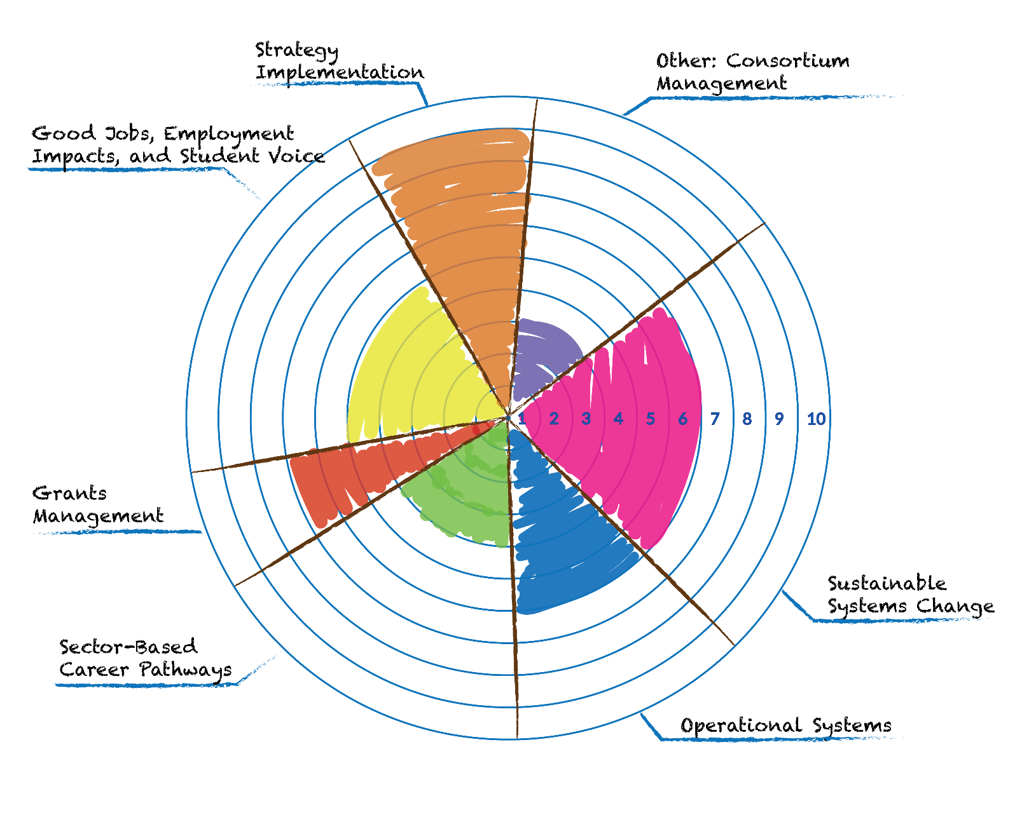

SCC Success Indicators Self-Assessment Wheel

(Project: ________________________________________)


