CSJQ Success Indicators Self-Assessment Wheel

(Priorities and Self-Assessed Competency)
The Critical Sectors Job Quality (CSJQ) Success Indicators identify key areas that grantees can focus on to support success. They are aligned with the CSJQ Funding Opportunity Announcement (FOA) and were developed by the U.S. Department of Labor. The effective use of the Success Indicators includes regularly performing self-assessments of grantee priorities and competencies in alignment with the indicators. The Self-Assessment Wheel and process are offered as technical assistance to support grantee success but are not considered official U.S. Department of Labor guidance.

Continuous Improvement and Self-Assessment
Regular self-assessment throughout the period of performance encourages continuous improvement, fostering unique and adaptive solutions. Grantee Project Directors have expertise and tacit knowledge that can elevate project success when explored and applied. The self-assessment process mapped out in this document attempts to surface areas of strength and areas for attention. Please print the blank Self-Assessment Wheel in this document and sketch the wheel as described below. Use a pen and highlighter or simply a pencil, whatever you have on hand. Please bring your wheel to the next Peer to Peer Meet Up.

Success Indicator Categories
The U.S. Department of Labor provides eight success indicators as general guides for grantees; however, grantees may add additional indicators specific to their context. Feel free to add a category of success to track and reflect on through this process.

- Effective Organizational and Operational Management
- Systems Change Impact
- Sustainable Systems Change
- Job Quality Strategy
- Strategic Partnerships
- Industry-Driven Workforce Development
- Worker Voice and Engagement
- Effective Training Design (For Tier 2 Grantees)
- Other grantee-identified indicator

Setting Priorities
Critical Sectors Job Quality projects set ambitious goals for systems change. Achieving planned outcomes demands strategic and timely resource allocation. Setting, monitoring, and adjusting priorities throughout the grant will help match resources to strategy expertly.
Using the blank Self-Assessment Wheel provided in this document, divide the wheel into wedges with one wedge for each Success Indicator. If desired, add a wedge for an additional category of your own. The wedge size for each Success Indicator should indicate the grantee's priority on each indicator. Higher priority indicators will have larger wedges, and lower priority items will have smaller wedges. Once all indicators are included in the wheel, move to the next step, assessing project competency.

Assessing Project Competency
Assess your project's current competency on a scale from 1 to 10, with 1 being the lowest competency level and ten the highest. Fill in each wedge according to your assessed level of competency. (See the example provided in this document for guidance.)

Example of a Completed Self-Assessment Wheel
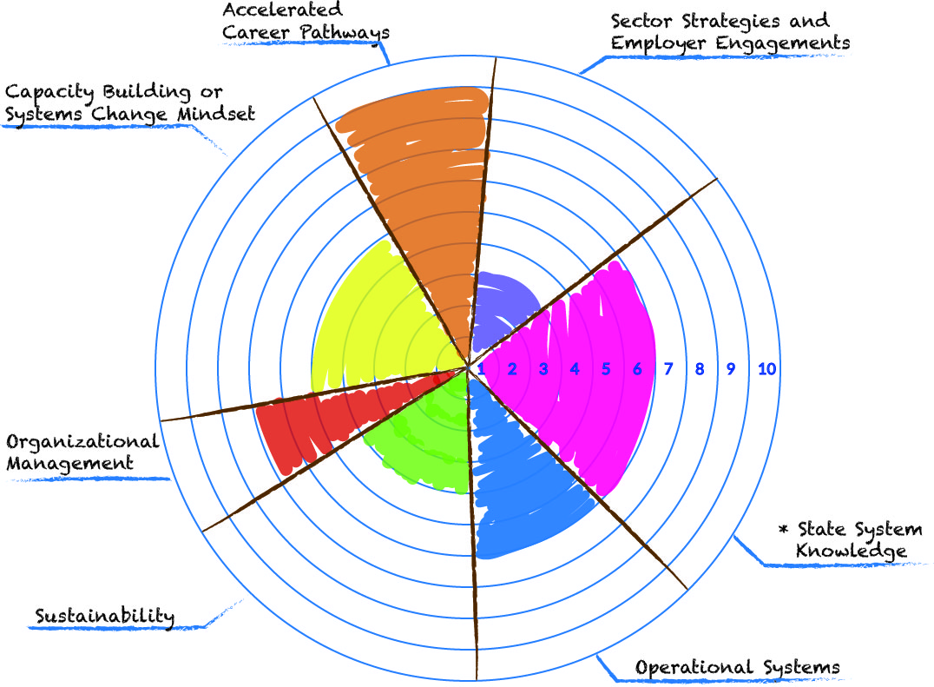

The size of the pie wedge indicates the level of priority.
The level of competency is indicated by the number of circles within the wedge.

Self-Assessment Wheel for Project:


The size of the pie wedge indicates the level of priority.
The level of competency is indicated by the number of circles within the wedge.

