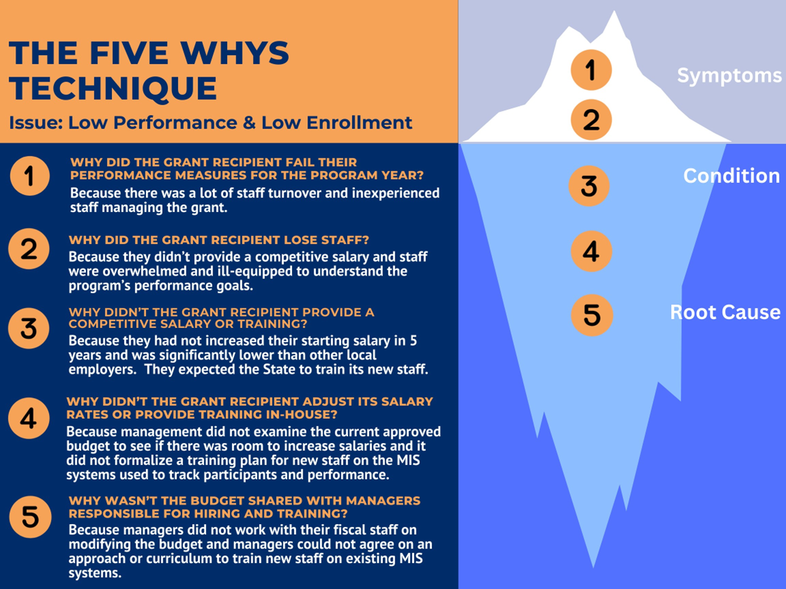
The graphic contains the title “The Five Whys Technique” with the issue reporting being low performance and low enrollment. The first “why” asked is “Why did the grant recipient fail their performance measures for the program year?” The response: “Because there was a lot of staff turnover and inexperienced staff managing the grant.”
The second “why” asked is “Why did the grant recipient lose staff?” The response: “Because they didn’t provide a competitive salary and staff were overwhelmed and ill-equipped to understand the program’s performance goals.”
The third “why” asked is “Why didn’t the grant recipient provide a competitive salary or training?” The response: “Because they had not increased their starting salary in five years and was significantly lower than other local employers. They expected the State to train its new staff.”
The fourth “why” asked is “Why didn’t the grant recipient adjust its salary rates or provide training in-house?” The response: “Because management did not examine the current approved budget to see if there was room to increase salaries and it did not formalize a training plan for new staff on the MIS systems use to track participants and performance.”
The fifth and final “why” asked is “Why wasn’t the budget shared with managers responsible for hiring and training?” The response: “Because managers did not work with their fiscal staff on modifying the budget and managers could not agree on an approach or curriculum to train new staff on existing MIS systems.”
The ride side of the graphic shows an iceberg, with numbers 1-5 listed. Numbers 1 and 2 are above water, and numbers 3-5 below water. Above water symbolizes the symptoms of the issue, whereas below the water, conditions of the problem are found. This finally leads to finding the root cause.

