Tribes and the Census

Proposed ACS Questions for Coming Years
Released to the Congress and the Public

At the end of March the Census Bureau sent the questions it is proposing to ask in the 2020 Census and on the Bureau's American Community Survey (ACS) to the Congress for review. The questions for the upcoming decennial census got all the attention, stirring up a major controversy over the inclusion of one on citizenship status. (See the April 3rd issue of this newsletter for details.)

Even though the population counts coming out of the 2020 Census are of major importance, used to apportion the seats in the US House of Representatives among the states and for the redistricting of federal and state legislative seats, the ACS questions are arguably of equal or greater significance. Most of the nearly $700 billion in federal dollars that are distributed based on the use of Census Bureau numbers in their allocation formulas involve programs that use ACS data on the characteristics of the population, rather than on the population counts themselves.

The 2020 decennial will, like the 2010 Census, ask simply about the age, sex, race, ethnicity (Hispanic origin) and relationship to the person regarded as the householder. On the other hand the ACS asks over 30 detailed questions involving a wide range of matters related to education, income, employment, migration, transportation, veteran's status and housing conditions. For programs distributing federal and state funds, state, regional and local planning agencies and businesses analyzing places to invest, it is primarily the ACS numbers that count.

The booklet showing the wording of the decennial and ACS questions that the Census Bureau recently sent to Congress has 20 pages devoted to the questions proposed for the upcoming Census. It has roughly 70 pages devoted to the questions proposed for future ACS forms.

The data derived from the ACS is particularly important as it is the only source of survey data covering every part of the United States, including every Indian reservation, former reservation area in Oklahoma and every Alaska Native village, as well as every county and city nationwide.

The ACS and Native Workforce Programs

The formula for the allocation of Native American workforce funds provided under Section 166 of the Workforce Innovation and Opportunity Act (WIOA) is one example of the importance of ACS data. The regulations for the program specifically provide that the funding appropriated by the Congress for the Section 166 Comprehensive Services Program be allocated by a formula involving the number of Native persons counted as unemployed and the number counted as in poverty within each grantee's designated service area as a proportion of the total of such numbers nationally. Supplemental youth funding is allocated by a formula involving Native youth in poverty.

In the 2000 Census this data came from a "long form" survey that was part of that decennial headcount. In 2010 this "long form" was no longer used. It was replaced by an ongoing survey, the ACS, conducted every month separately from the decennial census. (The Labor Department continues to use the 2000 "long form" data to allocate Native workforce program funds as a result of the refusal of the Employment and Training Administration to spend general ETA funds to pay for the special tabulation necessary to acquire the necessary data, as it has always done in the past.)

While the ACS data is important, and for the American Indian and Alaska Native (AI/AN) populations is the only source of numbers on Native unemployment and poverty down to the reservation level, the ACS questionnaire, designed for the general population, does not accurately reflect the situations of Native people, particularly in reservation areas. For example, this is the question on labor force status.

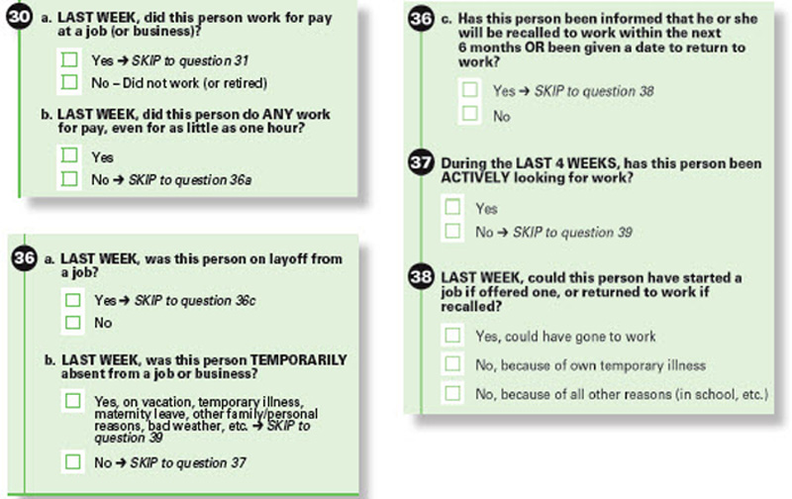

The question relies on the standard Census Bureau and Bureau of Labor Statistics (BLS) definition of unemployment. The three main elements of that definition are that the person has not worked in the last week, the person could go to work when a job is offered and that the person has "actively" sought work in the previous four weeks. If any one of these three conditions is not met, for example if the person has not actively sought work by directly contacting employers, then he or she is not considered to be unemployed, but simply "not in the labor force."

Under the conditions in many reservation areas such an "active" search for work is irrelevant. There are few job openings and when employment opportunities do arise, the news spreads quickly over the "moccasin telegraph." Moreover, the ACS collects virtually no information on the barriers to employment that often keep Native workers from accepting work or even "actively" looking for it, barriers such as lack of child or elder care, lack of reliable transportation or a lack of the training necessary to qualify for a job that is available. Persons with such barriers disappear from the unemployment data; they are counted as not in the labor force at all.

The ACS data also lacks the level of detail that's important for other aspects of the employment numbers. For example, the ACS collects information on the "class of worker," whether a person who is working is employed by a private for profit, nonprofit or government employer. While employment with a tribal government or by a tribal government-owned but profit-seeking enterprise are the most common types of employment on many reservations, there is no mention on the ACS questionnaire of such employers at all.

Accurate Data Must Come from Tribes and Native Organizations Themselves

Other ACS questions can also be problematic. The housing questions involve a simple, two-choice answer as to whether the housing unit is owned or rented. The variety of options provided currently under the Indian Housing Block Grant (IHBG) program and in the past under the many HUD-assisted housing initiatives in reservation areas are not well covered by this simple two-part answer. The one ACS question that does address the Native condition involves health coverage. IHS coverage is specifically listed as a possible answer to this question.

With no major changes currently proposed for the ACS questions in future years, accurate data on many characteristics of the Native population will have to rely on data that tribes and Native organizations collect themselves, using questionnaires that reflect the actual conditions in Native communities.

Norm DeWeaver norm_deweaver@rocketmail.com May 7, 2018
Redistribution of this information is encouraged

