
Spokane Washington

Name of Entity | Spokane Workforce Council
Featured Partners | - WIOA Title I Adult, Dislocated Worker, and Youth  - WIOA Title III Wagner-Peyser  - WIOA Title IV Vocational Rehabilitation  - Temporary Assistance for Needy Families WorkFirst
Highlighted Features of the Integrated System | - Partners Co-Located in Space Designed Around Customer Needs  - Integrated Service Delivery, No Program Silos  - Unified Business Services  - Co-Enrollment and Fully Integrated Funding  - Cost Sharing as Outlined in the One-Stop Operating Budget  - Flexible Non-Federal Resources  - Long-Term Investments in Staff Training, Communication, and Planning
Point of Contact | Dawn Karber, Chief Operating Officer at dkarber@spokaneworkforce.org
The Spokane Workforce Council coordinates workforce development services for Spokane County in eastern Washington. Spokane boasts the largest labor market area between Seattle and Minneapolis as well as strong job growth since 2014, particularly in the transportation/warehousing, manufacturing, healthcare, finance/insurance, and professional, scientific, and technical sectors.
In 2007, workforce partners began co-locating in the WorkSource Spokane American Job Center (AJC) to better integrate their services and improve the customer experience. The passage of the Workforce Innovation and Opportunity Act (WIOA) spurred partners on the Council to take this effort further by launching a customer-centered (re)design process. Feedback from customers and staff led to functional, philosophical, and physical changes to better align services with customer needs and expectations — eliminating silos and organizing around services, not programs. Today, WorkSource Spokane partners contribute to shared costs, including 25 percent of the One-Stop Operator (OSO) budget, to run a fully integrated workforce development system that integrates 34 funding streams; offers streamlined, consistent services to business and job seeker customers; and enjoys improved customer satisfaction, staff morale, and program outcomes.
This case study will describe major integrated design features from the customers’ point of view, then explore key systems that support integrated services, how and why these came to be, what difference they are making, and some advice for replication.

Spokane’s Integrated Service Design Features

Partners Co-Located in Space Designed Around Customer Needs
Spokane County has one comprehensive AJC, WorkSource Spokane, which brings together dozens of partner programs and funding streams. All are co-located within WorkSource Spokane on a full-time basis, including the following major programs:
WIOA Title I Adult and Dislocated Worker
WIOA Title II Adult Education
WIOA Title III Wagner-Peyser
WIOA Title IV Vocational Rehabilitation
Temporary Assistance for Needy Families (TANF) WorkFirst
Unemployment Insurance
Reemployment Services and Eligibility Assessment (RESEA)
Supplemental Nutrition Assistance Program Employment and Training (SNAP E&T)
Senior Community Service Employment Program (SCSEP)
34 public and private funding streams in all
WorkSource Spokane also shares space with the Spokane Resource Center, a HUD EnVision Center offering pre-employment supports such as food, housing, childcare, and mental health services. Next door is a specialized youth AJC, the Next Generation Zone, where youth access high school completion services, work-based learning, job search, and academic and life coaching funded through Adult Education, WIOA Title I Adult and Youth, state out-of-school youth reengagement dollars, and private philanthropic funding. Although YouthBuild recently moved out of the Next Generation Zone as they needed more space, the partners continue to co-enroll whenever it is possible and beneficial to the customer.
While many partners were co-located prior to passage of WIOA, they largely operated in silos, with separate program staff, services, and processes. As noted above, in 2015, the Council — representing all the partners, including TANF — embarked on a customer-centered redesign process to identify how WorkSource Spokane could better meet customer needs and expectations. Customers told them that program silos did not make sense. They just wanted a job, they did not understand why they had to go from person to person, and they wanted better services across the board. In response, Spokane made physical, philosophical, and functional changes. For example, the old welcome area typified a traditional “government office” and required customers to wait in line. The re-designed welcome area has a more professional look and no line. Customers are greeted quickly and can head to the resource room or, for those who need to wait to meet a staff member, grab a coffee and relax in the comfortable living room-style seating area.
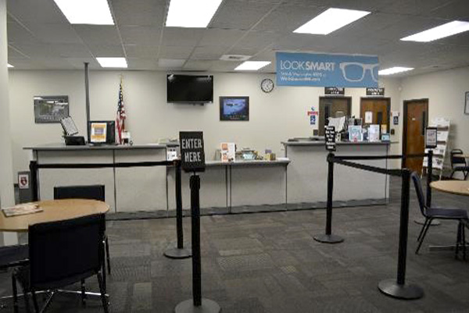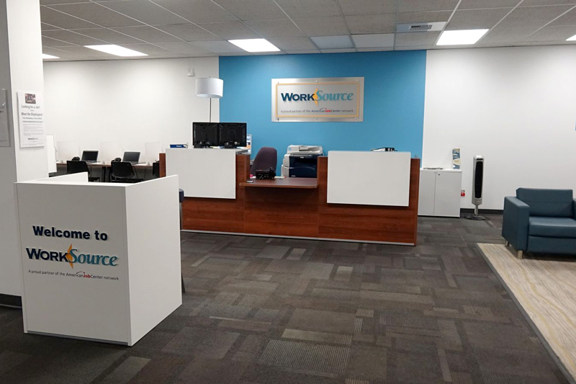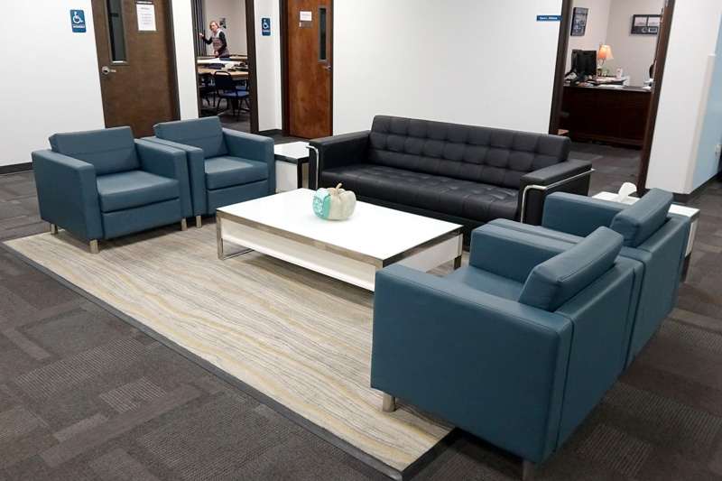
Welcome Area — After Redesign
Welcome Area — Before
Spokane also redesigned its resource room — its Technology Hub — based, in part, on feedback from people with disabilities. In addition to new paint, signage, and furniture, several changes made the space as accessible as possible for people with disabilities. Taller workstations and stools accommodate those who need to stand or are short. Easily moved rolling chairs do not block the aisle if someone forgets to push in a chair. New glass-enclosed meeting rooms reduce noise for customers who have one-on-one meetings or need the language translation phone service.
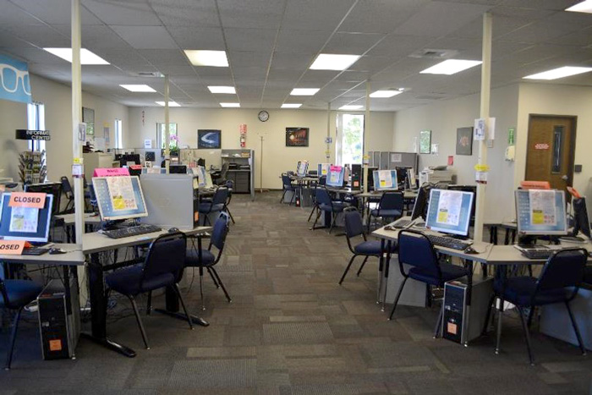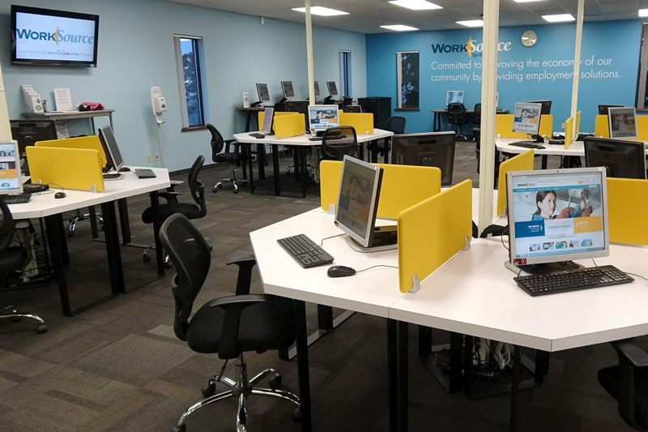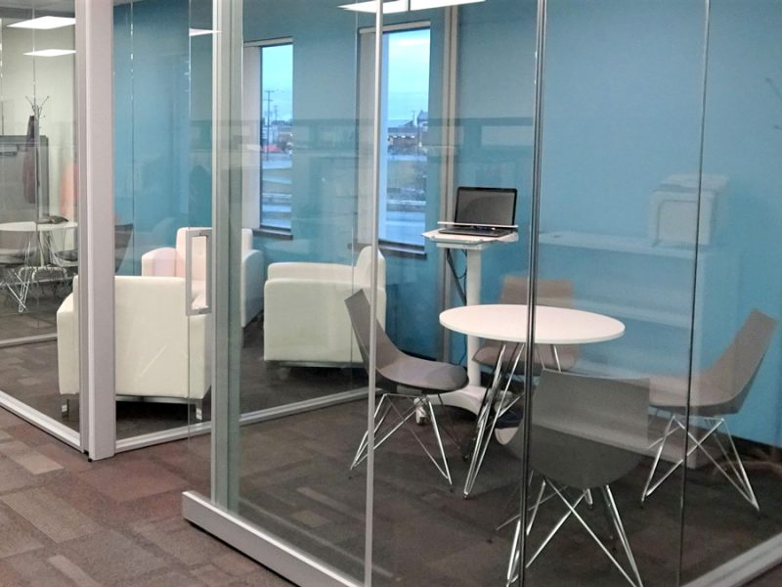
Resource Room — Before
The Technology Hub — After Redesign

Integrated Service Delivery, No Program Silos
In addition to the physical reconfiguration, the customer-centered design process also brought philosophical changes. WorkSource staff began to think about themselves as professional career coaches focused on services available to clients instead of programs and funding streams.
This philosophical shift necessitated functional changes in the way Spokane organized and delivered services. In the old system, people could receive completely different types and quality of services depending on which program served them. Now, anybody who comes into WorkSource Spokane flows through the exact same continuum of high-quality services. Instead of co-located case managers working on different programs, today, these staff are still employed by various agencies, but they are now career coaches who work on one of three frontline teams that serve all clients and who are funded with a variety of program sources.
All customers start with a coach on the Customer Access and Relationship Team, who greets clients, does a quick triage to understand their needs, gets them signed up in the virtual career coaching Management Information System (MIS), and connects them to a career coach on the Home Team.
The Home Team coaches build each individual a plan and provide basic services like assistance with a resume, cover letter, and job search, and information on other services like workshops. All information is tracked in the virtual career coach/MIS, so all coaches can always identify the services that have been provided to that customer.
When anyone walks in the door, you don’t ask them “what’s wrong with you?” in order to determine eligibility for a federal program, but rather “how can we help you?” because we know we have the flexibility and resources to be able to serve them no matter what their socio-economic status might be.
~ Mark Mattke, Chief Executive Office, Spokane Workforce Council
Those who face more barriers and need more individualized services and support then see a coach on the Continuous Engagement Team, who takes on the case manager role and helps with more intensive career coaching and training services, as needed.
All people who come into the center follow the same flow of services (as appropriate to their needs). Someone with a disability, for example, is not automatically referred to VR; rather WorkSource Spokane serves people with disabilities using the same continuum of services and coaches as everyone else, while VR staff support and educate the coaches so all can engage and serve them in the most effective and appropriate ways. (See below for more detail on staff training.)
In addition, instead of coaches being assigned to teach workshops (regardless of skill, interest, or comfort level), now staff who enjoy teaching workshops are part of the Workshop and Assessment Team. Their role and expertise are in providing workshops for customers as well as training, advising, and supporting career coaches on the various workshops and assessment instruments so that coaches know how to best inform and support their job seeker customers.

Unified Business Services
A fifth customer-facing team, the Talent Solutions Team, works with businesses exclusively. Spokane sees employers as the primary customer of the workforce system because the employer need is essential to effectively serving the job seeker customers who come into the centers. Staff do not represent programs but represent WorkSource Spokane and the services they offer local businesses. All materials share common messaging and branding. (VR staff on the Talent Solutions Team, however, have a niche role; they provide companies with information on disability employment law and accommodations and build relationships with those willing to hire people with disabilities.)

Systems that Support Integrated Partner Service Delivery

Co-Enrollment and Fully Integrated Funding
In the integrated service flow described above, there must be a way to assign costs that meets all program and contractual requirements. In Spokane, program eligibility and cost allocation are handled by an internal support team, the Financial Resource Management (FiRM) Team, which is – like the other teams – made up of staff employed by a variety of agencies.
The FiRM Team charges costs of the Customer Access and Relationship and Home Teams entirely to contracts that have basic services functions built in, such as WIOA Title I, Wagner-Peyser, Unemployment Insurance Reemployment Services and Eligibility Assessment (RESEA), and TANF WorkFirst. Nearly every client that enters is eligible for and can be co-enrolled in at least the WIOA Title I Adult basic services and Wagner-Peyser programs. This has the added benefit of entering every client into their MIS, allowing for a minimum level of tracking for every AJC customer in one AJC-controlled data system that can be accessed by all career coaches.
If a customer moves into phase three of the service continuum and begins to work with a Continuous Engagement Team coach, the coach obtains information necessary for determining eligibility for the potential range of more intensive program services, then works with the FiRM Team (without the customer) to facilitate enrollment. While awaiting eligibility determination, coaches know the intensive services most everyone would be eligible for, so they can offer those immediately to keep the customer engaged in services. From a customer’s point of view, they simply know of available services such as an individualized two-week workshop “Mindset for Success,” rather than programs or funding streams which can be confusing.
FiRM Team members determine eligibility based on information collected by the career coaches, then enroll customers and charge costs based on that eligibility as well as fund availability, time left on contracts to fully expend funds, service needs, and more.
The FiRM Team is responsible for understanding the laws, regulations, and contractual obligations associated with each funding source to ensure costs are appropriated in line with them. It is also responsible for executing contracts, monitoring, auditing, and developing appropriate internal controls and system checks. The FiRM Team plays a critical supporting role that enables the career coaches to focus on working directly with job seeker and business customers.

Cost Sharing as Outlined in the One-Stop Operating Budget
In addition to weaving funds as described above to cover the costs of staff time, partners at the AJC also contribute to shared costs using a formula based on the number of full-time equivalent staff (FTEs) in the center and customer usage of the center. Shared costs include costs like rent, utilities, technology, office supplies, and a portion of the OSO costs. Though the cost sharing details change somewhat from year to year, in 2020, partners share 25 percent of the OSO costs; the balance is allocated to specific contracts or grants (primarily WIOA Title I Dislocated Worker and Youth programs).

Flexible Non-Federal Resources
In 2014, the Spokane Workforce Council became a 501(c)(3) to pursue philanthropic grants to augment their federal funding, which has steadily declined in the last several years. Often these resources have fewer eligibility requirements than federal funding streams, which allows Spokane to “fill in gaps” in its uniform service delivery model.

Long-Term Investments in Staff Training, Planning, and Communication
The AJC opens at 9 a.m. Monday through Friday, which allows all staff to meet from 8-9 a.m. daily for training, information sharing, and team meetings. Spokane adopted this schedule during the redesign process in 2015-2016, as leaders recognized the importance of taking time to communicate the purpose of the initiative; hear from all staff; build staff understanding and capacity; and allow time for the teams to discuss, plan, refine, and buy into new ideas.
Some of the initial training sessions covered the basics of the workforce system (federal, state, and local), programs operating within the AJC, and community resources. Staff found it helpful to understand the entire system, their part in it, and how all the partners relate to each other; few had that understanding prior to the training. Later training covered emotional intelligence and equipped staff with the skills to manage change, stress, and an environment constantly in flux — training that later provided a shared language people could use to understand and address challenges when they were struggling with change. The material aligned with the nine core competencies outlined in the National Association of Workforce Development Professionals (NAWDP) workforce development professional certification. (As a side benefit, many staff went on to attain their NAWDP Certified Workforce Development Professional credential, and the Talent Solutions Team members all became Certified Business Services Consultants.)
Today, all staff still reserve the first hour of each day for “internal” work. Mondays and Fridays from 8-9 a.m. are reserved for training/professional development. Staff meet as teams on the remaining days to touch base; stay informed; develop and assess progress toward shared goals; identify challenges; and problem solve. Training was and continues to be provided by a mix of contractors, local subject matter experts, and staff from the Spokane Workforce Council leadership team and the OSO.

Looking Back: How and Why Did Local Partners Come Together?
As mentioned above, Spokane had been pursuing co-location since 2007 and trying to blend funding streams with a focus on services not programs but had not yet achieved significant integration. Staff did not understand services offered by other partner programs, so referrals were limited. The passage of WOIA and its common performance measures, along with the decision by the Governor to include TANF as a required partner in the system, raised awareness that programs must work together as one system. Spokane credits two mechanisms that did not exist prior to WIOA – the Memorandum of Understanding (MOU) and Infrastructure Funding Agreement (IFA) between the partners – with changing the depth with which they had to think about how to operationalize system service strategies and goals.
At the same time, the Department of Labor’s San Francisco Regional Office offered regional technical assistance funds to support areas interested in customer-centered design. And, the Next Generation Zone had just completed a successful physical and service redesign based on youth customer needs and expectations. Together, these factors gave Spokane the impetus to launch the customer-centered redesign process for WorkSource Spokane in 2015. As the Council’s Chief Operating Officer Dawn Karber put it, “Customer centered design helped us figure how to achieve streamlined services, while WIOA helped us all understand it was the goal.”
There were, of course, pockets of resistance from people who genuinely believed working in silos worked best for customers, but everyone got on board eventually. Spokane made several strategic choices that paid off: developing a shared vision among leaders, including all partners, dedicating time to train and upskill staff, keeping the process focused on customer needs and shared goals, giving staff ownership over the new service strategies, pushing persistently and with transparency through the challenges over the course of several years, and very publicly congratulating staff when customers started to say how much better the system had become.
Spokane began rethinking services by asking all staff to identify similar functions. Everyone started out naming programs, but it did not take long for most to recognize that the work they did with the customer was very much the same. By keeping customer feedback and needs at the fore, staff ultimately decided to become subject matter experts (SMEs) in specific functional areas that would align with the WIOA Title I basic, intensive, and training framework and would allow them to serve all customers who need that service. And so, they created the customer-facing and internal functional teams.
It all comes down to building this together from the ground up – the partners coming together to agree on what the customers need in our community and what our system needs to do to respond to that need and then designing around that. So you start from the basis of working collaboratively in a partnership. Everything flows from that, whether it’s service delivery, the IFA, policies, applying for grants together – that’s the core of how we do our work.
~ Mark Mattke, CEO, Spokane Workforce Council
The most difficult aspect was creating a workable model for cost sharing and staffing the teams. While it took time and was technically challenging, engaging partners in robust cost sharing conversations was not hard because everyone already had agreement on how they wanted the system to look before they dove into cost sharing. Partners already saw the value-add of an OSO who helps to oversee the system and to guide the teams, so were willing to contribute to a portion of the OSO’s costs (25% in Spokane). The initial Infrastructure Funding Agreement was framed as a one-year pilot. Everyone agreed to contribute for one year and then revisit the process. One year later, everyone agreed to continue.
Bringing in TANF was also a small challenge simply because they were a new partner that was not co-located prior to passage of WIOA. However, Spokane reports that it did not take long for the TANF WorkFirst provider to see the functional parallels between their program and other workforce programs, as well as significant overlap in their client populations and goals. In the end, TANF was the first program to integrate staff into the Home Team and do co-enrollment with WIOA Title I and Wagner-Peyser.

Impact
Today, WorkSource Spokane and the greater Spokane area see many benefits from the redesign. Clients no longer have to move from program to program looking for help. Doing eligibility for various programs behind the scenes means, from the customer’s point of view, they simply get services that help them on their employment journey. Customer satisfaction scores are up, and they say, in conversations, that this is a far better model than they experienced in past visits.
Staff have benefited from all the professional development and training, especially a deeper understanding of the workforce system as a whole. The functional teams, along with shared agreements on roles and responsibilities, allow more flexibility and efficiency for staff and programs and more consistent and effective services for customers. It has also led to greater job satisfaction, higher morale, and reduced sick leave and turnover. Council COO Dawn Karber talks with staff when they retire (and have nothing to lose by being completely honest). They report that this work model is the best they have experienced and allows them to focus on really helping the customer.
Full integration also led to improved program outcomes. For example, the Next Generation Zone’s efforts to align programs around career-connected services has resulted in more than triple the number of young adults served, receiving their high school equivalency, and entering apprenticeships each year since 2014. Spokane also tracks TANF outcome measures beyond “participation,” understanding that most TANF recipients want to obtain gainful employment at a sustainable wage, not to just check off participation requirements. As a result of Spokane’s aggressive co-enrollment approach, the TANF WorkFirst provider is extremely pleased and looking at how to broaden the model across the state.
Spokane found that private funders respond more positively to the Council’s holistic approach to improving the local economy and therefore are more willing to support those pieces that align with their mission and values. As a result, the number of contracts WorkSource Spokane manages has jumped by 50% since 2016 (they went from 22 contracts in 2016 to 34 today).

Peer Advice for Replication

Council and program leaders were vital to Spokane’s transition to a fully integrated workforce system. Prior to launching the redesign process, the Council developed a shared vision and messaging that each program leader reinforced with their respective program teams. They also committed the time and money required to redesign around customer feedback and successfully transition staff and services. Council CEO Mark Mattke says that forging a new path requires leaders with a critical set of qualities and skills:
A willingness to rethink how you have always done things
The ability to create and communicate a vision, and help keep everyone moving toward that shared vision in the face of challenges and a natural tendency toward inertia
Good relationships with regulatory bodies to get buy-in and ensure alignment with federal, state, and local rules
A relentless pursuit of making things better
The foresight to know that experiments and prototypes will not all work but are necessary on the way to finding solutions that work for everyone
That said, this shift cannot just be a “top down” process. Partners at the state and local level must buy in. Keeping customer feedback at the fore and reserving ongoing time for staff training, professional development, and planning together are vital to this end. Council staff understand that the daily 8–9 a.m. training/planning time does not take away from customers because they know that, without it, they would not be nearly as good at customer service. It is key to building teams, buy-in, and a sense that each is part of one system working to achieve shared outcomes.
There are a lot of things that are in the weeds – paperwork, eligibility, fiscal rules. Some people get really into the weeds and want to say no. It takes people with all kinds of strengths but keep the “why” and future vision in the forefront when things get tough. That vision helps you stay the course when it’s hard.
~ Jessica Clayton, Program and Development Director, Spokane Workforce Council
It is also critical, Spokane’s leaders stress, to empower the OSO with some authority, flexibility, and budget to meet partners’ needs as they arise. Doing that successfully requires partners who buy into the shared goals and recognize the value-add of someone to help oversee and guide the teams and integrated processes toward those goals. (For more information and support on customer-centered design or blended funding, the Spokane Workforce Council offers free and fee-based consulting services.)

This case study is part of a larger series developed for the Department of Labor Employment and Administration’s Chicago Regional Office, which explores how and why local workforce partners came together in six local workforce areas and the difference it is making in those areas. See this ION Community of Practice Resource page for more information and the full set of case studies.

