Census Business Builder Instructional Flyers
These flyers provide step-by-step instructions on using various features and functions of both the Small Business Edition and the Regional Analyst Edition of CBB.

Overview Instructions
Simple steps to access the information available in the Census Business Builder tool.

Small Business Edition
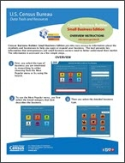
Download Small Business Edition, Overview Instructions [PDF - 3.8 MB]

Regional Analyst Edition
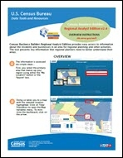
Download Regional Analyst Edition, Overview Instructions [PDF - 4.3 MB]

Accessing the Report Instructions
A key feature of CBB are the Reports that contains all of the data shown in the map (plus interactive bar charts). A single Profile Report is shown for the Small Business Edition of CBB, while the Regional Analyst Edition includes Summary and Detailed versions of the report for the user's region as a whole or for individual city or county parts of the region. These flyers provide instructions on navigating and manipulating these reports.

Small Business Edition
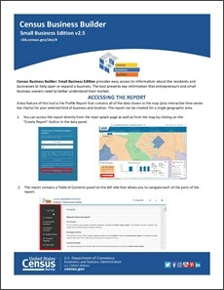
Download Small Business Edition: Accessing The Report [PDF - 1.1 MB]

Regional Analyst Edition
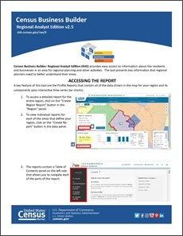
Download Regional Analyst Edition: Accessing the Report [PDF - 1.4 MB]

Data Upload Feature Instructions
These instructions are for both the Small Business Edition and the Regional Analyst Edition of CBB.
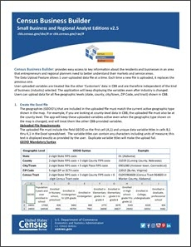
Download Small Business and Regional Analyst Editions: Data Upload [PDF - 1.6 MB]
The Data Upload Feature allows 1 user‐uploaded data file at a time. Each time a new file is uploaded, it replaces the previous one. Users can upload data for all five geographic levels (state, county, city/town, ZIP Code, and tract) shown in CBB.
Download a sample file of dummy data for every county in Maryland.
Sample Upload File [<1.0 MB]

Filtering Your Results Instructions
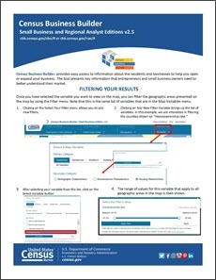
Download Small Business and Regional Analyst Editions: Filtering Your Results [PDF - 2.5 MB]
CBB allows the user to filter the geographic areas shown on the map to only show those that meet the users criteria based on up to 3 filter variables and values. This flyer provides a how-to guide on using the filter feature.

Map Classes and Color Palette
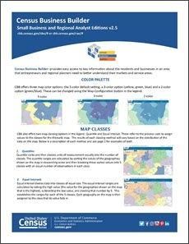
Download Small Business and Regional Analyst Editions: Color Palette and Map Classes [PDF - 1.1 MB]
CBB allows the user to change the map classes and color palette displayed on the map using a Map Customize feature in the Map Legend.
The map classes include an Equal Intervals method and a Quantiles method.
The color palette includes the default 5-color palette and 2-color (blue/green) and 3-color (blue/green/yellow) options.
This flyer provides step-by-step instructions on how to navigate these features on the map.

Navigating The Map Instructions
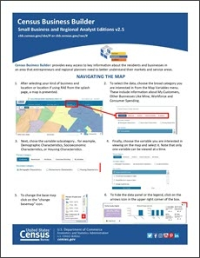
Download Small Business and Regional Analyst Editions: Navigating the Map [PDF - 1.8 MB]
CBB allows the user to dynamically change the kind of business, geographic area, map variable, and filter variable right on the map. The user can also change the level of geography shown on the map and perform other map manipulations. This flyer provides step-by-step instructions on how to navigate these features on the map.

Reference Layer Instructions
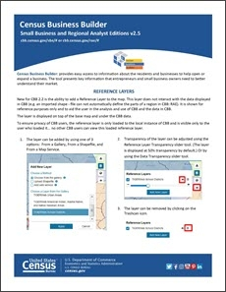
Download Small Business and Regional Analyst Editions: Reference Layers [PDF - 1.0 MB]
CBB allows the user to view 1 reference layer on top of the data on the map at a time using the Reference Layers feature. Each time a new layer is chosen, it replaces the previous one. Users can choose the layer from a pre-defined Gallery or by uploading their own ShapeFile or Map Service. This flyer provides step-by-step instructions on how to navigate these features on the map.

Tips and Tricks Instructions
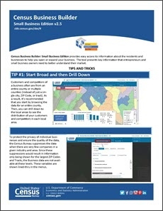
Download Small Business Edition: Tips and Tricks [PDF - 1.2 MB]
CBB allows users to find, access, and use detailed data for their kind of business, area, and region. This flyer provides quick tips on how best to use the features of CBB.

