EARNINGS AND COMPENSATION TRENDS OVER MORE THAN A CENTURY

An accurate understanding of how much individuals earn, and how earnings change over time, is essential to judgments about basic living standards, the role of earnings in relation to overall income, equity and inequality concerns, economic progress, and to decisions about government policy regarding the foregoing.

Many surveys report earnings, with frequently diverse results that are often attributable to varying earnings definitions and which workers are included. This analysis examines several governmental sources from the U.S. Census Bureau, Bureau of Labor Statistics (BLS) and the U.S. Bureau of Economic Analysis (BEA), which provide broad coverage, cover lengthy periods, and are all of very high quality. The most important points below are highlighted in boldface purple. Supporting data are attached above. All compensation/earnings amounts analyzed are adjusted for inflation, using the BLS Consumer Price Index (CPI) for all urban consumers (the conventional correction for inflation, although the Census Bureau uses a somewhat different CPI scale, for which the necessary data aren’t available to apply it to some older earnings data) for 2024 dollars.

Some of the earliest work-related data collected by BLS and its predecessors involved earnings, although little of these data are consistent with our modern series. This analysis reviews relatively consistent modern data, which are available in some cases from the early 20th century forward.

Summary. Over the long haul, compensation and earnings have tended to grow, with exceptions during extended depressions/recessions and high-inflation periods.
Trends differ somewhat depending upon the source, but a common pattern shows decline or stagnation in several key periods: the Great Depression, the 1970s (sometimes extending into the 1980s and even 1990s), the Great Recession period of approximately 2007 through the early 2010s, and the recent high-inflation period in 2021 and 2022.
The latest and broadest compensation data (now available for 2024) show the steepest compensation increases, although median earnings for full-time workers (not just employees) fell between 2023 and 2024, and remain below the 2021 level (albeit slightly higher than 2019). When 2023 annual data become available later this year, we may have a clearer picture of the most recent trends.
There can be no single best earnings indicator, because no single measure fully accounts for changes in the number of earners (lower during recessions), and variations in work time (whether part-time work, or jobless spells during a year). Therefore the most prudent analytical method is to examine patterns across multiple compensation surveys.
Several additional problems complicate comparisons over time. Most series examine individual earnings, but most individuals operate within households, and the rising prevalence of women in the paid workforce increased multiple earners in households.
Data sources vary in their breadth of coverage of workers (from private sector employees only to all workers); compensation (from monetary earnings only to all compensation, including non-monetary benefits); whether the information comes from employers (which don’t account for multiple jobs) or earners themselves; and how up to date the information is. For example, we now have hourly and weekly compensation/earnings data through sometimes nearly the first half of 2024, but no annual compensation/earnings data later than 2022 (2023 data will be released later this year).

This version considerably extends a prior analysis, which was restricted to three of the best sources, extending some of these further back in time, and including additional sources. It should be kept in mind that one of these additional sources – from the U.S. Bureau of Economic Analysis – is neither a survey nor based on original data, but rather classifies data collected by other agencies (in this case, primarily BLS and the Census Bureau). However, the BEA perspective is valuable, in that it makes an adjustment for full-time-equivalent employees (something done by neither BLS nor the Census Bureau, extends much further back in time (to 1929) than the BLS and Census Bureau series, and includes earnings as well as overall compensation (although it doesn’t measure compensation as thoroughly as does BLS).

There can be no single best earnings indicator. No single survey can supply the best evidence regarding earnings. The key contextual factors that influence earnings are the time covered (e.g., hourly, weekly, or annual); the amount of time that individuals work during the specified period; the breadth of the earnings definition (e.g., regular pay, overtime/bonus pay, or the inclusion of benefits such as health insurance, vacation, etc.); and the methodology used to adjust for inflation. Compensation is the broadest measure of earnings, including both cash payments and all non-cash benefits. Most workers whose pay is based upon an annual salary are not eligible for overtime pay, and many employers expect them to work more than the conventional 40 hour work-week: consequently their hourly pay could vary considerably depending upon how accurately their work time is measured. It should also be kept in mind that earnings and compensation reported here are before taxes.

Definitions of various types of workers. The term “workers” now generally refers to all individuals who obtain earned income. In 1948, 3 percent of workers were unpaid family workers, but by 1994 such unpaid workers had declined to an insignificant .1 percent of the workforce, a level where it has subsequently remained.

The remainder of the workforce is divided into employees (who obtain a wage from an employer) and the self-employed. Technically, a self-employed individual who incorporates is an employee of his or her own corporation, and surveys differ as to whether such incorporated self-employed are or aren’t included in an employee survey. Typically, only the unincorporated self-employed are classified as self-employed.

Trends in self-employment are important in reaching conclusions about overall earnings, for several reasons in addition to their falling share of the workforce. First, self-employment earnings are generally less precisely measured than employee earnings. Second, the two groups differ radically in terms of non-cash benefits, which are essentially zero for the self-employed, but from World War II to the present rose to nearly one-third of total compensation for employees.

Trends in self-employment. If both types of self-employed are included, their total share of the workforce has remained at about 10 percent since 2013. The unincorporated self-employed outnumber those who are incorporated, but the stability in the overall percentage masks two countervailing trends: the proportion of the unincorporated self-employed has declined, while the share of the incorporated self-employed has risen. BLS has only calculated the proportion of the incorporated self-employed in the workforce since 2000: between then and 2023 their share has risen from 3.3 to 4.1 percent of the total, whereas the share of the unincorporated self-employed has fallen from 7.5 to 6.1 percent over the same interval. Over the entire post-World War II period, unincorporated self-employment have declined from 18.5 (in 1948) to 6.1 percent of the workforce. During the initial period of this decline, the falling share of employment in the agriculture was a major factor in falling self-employment rates, with agricultural employment dropping from 13.1 to a mere 1.4 percent of total employment between 1948 and 2023 (using industry data).

Compensation: the Broadest Coverage of Earned Income

For compensation, we have good data from both BEA and BLS. Both of them supply information on both earnings and overall compensation. During the early 20th century, Federal and state governments began to require certain mandatory benefits, initially Workers Compensation at the beginning of the century, and later extended to Unemployment Insurance and Social Security retirement benefits in the 1930s (although the latter didn’t begin to be paid until 1940). The emerging impact of these developments can be seen in the first chart below. Compensation began to growth even faster than earnings beginning in the 1940s, as employers began to offer more generous benefits to retain employees during World War II, to circumvent Federal wage controls.

BEA data are best at understanding the beginning of the movement toward increasing benefit compensation, especially because BLS didn’t begin to broadly and consistently track benefit compensation until 1959 (for manufacturing production employees only), and then in 1966 for all private sector employees. BLS ended that series in 1977, and didn’t revive it until 1986 (using different but relatively comparable concepts), adding state and local government employees in 1991.

The BEA series differs from other sources in that it shows an inflation-adjusted decline only in the 1970s (although the CPS annual earnings series discussed below shows a similar pattern), whereas some other sources show that decline or stagnation extended into the 1980s and sometimes the 1990s. Another important difference is that BEA data indicate that the growth of benefits as a share of total compensation ceased in the early 1990s, and has remained relatively stable since then. However, more accurate BLS data on this subject indicate that the growth of benefits continued until 2018 for private sector employees, dropping by about a percentage point through 2023 (benefits continued to growth for state and local employees, until stabilizing from 2021 forward).

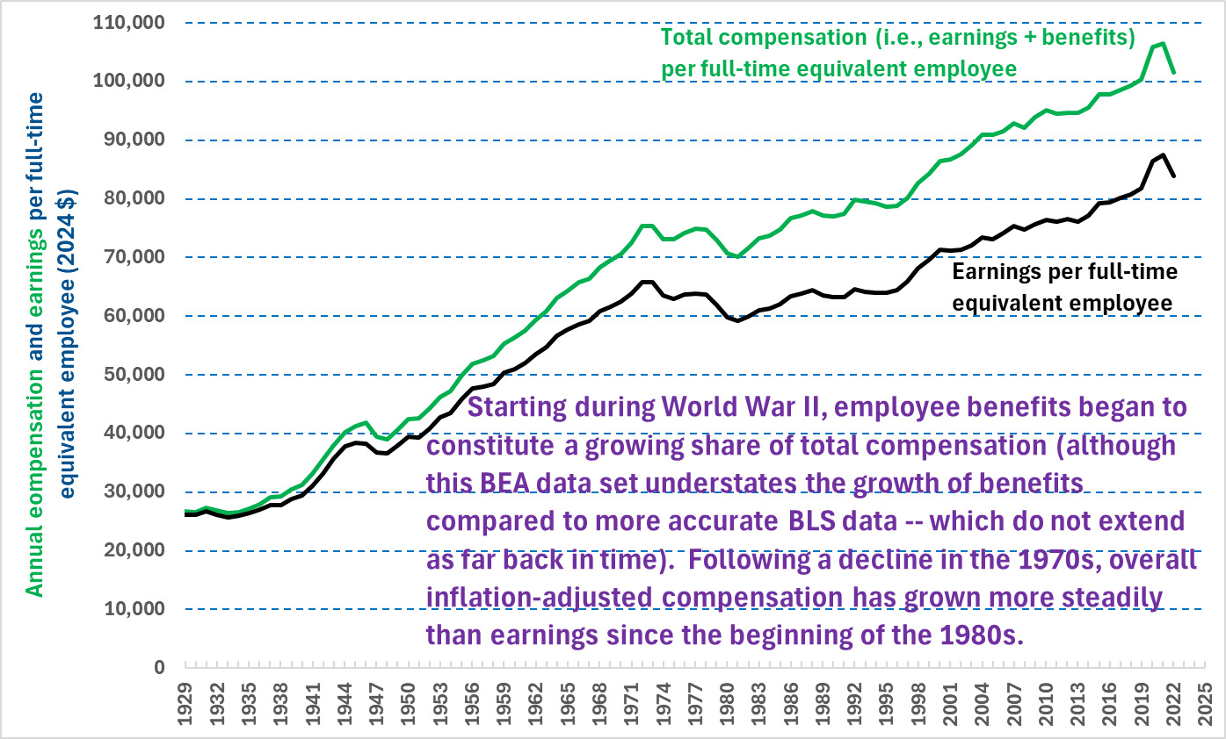
Source: U.S. Bureau of Economic Analysis

In 1966, BLS inaugurated a survey designed to cover virtually all types of earned income: now referred to as Employer Costs for Employee Compensation (ECEC). The most numerous categories of workers excluded from this survey are the self-employed and Federal employees. By 2023 these two groups constituted less than 10 percent of all workers, and from the mid-1980s to 2023 their share fell from roughly 11.5 to 8.5 percent of all workers. Federal employees constitute the smallest share: only about 2.5 percent of the total workforce, down from about 3 percent in the 1980s.

Two important points in ascertaining the impact of this exclusion are that both the self-employed and Federal workers often average higher pay than the workers included in the ECEC, but on the other hand the self-employed have virtually no non-cash benefits (the next survey summarized below includes all workers, with no exclusions).

As noted above, the growth of benefits as a share of total compensation began to pick up steam during World War II, and by 1959 – the start of the BLS series for manufacturing production employees (which excludes supervisors including forepersons) – already constituted 14.6 percent of total compensation. By 1966, when the BLS series for all private sector employees began, benefits accounted for 17.0 percent of compensation (the proportion was slightly higher for manufacturing production workers through 1977, likely because such works were more likely to be unionized).

Non-cash benefits now constitute nearly one-third of total compensation for all the employees included in the ECEC. This percentage has varied since such data were first issued by BLS in 1992, from 27.4 to 31.8 percent of total compensation, falling until the turn of the millennium, then rising through 2018 before then declining to 31.0 percent in 2023.

Trends. Because the longest time series is available for private sector employees, the chart below separately tracks private sector from state and local employees. In 2023, private sector employees constituted 80.5 percent of all workers, and state and local employees constituted only about 10.5 percent, which is why the average of the two groups is more reflective of the private sector averages. [In the BLS ECEC news releases, the combined average is referred to as the “civilian” category. See www.bls.gov/bls/news-release/ecec.htm#current]

These trends are sometimes erratic for state and local employees, although their overall pattern tends to mimic that for private sector employees. Since the late 1990s, compensation for both groups has generally risen. As shown, compensation tends to fall during recessions, and the pandemic recession followed by extremely high inflation both combined to reduce compensation in recent years. State and local employee compensation particularly declined, but private sector compensation began to rise again in 2023, and state and local compensation in 2024 – both rising fairly steeply.

Part of the superior compensation of state and local employees compared to private sector is due to their more generous benefits (discussed below), and partly because government employees are more likely to hold professional jobs, and have higher educational attainments.

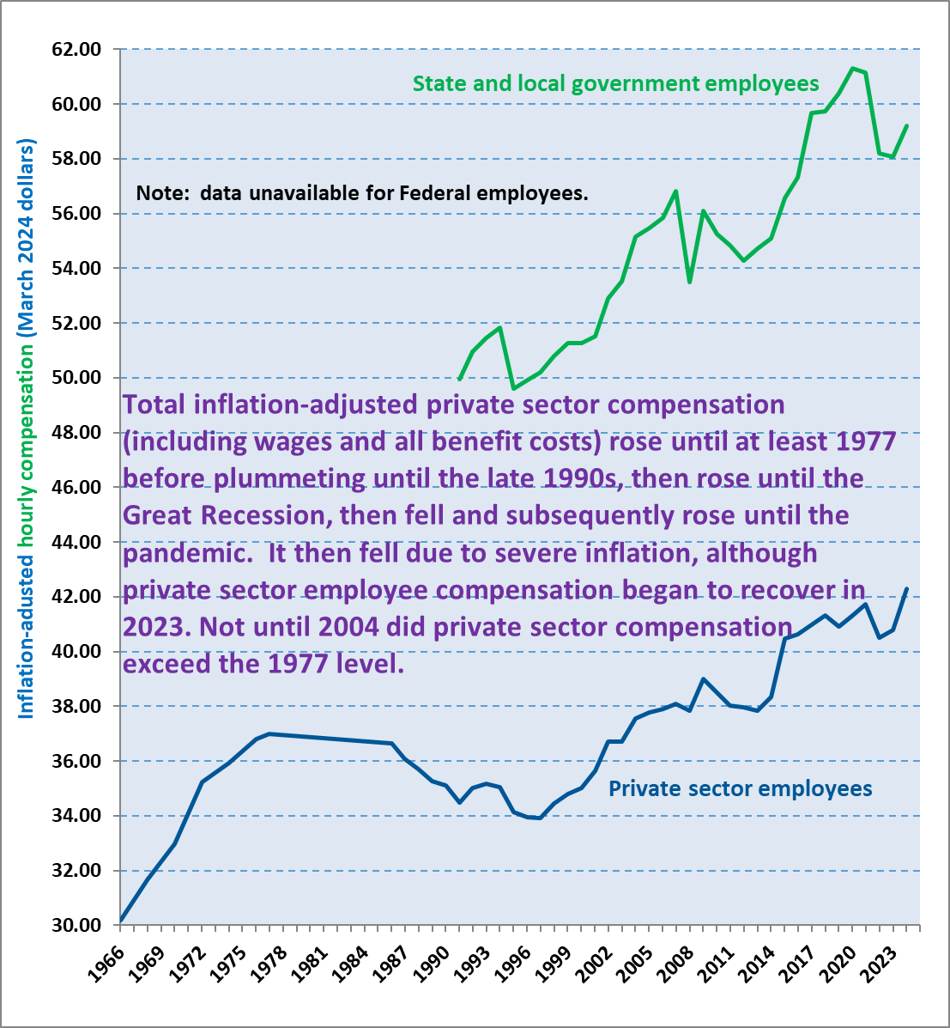
Source: BLS Employer Costs for Employee Compensation survey

The next chart shows the changing proportion of benefits over time for both groups of employees included in the survey, both for total benefits and for health insurance. The benefits provided to state and local employees are more generous than those given to private sector employees, and the gap has especially widened since the early 2000s, compared to a narrow gap during the 1990s.

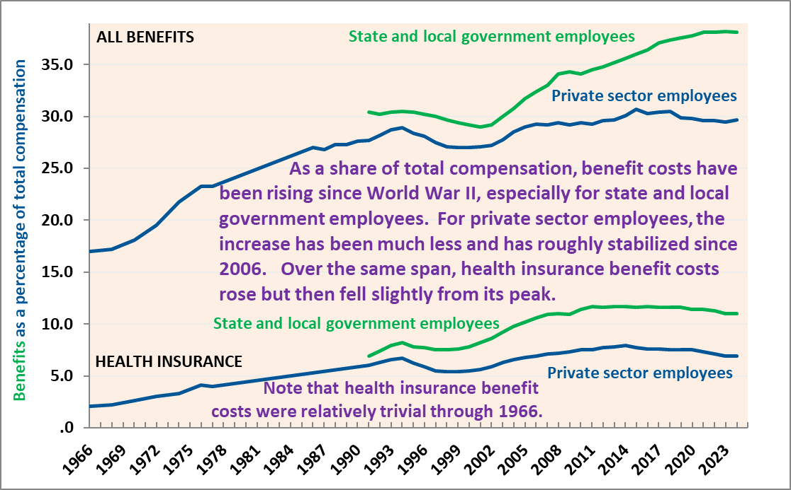
Source: BLS Employer Costs for Employee Compensation survey

Hourly and Weekly Earnings for Private Sector Employees Only

We now turn to two other BLS series, which have much narrower coverage of both compensation (restricted to earnings only), but which has the advantage of covering a longer timespan. One of these BLS series is a survey of employers (and therefore misses earnings from multiple jobs), while the other surveys earners themselves.

The first chart below, an employer survey of hourly earnings for manufacturing production employees, is the longest of our relatively comparable series, beginning in 1909 (although it should be noted that due to a later change in the industry classification system, the data prior to 1939 aren’t strictly comparable to later data). Adjusted for inflation, this series shows general growth except for the Great Depression (the only extended period of deflation in modern American history) and the high-inflation period immediately following World War II until earnings growth halted and then declined starting in the late 1970s. Earnings bottomed out in the mid-1990s, then rose until the early 200s before again stagnating during the extended Great Recession period until 2014. Earnings growth then resumed, but dipped during the recent high-inflation period, although it again began to growth in 2023.

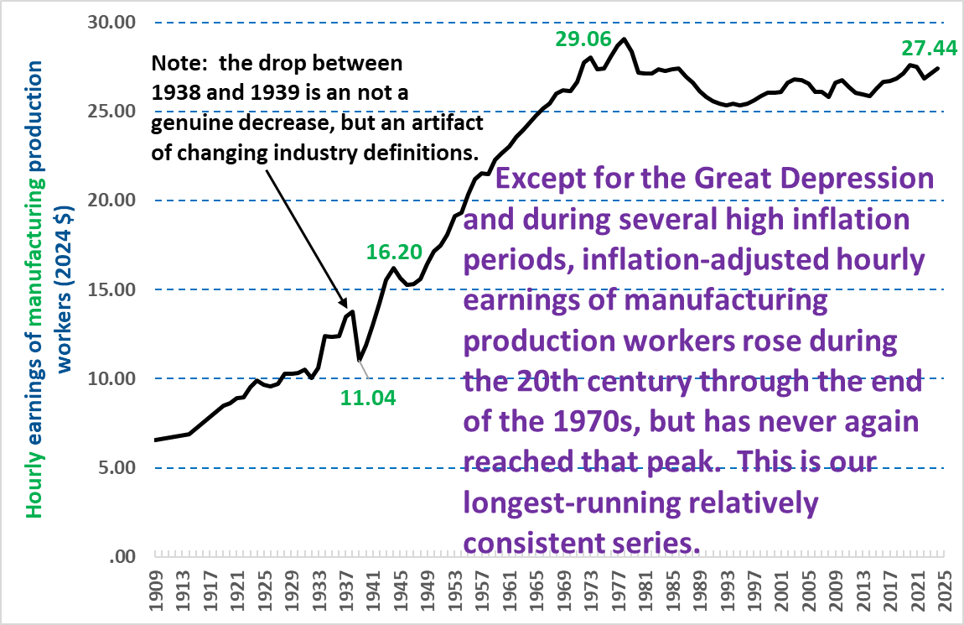
Source: BLS Current Employment Statistics survey, annual averages of monthly data

The next chart uses the same inflation-adjusted hourly earnings definition, also from employers, but covers all private sector production and non-supervisory employees, from 1947 forward. It shows a decline from the early 1970s extending through the mid-1990s, before resuming its general rise (again except for the Great Recession) until the beginning of the high-inflation period in 2021, with no clear rise through almost the first half of 2024. It should be kept in mind that this series doesn’t include the broad coverage available for all private sector employees since 2006, discussed next – which shows clearly rising earnings in 2023 and 2024 so far.

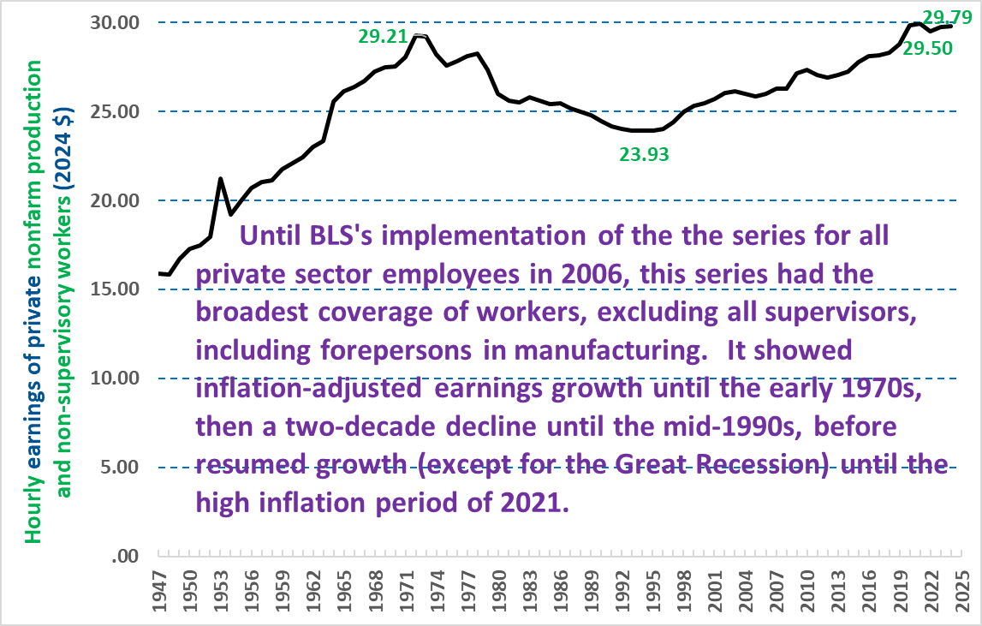
Source: BLS Current Employment Statistics survey, annual averages of monthly data

In terms of the earnings, the next survey has broader employee coverage, although the series only began in 2006. It pertains to all private sector employees, which in the 2006 to 2024 period constituted about 80 percent of all workers. These data come from employers, as do the ECEC data, in contrast to the Census Bureau data cited below, whose source is the individual earners (or someone in their household).

In 2006, BLS in its Consumer Employment Statistics (CES) survey (commonly referred to as the BLS “establishment” survey) began a new, much more comprehensive series tracking the earnings of employees. Prior to this, the CES tracked the earnings of production and non-supervisory employees only. The 2006 data are for the last 10 months of the year only, as BLS began this series in March.

Note that the base year BLS uses for its inflation-adjusted data is quite old (adjusting earnings to a combined 1982-84 base period), which results in much lower numbers than if 2024 was used as the base year, although this doesn’t affect the time trends.

Trends. The two charts below show both the similarities and the differences between the pandemic recession and its aftermath, compared to the previous recession (commonly called the “Great Recession,” as it was then among the worst recessions since the Great Depression).

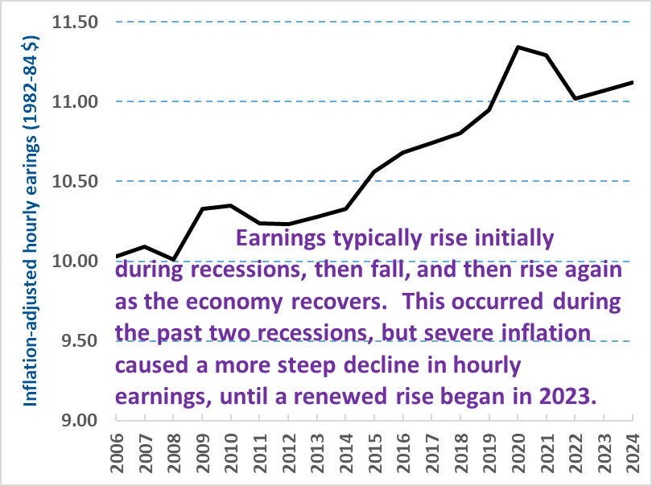
Source: BLS, Consumer Employment Statistics survey, annual averages of monthly data
Note: 2024 data are unweighted averages for the first five months of the year

The weekly earnings increase between 2022 and 2024 (shown in the chart below) was just .2 percent higher (compared to a .9 percent increase for hourly earnings), which is due to average weekly worktime falling between 2021 and 2024, from 34.7 to 34.5 to 34.4 to 34.3 hours (the 2019 annual average was 34.4). It should be kept in mind that the hourly and weekly earnings measures are connected, in that the weekly earnings average is merely the hourly number multiplied by the average workweek. Therefore when the two measures move in different ways over time, this is because of changes in worktime, not in the earnings rate.

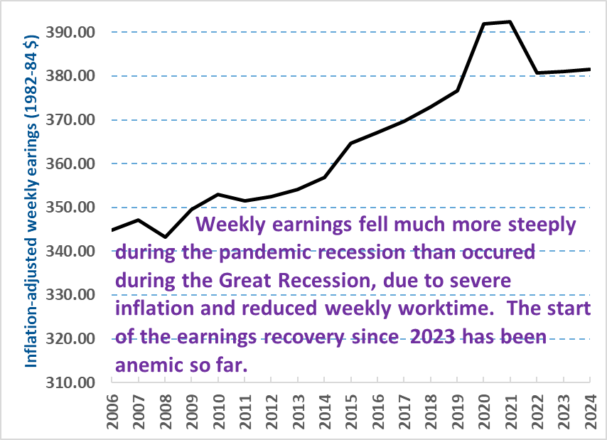
Source: BLS, Consumer Employment Statistics survey, annual averages of monthly data
Note: 2024 data are unweighted averages for the first five months of the year

Weekly Earnings of Full-Time Workers

The source of this next series is earners themselves (or someone in their household), as opposed to the employer survey data examined in all the charts above (it also relies upon the median rather than the mean average used in other sources). It has somewhat of a disadvantage in its used of the somewhat fuzzy concept of “usual” earnings, in contrast to the actual compensation/earnings definitions used in other series. BLS uses the concept of “usual” earnings to obtain a more typical picture of earnings, apart from the variations that occur from time to time in most people’s earnings. As shown in the chart below, this survey’s results are more erratic than those for other sources. However, they too show the common trend of a rise until the early 1970s (although this series only began in 1967), decline and then stagnation through the mid-1990s, followed by two separate growth spurts. One occurred in the late 1990s and early 2000s, while the other occurred from 2014 through the first year of the pandemic.

For the last few years, it shows that full-time median earnings have yet to fully recover, and in fact declined between 2023 annual average and the first quarter of 2024 – compared to the increases shown by the employer-based compensation and earnings results described in the previous sections (keeping in mind that the this survey covers all full-time workers, while the previous sources are both narrower in their inclusion of private sector employees only, and broader in that they examine earnings for all of them, not just among those working full-time).

Source: BLS Current Population Survey annual averages of monthly data

Annual Earnings of All Workers

The Census Bureau’s Annual Social and Economic Supplement (ASEC) to the Current Population Survey (CPS) doesn’t estimate the value of non-cash benefits (although it does collect data on whether workers have health insurance coverage through their employer). On the other hand, it covers all workers – including the Federal employees and the self-employed excluded by the ECEC, as described above. Moreover, data on hourly compensation rates -- such as the ECEC and the BLS establishment data analyzed in the next section below – do not account for how much time individuals labor, and insufficient earnings can be due to inadequate worktime as much as to a low wage rate. By measuring earnings over an entire year, the CPS ASEC data incorporate both a low earnings rate and inadequate worktime into their results. These data also cover the longest duration, from 1974 forward on an annual basis (annual earnings data from the decennial censuses and the CPS ASEC are available from 1939 forward, but not for every year, and not for the separate types of workers analyzed below).

These data are reviewed in two charts below, the first available for all workers since 1967, and the second available for a slightly shorter timeframe of 1974 forward that separates private sector, governmental, and self-employed workers.

Trends. Annual earnings for all workers tended to grow sluggishly in much of the 1970s, rose again in the 1980s through the turn of the millennium, and then grew sluggishly again in the expanded Great Recession period through 2014. Earnings then rose until 2019, prior to the pandemic, but again stagnated through 2022. Annual 2023 earnings won’t become available until September, but based upon other surveys an increase is possible.

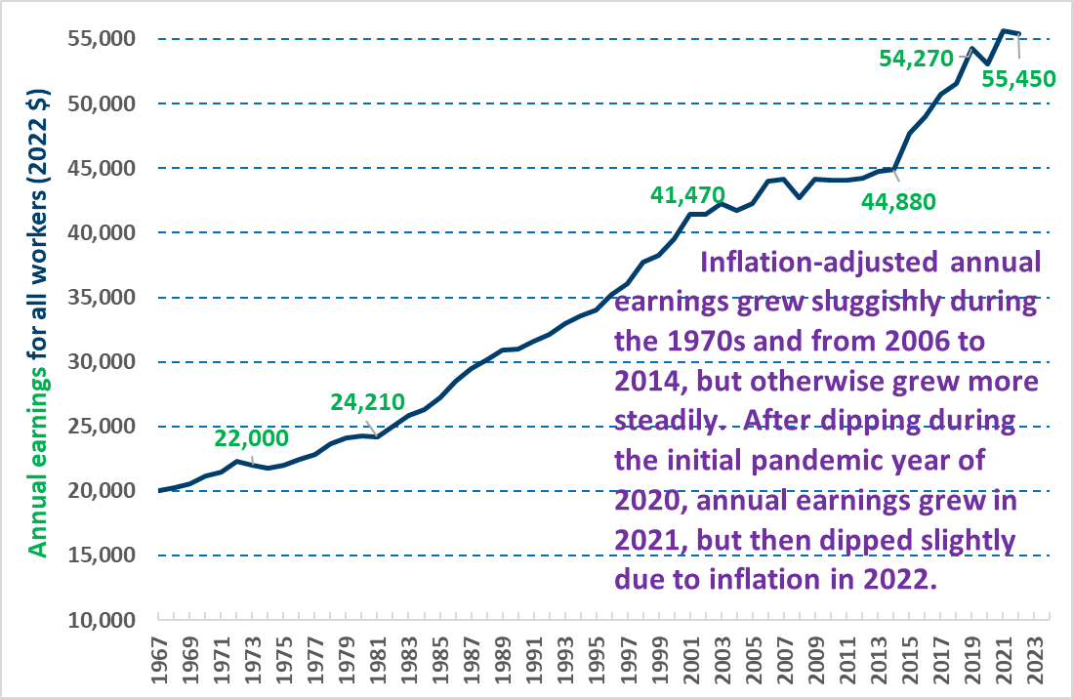
Source: U.S. Census Bureau, Current Population Survey (CPS), Annual Social and Economic Supplement

As shown in the chart below, private sector and governmental employee annual earnings tend to move in the same pattern, and there isn’t a large difference between them, most of which is caused by governmental employees being more likely to hold professional jobs and possessing more education. In contrast, annual earnings of the self-employed are much more erratic, and there is often a much larger gap between their earnings and those of employees. Self-employment annual earnings tend to fall much more during high unemployment periods than those of employees. This causes a significant narrowing of the employee/self-employed earnings gap, and sometimes a reversal of the more common pattern, whereby the annual earnings of the self-employed fall below those of employees – this occurred both during the 1980s, and more briefly during the pandemic recession.

As noted above, it should be kept in mind that the self-employed obtain virtually no non-cash benefits, which account for a nearly one-third of total compensation among employees. This would significantly narrow the overall the earnings advantage of the self-employed. The self-employed also face an important disadvantage relative to employees regarding after-tax earnings, in that they must pay the entirety of their Social Security withholding taxes, whereas for employees, employers pay half of this tax burden.

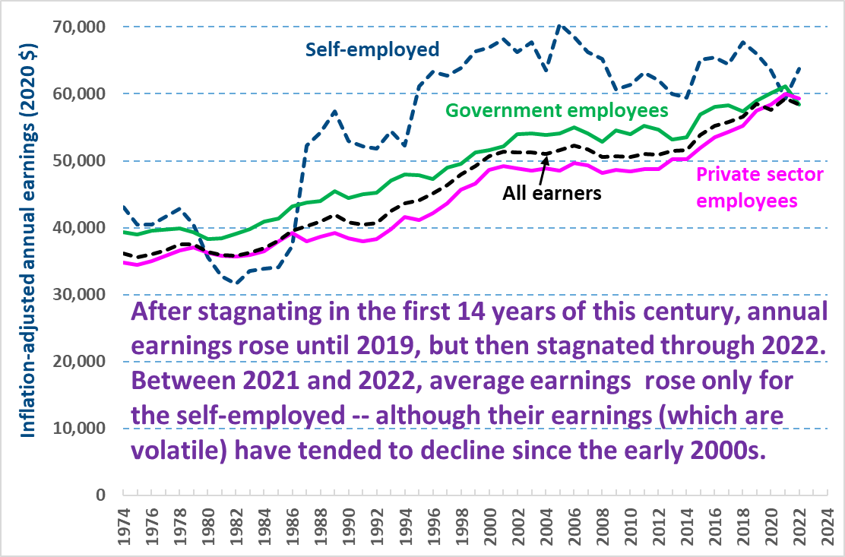
Source: U.S. Census Bureau, Current Population Survey (CPS), Annual Social and Economic Supplement

[6-18-24, by Frank Gallo, at Gallo.Frank@DOL.gov]

The official BLS CPI series begins with 2013, but can be extended earlier in time using a consistent series from Susan B. Carter et al, U.S. Census Bureau, Historical Statistics of the United States Millennial Edition, Volume 3, Economic Structure and Performance (2006), Table Cc1-2, p. 3:158.
For a good overview of BLS’s role, see “A Century of Wage Statistics : The BLS Contribution,” BLS Monthly Labor Review, November 1984 https://fraser.stlouisfed.org/title/monthly-labor-review-6130?browse=1980s#611454; for the early data itself, see Historical Statistics of the United States Millennial Edition, Volume 2, Work and Welfare (2006), pp. 2:254-281
Compensation and benefit trends for manufacturing production workers for 1959 through 1977 aren’t included in the charts, but are shown in the attached spreadsheet.
Note that these two tables use slightly different base years for the inflation-adjustment (2022 and 2020, respectively). When the Census Bureau issues the 2023 data later this year, I’ll convert both these charts to a 2024 base year for the inflation-adjusted adjustment. The choice of the base year affects the actual numbers, but doesn’t change the trendline.

