In continuing an examination of wealth gaps by Race and Hispanic origin, ETA extended the look at various key possessions to include ownership of and access to IT. The first two charts below examine historical trends for the entire population, followed by more in-depth looks at disparities for various minority groups.
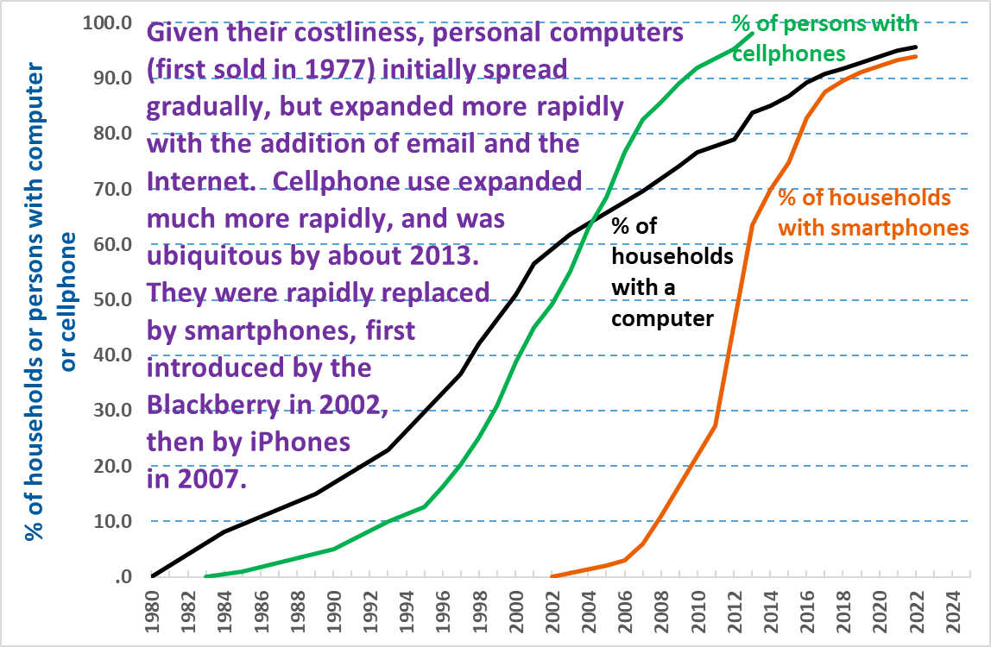

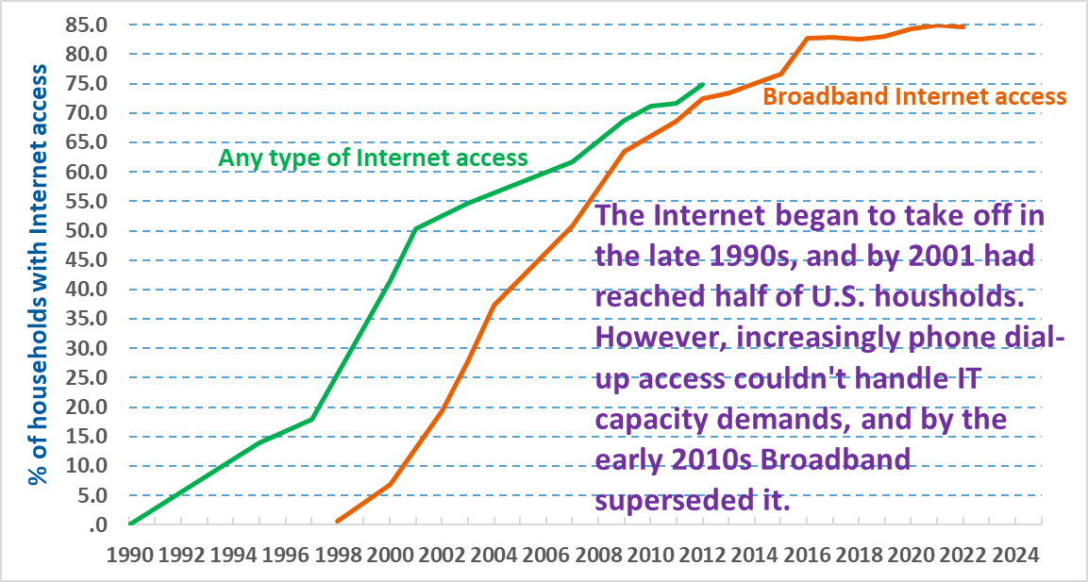

The next two charts show that although the most disadvantaged minority groups have nearly closed the overall gap in access to computers, this is largely because of smartphones, as there remains a significant gap in access to the type of computers best suited for working with documents and spreadsheets (which is especially important for school and work purposes).

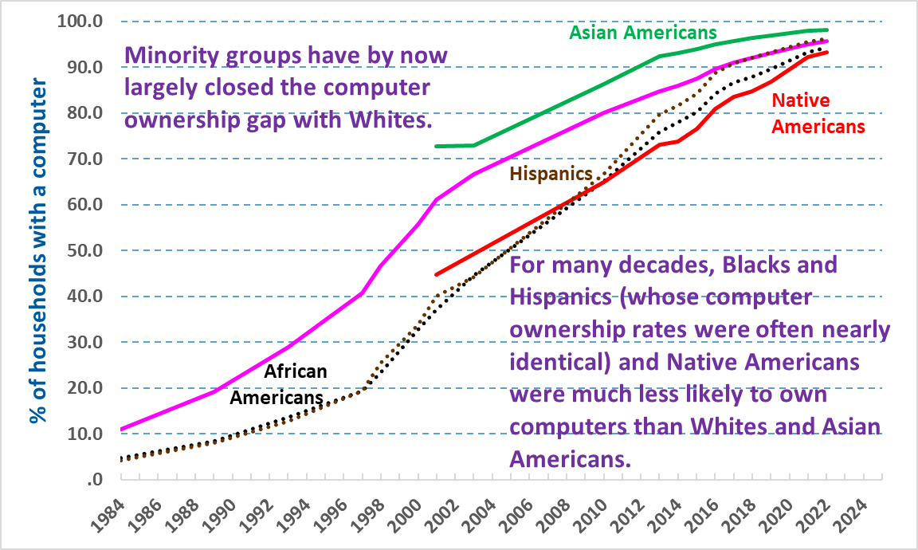

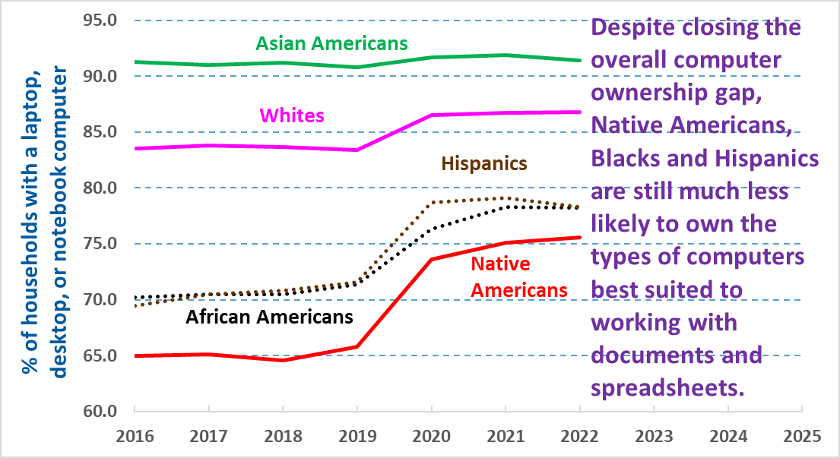
The last two charts examine Internet access, first in the initial Internet period looking at any type of Internet access (including dial-up), followed by the most recent period examining gaps in Broadband access. Unfortunately, in the initial period data were not published for Native Americans.

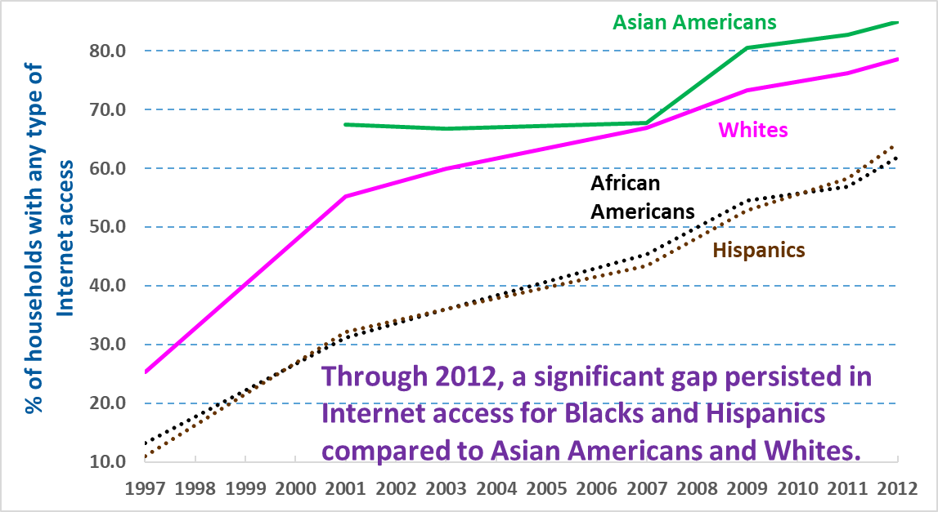

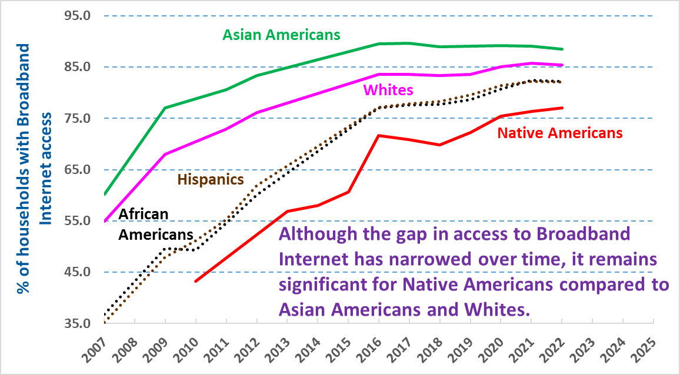
Frank Gallo | Workforce Analyst | Gallo.Frank@DOL.gov 5-28-24

