In the larger context of computer use and Internet access, there is so much additional information for ETA’s purposes on this subject, that this subject is done as a stand-alone piece. For your convenience, the identical narrative is both shown below and attached above (followed by the spreadsheets that show the complete underlying data). The first spreadsheet attachment should open at the second tab, but additional historical data and charts can also be seen in the first tab (shown at the bottom of the screen, on the far left), entitled “Trends.” The second spreadsheet attachment above shows data from the relevant Federal Reserve survey.

KEY TRENDS IN COMPUTER AND INTERNET USE
Over the past several decades, changes in electronic devices and software have caused major changes in lifestyles throughout the world. This review examines some of the most important changes over time, with special attention to the employed and unemployed. In some instances the focus is on various age cohorts, especially for teenagers and young adults, who are usually the quickest to adopt new inventions and tools. Supporting data are attached above.
Key surveys. The best and most important computer and Internet use research has been done by the U.S. Census Bureau, through two separate surveys. The Bureau has tracked computer use since 1984: its principal survey has been what is now called the Computer and Internet Use Current Population Survey (CPS) supplement. This survey has been conducted in varying months, although since 2013 it has been conducted every other year, and consistently in November since 2017. The latest data available are from 2021; data from the November 2023 supplement should become available sometime in 2024.
The other key Census Bureau survey is the American Community Survey (ACS), which first introduced computer and Internet questions in 2013. The ACS asks much fewer questions on this topic than does the CPS, and the questions pertain to households, not persons. One advantage of the ACS is that it has a much larger sample size, and therefore can provide data on detailed geographical areas, and for much more narrowly-drawn demographic groups. Because it is conducted annually, it is currently more up to date, providing 2022 data.
Important caveats. Given the major changes in this field over time, the Census Bureau has had to alter its questions in ways that sometimes do not permit tracking the same information throughout the past several decades. Because of these inconsistencies, the first year included in this review is 1994, although in many cases data are not available until much more recently. There have also been some major problems with the CPS supplement, which one can see by the time gap for many variables between 2003 and 2010, and sometimes through 2013. The supplement was conducted in the intervening years, but the results are so inexplicable that they are usually excluded from historical trends.

The best current source of data from the CPS supplement is no longer the Census Bureau itself, but rather from the U.S. Commerce Department, National Telecommunications and Information Administration’s (NTIA) Digital Nation Data Explorer (www.ntia.gov/other-publication/2022/digital-nation-data-explorer). Its data begin with 1998, so for earlier data it is still necessary to exam older Census Bureau sources.
The most important point to bear in mind is that the way in which most of the NTIA’s data are presented is quite different from how other sources present data. For example, instead of calculating the proportion of total persons who use the Internet in a particular way, the NTIA usually calculates the proportion of persons who use the Internet as the denominator. However, it should be possible to adjust their data to examine it as proportion of total persons, and I will later attempt this.
KEY FINDINGS
Given that the ACS data are for households, and only begins with 2013, most of this analysis relies upon the CPS. I have examined data beginning with the earliest available year (given the limitations explained above), but keep in mind that the time periods covered vary widely from chart to chart – in many cases data are only available for the past few years. To avoid confusion, I have only occasionally included the ACS data in the charts below, although ACS data are cited, and can be seen in the first attachment above.

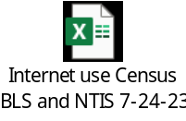
INTERNET ACCESS AND BASIC INTERNET USE
In examining Internet data, keep in mind that some questions ask about access to the Internet (usually calculated by household rather than by person), versus actual use of the Internet by a person. For example, it is perfectly possible that a household has Internet access, but some persons who live there don’t use it. Conversely, individuals can use the Internet from various locations, and therefore may use it even if they don’t have home access.
Generally, the employed are more likely to have access to and use the Internet. As the chart below shows, over time the digital gap between employed and unemployed individuals has significantly narrowed, for both Internet and smartphone use. By 2021, the gap between Internet and smartphone usage had also nearly disappeared.

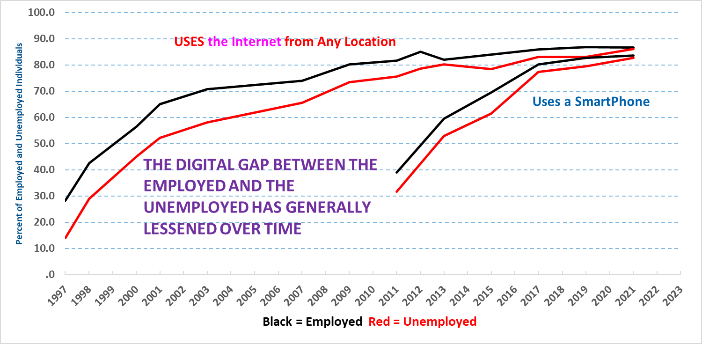
Source: CPS

Similarly, the digital employed/unemployed gap for Internet access at home has also great narrowed, and by 2023 more than 90 percent of households had home access.

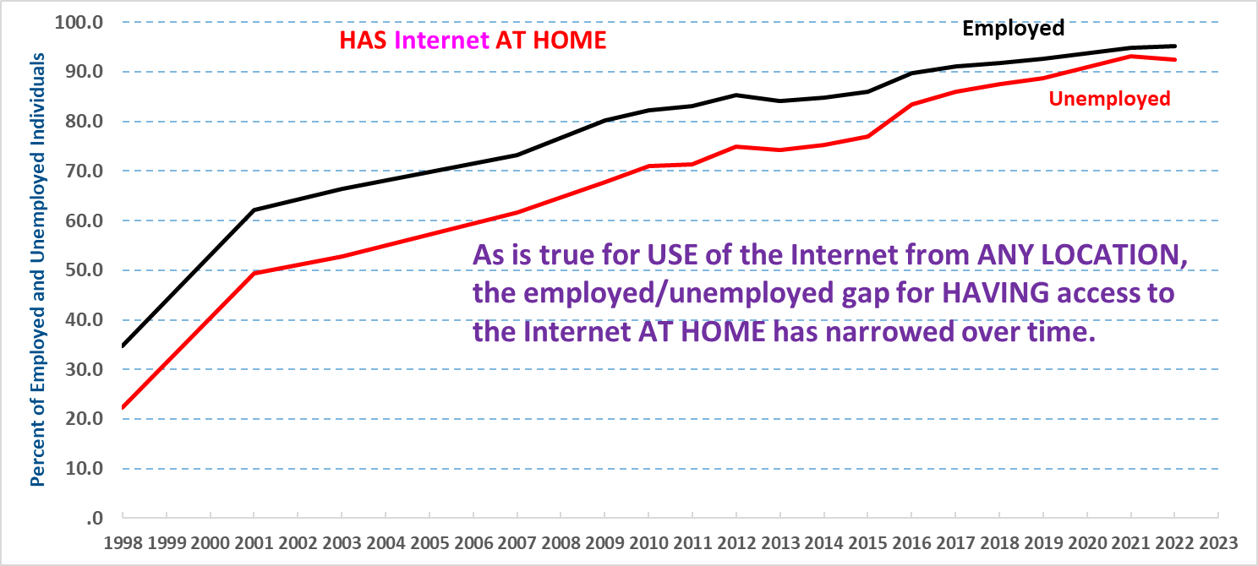
Source: CPS and ACS

We can also examine the reasons why employed individuals (actually, the data pertain to households with an employed person) do not use the Internet at home. Their reasons have greatly changed over time, sometimes in ways that are unexpected. As the chart below shows, the most common reason is that the household either doesn’t believe they need the Internet, or simply aren’t interested in it – and this factor has become more prevalent in recent years. The cost of electronic devices, adjusted for inflation, has significantly fallen over time, so it isn’t surprising that this factor has become less important in recent years. During the Great Recession’s extended high unemployment period the cost factor became more important for a few years, but this too is unsurprising. Lack of a home computer, or an inadequate one, has never been an important factor explaining the absence of Internet use at home.
Given that so many people have access to a computer at work, and that this proportion has risen over time, it is somewhat surprising that access to the Internet outside the home has never been a major reason why workers don’t use the Internet at home. Moreover, during the past two decades, this explanation has diminished to almost insignificance.

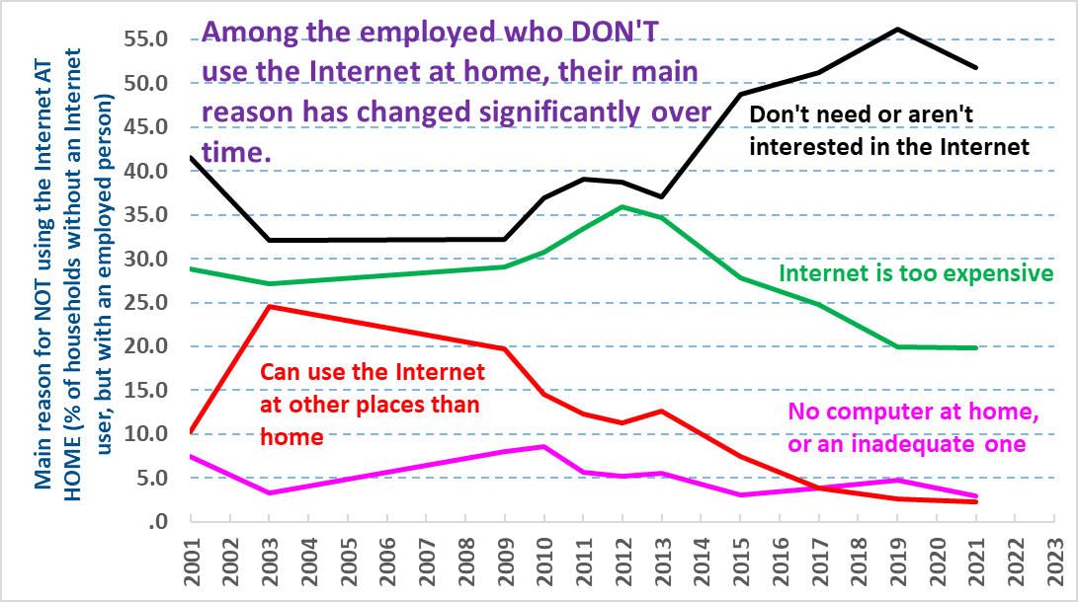
Source: CPS

Use of Different Types of Electronic Devices
The first home computers were exclusively desktop models, but beginning in the 1990s laptop computers became more common. Smartphones, tablet computers, and e-readers weren’t introduced until well into the 2000s. As the chart below shows, smartphones exhibited the most rapid adoption among workers, rising to more than 80 percent by 2021, and ACS data show that by 2021 and 2022, more than 90 percent of households included at least one person who had a smartphone. The development of more powerful and lighter laptop computers, and the introduction of smartphones, tablets, and e-readers caused desktop computer usage to significantly decline, although this appears to have bottomed out in recent years. Tablet usage grew significantly and then dropped slightly, and laptop usage has also plateaued for a number of years.

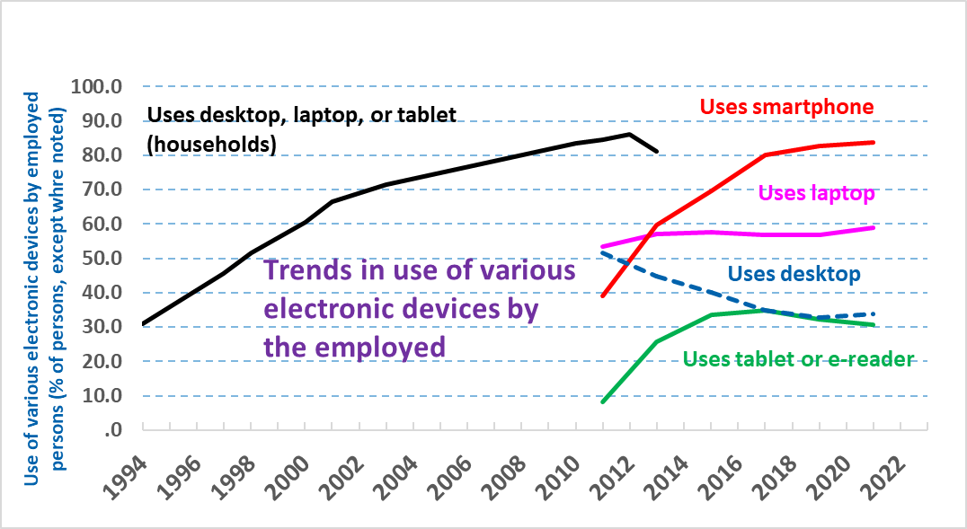
Source: CPS

Similarly, ACS data showed that household use of a desktop or laptop computer (by at least one person in the household) has plateaued at roughly the 80 percent level between 2013 and 2022. However, the household use of either of these devices or a tablet/e-reader continued to increase, growing from 83.8 to 95.7 percent of households between 2013 and 2022.
High-Speed Internet Subscriptions, and Use of the Internet at Work
The earlier years of the Internet were dominated by dial-up service, but over time the capacity and speed of this type of service could not keep pace with the growing electronic demands put upon them. Therefore, it became increasingly impossible to use the Internet without a high-speed service, and the chart below tracks how rapidly wired high-speed Internet service grew. The ACS uses a more expansive definition of broadband service (e.g., including satellite subscriptions), and shows a higher degree of penetration than does the CPS: rising from 73.4 to 91.0 percent of households with broadband Internet service between 2013 and 2022.
The chart below also shows employed individuals who use the Internet at work. This also grew rapidly, but may now have plateaued, a possibility that should become clearer when the 2023 data become available.

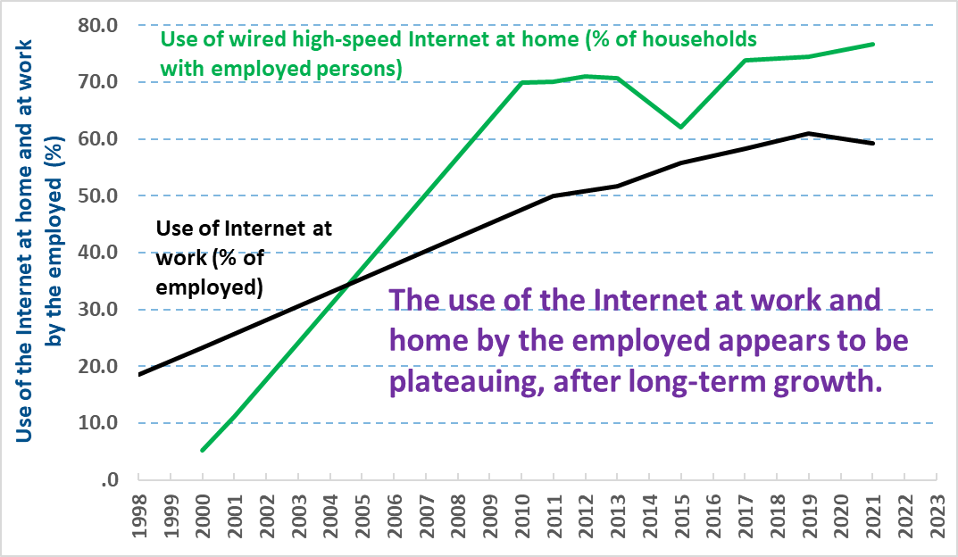
Source: CPS

Ways in Which Workers Use the Internet
The CPS supplement asks two important questions about use of the Internet by workers, shown in the chart below. The pandemic caused an acceleration of both online meetings and remote work (however, these meetings aren’t necessarily work meetings). Note that these figures are not based on all workers, but solely those who use the Internet at any location.

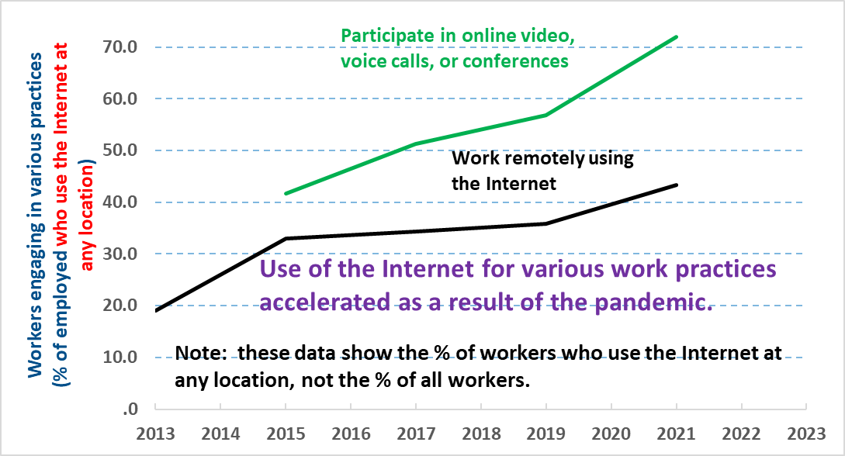
Source: CPS

Use of the Internet to Look for Work
Given that most employers now require individuals to apply for jobs online, workers have had to adapt by searching and applying there. However, as the chart below shows, in recent years this has peaked among both the unemployed and the employed, and actually declined by those not in the labor force (BLS defines this category as those who aren’t actively seeking work, although some of them at least look at online job openings, as the chart shows).

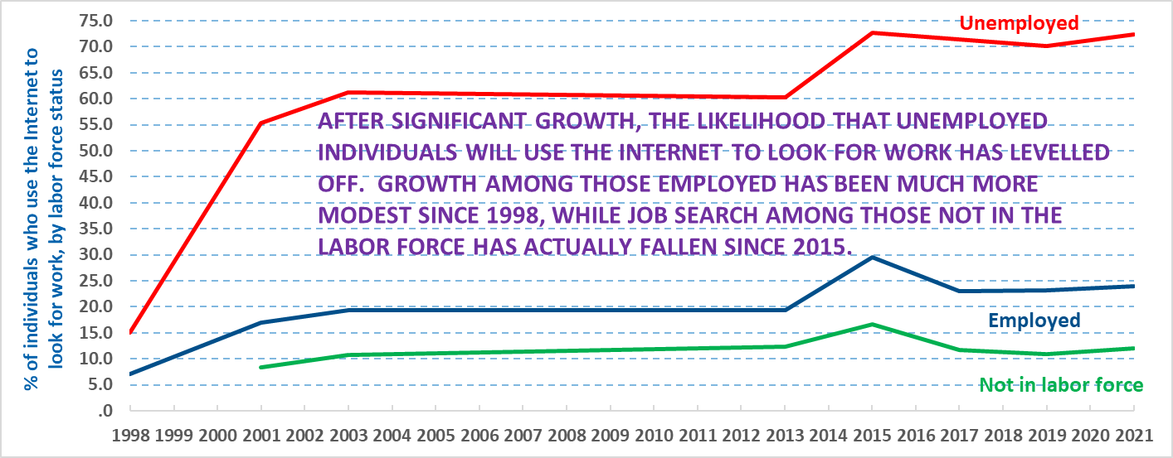
Source: CPS

Gig Work and the Internet
The CPS Computer and Internet supplements includes some extremely useful information related to what has relatively recently been called “gig” work, usually defined as self-employment that is often more sporadically performed than a more traditional self-employment. The two charts below track sales of goods and services online, respectively, and show that both are relatively uncommon among those who use the Internet. The two practices show diverging trends, with sales of online goods falling slightly, while sales of services online has risen. For both practices, individuals aged 25 to 44 are the most likely to pursue them, in contrast to the usual pattern of teenagers and young adults being most likely to use the Internet for various activities. In fact, young people are no more likely to sell goods or services online than are 45 to 64 year-olds.

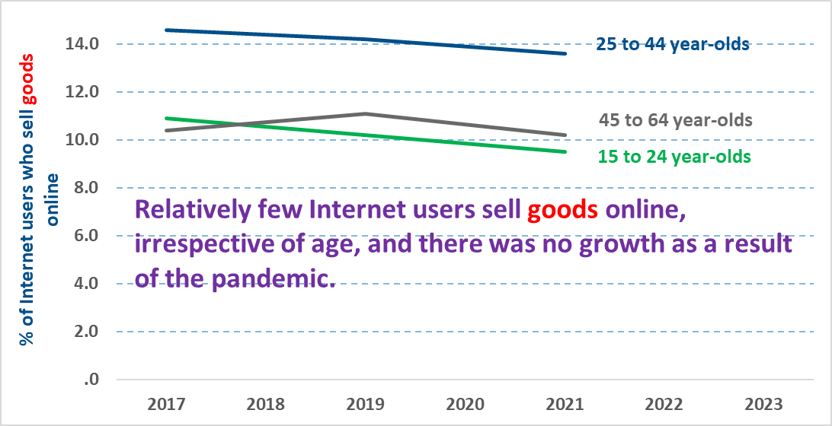
Source: CPS

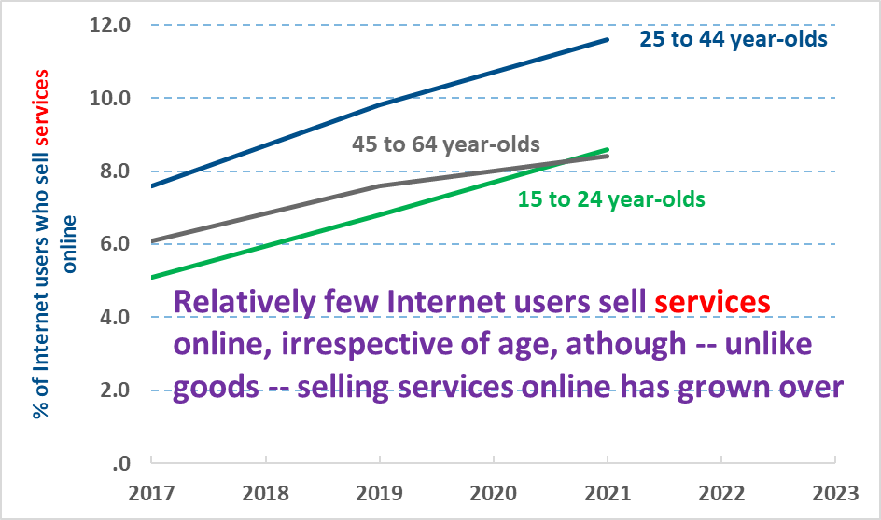
Source: CPS

The CPS results on gig work are relatively consistent with another useful survey on this subject, the U.S. Federal Reserve’s Survey of Household Economics and Decision-Making, shown in the table below. Both surveys show that gig work is relatively uncommon, and both show a slight decline in recent years for sales of goods via gig work. The Federal Reserve survey hasn’t consistently defined the sale of services via gig work, and for the 2021-2022 brief period in which the definition is consistent, there was no change. The CPS survey data only covers through 2021.

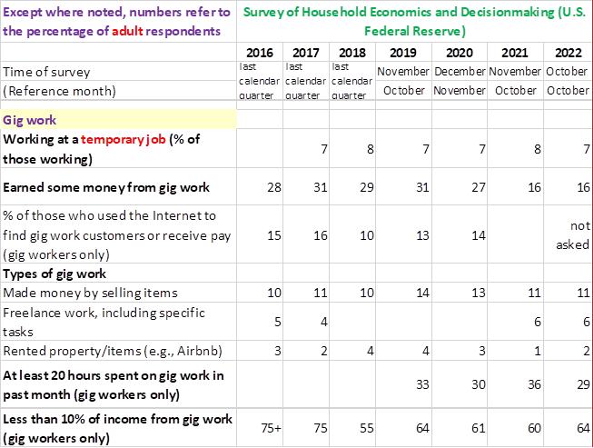
Source: U.S. Federal Reserve, Survey of Household Economics and Decision-Making

The CPS also includes an extremely useful additional question that sheds light on consumer demand for services sought online. As the chart below shows, this demand has rapidly risen, which likely explains the rising proportion of online sellers of services shown in the chart above.

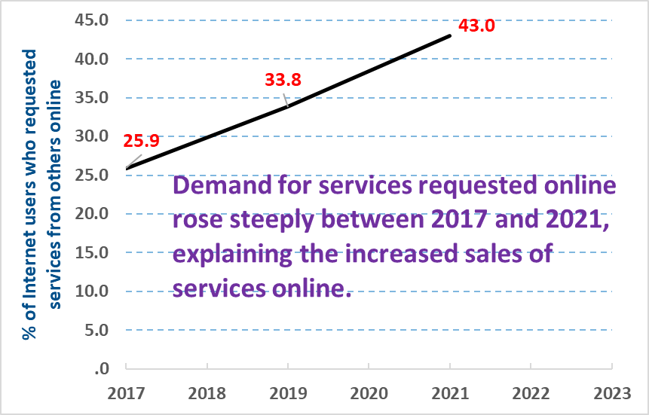
Source: CPS

Online Education and Job Training
Among Internet users, pursuit of online classes or job first grew rapidly, then sometimes plateaued or declined, but then accelerated during the pandemic. As shown in the chart below, this growth remained the case in November 2021 (the month of the supplement) for even teenagers and young adults, despite the fact that almost all students had returned to in-person schooling by the beginning of the Autumn 2021 Semester.

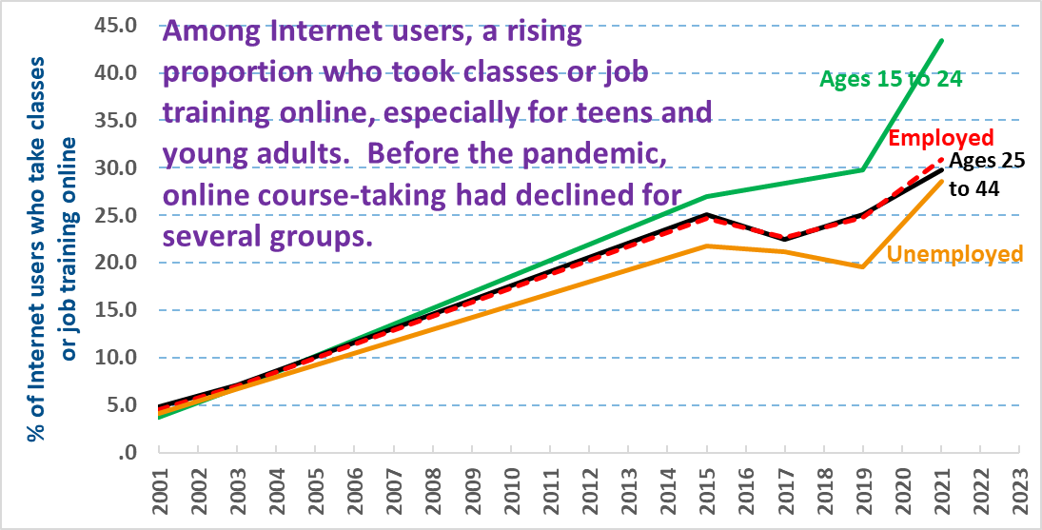
Source: CPS

Other Common Internet Uses
This section covers the use of the Internet for social interactions, entertainment, and shopping and banking. For entertainment, the focus is on the young people who are the most concentrated users of the Internet for this purpose.
Use of the Internet for texting or instant messaging expanded rapidly, and had become nearly ubiquitous by 2015 and afterward, as the chart below indicates. The CPS didn’t measure the use of the Internet for social media until 2015, by which time it had already become prevalent. However, its use has remained relatively stable at slightly more than 70 percent of Internet users since then.
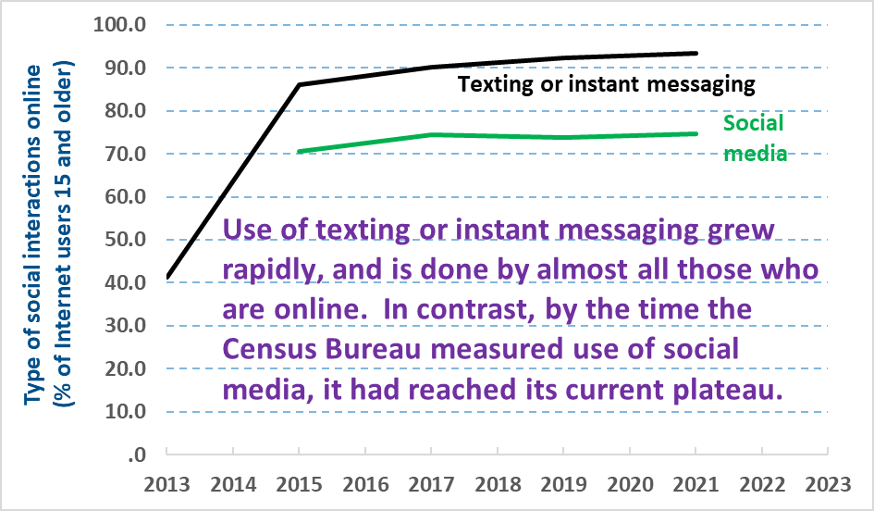
Source: CPS

The next chart focuses on the type of Internet activities for entertainment that young people pursue to a much greater extent than older cohorts. Somewhat surprisingly, there has been relatively little change in them since 2015. Also perhaps surprising is the relatively small proportion of young people who post their own content -- which has never risen above 30 percent – as opposed to using content posted by others.

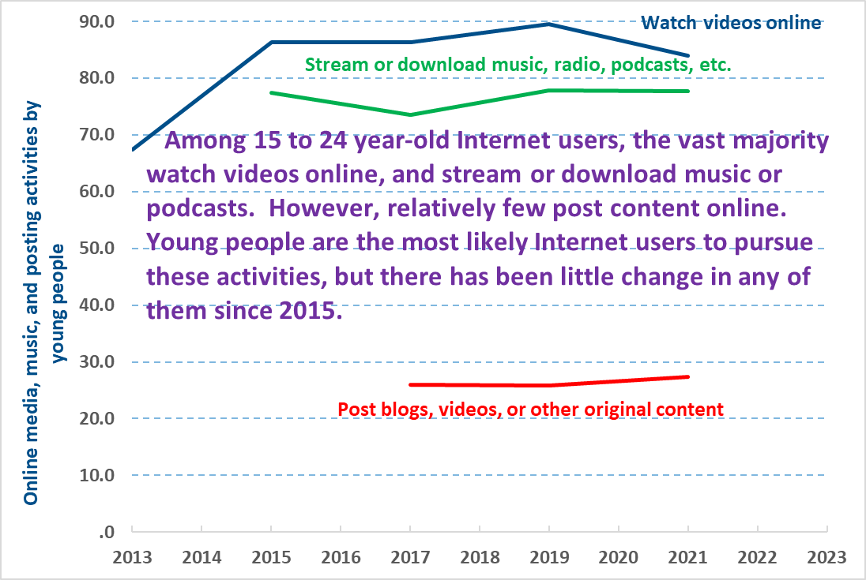
Source: CPS

Finally, the chart below tracks some basic consumer activities among Internet users, among all those who are 15 and older. Both online shopping and banking continue to rise, in contrast to the plateauing characteristic of a number of other Internet practices.

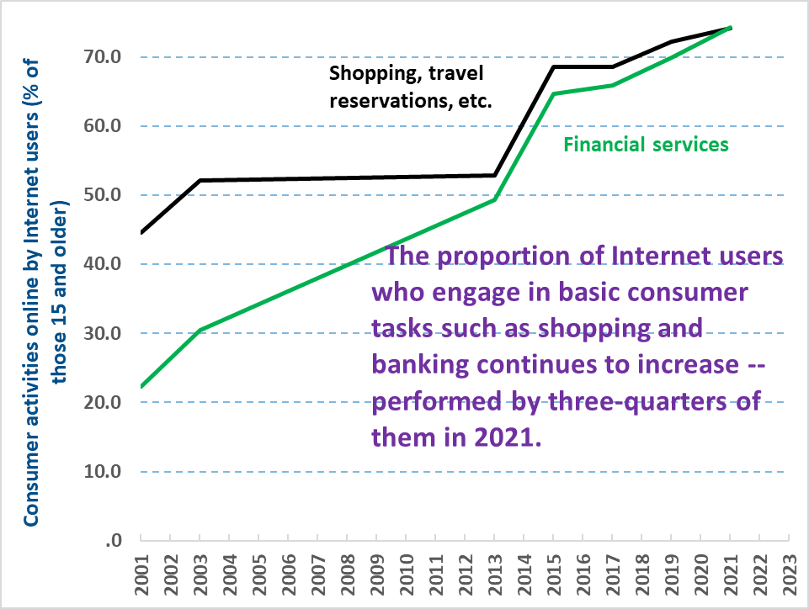
Source: CPS

Frank Gallo | Workforce Analyst | Gallo.Frank@DOL.gov 11-1-23

