LONG-TERM CONSUMER SPENDING PATTERNS

Because consumer spending is the primary engine that drives economic growth and employment, including employment patterns, it is worth understanding. The major trends are shown in two charts below, in which I have made adjustments to keep the categories consistent (in 1972 BLS included all vacation expenses in the recreation category, whereas in other years the agency assigned vacation lodging, food, transportation etc. costs to these other categories). The underlying data and sources are attached above (at the bottom of the data rows, spending by African Americans is shown for selected earlier years – I still haven’t finished these analyses).

The source for all these data is the U.S. Bureau of Labor Statistics (BLS) Consumer Expenditure Surveys, conducted each year from 1980 (except for 1983) forward, and much less frequently before that – only about once each decade between World War I and 1980, except for several years during World War II.

Important background. Two important contextual points should be kept in mind. First, consumer expenditures do not include governmental expenditures: governments spend a huge amount of money on education, healthcare, and transportation that would otherwise be borne by consumers. This explains why, for example, consumer education and healthcare spending are less than might be expected.

Second, the national income and product accounts (including GDP) are an alternative source of consumer spending data. Unlike the periodic consumer expenditure surveys through the 1970s reported here, consumer spending from the national accounts is available annually – officially from the U.S. Bureau of Economic Analysis from 1929 forward, and in widely-accepted academic data that begin with 1900. These data rely upon overall consumer spending and derive from different sources than the consumer expenditure surveys. The consumer surveys retain independent value because they provide demographic and other information not available from the national accounts data.

Long-term trends. Several key long-term patterns are clear.

- Food dominated consumer spending throughout history until the 20th century, but now accounts for only about 13 percent of U.S. spending.
- In 1900 and earlier, food and clothing constituted more than half of consumer spending, but only 15 percent now.
- For many spending categories, the degree of change slowed considerably from the 1980s forward, and has stabilized for some types of spending.
- Housing and related spending – including utilities, household operations, and furnishings/equipment – now dominates consumer spending in a way that food once did. Some of this spending is discretionary, especially that involving furnishings and equipment, and therefore the total amount should not be regarded as spending for necessities.
- Consumer transportation spending peaked in the 1970s, and it is probably not coincidental that the peak occurred just before the first international oil embargo that began to significantly increase energy prices. In the past decade, transportation spending has stabilized at about 16-17 percent of the total.
- Consumer healthcare spending has especially risen during this century, rising from 5.4 to about 8 percent (where it has essentially remained since 2014) – following relative stability at about 5 percent throughout the 20th century.
- The second chart below tracks some purchases that have always remained relatively minor. The most significant increase has been in entertainment and recreation, which rose more or less steady until the 1980s. Thereafter it has been the most volatile of all the spending categories, but has tended to fluctuate around the 5 percent level since the mid-1980s (ranging from 4.7 to 5.6 percent), with no consistent trend.
- Alcohol and tobacco spending peaked in the mid-20th century, and then declined. Spending for alcohol has roughly stabilized at about one percent of the total from the late 1980s forward, although since the beginning of the pandemic the proportion has been at a low point of .8 percent. The decline in tobacco spending slowed considerably after 2004, but still continued to drop until its low point of .5 percent since 2019.
- Personal care spending peaked in the 1960s, falling from 2.9 to 1.3 percent of the total between the early 1960s and the mid-1980s. It then generally remained at slightly above one percent of total spending, with very little fluctuation since the turn of this century.
- Human capital spending – education and reading – has always constituted a relatively tiny share of total consumer spending – not much more than personal care or combined alcohol/tobacco spending during this century, and below combined alcohol/tobacco spending until 1990.

Pandemic and post-pandemic trends. The pandemic and post-pandemic period, including the post-pandemic high inflationary period, does not generally seem to have significantly altered long-term spending trends. Here are some of the highlights for recent years. It should be kept in mind that many spending categories haven’t changed recently: the items below highlight those that have changed.

- After falling during the pandemic, the proportion of household spending devoted to food has been increasing for the past four years, albeit by only a .1 percentage point rise between 2022 and 2023, and the 2023 proportion didn’t differ from the immediate pre-pandemic period.
- Clothing spending immediately fell during the pandemic, presumably because people were interacting relatively little with those outside their immediate households. Although it bounced back somewhat in the pandemic’s aftermath, it has remained below the pre-pandemic level – despite a long-term decline, it had stabilized at about 3 percent between 2016 and 2019. By 2023, it had again stabilized, but at about 2.6 percent of total spending since 2021.
- Overall housing spending (including household operations, maintenance, and furnishings) immediately spiked in 2020, likely because individuals had little else to do in the initial pandemic year, and were catching up on maintenance and the fulfillment of long-desired home improvement projects. It subsequently fell each year, from 37.1 to 35.2 percent of total spending, between 2020 and 2023 – although the 2023 level remained above the pre-pandemic levels of 2011 to 2019.
- Shelter-specific spending (i.e., rent and mortgage payments) also rose in 2020, but after falling in 2021 have risen slightly, from 19.8 to 20.1 percent of total spending between 2021 and 2023. This likely reflects high housing inflation, as the 2023 level exceeded all years between 2011 and 2019.
- Spending on household furnishings and equipment spiked during the pandemic, but had fallen from 4.0 (the pandemic peak) to 3.2 percent by 2023 as a share of total spending, and the latest level had returned to the approximate 2015 to 2019 level.
- Transportation spending unsurprisingly dropped during the pandemic, but has gradually risen from 16.0 to 17.0 of total spending between 2020 and 2023. However, the increase between 2022 and 2023 was only .1 percentage point, and the 2023 level matched the 2019 pre-pandemic average.
- Entertainment spending also unsurprisingly spiked during the pandemic, but fell from 5.3 to 4.7 percent between 2021 and 2023, albeit with no change between 2022 and 2023. To find less spending on entertainment than that during the past few years, once must go back to the early 1980s, when video recorders were just beginning to sell.
- Likely because of fewer people attending postsecondary schools, education spending fell to 1.8 of total spending in 2021 and 2022, but then spiked to 2.1 percent in 2023. The last time education spending was as low as 1.8 percent was in the early 2000s, and even the increase to 2.1 percent remained below the 2012 to 2019 pre-pandemic levels.

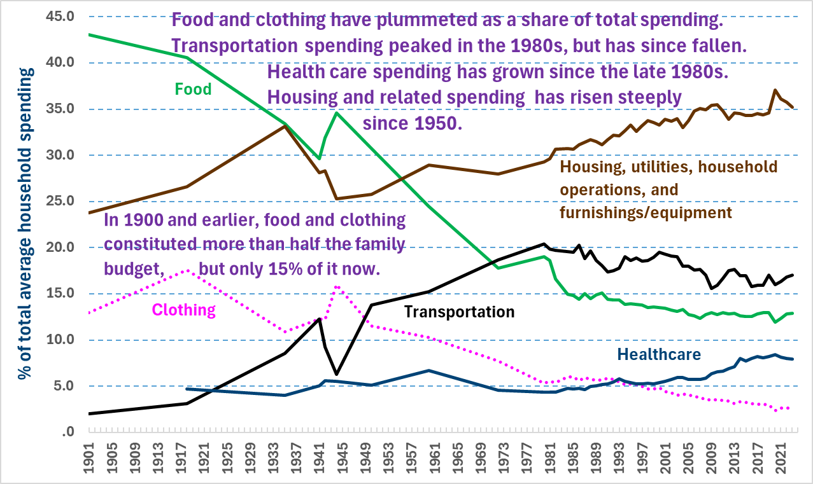

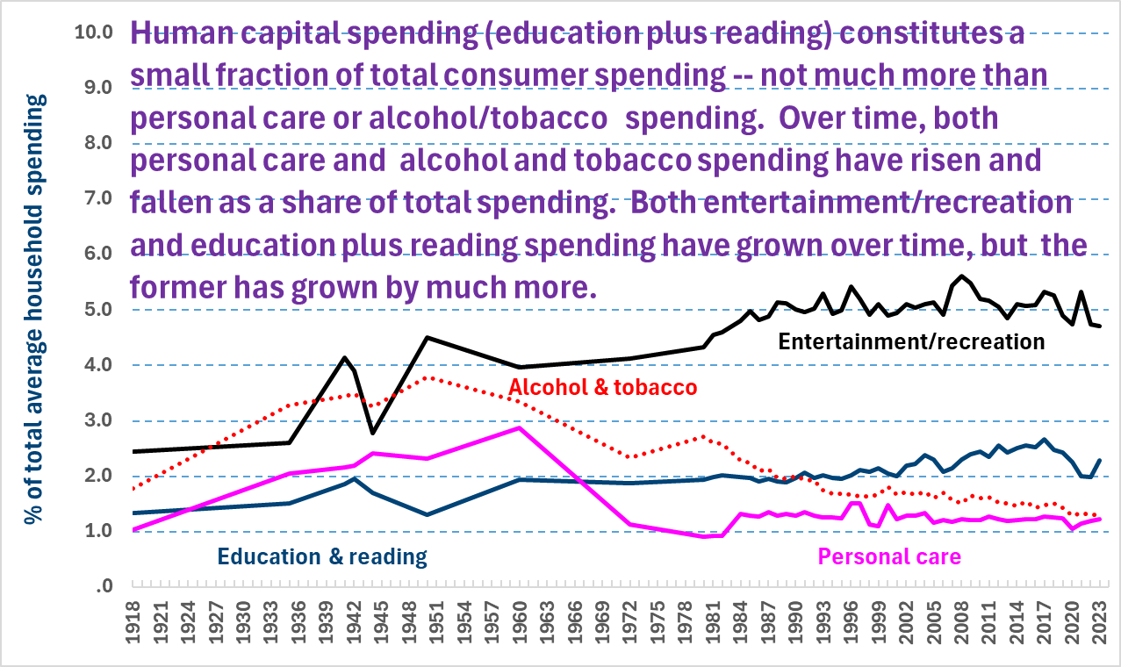
[9-25-24, by Frank Gallo, at Gallo.Frank@DOL.gov]

