UPDATED SMARTPHONE AND COMPUTER OWNERSHIP DATA, AND INTERNET BROADBAND ACCESS

The U.S. Census Bureau and Pew Research Center have recently issued updated data for cellphone and smartphone ownership data (from Pew, through 2024) and household ownership of smartphones, various types of computers, and Internet broadband access (for 2023, from the Census Bureau)). The Pew report also includes a number of additional interesting elements, including the proportion of users who only use smartphones, and lack any other type of computer (about 15 percent of the total, concentrated among low income and less educated individuals). See www.pewresearch.org/internet/fact-sheet/mobile/?utm_source=Pew+Research+Center&utm_campaign=8d274c3a53-Weekly_11-16-24&utm_medium=email&utm_term=0_-8d274c3a53-399625017

The two charts below show long-term trends, incorporating these new data. Note that cellphone ownership is for persons, and the other data below pertain to households.

It should be kept in mind that there are some inconsistencies with these data, and not merely between the two sources. With the 2023 data, the Census Bureau has significantly revised its estimates downward from for a number of recent years (generally, 2015 forward), with no explanation as to why this revision occurred. The Census Bureau data are available from the Table S2801 series, with no narrative explanations, at https://data.census.gov/advanced

The Pew data aren’t consistent with other survey data on cellphone ownership (only available through 2010), as the Pew data show lower personal ownership rates. However, because the Pew data are available for many recent years, I have substituted its data for other, higher estimates that I previously used.

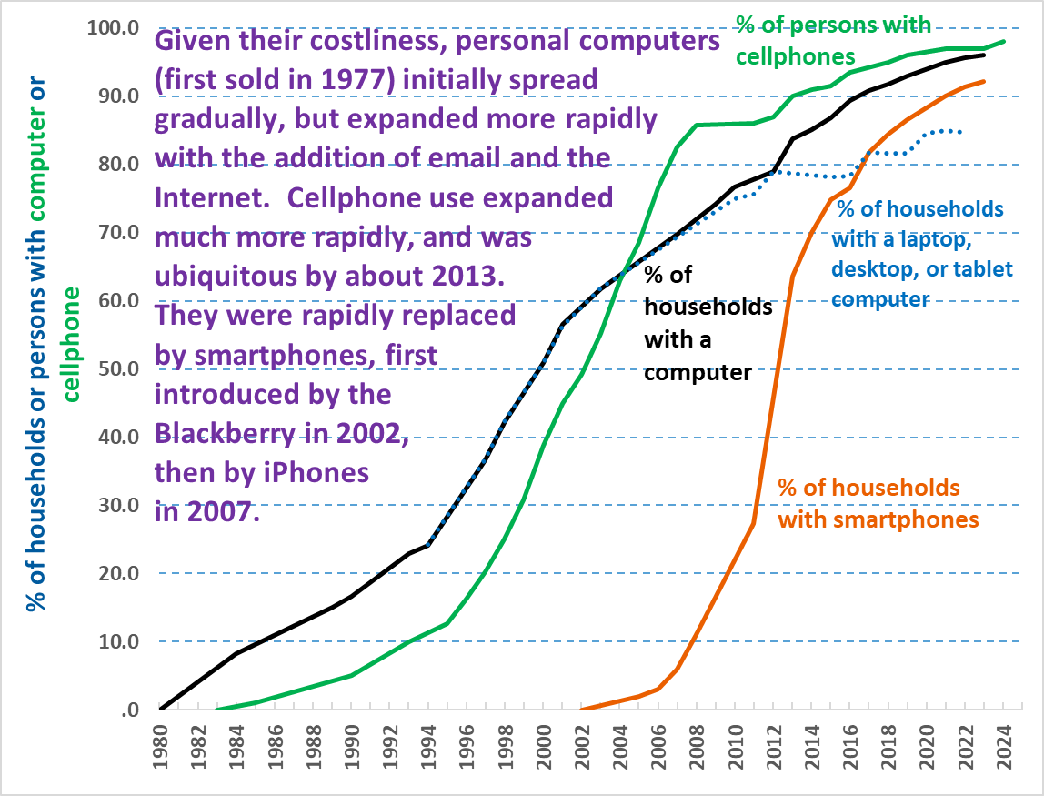
Sources: U.S. Census Bureau, American Community Survey; and various private sector surveys

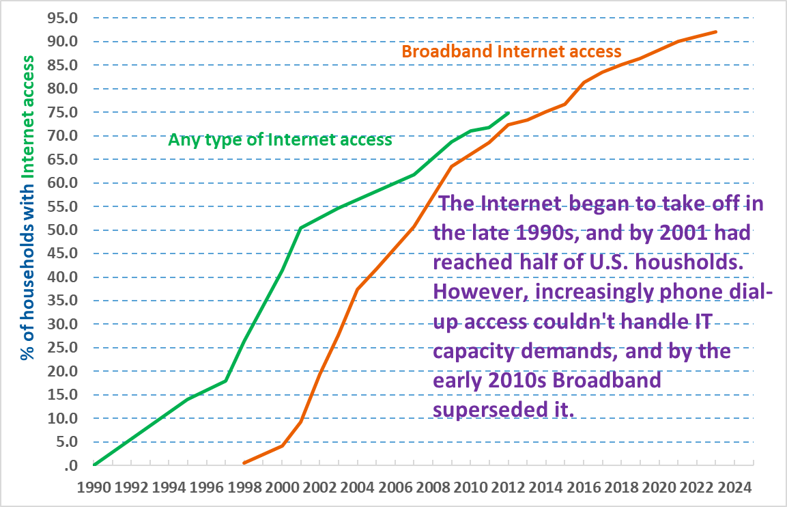
Sources: U.S. Census Bureau and U.S. National Telecommunications and Information Administration

[11-22-24, by Frank Gallo, at Gallo.Frank@DOL.gov}

