



Employment and Training Administration (ETA)

Reentry Employment Opportunities (REO)
Grantee Performance Management System (GPMS)

Grantee User Guide
Version 1.4
December 28, 2022

Prepared By:
United States Department of Labor
Office of Chief Information Officer (OCIO)
200
Constitution Ave NW
Washington, DC 20210

SUMMARY OF CHANGES
ISSUES
Issue | Description | Section | Page
DELETIONS
Description
None
GENERAL COMMENTS:
N/A.

TABLE OF CONTENTS
SUMMARY OF CHANGES 1
TABLE OF CONTENTS 2
1. INTRODUCTION 4
2. TARGET POPULATION & CORE SERVICES 4
3. CASE MANAGEMENT OVERVIEW 5
4. DOCUMENT OVERVIEW 6
5. REO CASE MANAGEMENT APPLICATION CORE FUNCTIONAL REQUIREMENTS 6
6. USER MODULES 7
7. UNIVERSAL FEATURES 8
7.1. Navigation Buttons 8
7.2. Dropdowns 9
7.2.1. Field-Level Help / Tool Tip Tool Tip 9
7.3. Required Fields 9
7.4. Calendar Buttons 10
7.5. Upload Documents 10
7.6. Grids 11
7.7. Action Icons 12
7.8. Need Help Page 12
7.9. Data Validation Messages and Alert Banners 13
8. NAVIGATING THE REO GPMS 14
8.1. Register with login.gov 14
8.2. Request for User Assignment 22
8.2.1. Request for Assignment (RA) Process 23
8.3. Request for Assignment Approval – Grantee Administrator 26
8.3.1. Grantee (Primary) or Intermediary Request for User Assignment (GIAR) Approval 26
8.4. Cases 27
8.4.1. User Roles and Pages Overview 28
8.5. Admin 37
8.5.1. Grantee Admin – Users 37
8.5.2. Grantee Admin – Approve or Deny Request 38
8.5.3. Grantee Admin – User profile 38
8.6. Reports 39
8.6.1. Summary Report 39
8.6.2. My Progress Report 41
8.6.3. WIPS UPLOAD 43
8.6.4. Go To WIPS 45
9. CASE MANAGEMENT 46
9.1. Add Participant 52
9.1.1. Program and Participant: (Youth) 52
9.1.2. Demographic 53
9.1.3. Employment/Education Information 56
9.1.4. Public Program Information: 57
9.1.5. WIOA and Other Program: 59
9.1.6. Criminal Justice: 60
9.2. View/Edit Case Information 62
9.3. IDP (Individual Development Plans) 63
9.4. Assessments 64
9.5. Services 66
9.6. Outcomes 86
9.7. Follow-Up 91
9.8. Notes 96
9.9. Documents 97

INTRODUCTION
The Reentry Employment Opportunities (REO) program office operates within the Employment & Training Administration’s Office of Workforce Investment at the U.S. Department of Labor. Authorized as research and evaluation under Section 169 of the Workforce Innovation and Opportunities Act of 2014 (WIOA), grant programs funded through REO connect current or formerly incarcerated adults and youth involved in the justice system with occupational skills training and Registered Apprenticeships leading to industry–recognized credentials and employment in industries and occupations that offer competitive wages and opportunities for advancement. In addition to career training and planning, REO programs also fund supportive services0_{F}¹ such as housing and childcare, for participants. Employer partners are an important part of REO programs, advising them on in-demand skills and credentials and providing paid work opportunities.
The REO program office’s goal is to develop strategies and partnerships that facilitate the implementation of successful reentry programs at the state and local levels to improve the employment outcomes of reentering citizens. Community- and faith-based organizations across the country operate reentry programs that utilize various program models and promising practices. REO grant programs are designed to test the effectiveness of program models and strategies when adapted and applied to a public workforce system setting. The REO program office partners with the Department’s Chief Evaluation Office (CEO) to conduct implementation and impact evaluations of select REO grant programs. This facilitates program improvement and contributes to the evidence base of what works in reentry employment programs. The growing evidence base is used to inform future workforce development policy regarding justice-involved youth and adults.

TARGET POPULATION & CORE SERVICES
WIOA defines “offenders” as adults or juveniles who have been subject to any stage of the criminal justice process, and for whom services under WIOA may be beneficial, or people who require assistance in overcoming artificial barriers to employment resulting from a record of arrest or conviction. Adult reentry programming focuses on persons aged 18 or older who were sentenced under the adult criminal justice system.
Core services for REO program participants include the following:
Youth & Young Adults: These projects focus on post-release services that include apprenticeships; case management; credit retrieval; diversion from adjudication; expungement of juvenile records; follow-up; high school diploma equivalency preparation; job placement; mentoring; occupational skills training; staff and leadership development activities; restorative justice opportunities; tutoring; work experience; and other supportive services.
Adults: Adult projects focus on pre- and post-release services that include apprenticeships; case management; career exploration through work experience and internships; employer connections; high school diploma equivalency preparation; job placement; legal assistance; mentoring; needs assessments; occupational training in in-demand industries; and pre-employment skill-building services.

¹ The Workforce Innovation and Opportunity Act Desk Reference: Supportive Services
(https://ion.workforcegps.org/resources/2017/07/14/09/22/Supportive_Services_Desk_Reference).
TEN No. 12-21: Practitioner’s Guide to Supportive Services
(https://www.workforcegps.org/Newsletters/2022/05/27/11/30/~/link.aspx?_id=29E73168F91C44309A8D72C2B4C8799A&_z=z).

CASE MANAGEMENT OVERVIEW
The Reentry Employment Opportunity Case Management Application (REO GPMS) is developed as a web-based, mobile-accessible application to support the REO program’s mission and goals. The REO GPMS user groups are divided into two categories, internal users and external users. The internal user group includes the REO program staff, performance management/evaluation team, Field Project Officers (FPOs), and REO technical assistance contract team members. The external user group includes grantee program directors, case managers, data entry personnel and lead workers supporting direct grantees and sub-grantees (intermediaries).
The following provides a high-level overview of the functions carried out by these user groups using the REO GPMS.

External Users:
Grantee Admin
Manage all users, sub-grantees, and sites
Approve grantee user access requests Generate consolidated reports
Generate and transfer PIRL file to WIPS Supervisor
View/edit all cases for grantee, sub-grantee, or site Generate consolidated reports
Lead Case Manager
Sub-grantee Admin Manage sub-grantee | Generate limited reports  Case Manager
View/edit all cases for grantee

Approve sub-grantee user access requests

New case intake
Data entry/case information updates
View/edit only assigned cases
Generate sub-grantee reports
Reports

DOCUMENT OVERVIEW
This user guide consolidates all technical information and instructions for use of the REO GPMS, including information specific to each user role, and serves as a vehicle for documenting the various management areas/processes within the REO GPMS (e.g., the methodology, allocated resources, management processes and procedures, operational tasks and review activities, and interrelationships with other documents (as necessary)). This Guide is intended for use in conjunction with tip sheets, and the REO GPMS Data Dictionaries.
This document is actively updated as the REO program scope changes and is to be used only with the designated REO GPMS release versions.

REO CASE MANAGEMENT APPLICATION CORE FUNCTIONAL REQUIREMENTS
The REO GPMS is developed using OCIO’s Case Management Platform and supports the Case Management lifecycle of the participants of the REO programs and the REO Program Office. The core components of the REO GPMS provide an efficient and user-friendly set of core functions as part of a web-based system for the grantees to manage the participant information, services, outcomes, assessments, follow ups. The Quarterly Performance Reporting (QPR) and data/file transfer for each grant quarterly to WIPS are at the core of all the REO components. Most of the case management functions, features and user interface are developed to support data collection, processing, and transfer of that data to WIPS for performance reporting.
The table below provide an overview of the functional areas and features supported in the REO GPMS.
Functional Area | Description
User Assignment | Using the security module, administrators may grant and restrict user access to the specific grants, features and functions of the application for individual users based upon role.
Case Management | Allows user to add, update, and track cases through the participants lifecycle in the REO programs.
Services Management | Allows users to add, update, delete, and track services, including program required services, supportive services, and paid training provided to participants
Outcome Management | Allows users to add, update, delete, and track participant outcomes.
Exit Management | Allows users to exit participants based on pre-defined requirements.
Follow-Up Management | Allows users to add, edit, delete and track follow-up services provided to program participants.
Admin Module | Allows users to see the summary of the organization details, approve/deny user assignment requests, add/assign/remove sites or subgrantees.
Reporting | Provides standard reports that support DOL reporting requirements for internal and external users, allowing users to generate reports that are pertinent to their roles.

USER MODULES
Table below shows the modules included in the REO GPMS to support the business operations and functions required for managing clients, delivering services, monitoring program performance and generating reports.
Module | Functions/Objectives
Grant & Grantee Management | Add New Grant  Update Grant Information  Add Grantees  Update Grantee Information  Update Subgrantee Information  View Grantees  View Grants
User Management | Add New User  Update User  Sub-grantee Management  Case Transfer
Case Management | Add New Case - Youth  Add New Case – Adult Cases Overview  View, add, edit, or delete:  Notes
Intake Management | Intake form  Assessment at Entry  Assessment at Six Months  Add IDP/New Goal  Add, edit, or delete Basic Skills
Services Management | Add, Edit, View:  Education Services  Workforce Development  Training #1/2/3  Supportive Services  Service History
Outcome Management | Add, edit, delete:  Employment  Education
Credentials
Recidivism
Measurable skills gain
Exit
Exit Management | Exiting a participant after core services delivered.
Follow-Up Management | Add, edit or delete Follow Ups for:  First Quarter After Exit  Second Quarter After Exit  Third Quarter After Exit  Fourth Quarter After Exit
Administrative Module | View Organization Summary  Approve or deny user assignment requests  Add, Assign or Remove Sites  Add, Assign or Remove Subgrantees
Reporting | Summary Report  My Progress Report  Generate PIRL  Generate Sample QPR  Go to WIPS
WIPS Integration | Temporary reports are generated in REO (Grantee Status Report)  Goal is to make sure WIPS is generating QPR (with correct and accurate data)

UNIVERSAL FEATURES
This section provides information on the basic functionalities found throughout the REO GPMS. These features include:

NAVIGATION BUTTONS
Navigation Buttons provide a simple method for the user to move through the various screens.
Button | Function
CANCEL (A) | Closes the page without saving the information and returns to the main overview page
SAVE & CONTINUE (B) | Saves the information and proceeds to the next page after validating all the required fields are filled in for the current page
SAVE AS DRAFT (C) | Saves the information without validating if all the required fields are filled in for the current page
BACK (D) | Returns to the previous page after validating all the required fields are filled in and saving the information of the current page
COMPLETE INTAKE (E) | Completes the Intake status of the case by validating all the required fields and changes the status of the case to Active
SAVE (F) | Saves the information on the user interface/screen
UPDATE (G) | Updates the information on the user interface/screen
Button | Function
SAVE AND ADD ANOTHER  (H) | Saves the information and proceeds to the next page to add another information within the same module.

DROPDOWNS
Dropdowns are used to provide a pre-determined list of acceptable values and to ensure that only those values are selected and entered into the REO GPMS.

FIELD-LEVEL HELP / TOOL TIP TOOL TIP
Any field marked with a question mark () contains a tool tip that is displayed when the user hovers over the question mark. At that time, the helpful information will be displayed, indicating specific instructions or data validation limits on the field in question. No action is required on the part of the user.
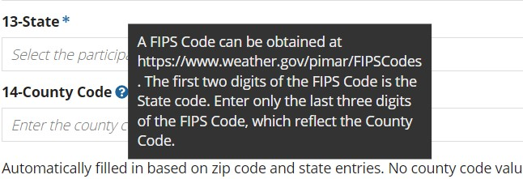

REQUIRED FIELDS
Any field with an asterisk () next to it is mandatory and requires user input. If a page contains multiple required fields, they must all be filled in order to Save or Update the information. If a user attempts to save/update without entering all the required fields, the error message “A value is required” will be shown. Additionally, all the fields that are missing user input will be highlighted in red.
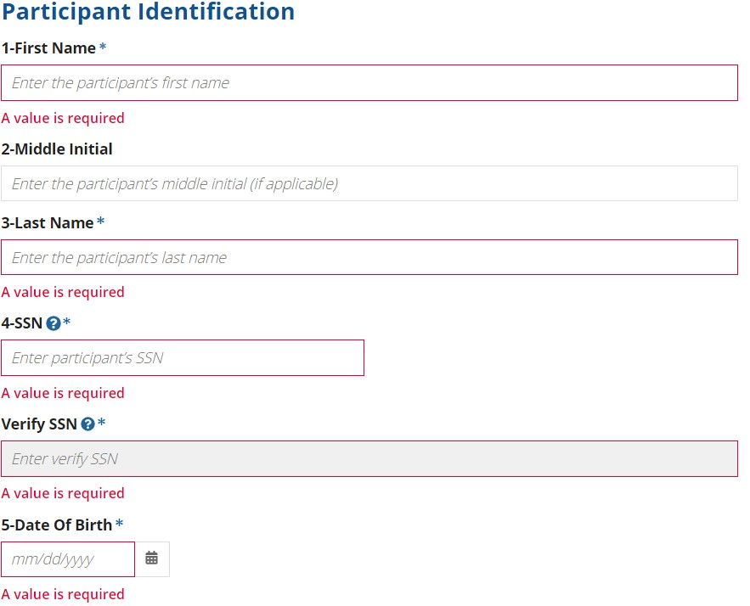

CALENDAR BUTTONS
When entering dates into the REO GPMS, users may either type the date directly into the appropriate field or use the Calendar button to select a date. Dates are displayed in the standard MM/DD/YYYY format. When selecting the Calendar button, the current month is initially displayed. Use the arrows (< and >) to navigate to the correct date before selecting the Enter button.
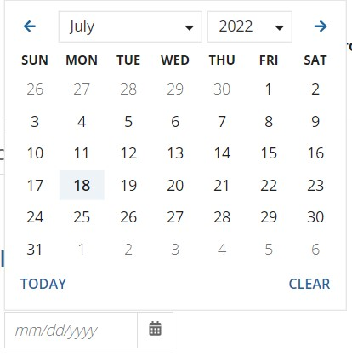

UPLOAD DOCUMENTS
When adding any document to the Case, the user will be prompted to select the Upload button. Once the Upload button is selected, the user is prompted to choose one or more files from their local hard drive, using the file browser, before selecting the Open button to execute the upload. That action can be repeated for additional files.
At present, only pdf and Docx files are acceptable to be uploaded to the REO GPMS.
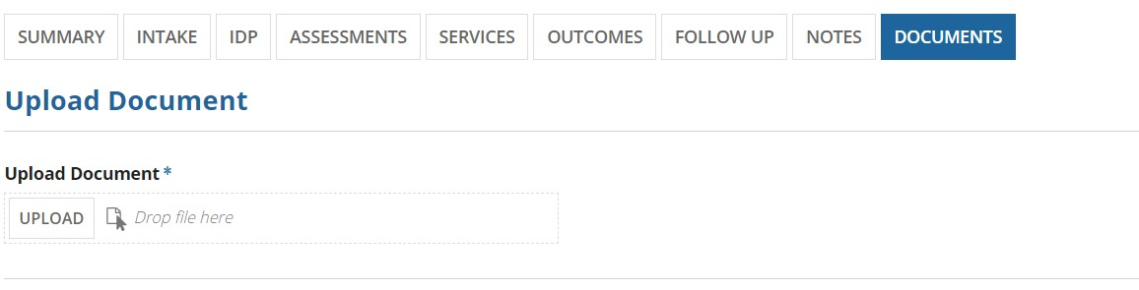
Uploaded pdf documents can be viewed and deleted whereas uploaded Docx documents can be downloaded and deleted.
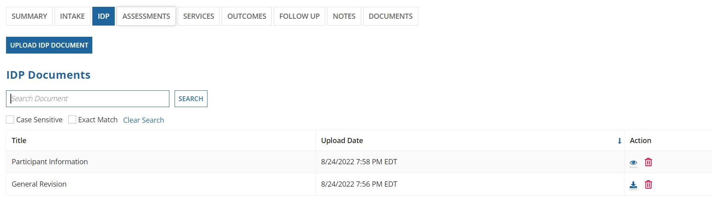

GRIDS
Grids are used in the REO GPMS to display rows of data in a tabular format. Grids also allow users to select a specific item for further viewing or action. At other times, the user can select a link associated with the data row to move directly to that row’s data.
In many cases, the Grid may contain an arrow (pointing up and down) within the header row indicating that data within the grid can be sorted in either ascending or descending order. Simply select the arrow next to the title in the grid’s header row to sort the data. Select the arrow next to the title in the grid header again to sort in the reverse order.
When a Grid has many rows, the number of rows is displayed in the bottom right corner of the page. To move quickly between the grid’s results, select the arrows to move forward (>) or backward (<). To move quickly to the first or last screen of grid results, select the arrows to move forward/end (>>) or back/beginning (<<).
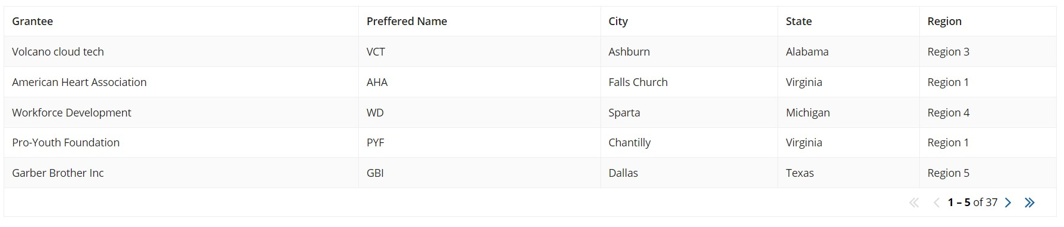

Role Name | Abilities
Tabs | Menu options that allow users to navigate to different tabs.
Navigation Buttons | By clicking these buttons, the user can navigate to different pages.
Role Name | Abilities
Dropdown Lists | Provide a list of allowable values for the field to which it is attached.
Tool tip | When the user hovers over this item, additional information is displayed.
Required Fields | Displayed with an asterisk (*) directly next to a field label. These fields are mandatory and require user input.
Calendar Buttons | Buttons are used for selecting a date.
Upload Documents | Button used to upload documents.
Grids | Displays relevant data.
Validation Messages, Alert Banners | Displays required or recommended actions.
Header Content/ Banner | Banner displays grantee

ACTION ICONS
Action Icons visually represent the actions that can be taken by the user. Each action includes a caption that displays the meaning of the visual. The captions are visible when the user hovers over the action icons in the application. Example icons for Export cases, Update note, and view document are given below.
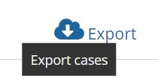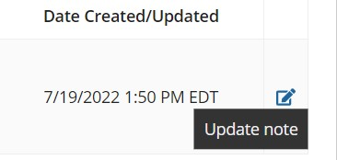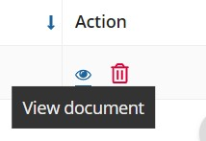

NEED HELP PAGE
Need help section is used to provide useful links for the REO GPMS. It can be found above the information banner on the external site.
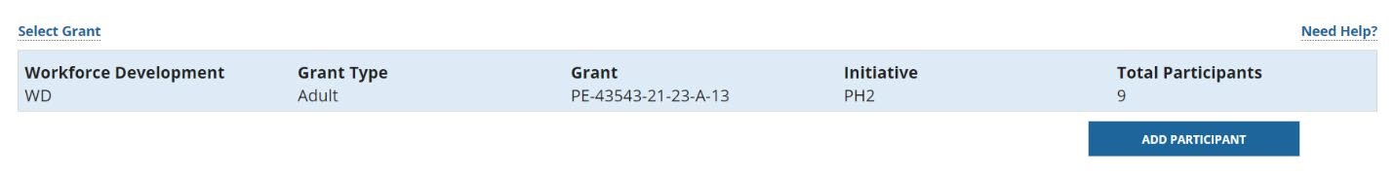
Once clicked, a new screen with the helpful links, shown under REO Help, and downloadable intake forms in PDF file format for Adult and Youth grant types, shown under Intake Forms section. The user can select the Go Back button on the left bottom to return to the previous page.
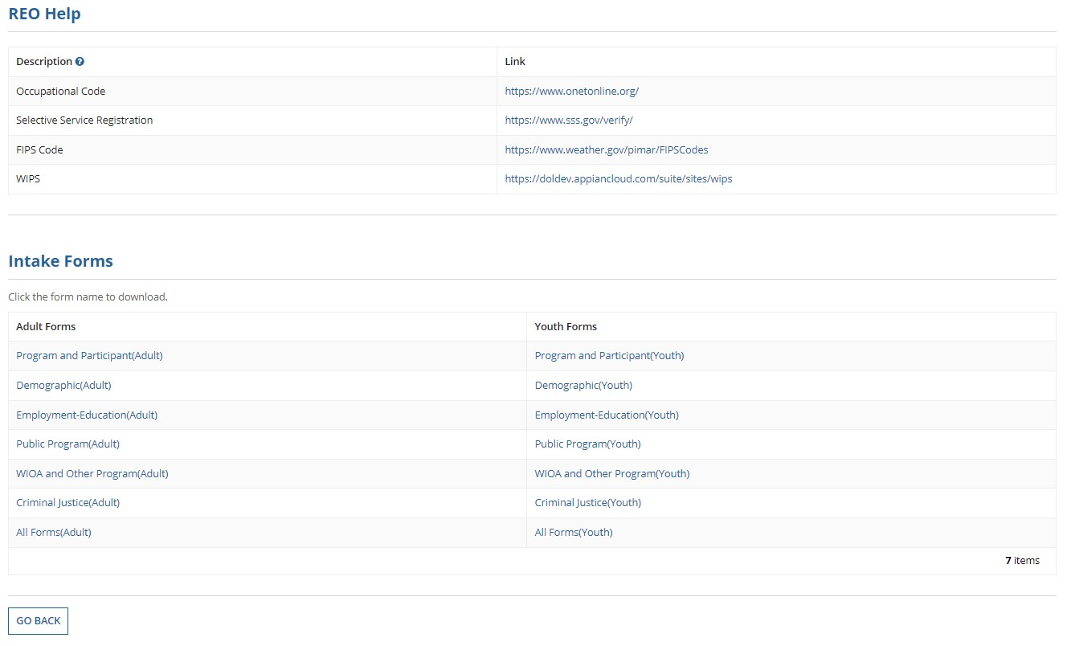

DATA VALIDATION MESSAGES AND ALERT BANNERS
The REO GPMS user interface screens perform data validation on data elements/input fields to ensure that the input is meeting the validation criteria defined in Workforce Integrated Performance System (WIPS) Logic Rules and displays data validation messages when the user is required to take corrective action before moving forward.
Alert Banners are displayed for user information and do not require corrective action before moving forward and appear on the data entry screen while the data is entered.
A green banner is displayed to give confirmation to the user when data is saved/updated successfully. (Example is show in screen shot below in the green box that says, “Data has been successfully saved.”).
Validation banner “Data has been successfully saved” is shown below:
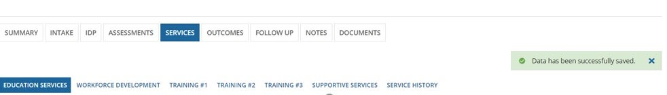
A yellow banner is displayed to inform and remind the user for the next action. (Example is shown in screen shot below in the yellow box that says, “
Please enter the qualifying service that occurred on the program entry date-6/12/2022. Intake,
assessments and supportive services are not considered qualifying services.”
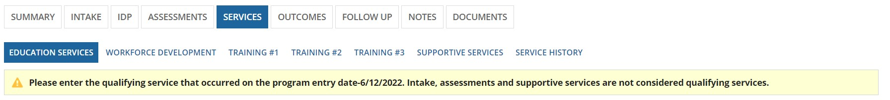
A red banner is displayed to inform the user for the missing fields. (Example is shown in screen shot below in the yellow box that says, “
Missing values for required fields, please check the complete form for required fields and error
messages.”
Confirmation Messages are displayed when user navigates away from screens/forms without saving data to alert the user, as shown below:
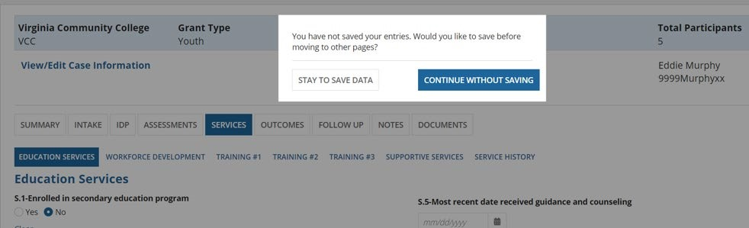

NAVIGATING THE REO GPMS
In order to navigate & utilize the REO GPMS, you must first register an account and then request an assignment. This process will be described in detail below.

REGISTER WITH LOGIN.GOV
All external users are required to create an account with login.gov. When the external users access the REO GPMS, the first page allows the users to create an account with login.gov, by clicking the Register button, on the page shown on the starting page of the REO GPMS for external users.
To register an account, navigate to cmp.dol.gov. You will see the screen below. Click on the “I agree” button.
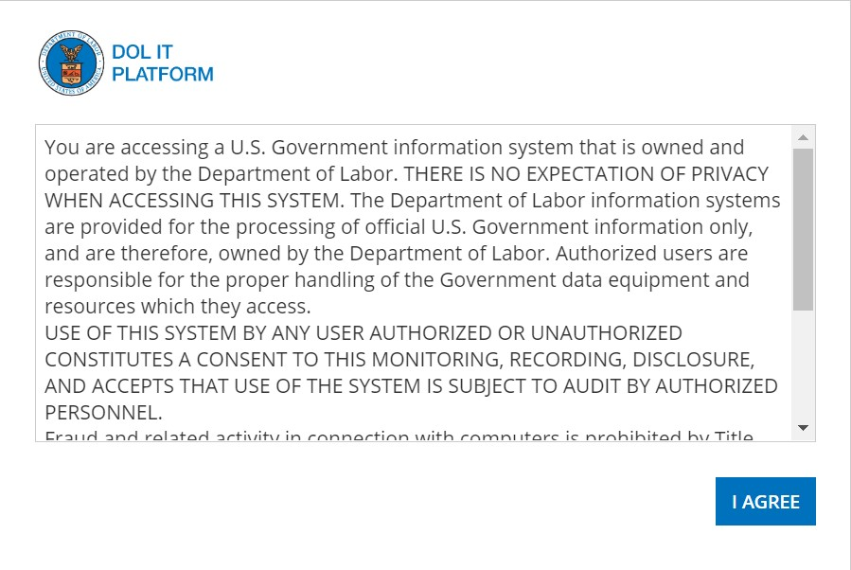
Next, you will see the screen below, there are three links, click on the link that states “click here if you are a Login.gov User”.
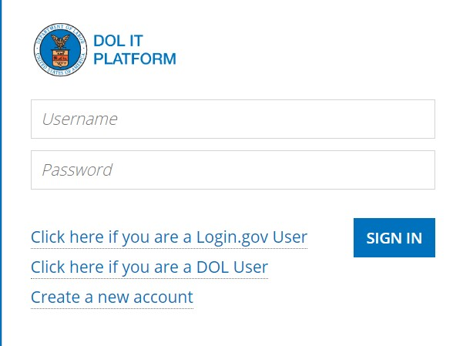

Now the Login.gov sign in page is shown. Click on the “create an account” button to start the account sign up process.
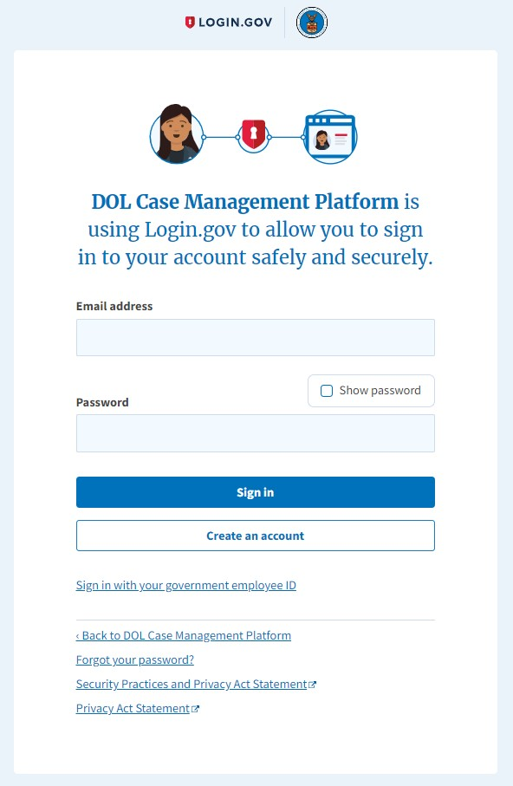

Next, enter your email, click on the “I read and accept the Login.gov Rules of Use” and click the submit button.
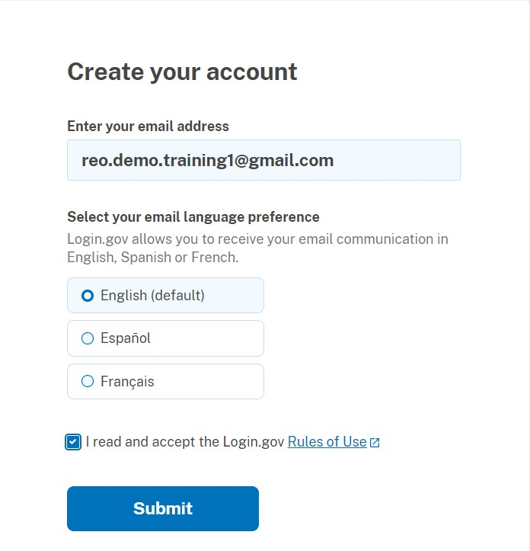
Now a message is shown to check & verify your email.
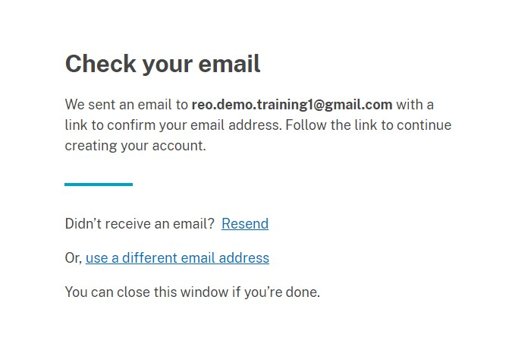

In your email inbox, open the email from login.gov and click on the blue “confirm email address button”.
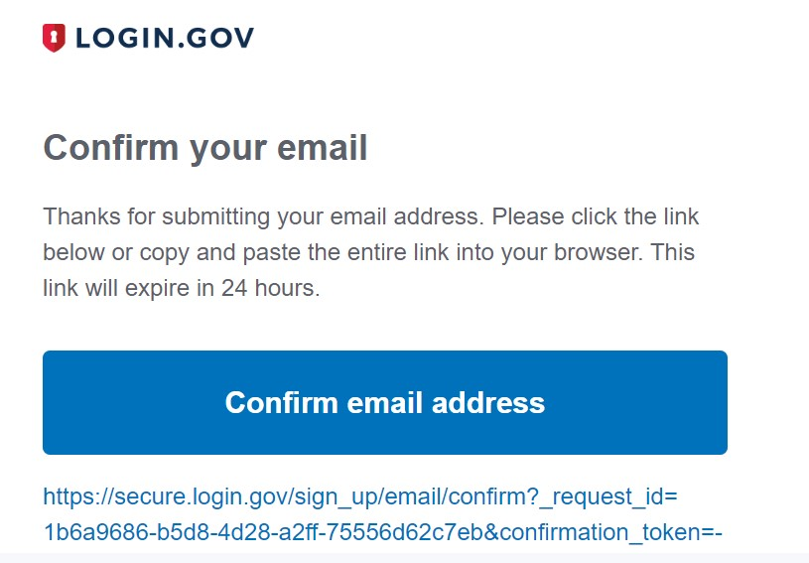

Next, enter a strong password and click on the “Continue” button.
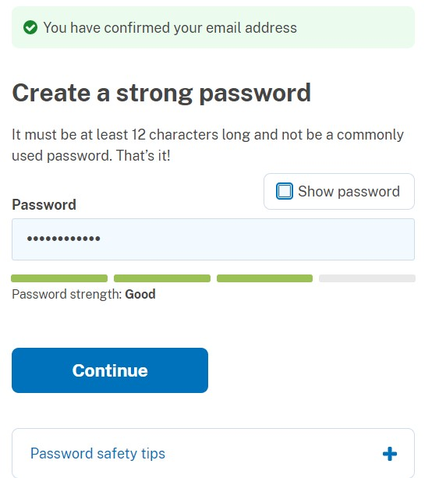

Next choose an authentication method, the most convenient option is Text or voice message and click on the “Continue” button.
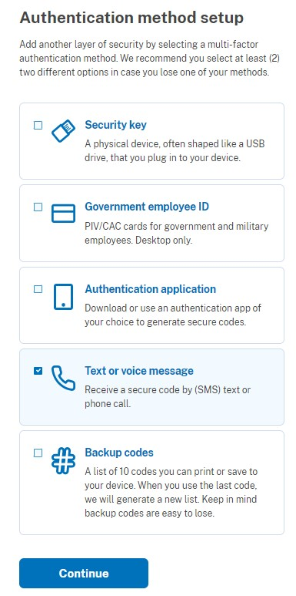

If you chose to authenticate with text or voice, then you will see an option to enter your phone number and click on send code button to receive an authentication code either by text or voice depending on which option you chose. If you chose another option, then you must follow those specific directions to authenticate your account.
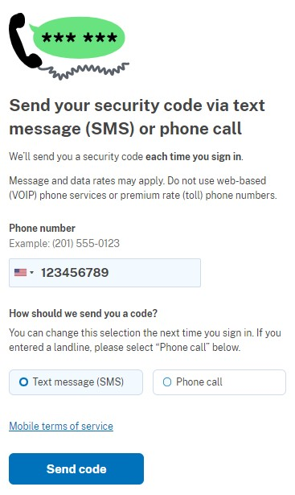
Next, enter your one-time code that you received and click on the submit button.
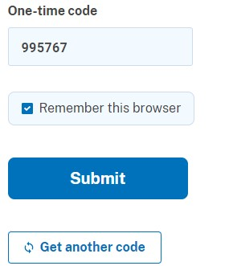

Once you verify the one-time code, you will see a message shown in the screenshot below. Next either you can add another method or skip for now. For this guide, we will click on “Skip for now” link.
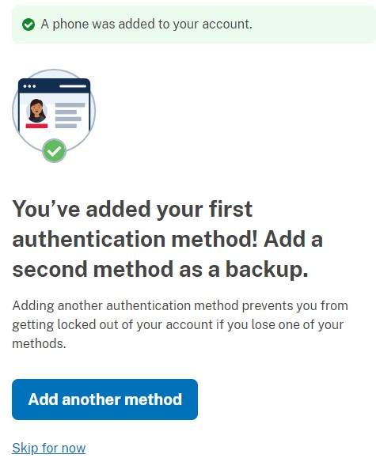

Next, click on “Agree & Continue”, this is your final chance to add another authentication method, if you would like to add it you can do so by clicking on the “Add a second authentication method” link.
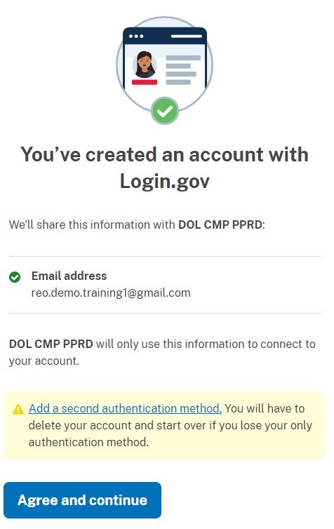
After successfully completing the “Create an account” process in login.gov, the external users go back to the REO GPMS starting page and click the “Login” button to attempt to log in and access the REO GPMS through DOL CMP. The “Login” button takes the users to the same page shown above. The external users must use the newly created user credentials (email address and password) to access DOL CMP Dashboard.
The first time, the external users are asked complete the user profile configuration. The following two screens show the user profile configuration process:

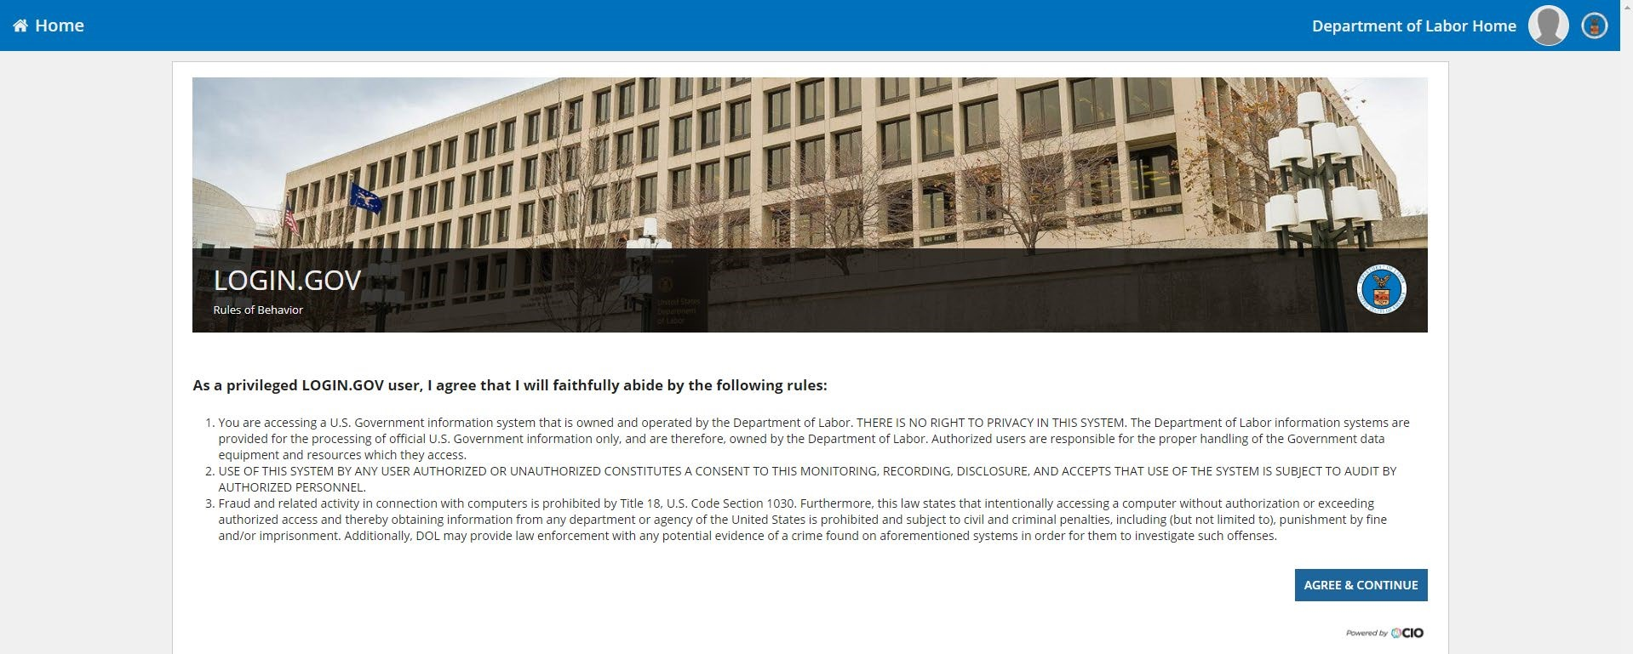

On this page, replace the email in the first and last name fields with your first and last name.
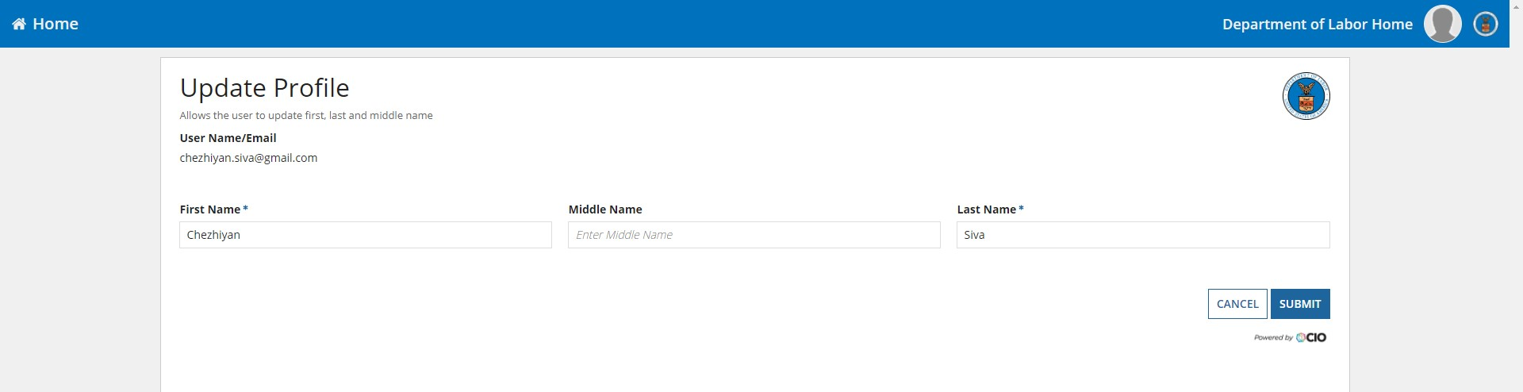

Once the user profile is configured, the external users can access the REO GPMS from the DOL CMP Dashboard.
The very first time you access this page, in the REO tile, the “Enrol” button is shown. You can click on “Enrol” and follow the process in section 8.2 to request for user assignment.
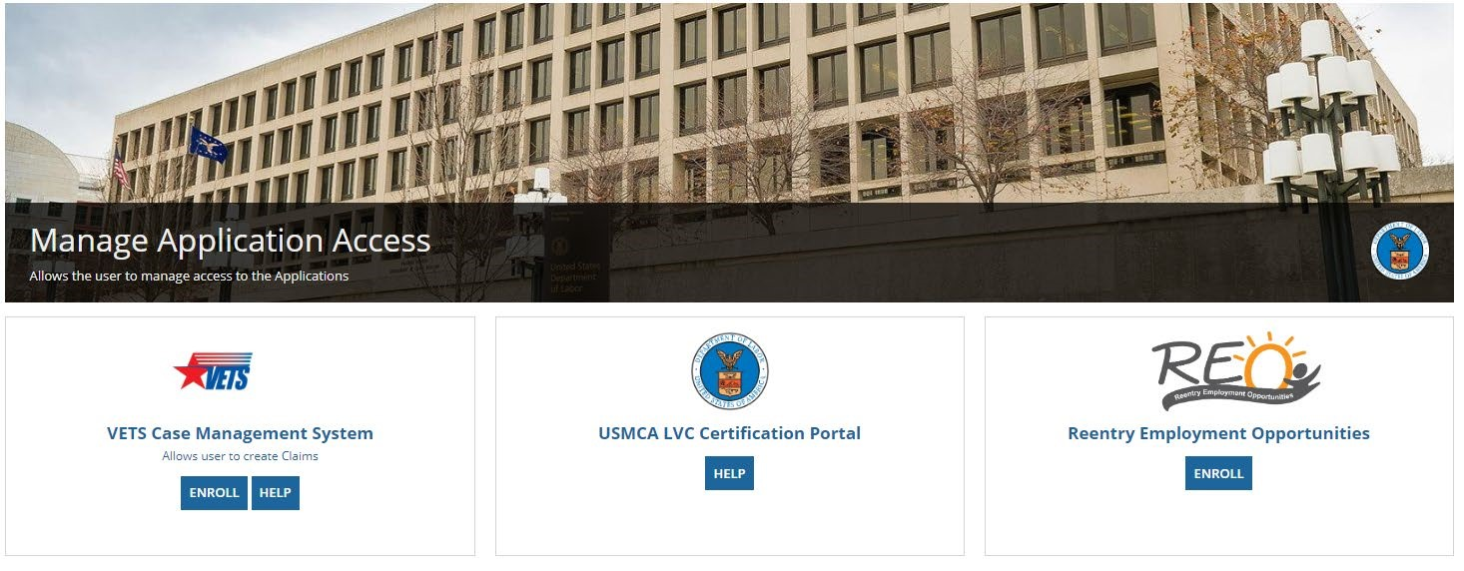

REQUEST FOR USER ASSIGNMENT
The REO GPMS uses the DOL CMP process for managing user access requests using the DOL CMP User Management Application (UMA). One application user account is assigned “REO Admin” role. That user account has access privileges to provision both internal and external user account on the DOL CMP platform.
All users approved to access REO application must complete the assignment request before access to viewing, editing or updating any information/data on the application. Usually, the Grantee Admin request is the first request to be submitted and assigned to a Grantee.
The request for Grantee Admin assignment for a Grantee is reviewed and approved by the internal users with Program Admin role. All other requests are approved and managed by the Grantee Admin.
The diagram below shows the assignment and relationship, between organization types and user roles, for external users, within REO GPMS.
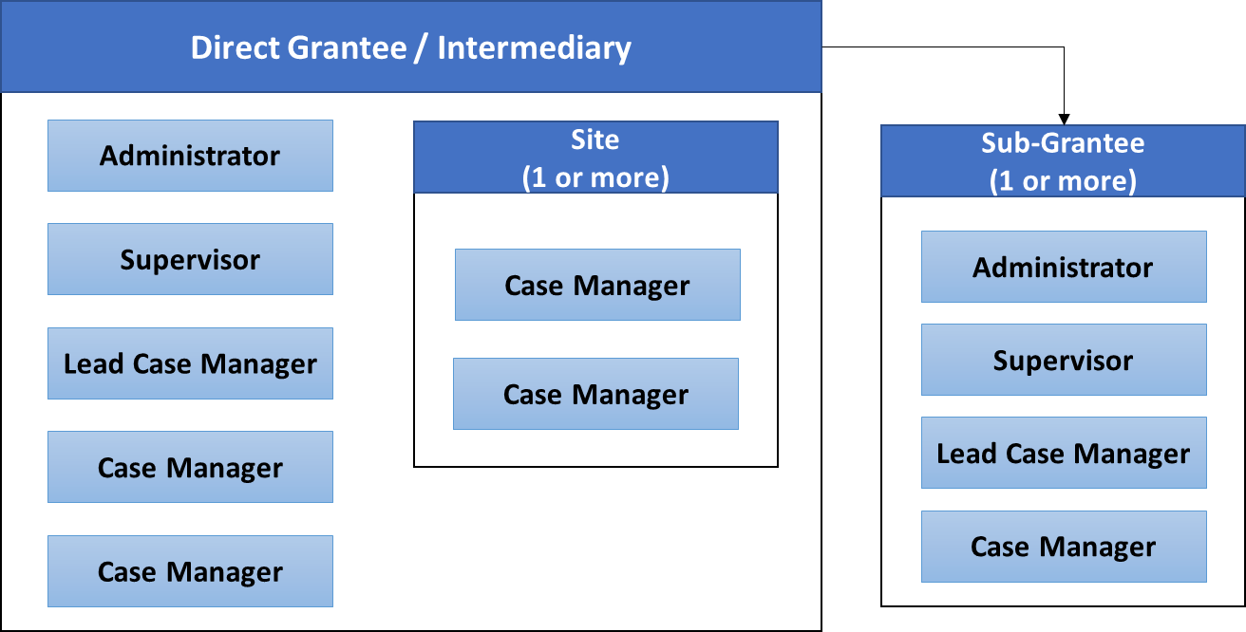
The User Management module allows users with Program Admin privileges in the REO GPMS to approve requests to add, modify or delete users with Grantee Admin roles to a particular Grantee (or Organization). The REO GPMS allows users with Grantee Admin roles to add, modify, or delete Grantee Users (Supervisor or Case Manager) to the Grantee (or Organization) they are managing.

The diagram below shows the workflow used for Step 3 of the user account request process.
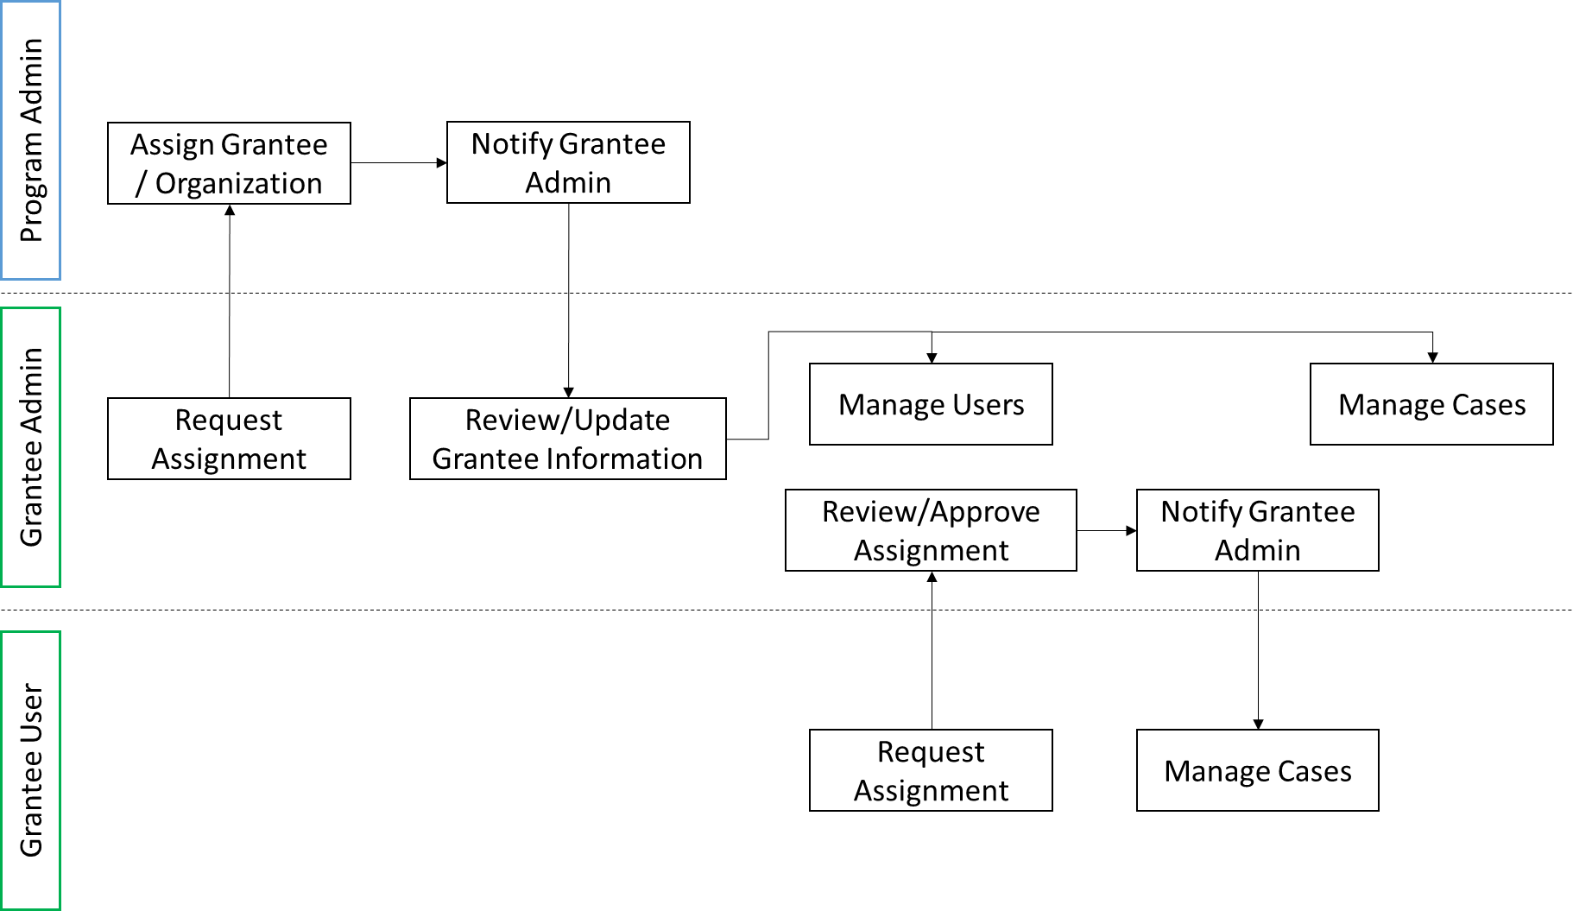

REQUEST FOR ASSIGNMENT (RA) PROCESS
Any new user accessing the REO GPMS for the first time is required to submit a request to be assigned (or associated) with a particular organization. The new users to the REO GPMS are required to follow the steps (referred as RA steps) to request assignment.

RA Step 1: Welcome Page
New users, user accounts without assignment or association with a grantee organization, are presented with the welcome page which includes Selecting a Grantee Organization with Role as shown below
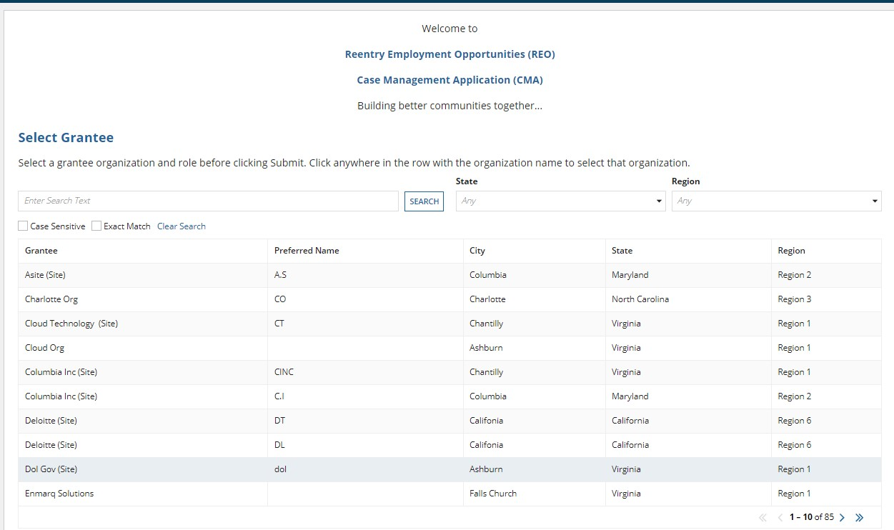

When the user selects any Grantee organization then Role selection dropdown will be displayed as shown below
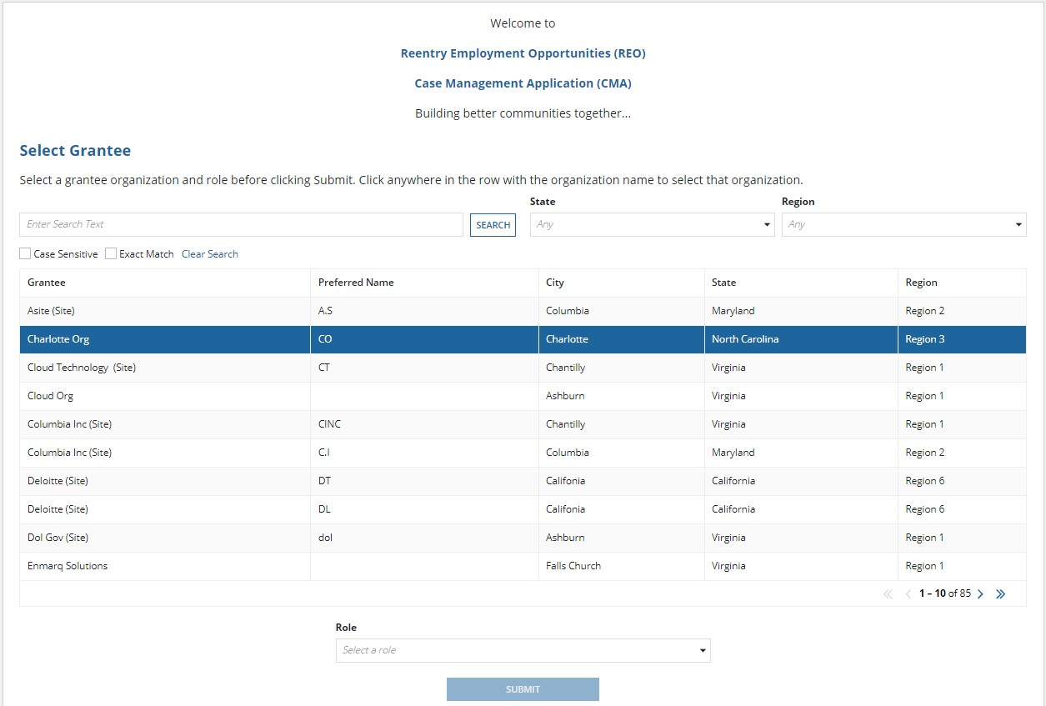
Submit button will be disabled until the role is selected.
When Role is selected button is enabled as shown below.
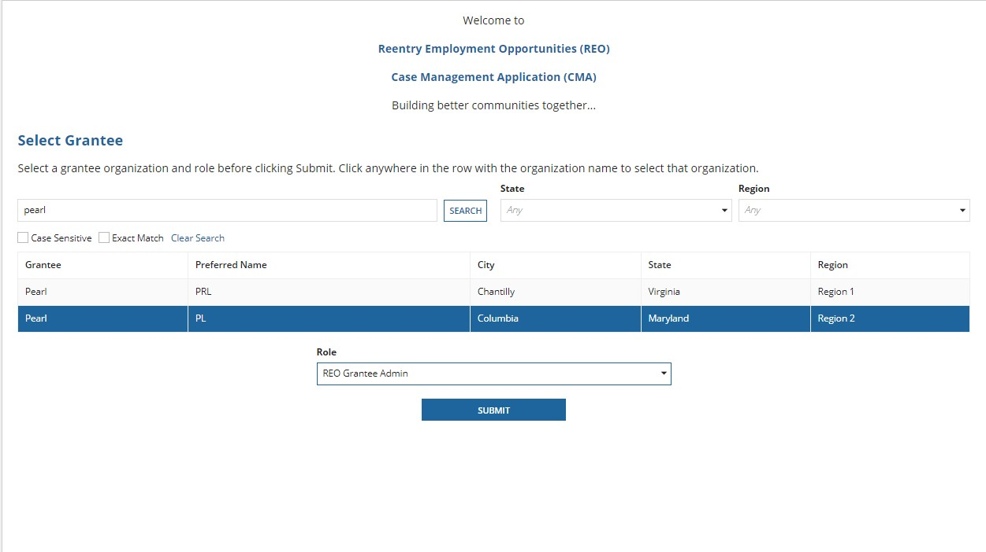

RA Step 2: Confirmation
When the user clicks on the submit button, it will direct them to the confirmation page with a message “Thank you for submitting your request for assignment” and a request timeline is shown.
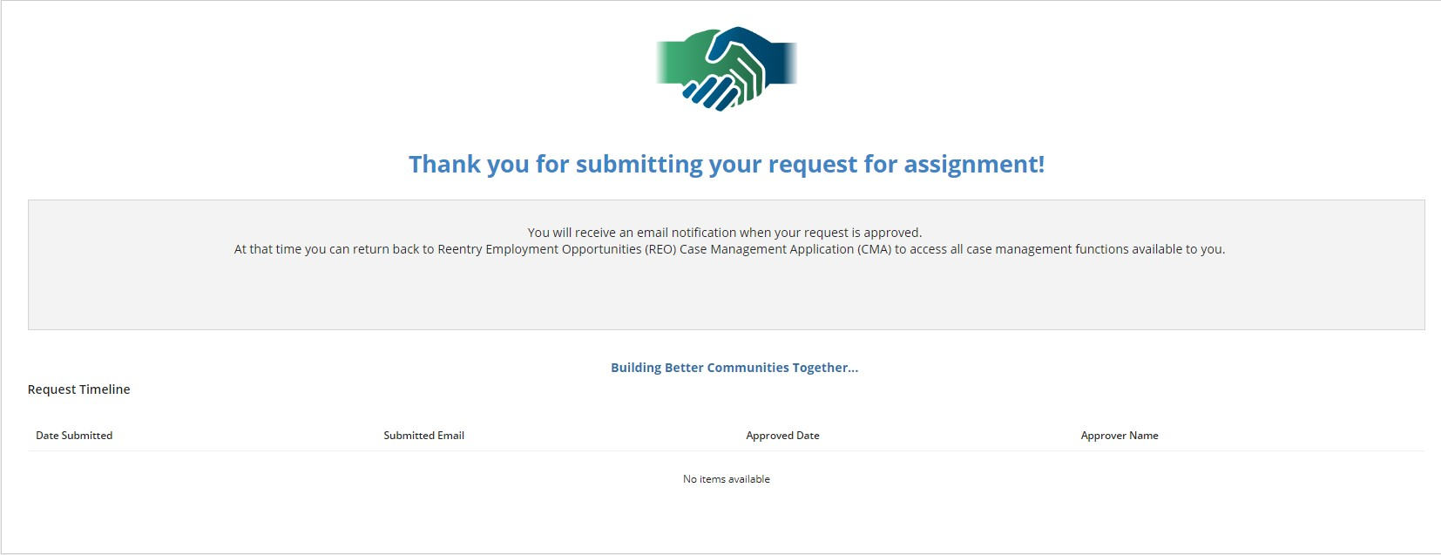
Upon refreshing the page, this screen will be shown until the request is approved.
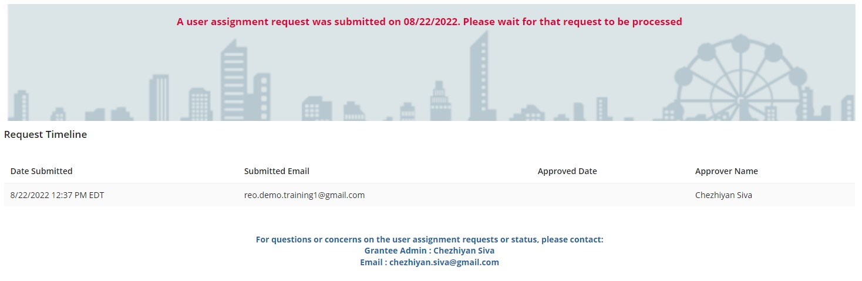

After the confirmation page, the user must log out of the REO GPMS and wait for the approval decision. If the User Assignment Request is approved, the user can come back to the REO GPMS starting page to login to DOL CMP Dashboard and access the REO GPMS. Since the User Assignment Request is approved at this point and the user is associated with an organization (Grantee-primary or Intermediary) and a Grant, the external users can access CASES, REPORTS or ADMIN tabs based on their role in the organization.

REQUEST FOR ASSIGNMENT APPROVAL – GRANTEE ADMINISTRATOR
If the request assignment is for the Supervisor, Case Manager or Data Entry Operator role, the request is routed to the Administrator of the Grantee (primary) or Intermediary organization selected by the user. When the request is submitted, an email is sent to the Administrator of the Grantee (primary) or Intermediary organization. The Administrator of that organization approve or deny the request from ADMIN page of the external site.

GRANTEE (PRIMARY) OR INTERMEDIARY REQUEST FOR USER ASSIGNMENT (GIAR) APPROVAL
Users who are administrators on the external GPMS site can access the ADMIN page, which allows the user to view the pending Assignment Requests. Clicking the First Name or Last Name of the requester takes the Administrator user to the Approve/Deny Assignment Request page.

GIAR Step1
Click the First Name or the Last Name of the user from the Assignment Requests section.
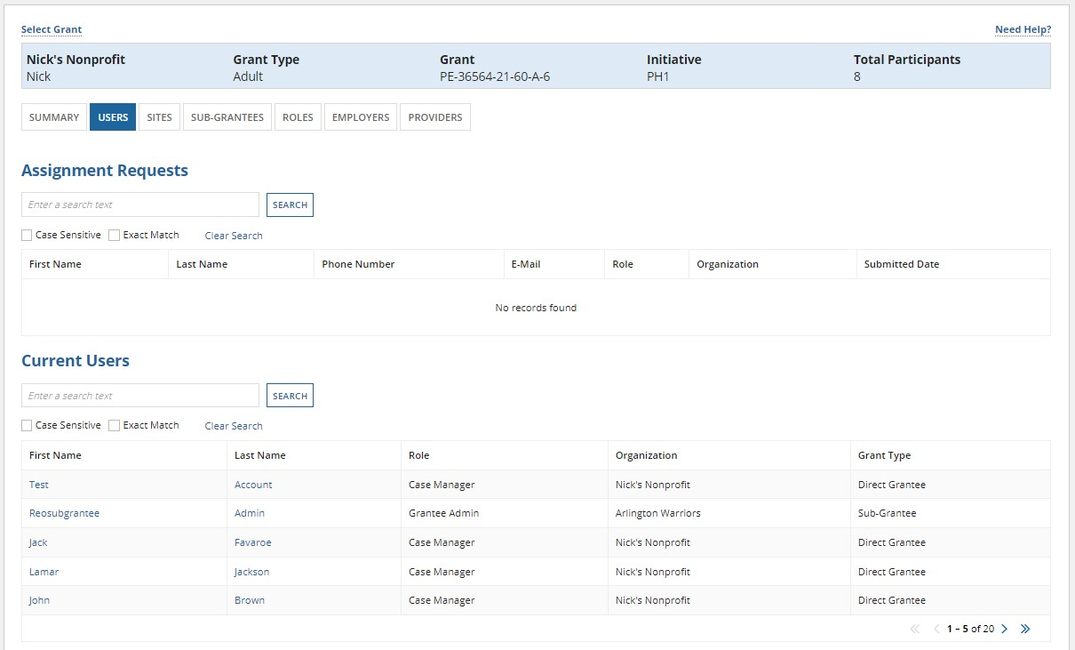

GIAR Step 2
Once the user with administrative role selects one of the users shown in assignment requests, then the administrative user will be able to approve/deny assignment request as shown below:
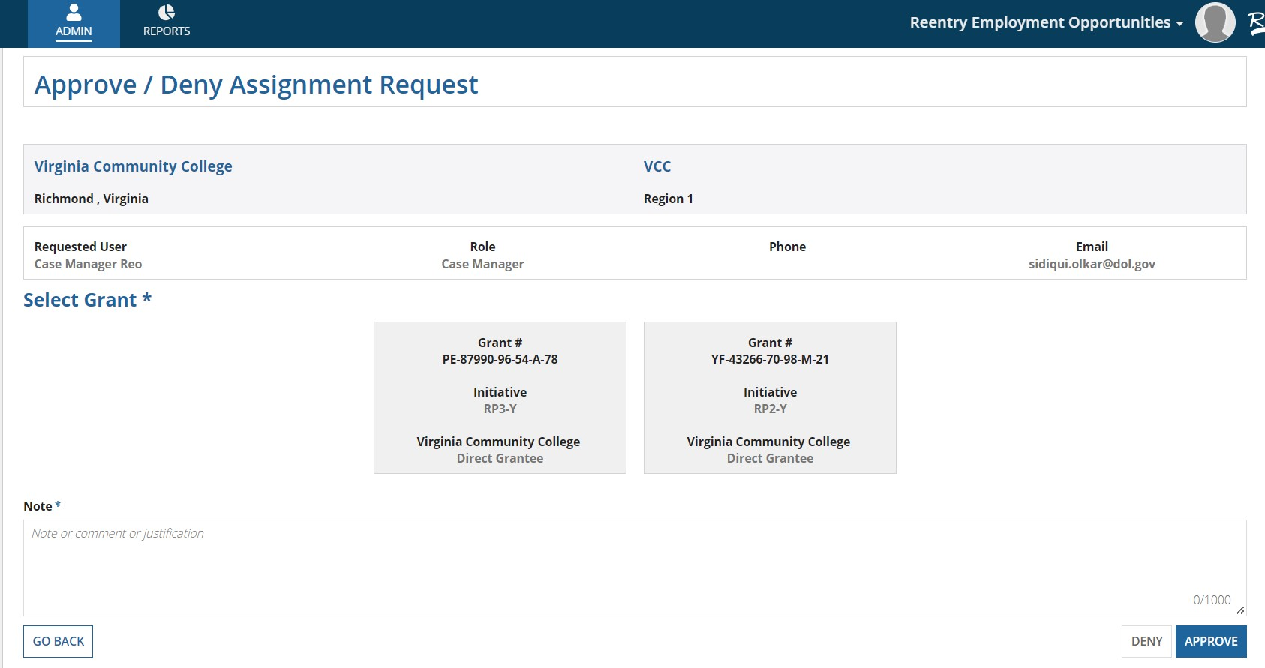

CASES
Cases can be accessed from the Cases tab. The user can click the “Select Grant” button to choose a grant type and grant.
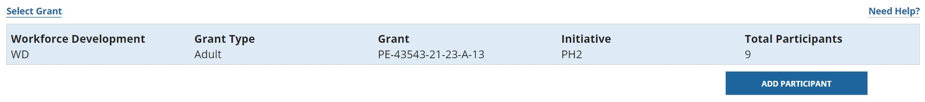
Once Select Grant button is clicked, the following screen is displayed.
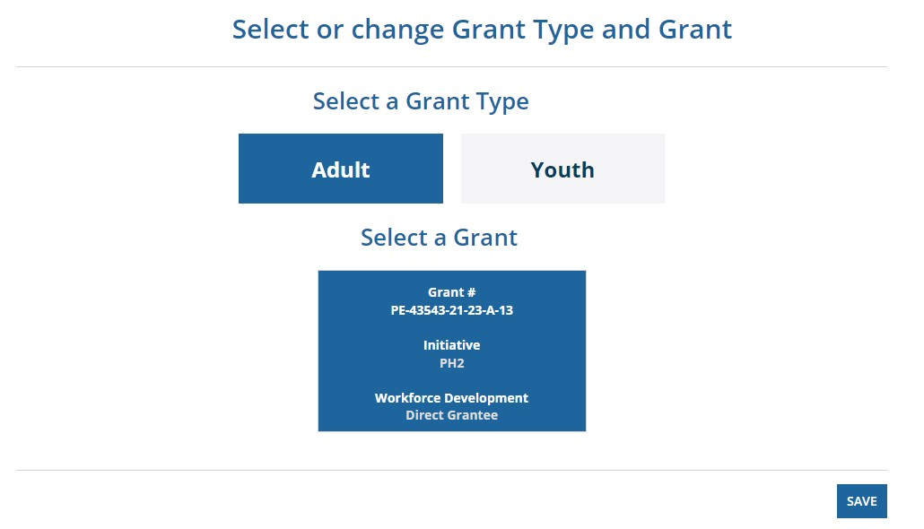
The user must select a grant type and grant and click save to continue. If the Save button is not clicked, then the changes will not occur.

The user can now see the cases related to their grant type and grant as shown below.
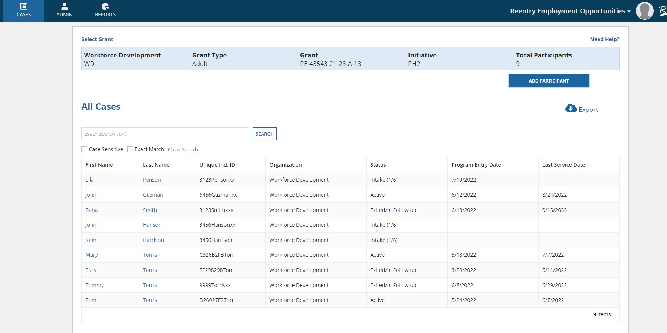
The cases page shows all the cases associated with the selected grant.
The cases page also provides the user an option to download all or selected cases (using the search bar to filter specific cases) into an excel document. This can be done by clicking on the “export” icon.
When the user clicks on the “export” icon, the user will see two both “download” and “clear” icon.
The user has an option to download a document or clear a document. When user clicks on download, document will be downloaded in an excel format. When the user clicks on clear, then the document will be deleted, and the user will be redirected to “All Cases”

USER ROLES AND PAGES OVERVIEW
Tabs showcasing the menu items for the REO application.
User Roles of REO GPMS (External Site)
User Role | Level of Access
Grantee Admin | Grantee Admin has the highest level of access and is able to perform all functions without limitations. For example, only Grantee Admins can approve all role change requests; Grantee Admin also has full access to Admin and Reports tab
Supervisor | Supervisor has the second highest level of access and can request their role to be changed as either lead case manager or case manager
Lead Case Managers | Lead Case Managers have the third highest level of access and can request their role to be changed as a supervisor or case manager
Case Managers | Case Managers can request their roles to be changed as a lead case manager or supervisor
User Role | Level of Access
Partner Case Managers | Partner Case Managers are case managers that are playing the “supporting” role for a given case. Partner Case Managers will have limited access on the information they can edit for cases where they are playing the “supporting” role

USER ROLES OVERVIEW
User Role | Access Level | Duties
Admin | - Edit/view all grant data, including sub-grantees  - WIPS access | - Approve new users and user roles  - Submit quarterly reports to WIPS  - Add sub-grantees and sites (optional)  - Assign case managers to sites (optional)
Sub-grantee Admin | - Edit/view all sub-grantee data  - NO WIPS access. NO primary grant access. | - Approve new sub-grantee users & assignments - Add sub-grantee sites (optional)
Supervisor | - Edit my organization’s cases only  - View my organization and sub-grantee cases | - Assign cases to case managers  - Assign case managers to sites, if desired  - Oversee program and site performance
Sub-grantee Supervisor | - Edit sub-grantee cases only  - View sub-grantee cases only | Same as above
Coach | - Edit my caseload and colleagues’ cases  - View my organization only (not sub-grantee) | - Manage participant data across sites  - Add new employers and providers (all users)
Sub-grantee Coach | - Edit my caseload and colleagues’ cases  - View my organization only (not sub-grantee) | Same as above
Case Manager | - Edit my caseload only  - View my site or HQ cases only (not across sites) | - Manage my caseload  - Add new employers and providers (all users)
Sub-grantee Case Manager | - Edit my caseload only  - View my site or HQ cases only (not across sites) | Same as above

USER ROLES DIAGRAM

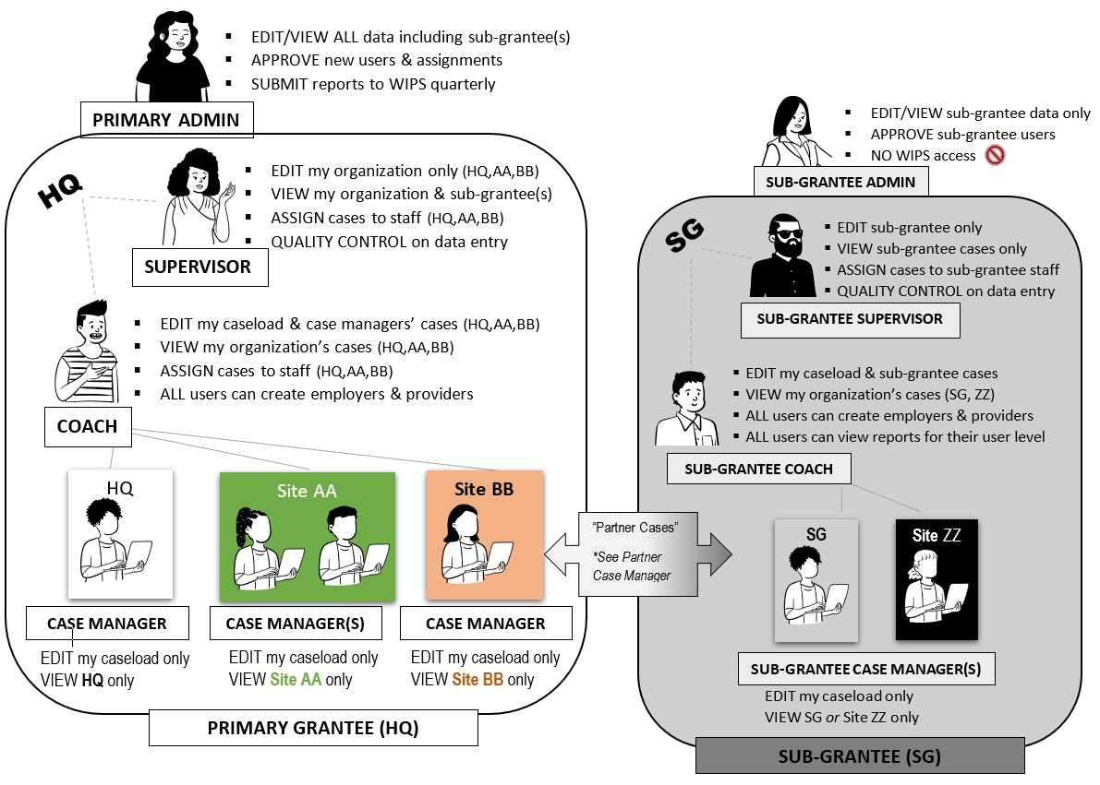
Users navigate through the REO GPMS (External Site) using these tabs.
Tab | Explanation
Cases | Shows the cases based on the grant and grantee selected. Use the “Select Grant” button to make changes.
Admin | All users have access to admin tab. The level of access for each user varies based on user role. Depending on the user role, the user will be able to access the following tabs:  - Summary  - Users  - Sites  - Sub-Grantees  - Roles  - Employhers  - Provides
Reports | External users can generate various reports. Based on user roles, external users can generate reports such as:  - Summary Report  - My Progress Report  - Generate PIRL File  - Generate Sample QPR
The Cases page displays the “All Cases” grid (Grantee Admin role)
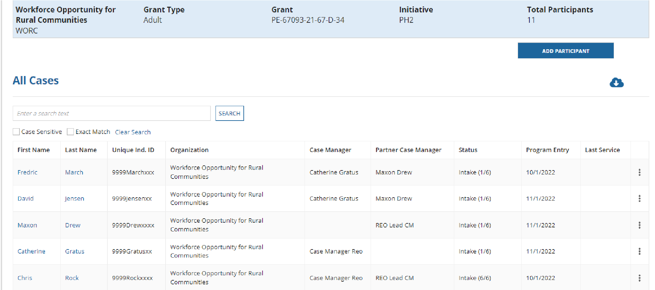
Grantee Admin has the highest level of access and can perform all functions without limitations. By clicking on the Participant’s name, the case related information is displayed.
The Cases page displays three tabs for viewing cases for the users with Case Manage role, as shown in the screen shot below. The “My Cases” tab shows cases that are assigned to the Case Manager with full access to edit or update the case. The “All Cases” tab shows all cases with edit or update privileges enables only for the cases assigned to the Case Manager. The “Partner Cases” tab shows the cases for which the Case Manager has limited privileges to edit or update the case.
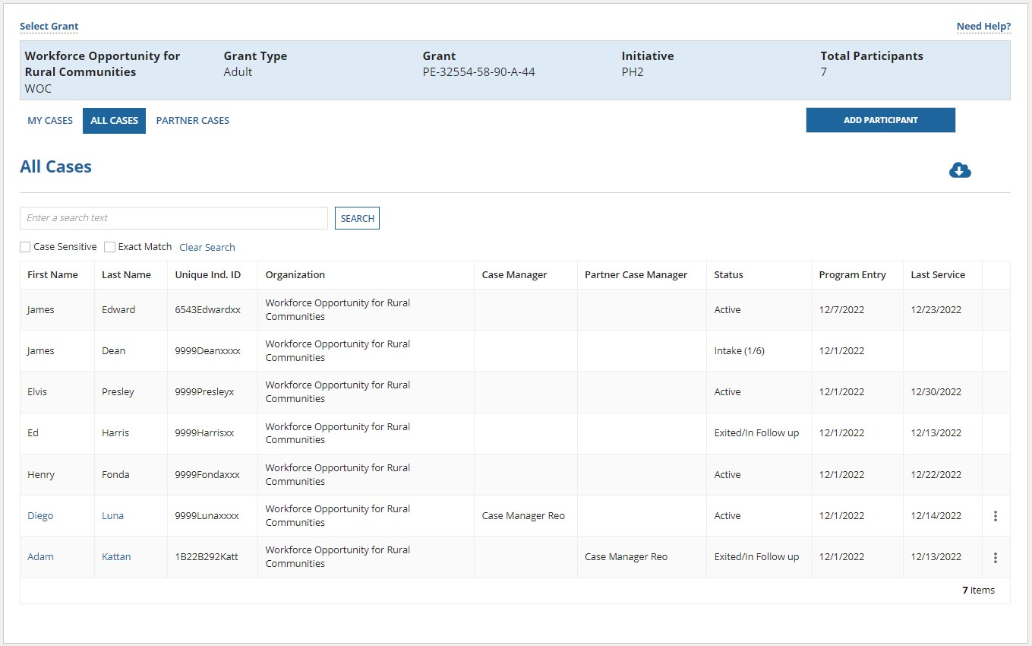

Summary tab:
Summary tab gives a brief information about the participant.
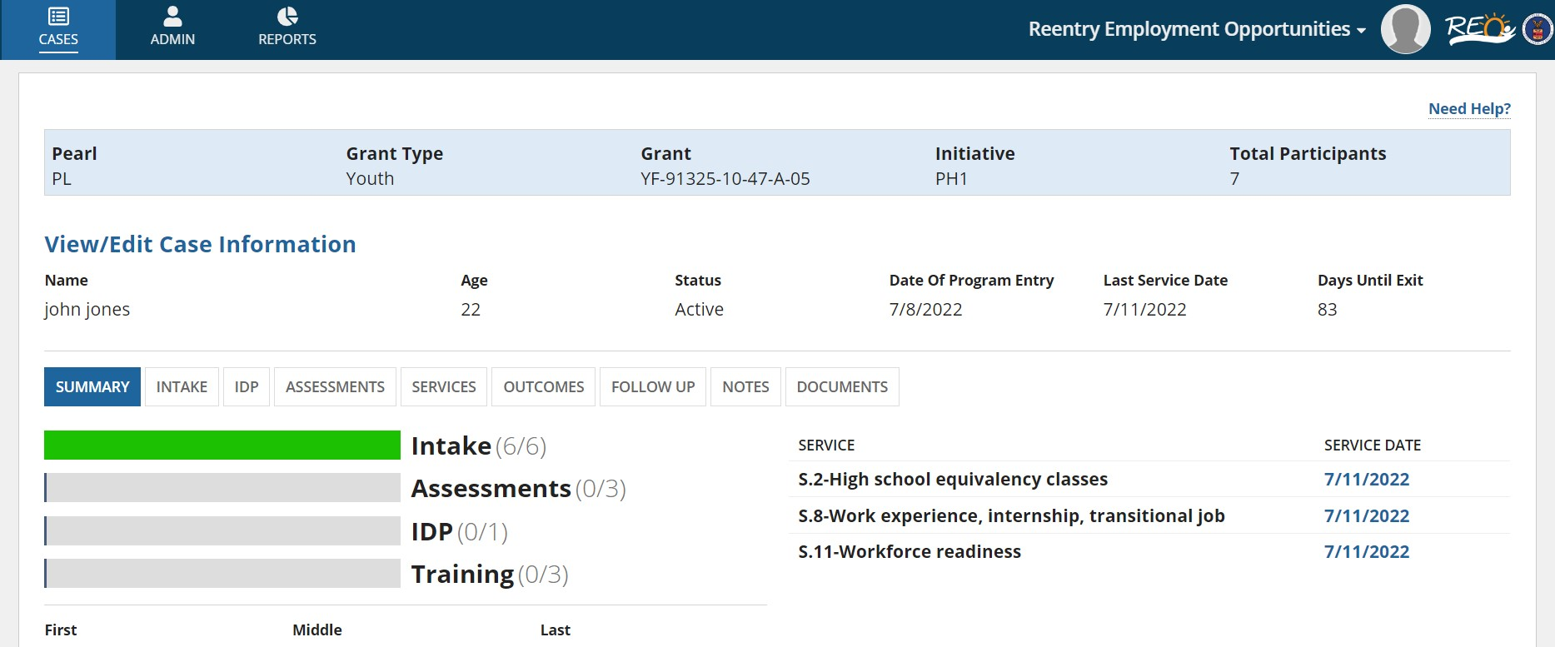
The following tabs are used for a case to collect data about a participant:
Tab | Explanation
SUMMARY | A detailed description of the Participant can be found on this tab.
INTAKE | External User can view / edit the Participant’s Intake forms
IDP | External User can upload/view documents related to IDP.
ASSESSMENTS | External User can view / save / update Participant’s Pre/Post Assessment Scores
SERVICES | External User can view / save / update different services provided to the participant
OUTCOMES | External users can view / save / update the outcomes / benefits gained by the participant
FOLLOW UP | External users can view / save / update the status of the participants who have exited the program
NOTES | External users can add / view / update / delete the case notes
DOCUMENTS | External users can add/view Documents related to case
Users navigate through INTAKE forms using these tabs, when a case in Intake status is selected from the Cases Tab or when a case in Active status is selected from the Cases Tab or when clicked on Add Participant button under the landing page of Cases Tab

Intake:
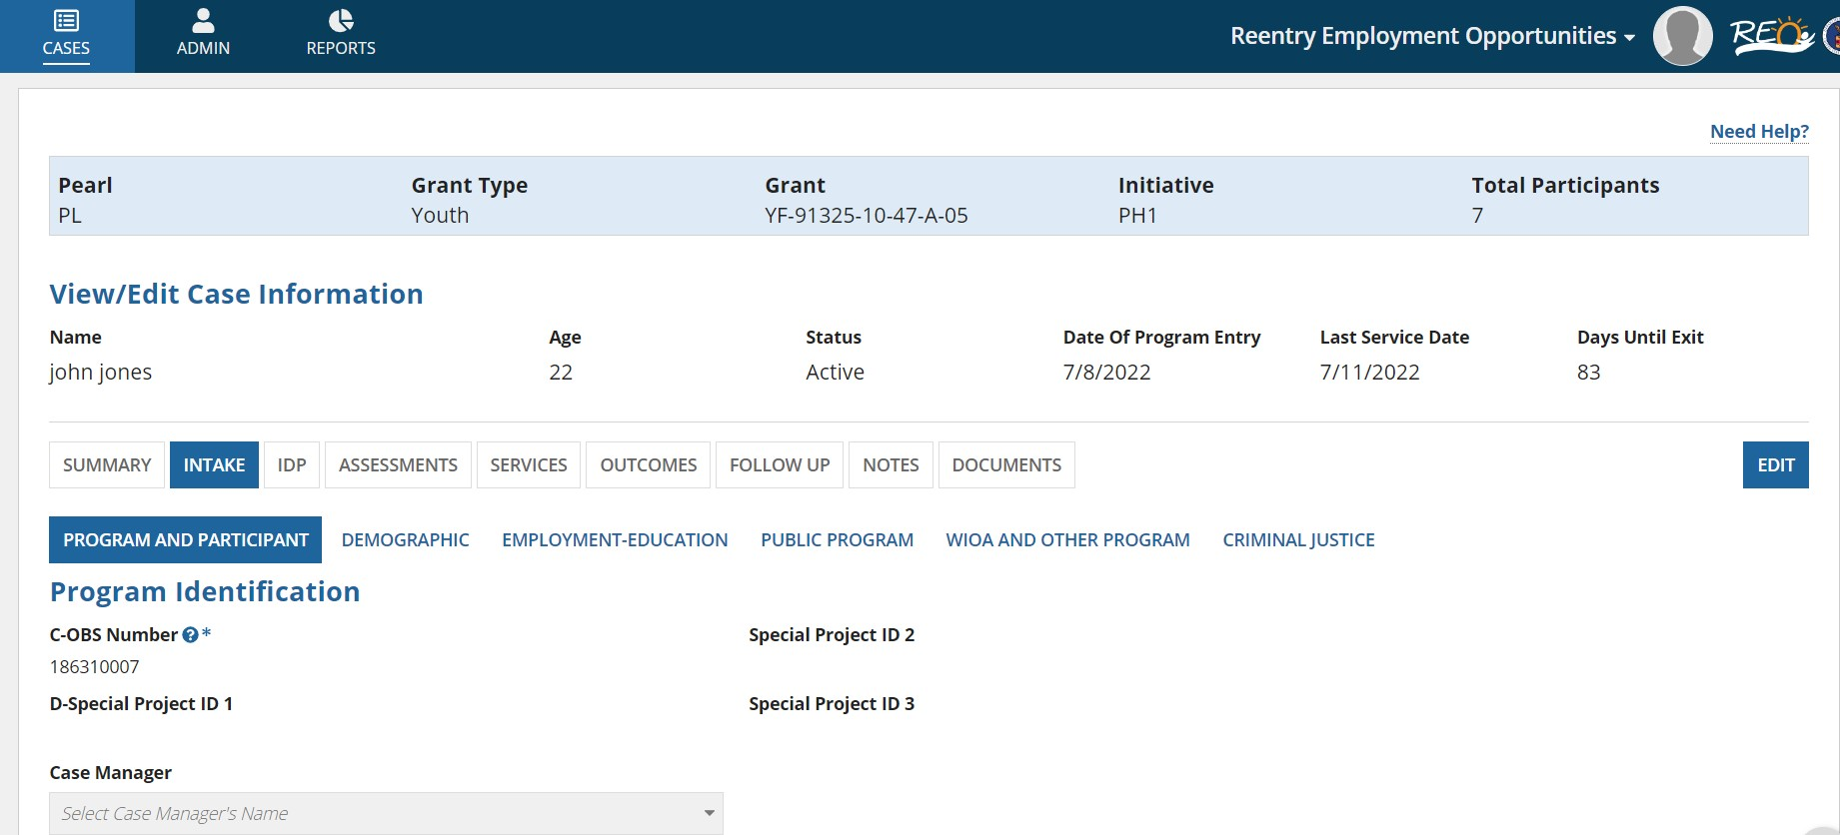

Tab | Explanation
PROGRAM AND PARTICIPANT | Participant’s basic information like Name, SSN, date of birth, Phone, Address, OBS number, etc.  are collected in this tab. External users can SAVE/ SAVE AS DRAFT / EDIT the data
DEMOGRAPHIC | Participant’s demographic information like sex, ethnicity, disability status, veteran status, etc. are collected in this tab. External users can SAVE/ SAVE AS DRAFT / EDIT the data
EMPLOYMENT-EDUCATION | Participant’s employment and education information is collected in this tab. External users can SAVE/ SAVE AS DRAFT / EDIT the data
PUBLIC PROGRAM | Participant’s public program information is collected in this tab. External users can SAVE/ SAVE AS DRAFT / EDIT the data
WIOA AND OTHER PROGRAM | Participant’s WIOA and other program information is collected in this tab. External users can SAVE/ SAVE AS DRAFT / EDIT the data
CRIMINAL JUSTICE | Participant’s criminal justice information is collected in this tab. External users can SAVE/ EDIT the date

IDP:
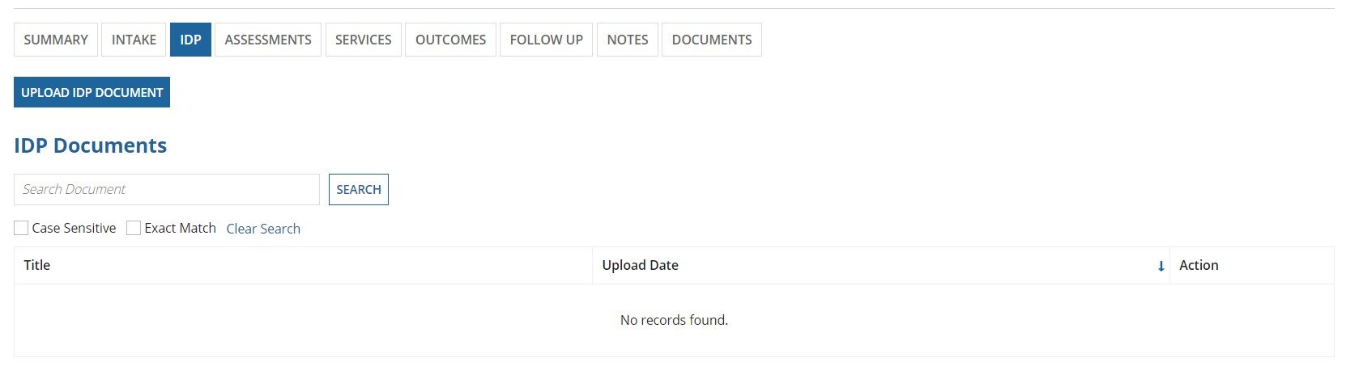

Assessments:
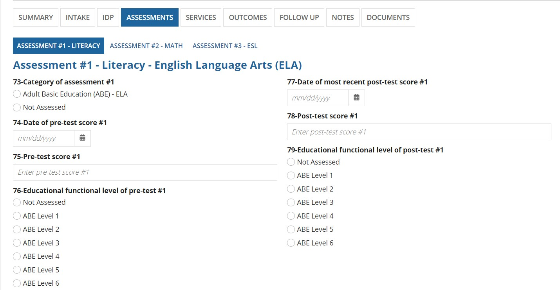

When a case in Active status is selected from the Cases tab and clicked on “ASSESSMENTS” &, the users navigate using these tabs.
Tab | Explanation
ASSESSMENT #1 - LITERACY | External User can view / save / update Participant’s Pre/Post Assessment Scores for Literacy
ASSESSMENT #2 - MATH | External User can view / save / update Participant’s Pre/Post Assessment Scores for Math
ASSESSMENT #3 - ESL | External User can view / save / update Participant’s Pre/Post Assessment Scores for ESL

Services:
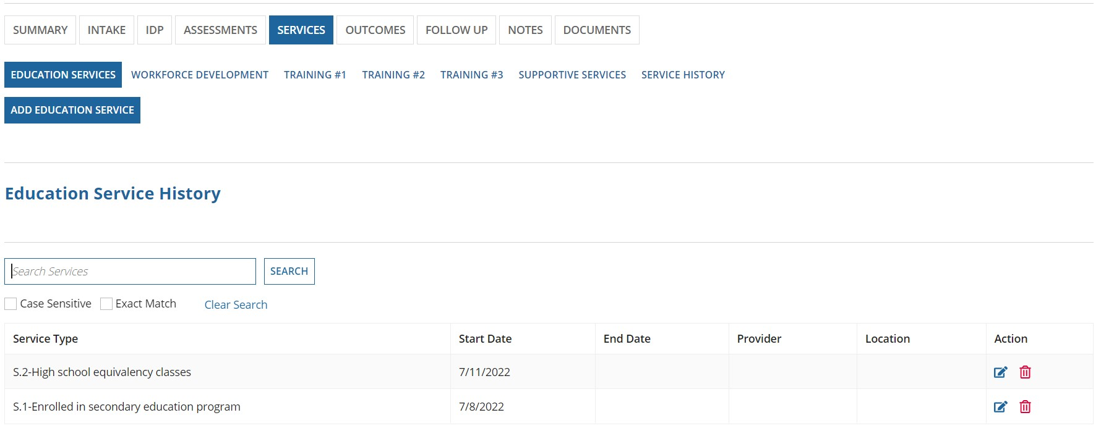

When a case in Active status is selected from the Cases Tab and clicked on SERVICES button, users navigate using these tabs.

Tab | Explanation
EDUCATION SERVICES | External user can view, save or update education services provided to the participant
WORKFORCE DEVELOPMENT | External user can view, save or update work related services provided to the participant
TRAINING #1 | External user can view, save or update training services provided to the participant
TRAINING #2 | External user can view, save or update services provided to the participant
TRAINING #3 | External user can view, save or update training services provided to the participant
SUPPORTIVE SERVICES | External user can view, save or update supportive services provided to the participant
SERVICE HISTORY | External users can view the history of services provided to the participant.

Outcomes:
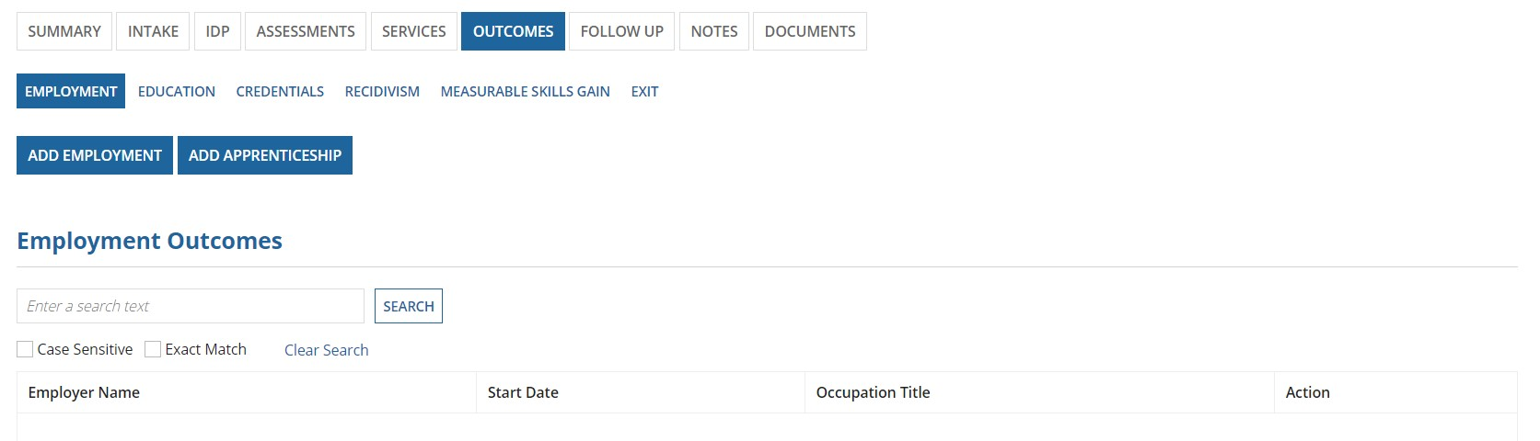
Outcomes tab contains the following sections: Employment, Education, Credentials, Recidivism, Measurable skills gain, & Exit.
Tab | Explanation
EMPLOYMENT | External user can add, view, or update employment and apprenticeship outcomes of the participant
EDUCATION | External user can add, view, or update education outcomes of the participant
CREDENTIALS | External user can add, view, or update credential outcomes of the participant
RECIDIVISM | External user can add, view, or update recidivism information of the participant
MEASURABLE SKILLS GAIN | External user can add, view, or update measurable skills gain outcomes of the participant
EXIT | External user can add, view, or update exit/reactivation outcomes of the participant

Follow Up:
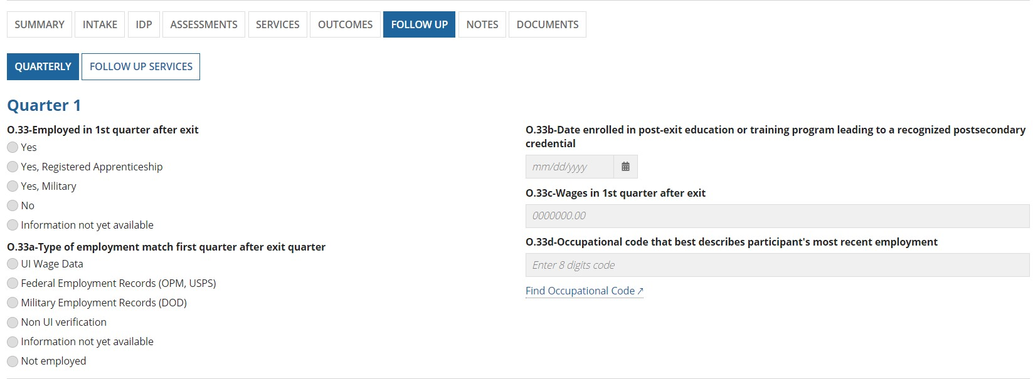
Tab | Explanation
Quarterly | Collects data of the participant from Quarter 1, Quarter 2, Quarter 3, Quarter 4
Follow up Services | External user can view, save or update work related services provided to the participant

Notes:
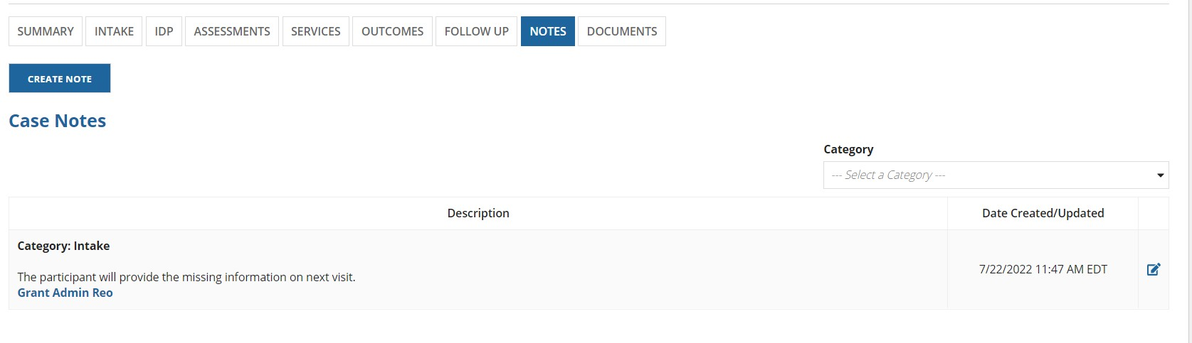
In the Notes section, the user can keep track of the Notes related to the case.

Documents:
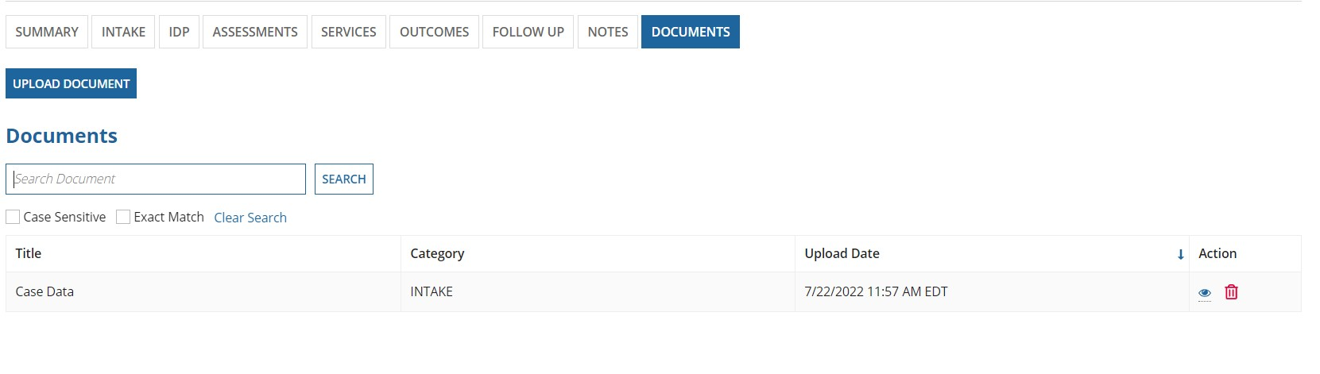
The documents tab allows the user to upload PDF files only. The uploaded document will be shown in the Documents grid.

ADMIN
Based on the User’s role or permissions, the admin page will display varying tabs that includes Summary, Users, Sites,
Sub-Grantees, Roles, Employers, and Providers. The banner will not be shown to the internal users on the admin console.
Grantee Admin (external users) view:
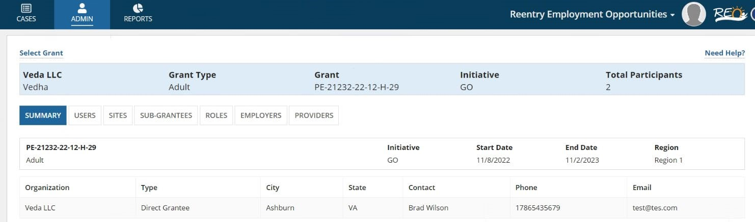
Case Manager / Lead Case Manager / Supervisor (external users) view
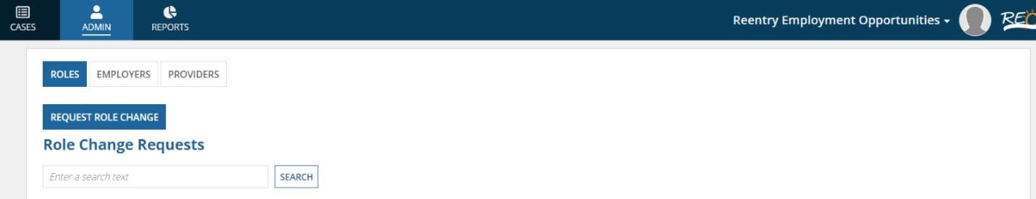

GRANTEE ADMIN – USERS
This section displays following sub sections:
- Assignment Requests: List of all user assignment requests for grantee and pending for approval. A link will be provided on First and Last names of user requests that navigates to user approval screen (explained in section 8.6.2 below)
- Current Users: List of all users who have access to grantee and grant. A link will be provided on First and Last names of current users that navigates to user profile and make changes to grant access (explained in section
8.6.3 below)
- User Activities: List of recent activities or grants accessed by users within the grantee organization
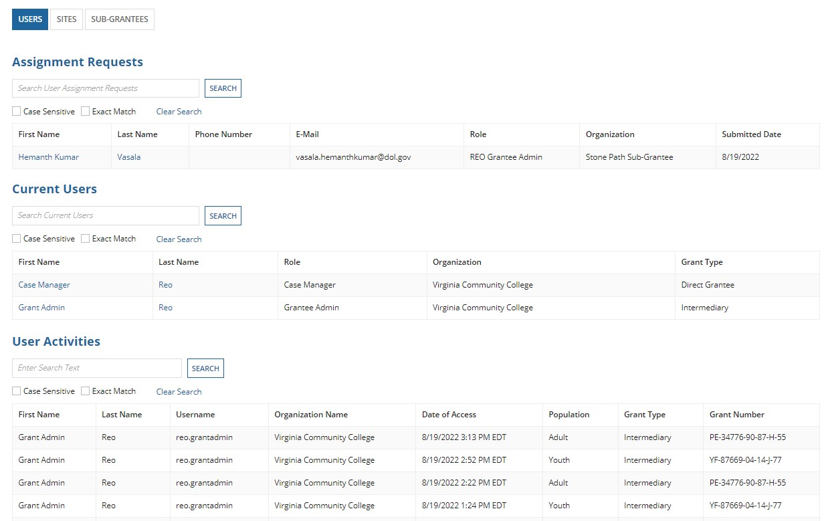

GRANTEE ADMIN – APPROVE OR DENY REQUEST
If there are any requests shown under “assignment requests,” then the user will be able to approve or deny request as shown below. Grantee admin can select one of the grants listed under “Select Grant” and approve or deny the request with notes provided. If the request is approved selected user will appear in current users section of users tab.
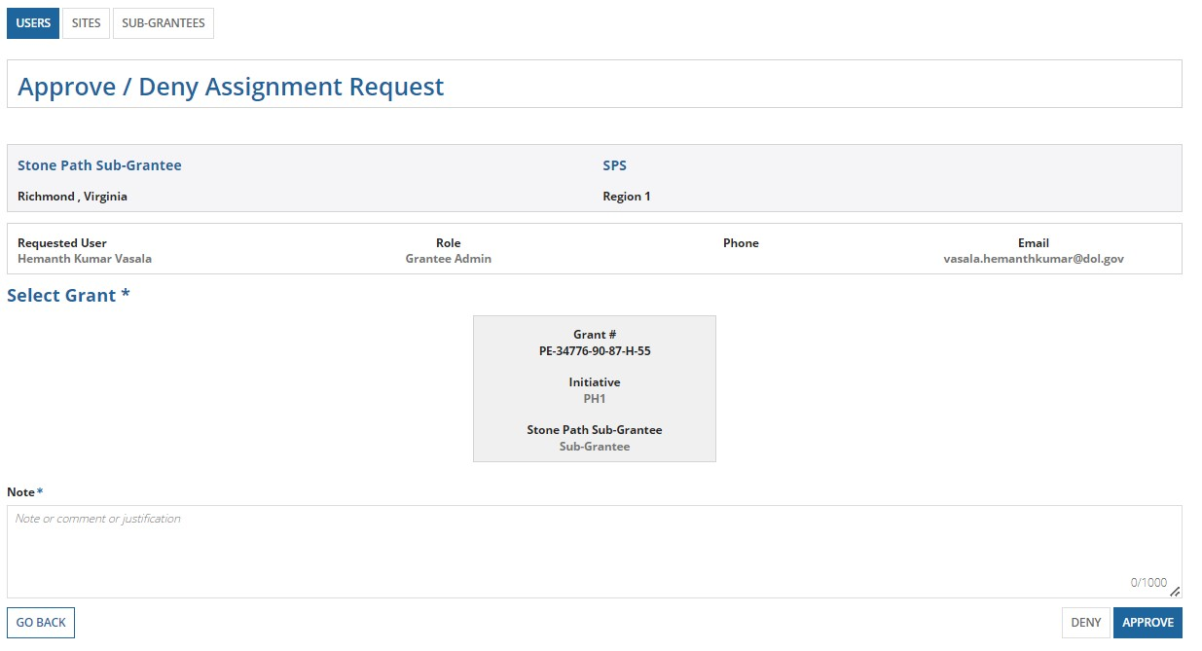

GRANTEE ADMIN – USER PROFILE
This page displays user profile information with two sections assigned grants to user (case manager / supervisor / sub– grantee (or) site admin) and available grants to the grantee organization for assignment to users. Grantee admin can assign / un-assign grants for the selected user
A grant can be removed from assignment by clicking on ‘x’ mark in the assigned grants grid
A grant can be assigned by clicking on ‘+’ mark in available grants grid
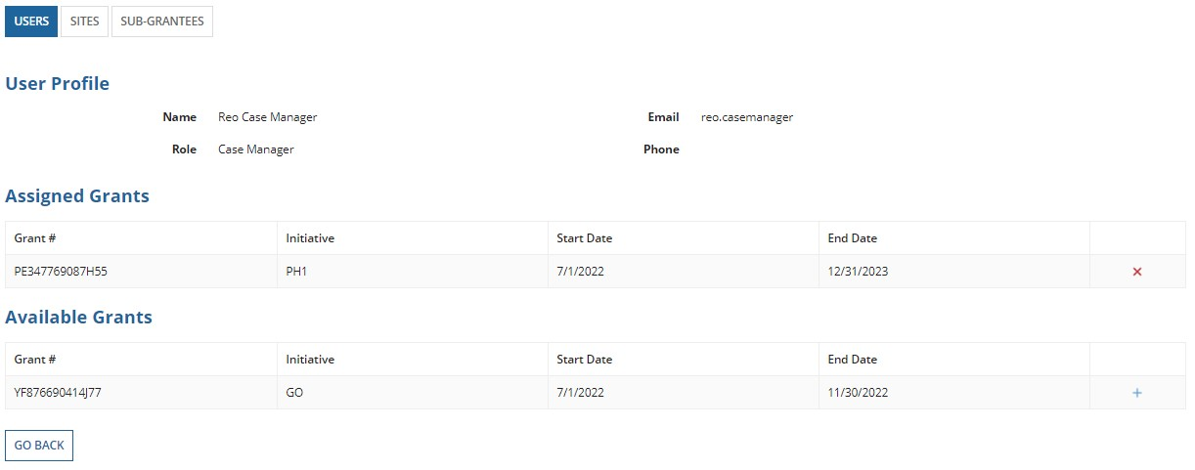

REPORTS
Reports for External Users
Step 1) Using Login.gov, Log in to and access the REO website.
Step 2) Use the Select Grant button to select your Grant type and Grant. Step 3) Click on Reports tab
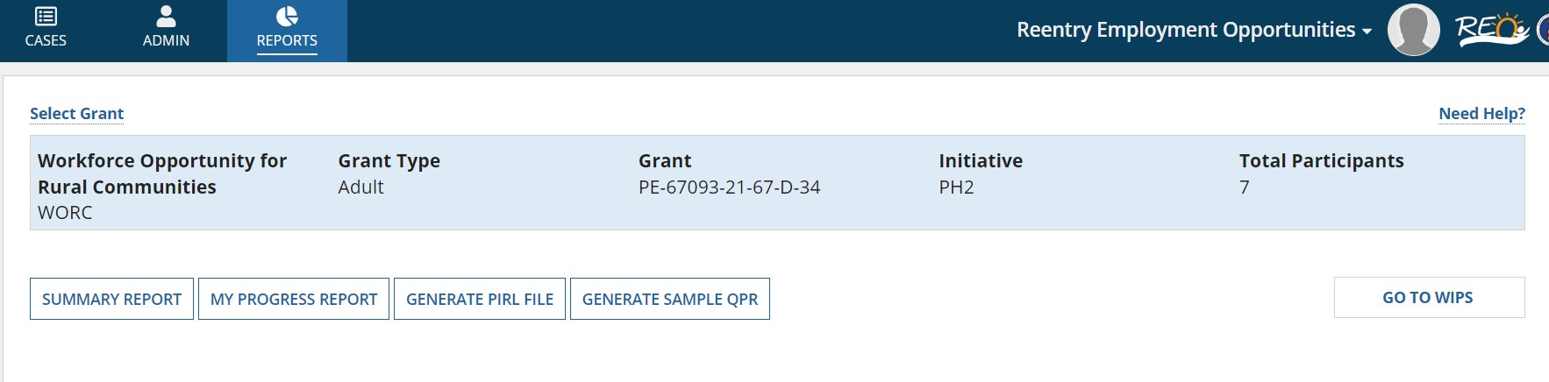
Based on the user’s role or permissions, the external site reports tab will display any or all of the following : a) Summary Report
- My Progress Report
- Generate PIRL File
- Generate Sample QPR
- Go to WIPS

SUMMARY REPORT
Step 1) Using Login.gov, Log in to and access the REO website.
Step 2) Use the Select Grant button to select your Grant type and Grant.
Step 3) Click on the Reports tab.
Step 4) Click on the Summary report.
When the user selects “Summary Report,” a report will be displayed as shown in the two images below.
The summary report includes the following sections:
- Participants – shows the total participants and the enrollment status of the participant
- Status – shows the participants in various status like Intake, Active and Exited/In Follow up o Intake – indicates that the participants are not provided any qualified services
  - Active – inciates that the participants are enrolled and provided services, but not exited from the program
  - Exited – indicates that the participants are exited from the program
  - Other Exits – indicates that the participants are exited from the program for some reason
- Accepted participants by Gender and Race
- Applicant Education Level
- Age at Enrollment
- Housing Status at Entry or Prior to Confinement
- Special Groups
- Applicant Offender Status
- Other
- Prior Offense
- Exit Status
The information displayed in the summary report can be displayed both as a grid or as a chart. The user can toggle between the grid and chart-type summary report.
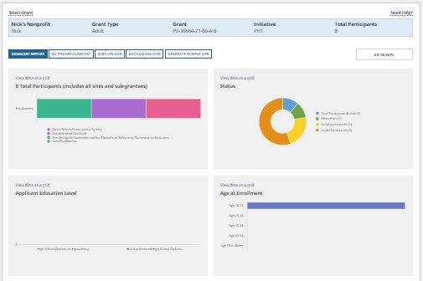
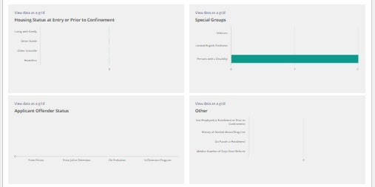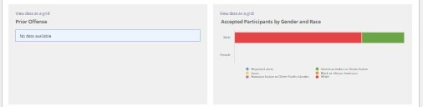

Summary Reports can only be generated for Adult participants. If there is no report available at that time, then a message “Report is not available at this time,” will be displayed as shown below:
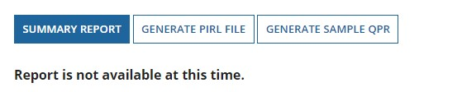

MY PROGRESS REPORT
Step 1) Using Login.gov, Log in to and access the REO website.
Step 2) Use the Select Grant button to select your Grant type and Grant.
Step 3) Click on Reports tab.
Step 4) Click on My Progress Report, select required fields such as time period, category, quarter end date, and detail and click on Generate Report.
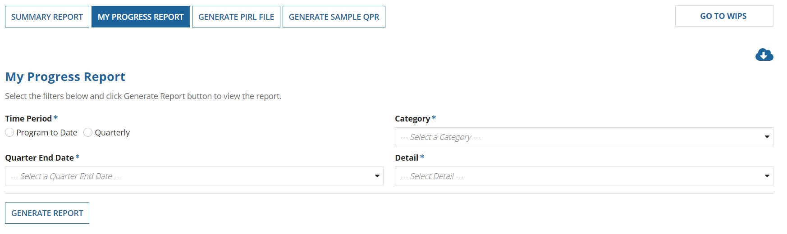
Based on selections made for time period, category, quarter end date and detail, a report is generated with the following information:
a) Total Participants (including participants in Intake, Active and Exited/In Follow Up state) b) Outcomes
- Total Exiters
- Active in Program
- Criminal Justice Outcomes
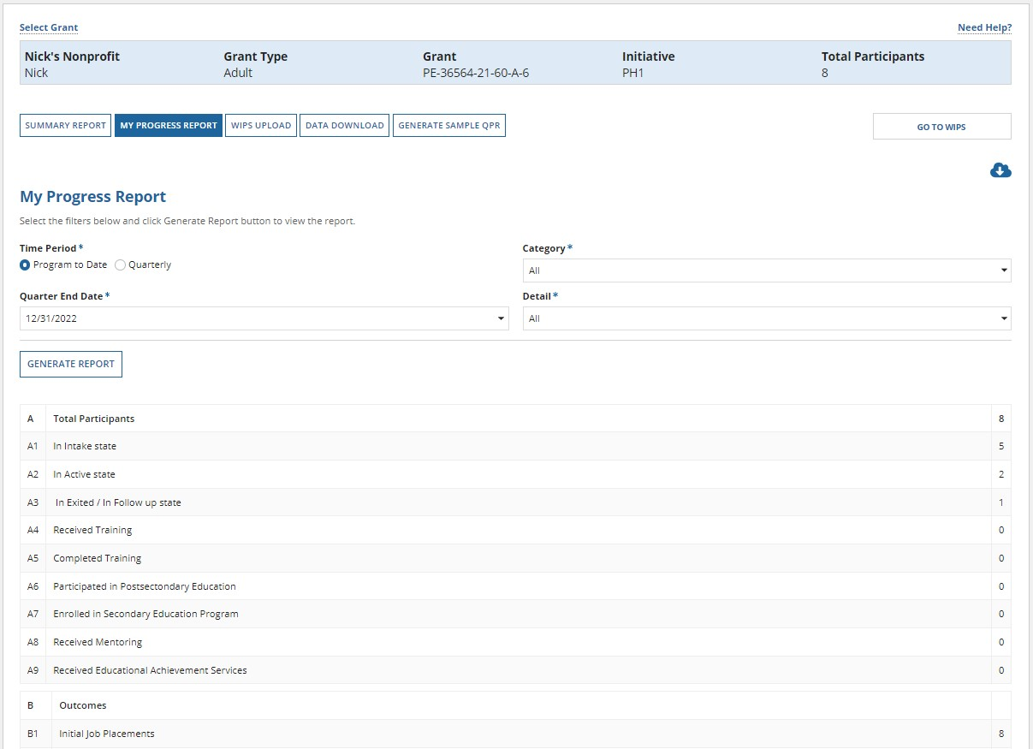
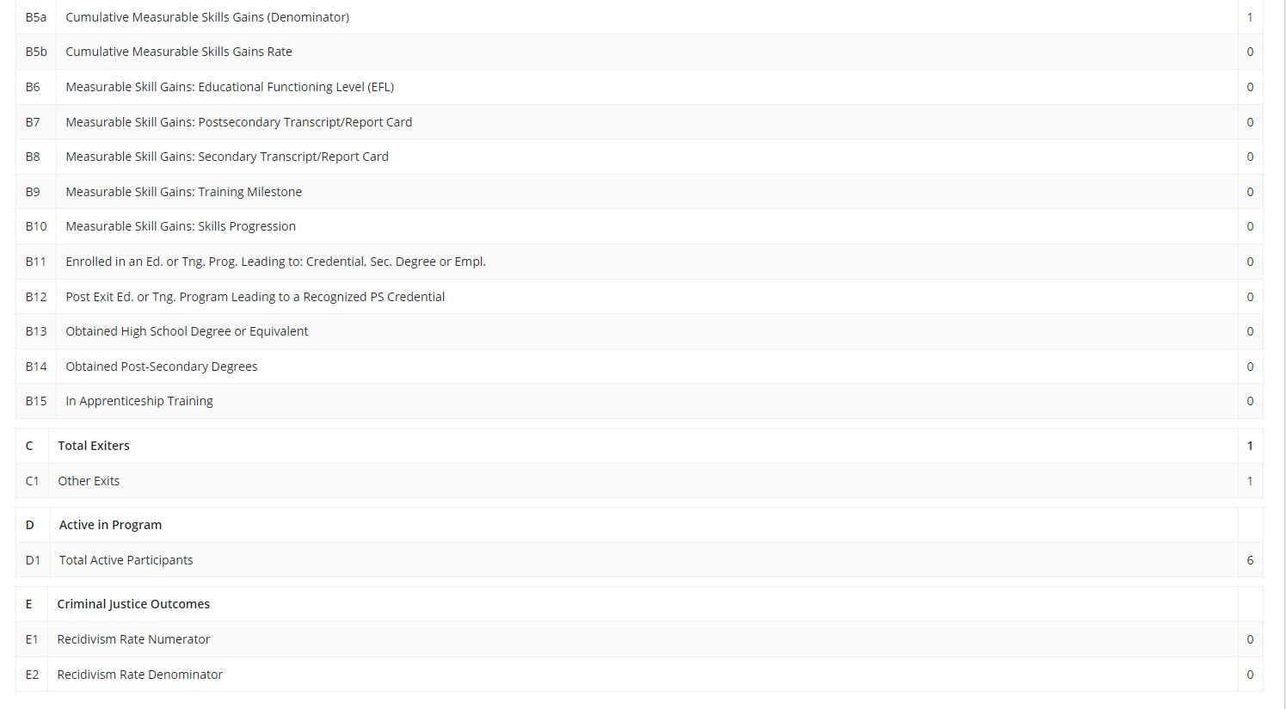
This report information can also be exported into an excel by clicking on the export icon. Clicking on the export icon will allow the user to download the excel.
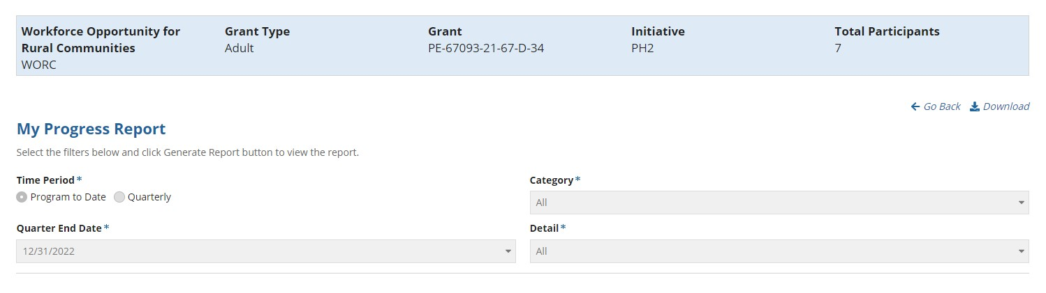

WIPS UPLOAD
Step 1) Using Login.gov, Log in to and access the REO website.
Step 2) Use the Select Grant button to select your Grant type and Grant.
Step 3) Click on Reports tab.
Step 4) Click on WIPS UPLOAD, select quarter end date and submit.

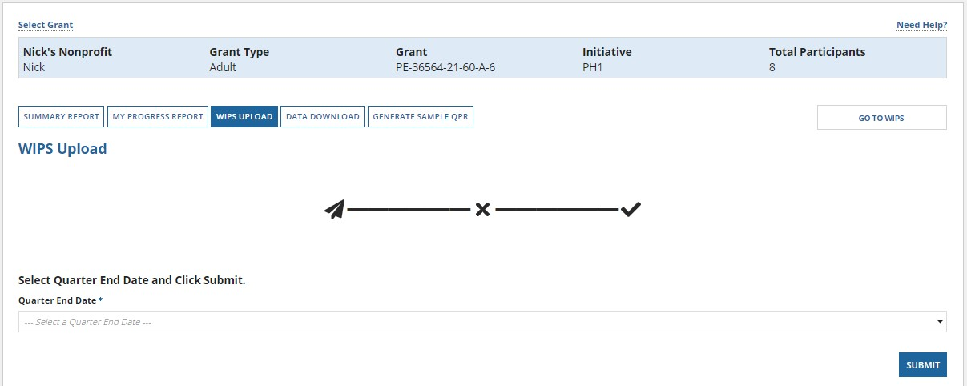
Step 5) “Successfully generated PIRL File” message is shown. Click on the “Go to WIPS” button to go to WIPS website and view the QPR there.

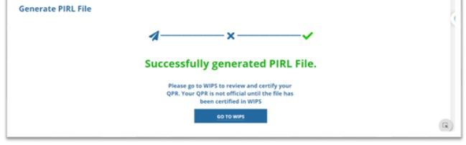

If the user cannot generate a PIRL file, the error codes appear to inform the user.

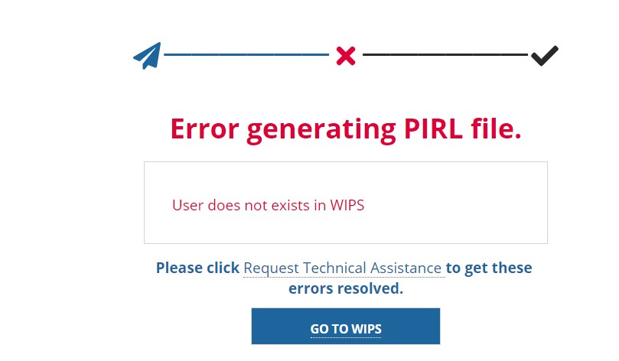
Possible error codes are given below.
- "User does not exist in WIPS"
- "User does not have requisite role, group, and function"
- "Grant is not under user's WIPS Profile"
- "Quarter is not available for upload"
- "Reporting period locked based on Program"
- "WIPS is in maintenance mode and unable to accept the file at this time"
- "Recipient is not valid."
- "Recipient is not under user's WIPS Profile."

Generate Sample QPR
Step 1) Log in to the REO website.
Step 2) Use the Select Grant button to select your Grant type and Grant.
Step 3) Click on Reports tab
Step 4) Click on generate sample QPR, select the quarter end date, and press submit.

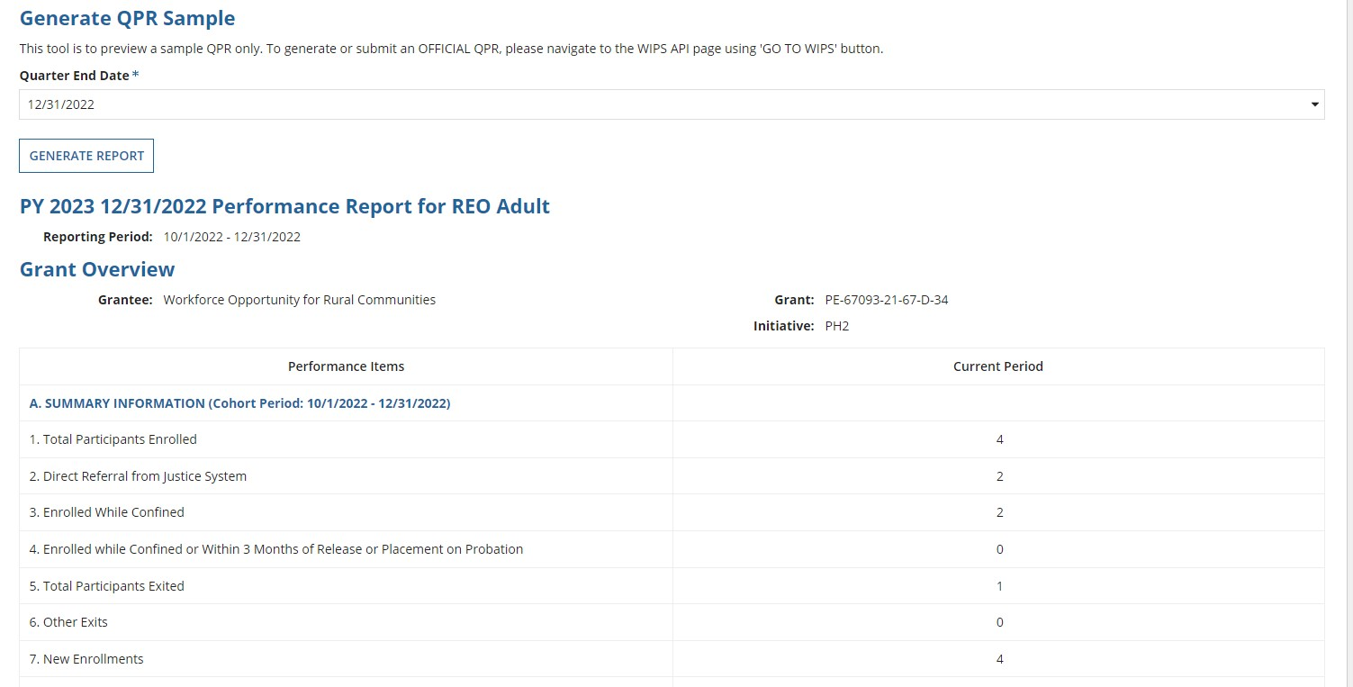
A report is generated with the following information:
- Summary Information
- Participant Summary Information
  - Sex
  - Ethnicity / Race
  - Education Level
  - Age at Enrollment
  - Offender Status
  - Housing status at entry or prior to confinement
  - Prior Offense
  - Special Groups
  - Other

GO TO WIPS
The user can click on the “Go To WIPS” button as shown below to be directed to the WIPS login page
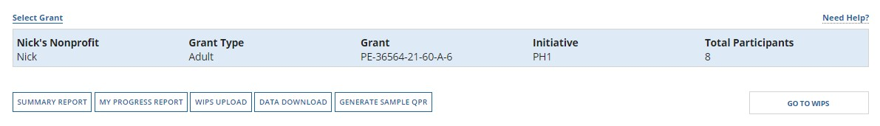

CASE MANAGEMENT
This Case Management module provides some of the core functions of the REO GPMS for the Grantees and SubGrantees. The users with Administrator (Admin), Supervisor, Case Manager and Data Entry Operator roles use this module (and the associated modules) daily to manage clients’ (participants of REO grants) records and information in the REO GPMS.
The Case Management module allows the grantees and sub-grantees to perform the following functions:
- Add New Participant (Adult or Youth) – using Adult Enrollment-Intake screens
- Cases Overview – the primary landing page for the external users lists all cases for the Grantee or Sub-Grantee organization. This list is showing only the cases managed by the Grantee or Sub-Grantee organization.
- View, add, edit or delete: Notes
Population/Grant Type and Grant Selection:
The REO GPMS requires the external users to select the population/grant type, Adult or Youth as well as a Grant. The user can only select one grant at a time. Once this selection is done, then the user can see all the Adult or Youth related cases under cases tab. The user can also see reports applicable only to the selected population. The following shows the Population/Grant Type and Grant selection page:

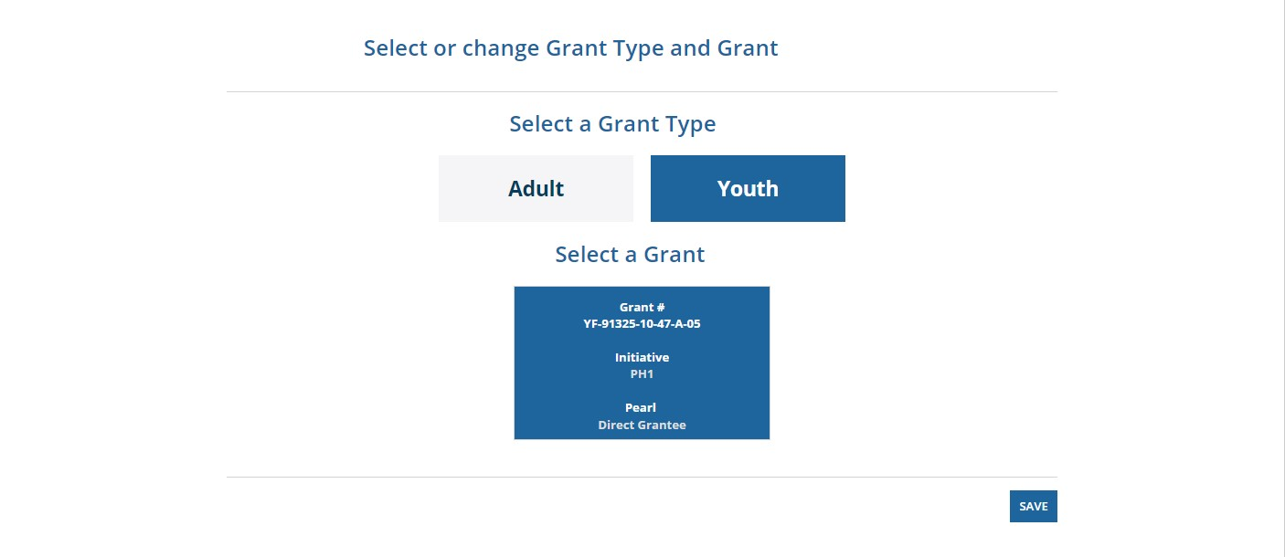

All the cases related to Youth will be shown in Cases page. Once the grant type is selected by an external user the first time, the next time the user logs in, the REO GPMS will show the selection made earlier.

After selecting the population/grant type, the user can see the cases assigned to them under the cases tab as shown below.

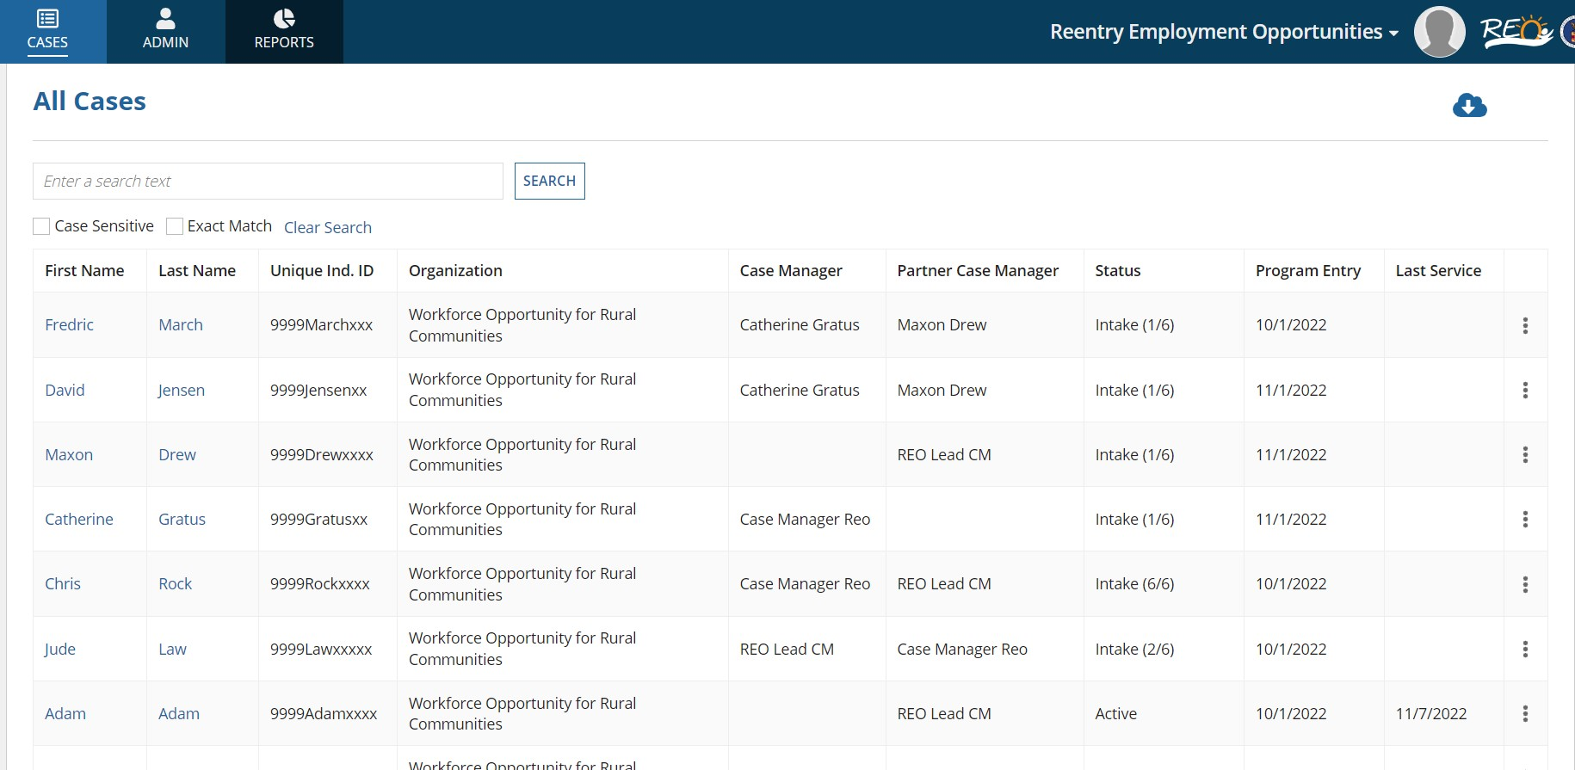
Under cases tab, the user can see the following information about a case in a grid format:
First & Last Name
Unique Ind. ID
Organization
Case Manager
Partner Case Manager
Status
Program Entry Date
Last Service Date
Elipsis column
By clicking on first or last name, the user can open any case. The user can also use the ellipsis icon and click on ‘view/edit’ case to open a particular case

Intake Case Status:
The “intake” status means that the user has not submitted the case yet.
If the user selects a case that is under “INTAKE” status, then the user will only see two tabs (Summary and Intake) for that case as shown below:
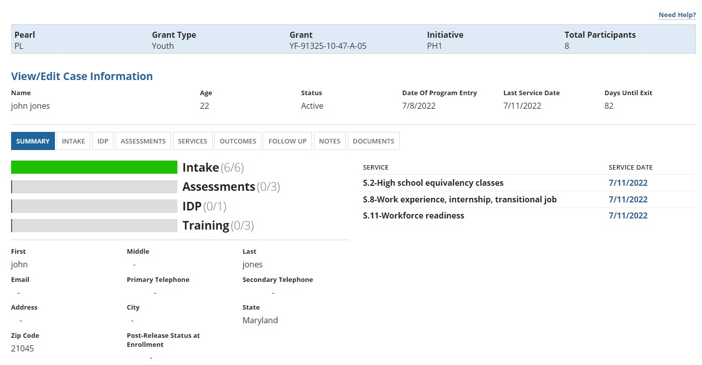
Intake process is divided into the following categories (as shown in image below):
Program and Participant Identification
Demographic
Employment-Education
Public Program
WIOA and Other Program
Criminal Justice
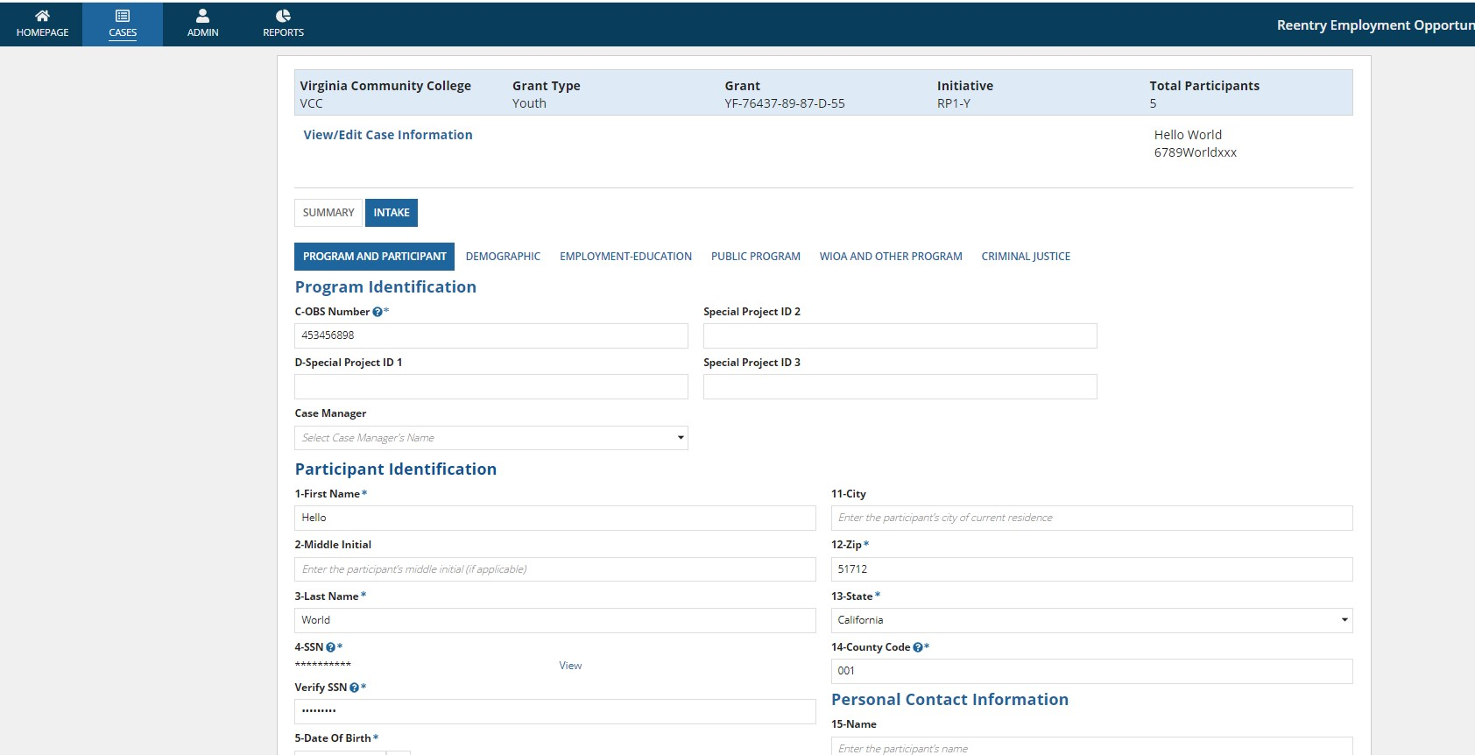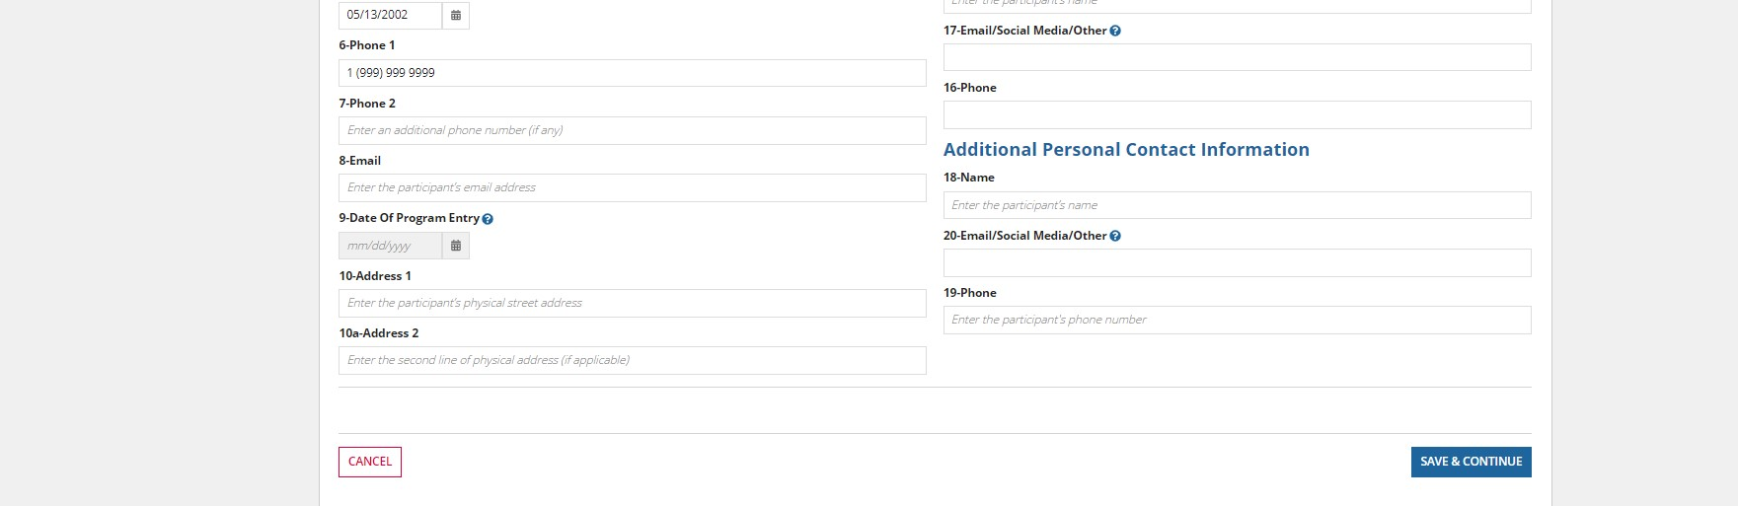
To create a case management record, the user must fill ALL the required fields for Program and Participant Identification. Once this is done, then the case status will be shown as INTAKE.
By clicking the first name or last name of the case which has INTAKE status, the user can fill the remaining tabs which have required fields.
Once the user enters all the required fields on all the forms, a submission button is shown in Criminal Justice page where user will see “COMPLETE INTAKE” button.
Once the user clicks on the “complete intake” button, the case status will be changed to “ACTIVE.” The case is now considered an “Active Case.” Active Case Status:
Once the case is under active status, the user can see the remaining following tabs to fill the data. These tabs are:
IDP
Assessments
Services
Outcomes
Follow-up
Notes
Documents

Note: while entering the required fields on each tab of INTAKE, the user will see Cancel and Save & Continue buttons on first page which Program and Participant Identification. User will also see BACK and SAVE AS DRAFT buttons with the CANCEL and SAVE & CONTINUE buttons.
On the final page of INTAKE, which is CRIMINAL JUSTICE, the user will see COMPLETE INTAKE button with SAVE AS DRAFT, BACK and CANCEL.
By clicking on Save as Draft, the user can save the information already filled and can work on the page later. All the information will be saved, and the user cannot lose the data by clicking on the SAVE AS DRAFT button.
Every field has clear option once the user enters the data or selecting any option. By clicking on clear, the user can clear the data for that field and select other option if needed. This applies to all the fields including ASSESSMENT & IDP, SERVICES, OUTCOMES and FOLLOW UP options as well.
For all the tabs, header content (banner on top) is the same. This header consists of Organization name, Grant type, Grant, Initiative and Total participants of the user.
If the user is missing any required field while entering the data for each tab, then clicking on SAVE & CONTINUE will show error messages. For the field “A value is required” error message will be displayed and also an error message “Missing values for required fields, please check the complete form for required fields and error messages” will be shown at the bottom of the page.
Note about date fields: A future date cannot be selected for any date field. If the user selects any future date, then the user will see “Date entered cannot be a future date” error message.
All the required fields entered, and all the error messages must be resolved before submitting the case.

Summary Page:
The summary page displays all the information of the case at a high level. This summary information consists of all the primary details of the case like candidate general information. All of the intake, assessments, IDP, training services progress, date of program entry, last service date, case creation date, etc.
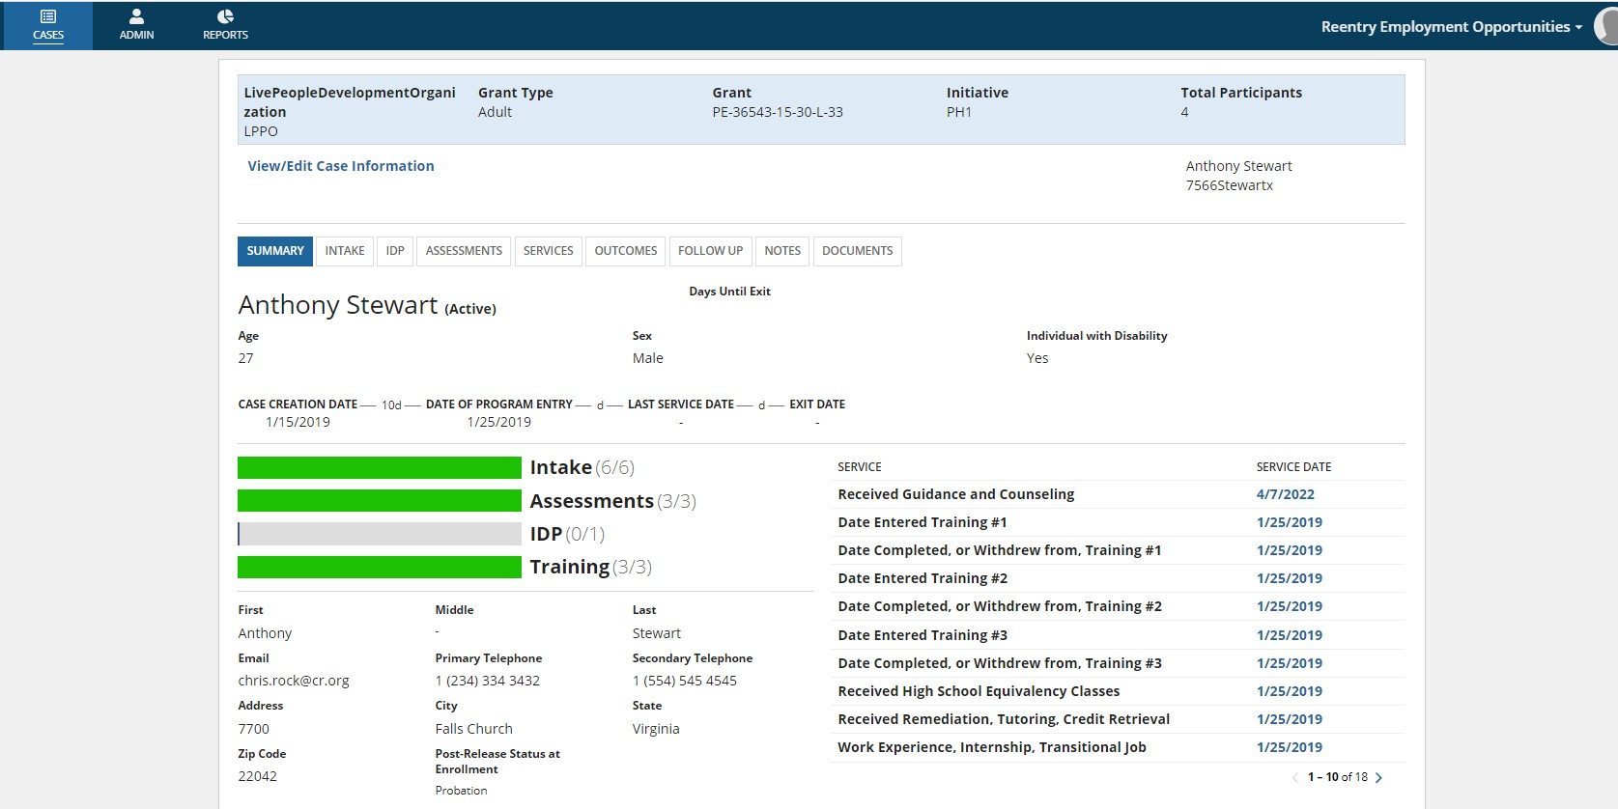

ADD PARTICIPANT

PROGRAM AND PARTICIPANT: (YOUTH)

Program and Participant: (Youth)
The case management record starts from the “Cases” page of the REO GPMS. Clicking “Add Participant” button on this page takes the user to the page where the Grant for which the participant is being enrolled.
User must enter Program Identification and Participant Identification details here in this section. C-OBS Number and participant personal information such as First Name, Last Name, SSN, etc., can be entered here. All the required fields must be entered in order to proceed further. All the required fields are listed below
C-OBS Number: The Observation Number is a unique number which identifies participant record in output data files. OBS number must be a 9-digit number and user cannot enter first two digits as zeros. The first 3 digits can correspond to a program site, the next 2 digits to a particular staff person and the final 4 digits can repeat the last four digits of the participant's social security number.
Example: 009123456 is invalid because of first two digits are zeros. 912345667 is valid
First Name: First Name of the participant (This first name can be a min of two-character length and maximum of 250 characters)
Valid First Names can be: David#$@%^
David12345
David 1234
Invalid First Name: D
Lats Name: Last Name of the participant (The last name also must be a min of two-character length and maximum of 250 characters same as last name).
SSN: SSN number of the participant. The SSN number must only contain numeric characters and contain exactly 9 characters. The tool tip provides the validations applicable for SSN field.
If the user is not sure about the SSN number of the participant, he can enter “999999999” and proceed further to enter other information. Also, SSN cannot end with “0000” and 4th and 5th characters cannot be entered as “00”.
The SSN cannot start with “000” or “666”. The SSN cannot start with “9”, except “999999999”.
Verify SSN: Same SSN what we entered for SSN field can be entered here to validate it. Once the same SSN is entered for both SSN and verify SSN fields, a “view”/”hide” functionality becomes enabled. Due to security reasons, the entered SSN/verify SSN fields are masked. If the user wants to see the actual number entered for SSN, then they can click on “view” button to view it. Date of Birth: Date of Birth of the participant entered here.
For a youth participant the age limit should be greater than 12 years to less than 24 years and for an Adult participant the age limit should be greater than 17 years and less than 65 years. We can ignore the warnings for an adult participant if you enter the age below 17 but we don’t have any such rule for Youth.
Zip: Zip code of the address of the participant
Zip code must be a 5-digit number. For example, 40202 is in Louisville, 50309 in Des Moines.
State: State of the participant
State of the participant can be selected from the drop-down menu.
County code: County code of the participant.
County codes can be found here https://www.weather.gov/pimar/FIPSCodes. You can find counties and 6digit FIPS codes of the counties here in the provided link. The first two digits of this code is State Code. Only last three digits can be entered from the FIPS codes as county codes.

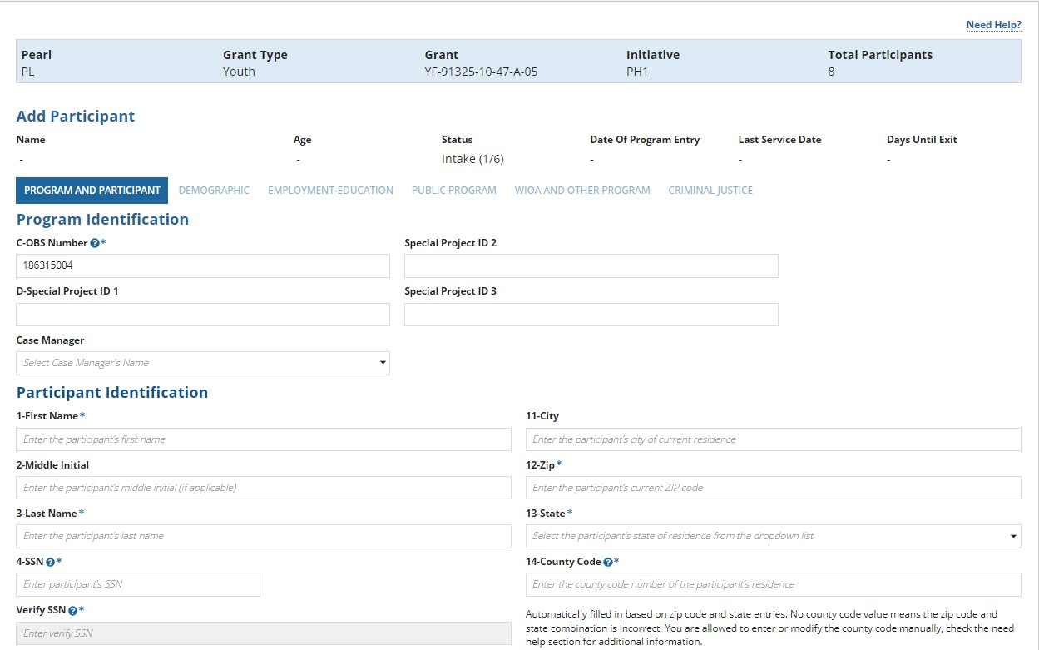

Once the user enters all the required fields, the user can click on Save & Continue to enter Demographic details. A User can close the tab enter the details later, user will see that participant in all cases grid. User can search with the participant first name, last name or unique ind. ID to find the participant. At this stage, the case status will be Intake (we can see the status column in all cases grid).

By opening the case, user will see the Summary details related to that case. By clicking on Intake button user can select and enter more participant related information. A user can click on Cancel after entering the program and participant information, in this case no case will be created, and user will be directed to All Cases grid.

Program and Participant: Adult
All the fields and functionality of the program and participant page is like the Program and Participant Youth page.

DEMOGRAPHIC

Demographic: Youth
All the Demographic related data (statistics the describes the population) can be entered here. On the Demographic page we have sex, ethnicity, disability, alcohol, health related issues etc. User must select all the required fields in this page to continue to the next page. All the required fields we have on this page are listed below.
Sex
Male, Female and Did not self-identify any one option can be selected for this field. If the user selects male as an option another field “Date Verified selective service registration” can be entered, we have a link here https://www.sss.gov/verify/ by clicking on the link and visiting the site, we can verify the applicant whether he already registered with Selective Service. Male applicants from 18 to 25 can register here and download the registration from without SSN. Ethnicity: Hispanic/Latino
▫ Yes, No and Did not self-identify any one option can be selected for this field.
American Indian/ Alaska Native
Yes, No and Did not self-identify any one option can be selected for this field.
Asian
Yes, No and Did not self-identify any one option can be selected for this field.
Black/ African American
Yes, No and Did not self-identify any one option can be selected for this field.
Native Hawaiian/Hawaiian/Another Pacific Islander
Yes, No and Did not self-identify any one option can be selected for this field.
White
Yes, No and Did not self-identify any one option can be selected for this field. Individual with a Disability
Yes, No and Did not self-identify any one option can be selected for this field. If it is Yes fields from 25 to 25f become required fields and the user must select these options.
Category of Disability (it is a drop-down menu; any option can be selected from the drop-down list of items) the option we have for this one, are:
Physical/Mobility Impairment.
Mentalor Psychiatric Disability. Vision-related Disability. Hearing-related Disability Learning Disability.
Cognitive/Intellectual Disability
Participant did not disclose type of disability.
No Disability, user can select multi options here and if we select “No Disability” all the options we selected earlier will disappear.
Individual with a Disability – State Developmental Disabilities Agency (SDDA) services.
SDDA or no can be selected.
Individual with a Disability – Local or State Mental Health Agency (LSMHA) services.
LSMHA or no can be selected
Individual with a Disability - Medicaid HCBS services.
LSMHA or no can be selected.
Individual with a Disability – Work setting (Drop down menu). Competitive Integrated Employment
Individual Supported Employment
Group Supported Employment
Sheltered workshop
Combination of two or more settings
Not Employed. User can select any option from the list
Individual with a Disability – Type of customized employment services received. (Drop down menu)
Discovery assessment services
Developed a customized employment search plan
Secured employment as a result of receiving customized employment No CES Services. User can select any option from the list Individual with a Disability – Financial capability. Benefit planning services
Financial capability/asset development services
Benefit planning services and financial capability/asset development services No
Veteran status
Yes, No or Status not known can be selected.
Eligible veteran status. (Drop down menu)
Yes<=180
Yes, Eligible Veteran
Yes, Other Eligible Veteran
No. Any one option can be selected.
Homeless veterans' reintegration program participant. For this User has to enter first five numbers of the DOL Grant number.
Once all the required fields are selected user can continue to the next page.
Also, if “24-Individual with a Disability” is yes user has to select field “43-Individual with A Disability Individualized Education Program (IEP) Participant” in Employment-Education which has three options Current IEP, Previous IEP and Not Applicable. User has to select either Current IEP or Previous IEP here in this page Not applicable is selected when we select No or Did not self-identify as option for the field “24-individual with a Disability” and also we must select field “44-Individual With A Disability Section 504 Plan” as Yes if “24-Individual with a disability” is selected as Yes and No is selected when we select “24-Individual with a disability” as No or Did not self-identify.
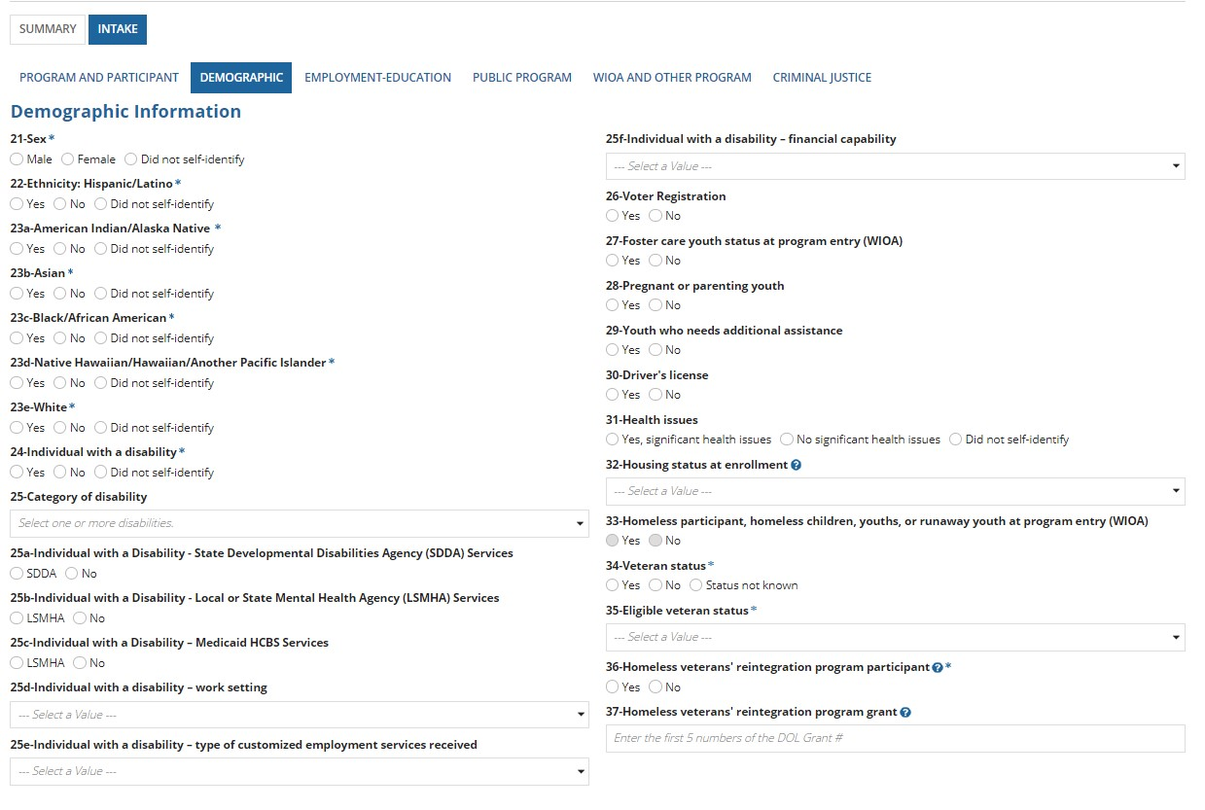

Demographic: Adult
Adult demographic fields and functionality same as youth demographic page. However, adult page has two additional fields, which are:
26-Cultural barriers at program entry which has options
Yes, No and Did not self-identify
28-Alcohol/drug abuse at enrollment which has options
Yes, No and Did not self-identify

EMPLOYMENT/EDUCATION INFORMATION

Employment/Education: Youth
Employment status and Education details information can be captured here on this page. The required fields here are:
38- Employment status at program entry which has options Employed
Employed, but Received Notice of Termination of Employment or Military Separation is pending Not in labor force
Unemployed
40-Highest school grade completed at program entry.
0 to 12 number of school grades completed can be entered here.
41-Highest educational level completed at program entry which has options
Attained secondary school diploma
Attained a secondary school equivalency
The participant with a disability receives a certificate of attendance/completion as a result of successfully completing an individualized Education Program (IEP). (If we select this option field 42-School status at program entry will display 4 options)
Completed one of more years of postsecondary education
Attained a postsecondary technical or vocational certificate (non-degree)
Attained an associate degree Attained a bachelor’s degree
Attained a degree beyond a bachelor’s degree
No Educational Level Completed (If we select this option field 42-School status at program entry will display 4 options)
The participant with a disability receives a certificate of attendance/completion as a result of successfully completing an individualized Education Program (IEP) which is option 3 and No Educational Level Completed which is option 9, if we select any other option only two options will be displayed for 42-School status at program entry, those are (In-school, Postsecondary school and not attending school, secondary school graduate or has a recognized equivalent).
42-School status at program entry which has options
In-school, secondary school or less
In-school, Alternative School
In-school, Postsecondary school
Not attending school or Secondary School Dropout
Not attending school, secondary school graduate or has a recognized equivalent Not attending school, within age of compulsory school attendance.
These all options can be displayed if we do not select any option for 41-Highest education level completed at program entry.
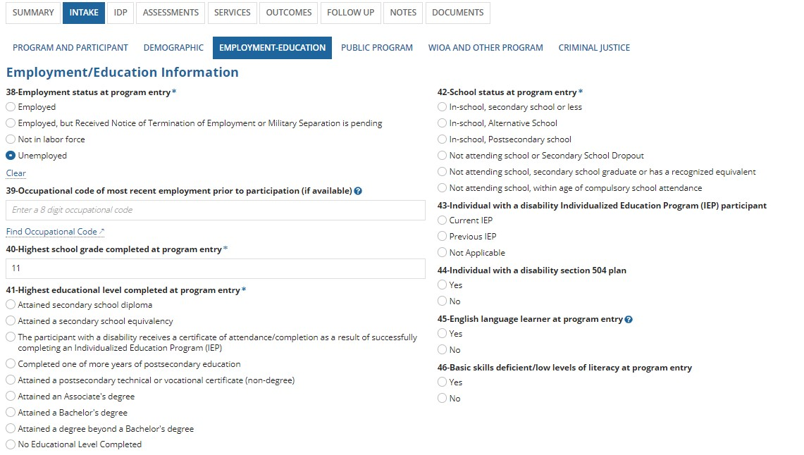
When the user selects Current IEP or Previous IEP for the field “43-Individual with A Disability Individualized Education Program (IEP) Participant” in Employment-Education, then user has to select yes for “24-Individual with a Disability” in demographic. Not applicable is selected when we select No or Did not self-identify as option for the field “24-individual with a Disability” and when we select “yes” for the field “44-Individual with A Disability Section 504 Plan” then “24Individual with a disability” is selected as Yes and No is selected when we select “24-Individual with a disability” as No or Did not self-identify.
Once all the appropriate fields are selected, clicking on save & continue will direct you to the “Public Program” page. Save as draft can be selected if the user wants to enter the data later, user can visit the previous page by clicking on the Back button.

Employment/Education: Adult
The field “Individual with a disability section 504 plan” which we have in Employment/Education: Youth page we do not have that field in “Employment/Education: Adult”, but the functionality is the same as the youth page.

PUBLIC PROGRAM INFORMATION:

Public Program: Youth
Participant income and public assistance status are captured on this page but there are no required fields here. User can select any option and by clicking on continue he/she will be redirected to the “WIOA and Other Program” page.
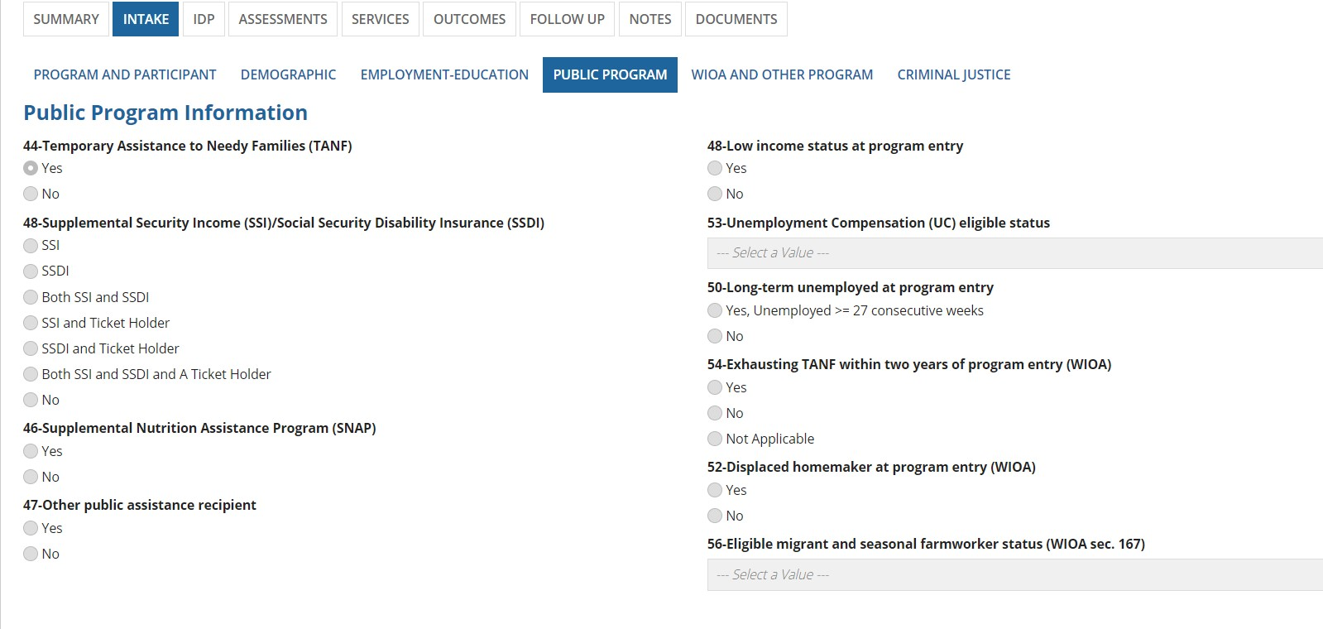

Public program: Adult
There are some additional questions for the adult participants, but none are required.
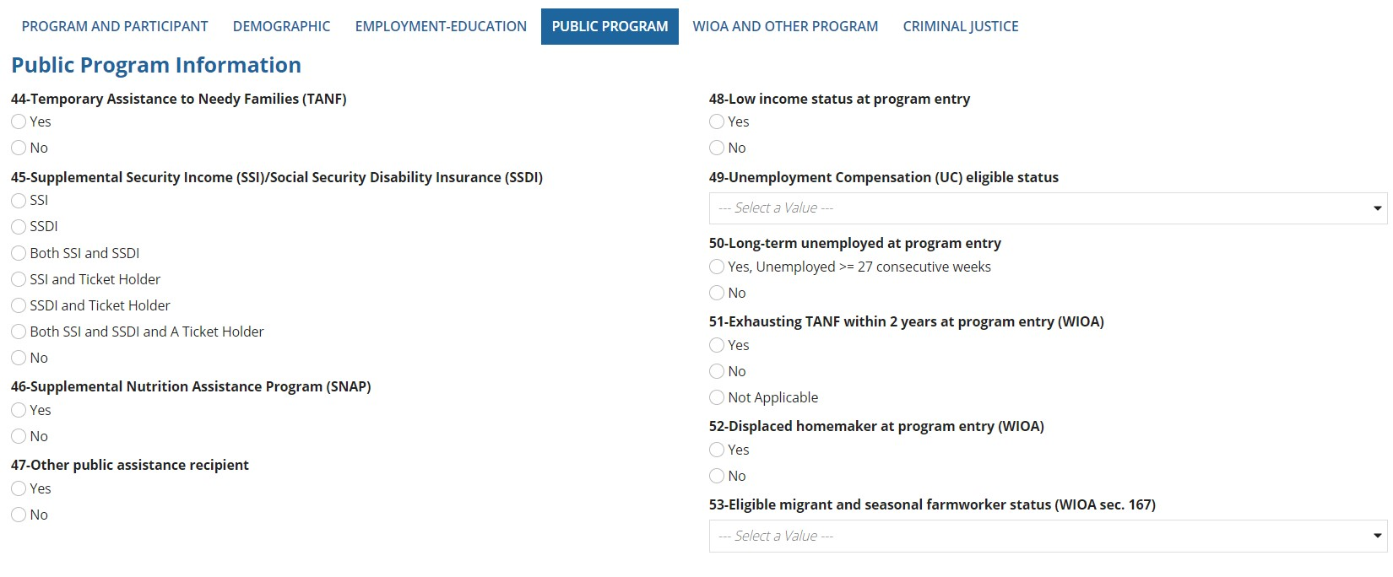

WIOA AND OTHER PROGRAM:

WIOA and Other Program: Youth
Participant’s past and current WIOA participation details are captured on this page. There are no required fields on this page. Once the user selects any option, they will be directed to “Criminal Justice” page.
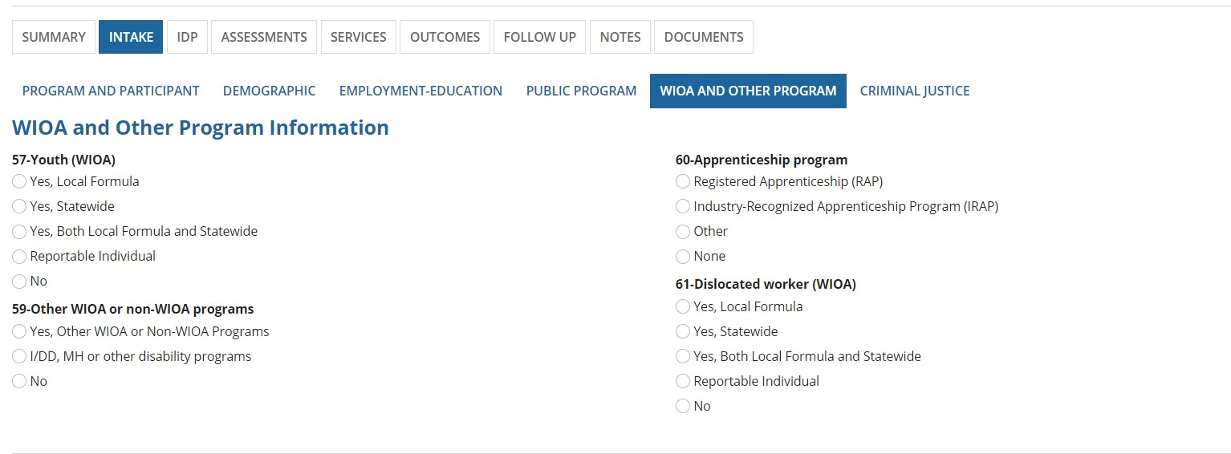

WIOA and Other Program: Adult
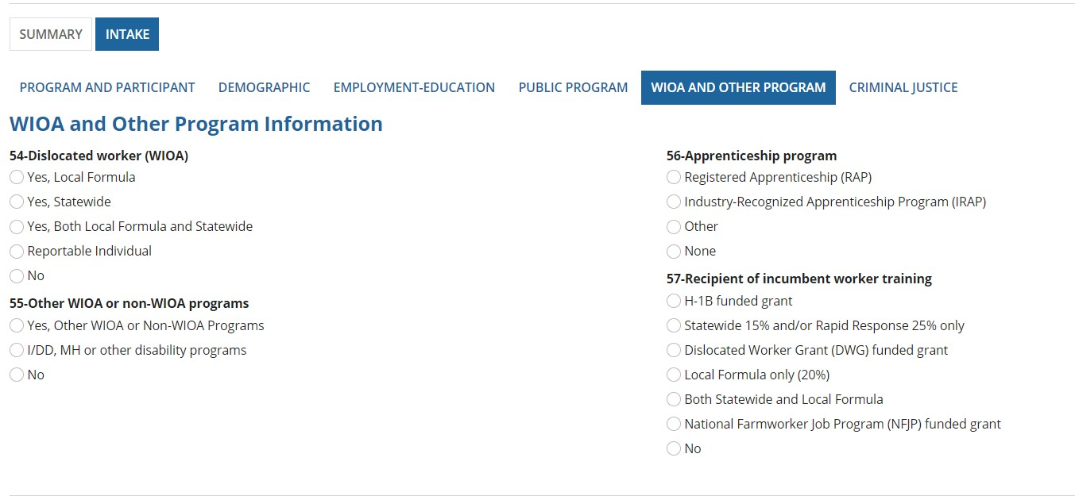

CRIMINAL JUSTICE:

Criminal justice: (Youth)
Past and present criminal justice information of the participant can be captured here on this page.
The required fields on this page are indicated with a blue asterisk (*) at the end of the field name.
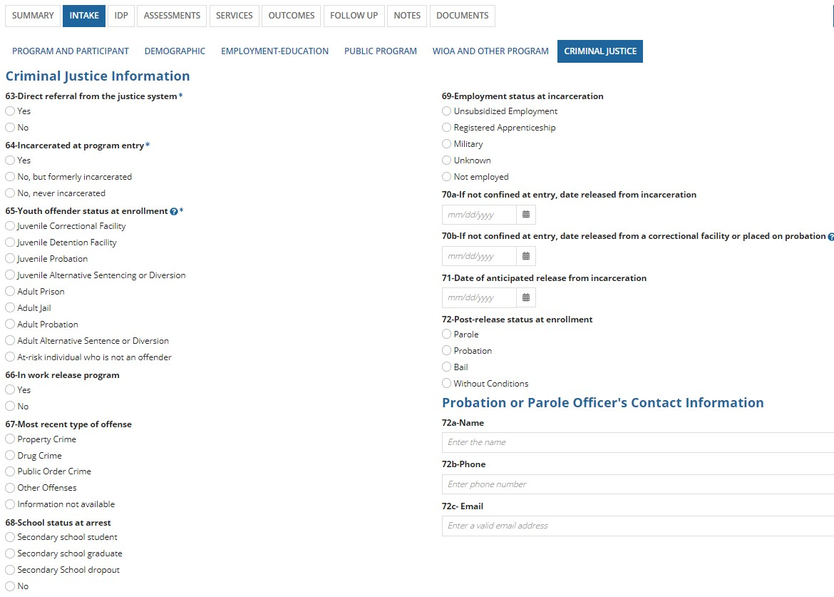

Criminal Justice: (Adult)
Slightly different questions but overall functionality is the same as the youth case.

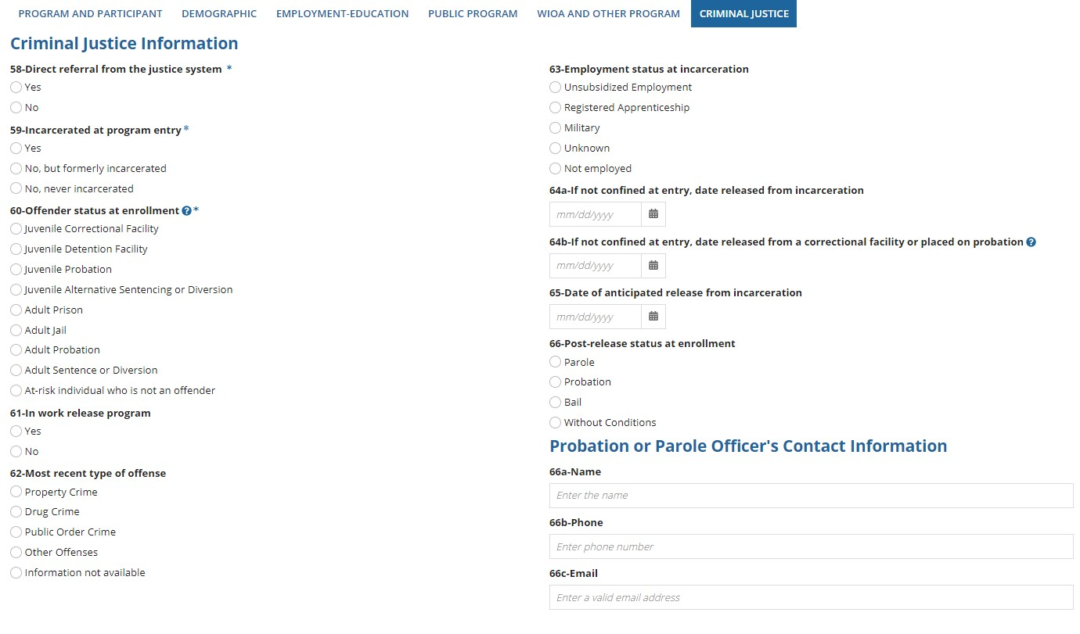

VIEW/EDIT CASE INFORMATION
REO CMP application allows user to edit the case. Take any case which has active status, click on Intake user will see all the Intake related tabs and edit option in the right corner. By clicking on the “EDIT” button user can edit the forms. Same way by clicking on the view button, user can see the form in view mode.
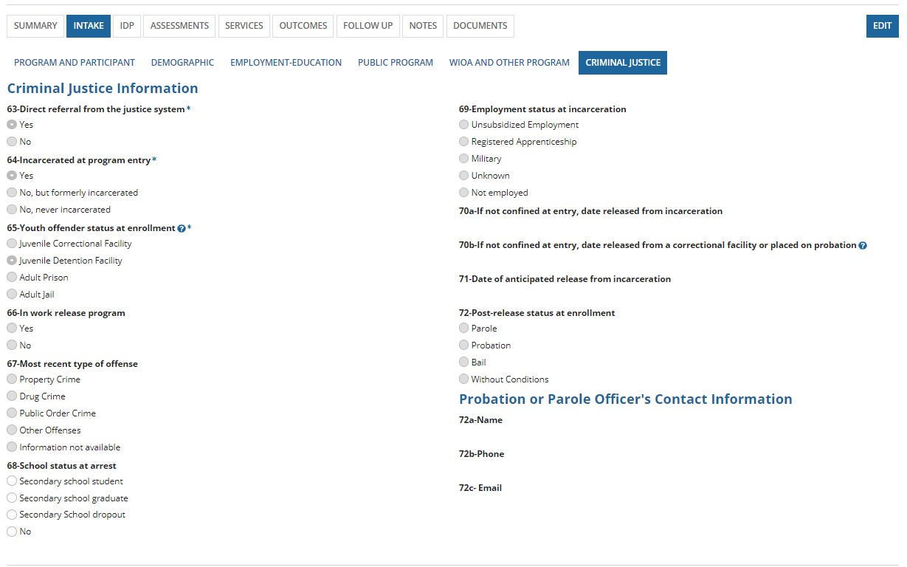
“VIEW” button is show below:
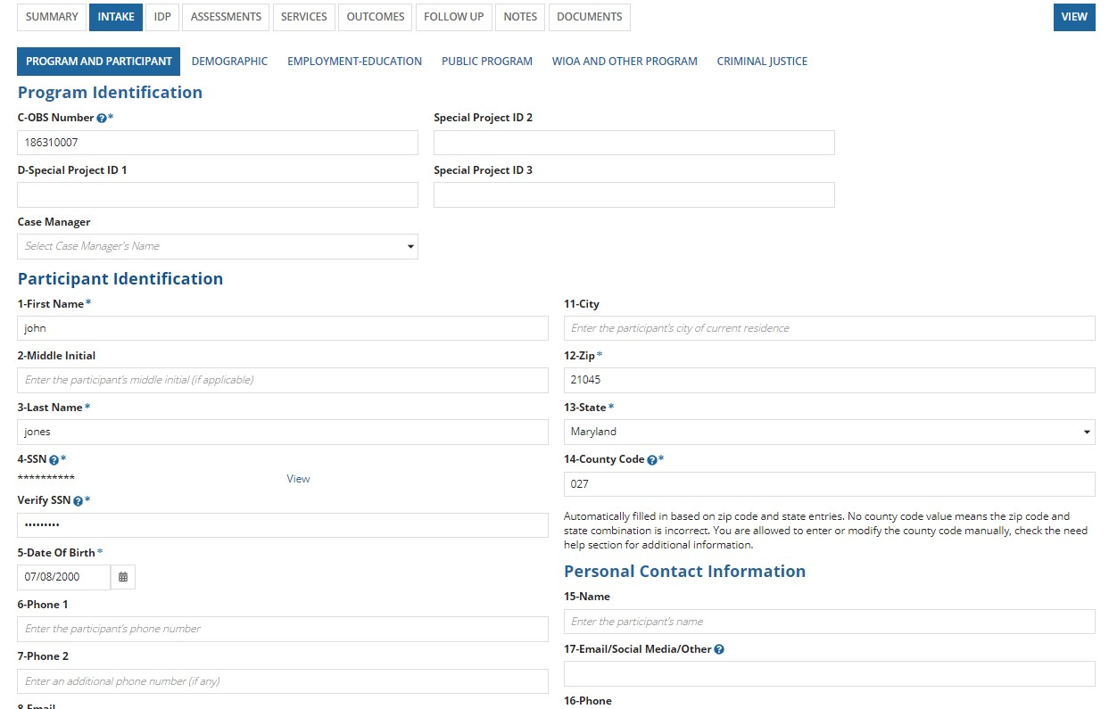

IDP (INDIVIDUAL DEVELOPMENT PLANS)
A user can create a new IDP by clicking on the create IDP button on the IDP page. To navigate to this page a user must take any active case, once clicking on the case from all cases grid user will see all the tabs like Summary, Intake, IDP etc., from these tabs by clicking on the IDP button user will see the IDP interface. By clicking on the “UPLOAD DOCUMENT” button, the user can upload the IDP document to the REO application. An optional title and description of the document can also be added. When the user clicks on “Submit” button, the document will be displayed in the “IDP Documents” grid.
Follow the step-by-step instructions mentioned below to add/navigate IDP tab of the REO application.
- IDP can be provided for participants that have successfully completed the intake process and are in “Active” case status
- Open participant case that is in “Active” status or “Intake (4/6)” or “Intake (5/6)” or “Intake (6/6)” and click on “IDP” tab. You will see a screen as shown below. REO GPMS allows only two types of documents to be uploaded. i. Word document ii. Pdf document
Word document can be downloaded, whereas Pdf document can be viewed directly in the application.
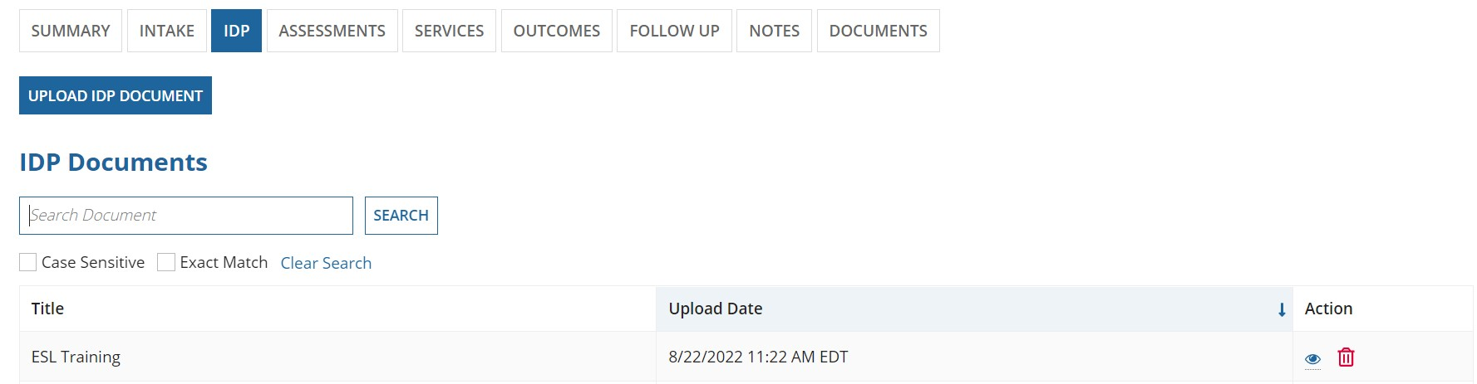

- You can upload an IDP document to the REO application by clicking on “Upload IDP Document” button.
a. Clicking on the upload idp document, opens a screen as shown below:

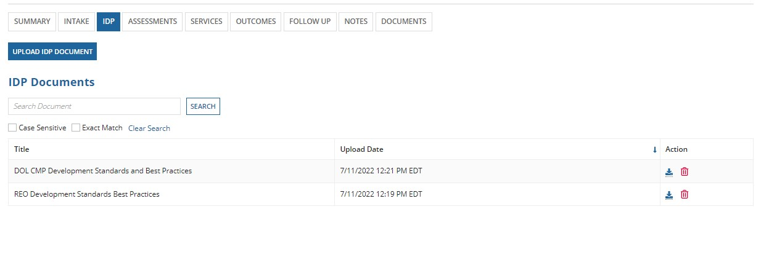 b. Click on “Upload” to attach a document and click “NEXT”.
c. Clicking on “NEXT”, opens a screen shown below:
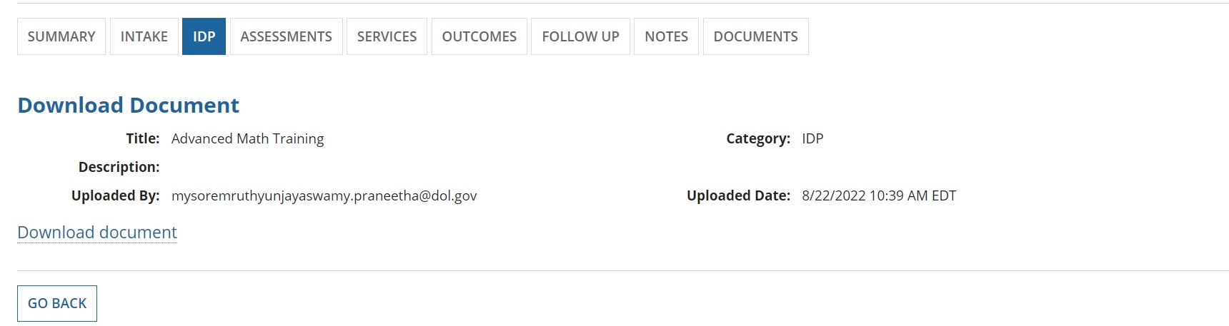 b. Click on GO BACK button to view the IDP Homepage.

7. To delete a document, click on Delete icon. A confirmation dialog box, with YES/NO options opens.
- If you click on NO, then you will simply stay on the same page.
- If you click YES, then the document is deleted and will not be shown in the grid anymore.
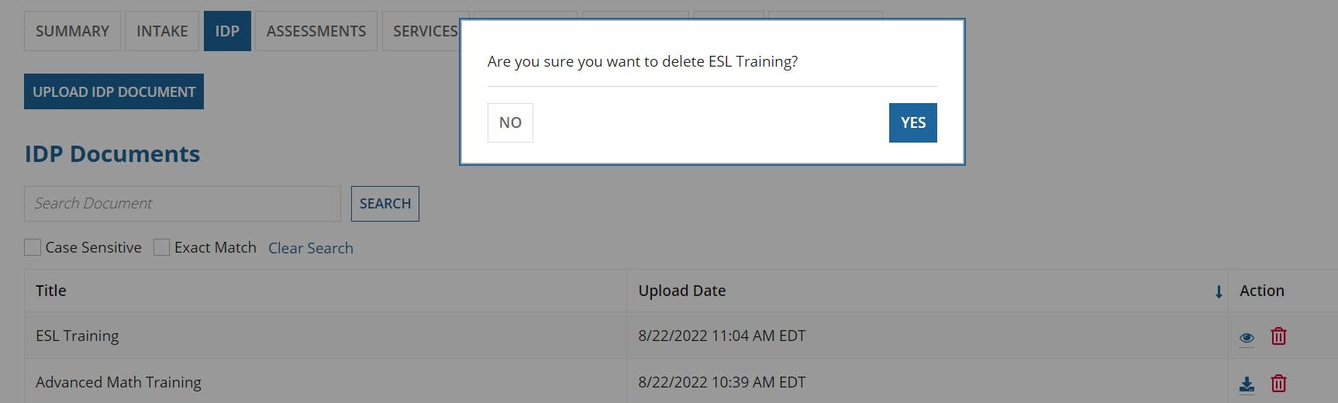

ASSESSMENTS
Assessment screens captures pre and post assessments of the participant. Generally, literacy and numeric gains are captured here. It is very helpful for tracking participant’s education gains and can be used to document measurable skills gains specific to educational functional Levels.
There are 3 assessments user needs to complete each form contains the same data elements. These assessments focus on Literacy, Math and ESL.
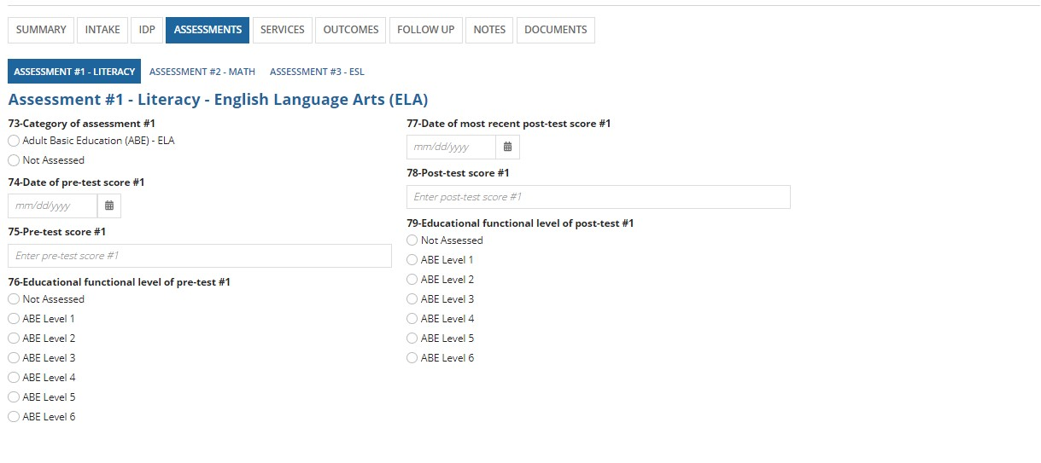
On this screen,
if we select “73-Category of assessment #1” as not assessed then reaming fields will be disabled showing “76-Educational functional level of pre-test” and “79- Educational functional level of post-test” are disabled with “Not Assessed”. If we clear the option not assessed remaining fields and those values are enabled for selection.
If we select “73-Category of assessment #1” as (Adult Basic Education (ABE) -ELA) then “74-Date of pre-test score#1”, “75-Pre-test score#1” and “76-Educational functional level of pre-test” will become require fields with the field “73-Category of assessment #1”.
Similarly,
if we select only “74-Date of pre-test score #1” then “73-Category of assessment #1” and “76-educational functional level of pre-test” will also become required fields and we must select any option for these two fields.
While selecting the date, we must not select a future date. And also, while entering date for “77-Date of most recent post-test score #1” we must enter same date or later date than the date of pre-test score.
▫ If we give any value to the field “75-Pre-test score #1” then the fields “73-Category of assessment #1”, “74Date of pre-test score #1” and “76-Educational functional level of pre-test” will become required fields.
Apart from “Not assessed”, If we select any option for the “76-Educational functional level of pre-test” then the fields “73-Category of assessment #1”, “74-Date of Pre-test Score #1” and “75-Pre-test score #1” will become required fields.
If we enter any date for “77-Date of most recent post-test score #1”, then with the field 77, “78-Post-test score #1” and “79-Educational functional level of post-test” will become required fields.
▫ If we enter any value for “78-Post-test score #1, “77-Date of most recent post-test score #1”, and “79Educational functional level of post-test” will become required fields.
▫ If we select “79-Educational functional level of post-test” value as not assessed, then fields "77 and 78” will be disabled. Other than Not Assessed if we select any option for 73 both “71 and 72” will become required fields.
Note: While entering date, we must select a date that is same date or later date than the “Date of Program Entry” or the case creation date. And we should not enter any negative value for “69-Pre-test score #1” and “72-Post-test score #1”.
Same logic and rules apply for Assessment #2 MATH – Math and Assessment #3-ESL.

SERVICES
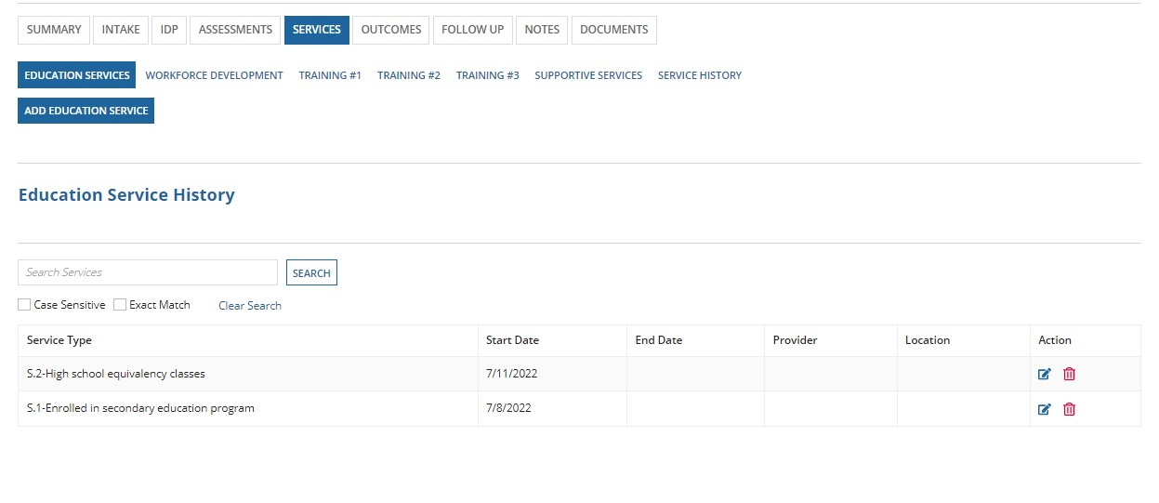
The Services Tab gives information about different services provided to the participant. The services tabs are given below.
Education services
Workforce development Training #1
Training #2
Training #3
Supportive services
Service history

Education Services:
The user can click on “ADD EDUCATION SERVICE” and the screen below will be shown. Service type and Start date are required fields. To add multiple services, the user can click on “SAVE & ADD ANOTHER” else “SAVE & CLOSE” can be clicked.
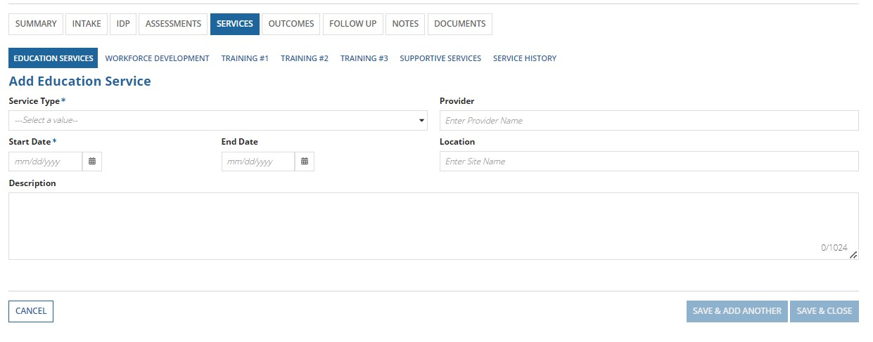

Education Services: (Youth)
For Youth participant, the Service type includes questions from S.1-S7. One service at a time can be entered and the saved entries will be shown in the “Education Services History grid”.

Education Services: (Adult)
Two fields “Enrolled in secondary education program” and “Most recent date received college-bound activities” we do not have on adult page, but the functionality works same as education service youth page. We do not have any required fields here but when we enter any date for “S.5-Date of post-secondary education or training placement” field “S.4Enrolled in post-secondary education during program participation” will become a required field.

Follow the step-by-step instructions mentioned below to add/navigate Education Services tab in Services section of the REO application.

- Services can be provided for participants that have successfully completed the intake process and are in “Active” case status
- Click on a participant case that is in “Active” status or “Intake (4/6)” or “Intake (5/6)” or “Intake (6/6)”. You will be directed to the summary page of that participant as shown below:
  - Notice that since the case status is “active,” you can access the entire platform such as IDP, Assessments,
Services, Outcomes, Follow-up, and Notes
- Click on the services tab. It will directly open the education services screen as shown below:
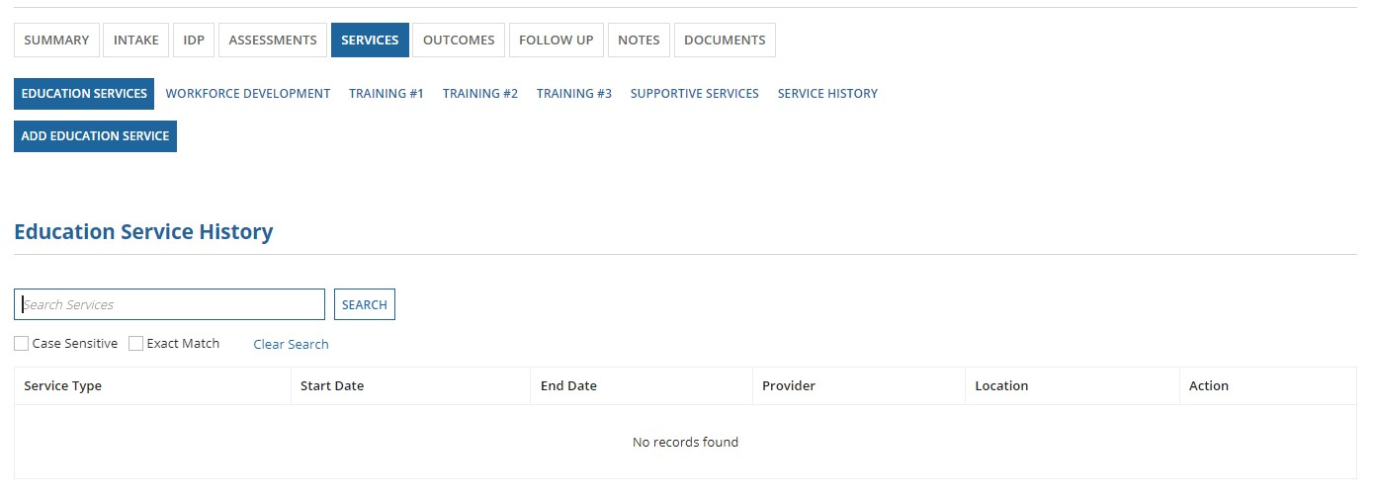
Notice that a variety of services can be added for the participant such as education services, workforce development services, trainings, supportive services, etc.
- Click on “Add Education Service” on the education services screen to add an education service

- When you click on “Add Education Service,” a new screen opens as shown below:
  - You can add the education service using this screen. ‘Service Type’ and ‘Start Date’ are required fields in this form as denoted by an asterisk (“*”)
i. ‘Service Type’ is a dropdown field that will allow you to select the type from the options provided
  - Optional details such as end date, provider, location, a brief description of the service can also be added
  - An “Education Service History” grid is also displayed at the bottom of the page. This grid shows a list of all the education services that were received by the participant
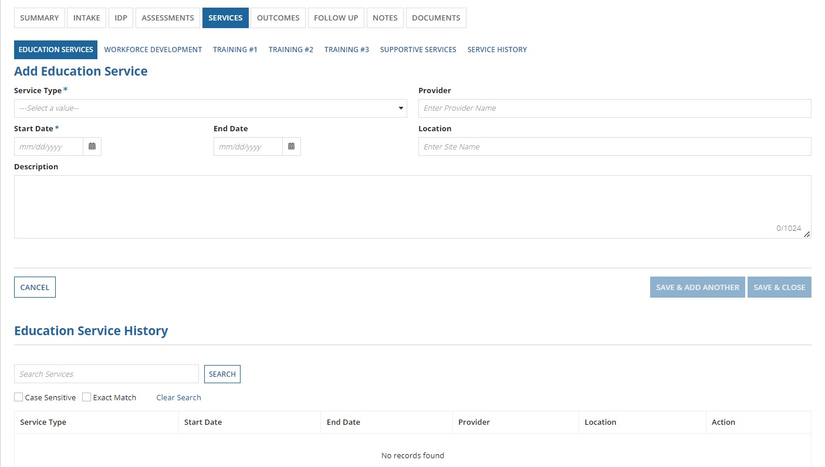
- Once all required information is filled for the service, the “Save & Add Another” and “Save & Close” buttons enable at the bottom right as shown below
  - Clicking on “Save & Add Another” will save the existing service record and will directly open another form to add a new education service
  - Clicking on “Save & Close” will save the existing service record and take you back to the home screen for education services tab where this service record will be shown under the education service history grid
  - Clicking on the “Cancel” button on the left will cancel the action of adding this service for the participant
  - The image below shows adding a ‘high school equivalency classes’ education service for the participant
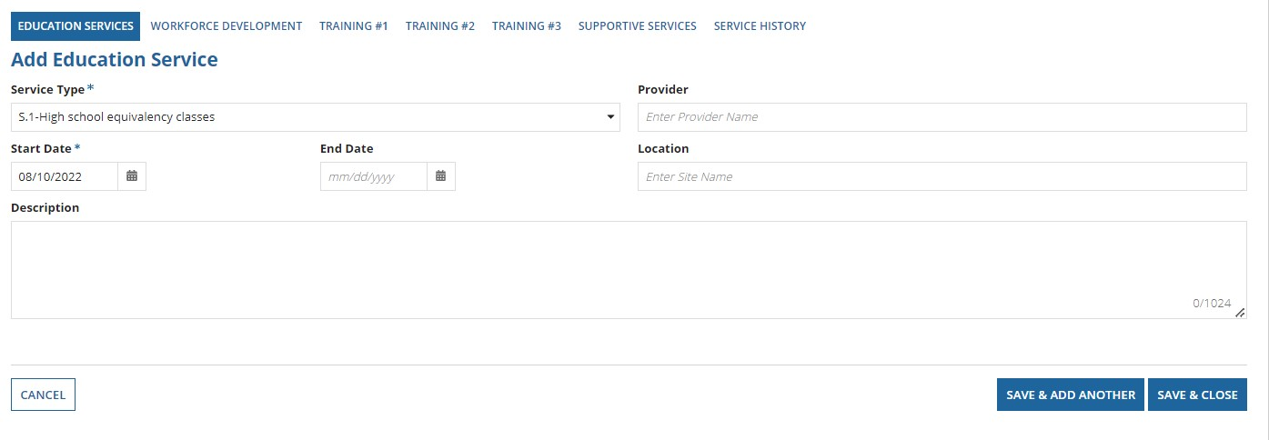
- The home screen of the education service tab now displays the ‘high school equivalency classes’ education service record in the “Education Services History Grid” as shown below
  - In the “Education Service History Grid,” the service type and start date of the service will always be shown. If you add details such as end date, provider, and location, then those details will also be shown in the grid.
  - The action column of this grid has both “edit” and “delete” icons to edit/delete the service record as needed
  - A search functionality is also available to use to filter searches for “Education Service History” table. Instead of seeing all the records, you can use search functionality to search for information available in the table i. While searching, you can turn on/off for the search to be ‘case sensitive,’ or ‘exact match’
  - Case sensitive searches will show results even for partial matches. Exact match searches will only give results that exactly match your search
  - A ‘clear’ link is also available for you to clear the search data
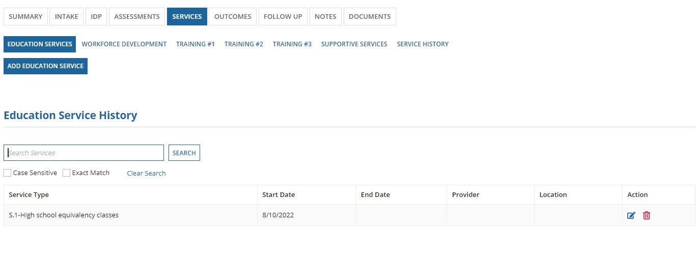
- To edit an education service record, click on Update Education Service icon. New screen opens to display all the details of the record when it was created.
a. You are not allowed to change the service type, but you change the Start Date of the service, end date of the service, provider, location, and description of the service.
Once you are done with updating, click on SAVE button. You can see the updated data in the grid.
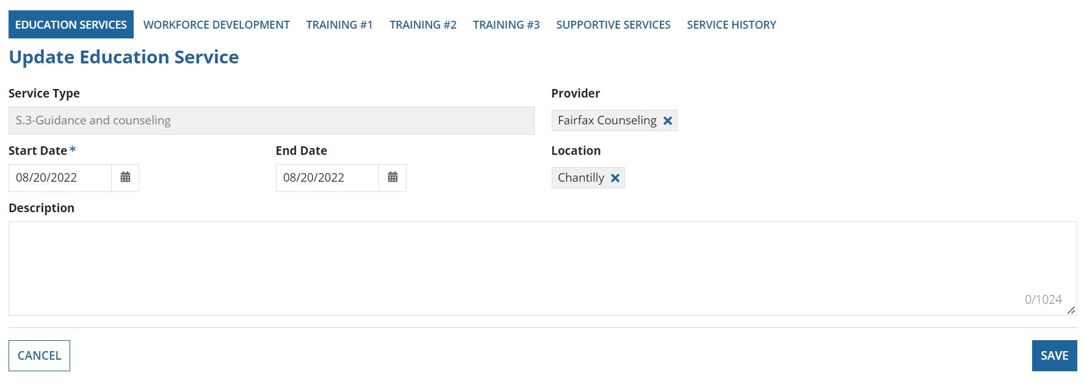
9. To delete an education service record, click on Delete Education Service icon. A confirmation dialog box, with YES/NO options opens.
- If you click on NO, then you will simply stay on the same page.
- If you click YES, then the service record is deleted and will not be shown in the grid anymore.

Workforce Development:
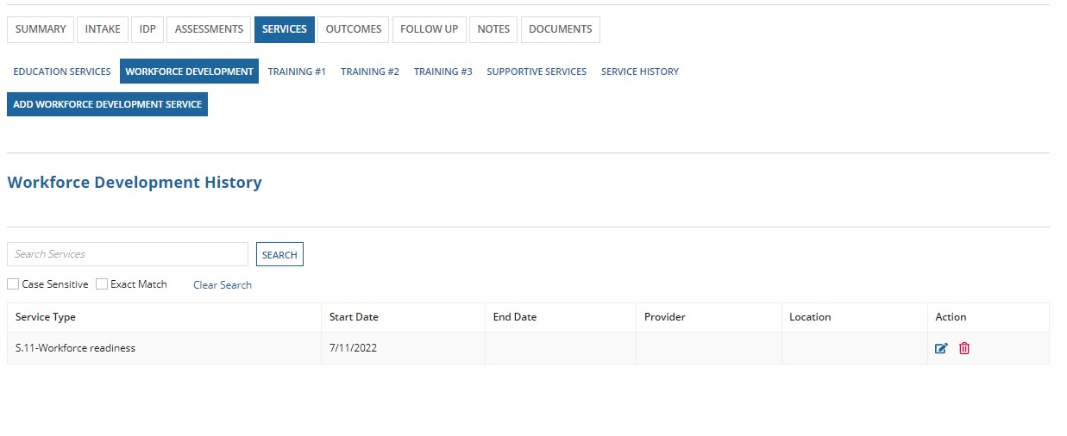
Workforce Development: (Youth)
To add a Workforce Development, click on the “ADD WORKFORCE DEVELOPMENT SERVICE” button, Select as Service type and a Start date and add the additional details. Service type contains items from S.8 to S.15.
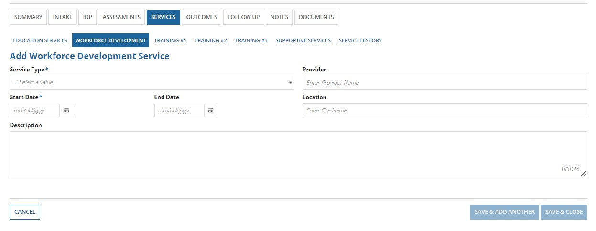

Workforce Development: (Adult)
The functionality and the fields of the Workforce Development Adult is same as youth page.
Follow the step-by-step instructions mentioned below to add/navigate Workforce Development tab in Services section of the REO application.

- Services can be provided for participants that have successfully completed the intake process and are in “Active” case status
- Open participant case that is in “Active” status or “Intake (4/6)” or “Intake (5/6)” or “Intake (6/6)” and click on
“Services” tab. Then click on “Workforce Development” tab. You will see a screen as shown below
  - On this screen, you can add a workforce development service by clicking on “Add Workforce Development Service”

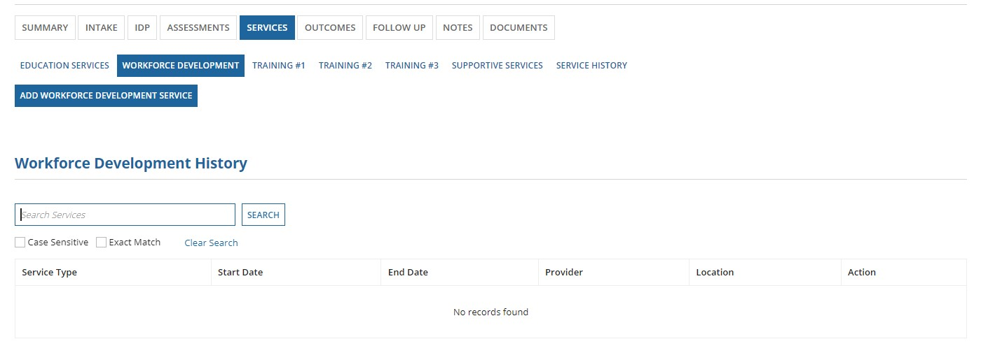
- Clicking on “Add Workforce Development Service” will open a screen as shown below
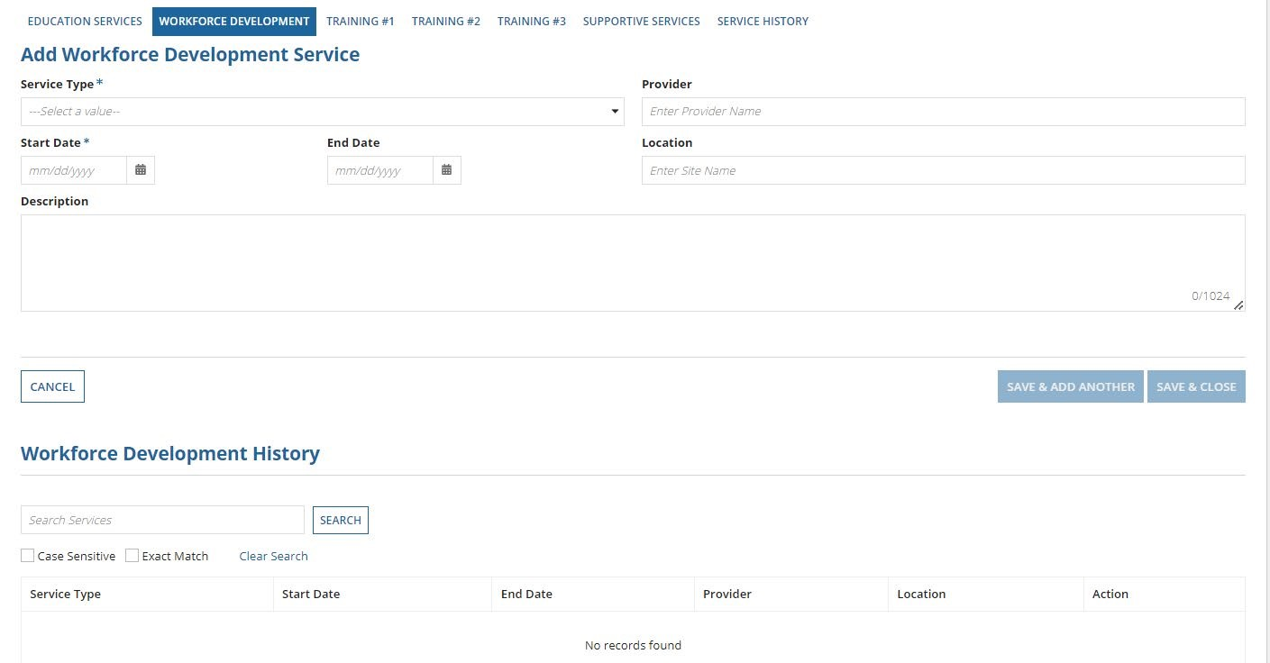 a. You can add the workforce development service using this screen. ‘Service Type’ and ‘Start Date’ are required fields in this form as denoted by an asterisk (“*”)
i. ‘Service Type’ is a dropdown field that will allow you to select the type from the options provided
  - Optional details such as end date, provider, location, a brief description of the service can also be added
  - A “Workforce Development History” grid is also displayed at the bottom of the page. This grid shows a list of all the workforce development services that were received by the participant

- Once all required information is filled for the service, the “Save & Add Another” and “Save & Close” buttons enable at the bottom right as shown below
  - Clicking on “Save & Add Another” will save the existing service record and will directly open another form to add a new workforce development service
  - Clicking on “Save & Close” will save the existing service record and take you back to the home screen for workforce development services tab where this service record will be shown under the workforce development history grid
  - Clicking on the “Cancel” button on the left will cancel the action of adding this service for the participant
  - The image below shows adding a ‘Leadership Development’ workforce development service for the participant 5. The home screen of the workforce development service tab now displays the ‘Leadership Development’ workforce development service record in the “Workforce Development History” table as shown below
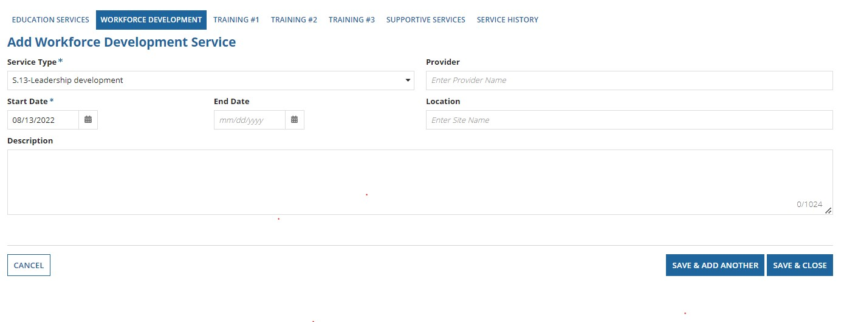
- The home screen of the workforce development service tab now displays the ‘Leadership Development’ workforce development service record in the “Workforce Development History” table as shown below
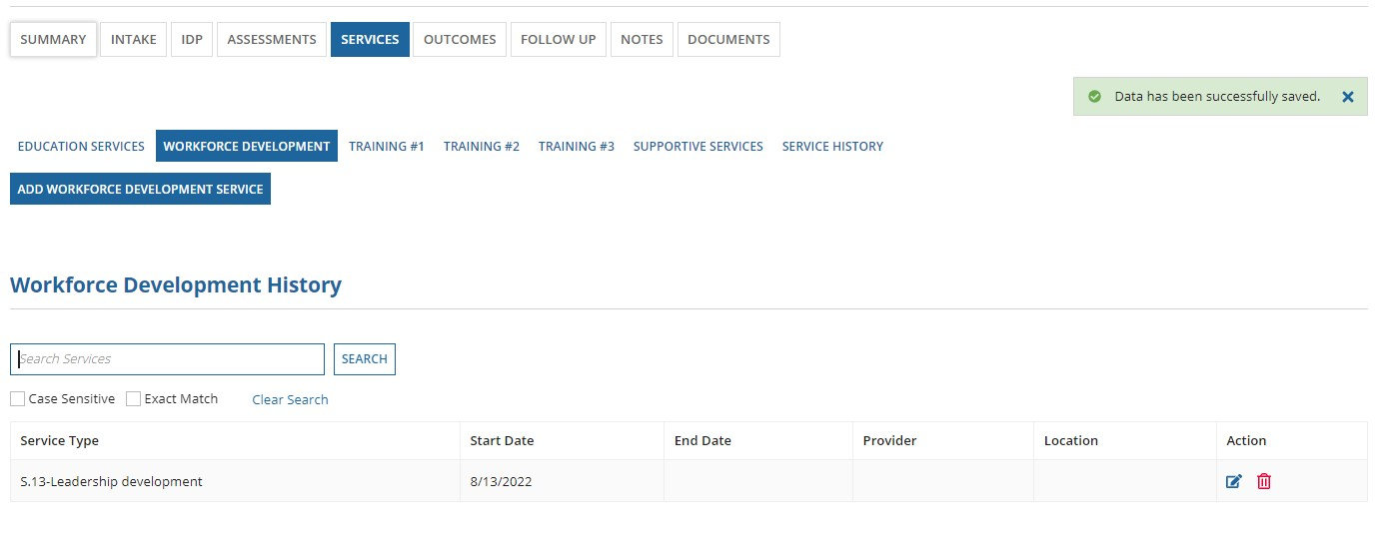
- In the “Workforce Development History Grid,” the service type and start date of the service will always be shown. If you add details such as end date, provider, and location, then those details will also be shown in the grid
- The action column of this grid has both “edit” and “delete” icons to edit/delete the service record as needed
- A search functionality is also available to use to filter searches for “Workforce Development History” table. Instead of seeing all the records, you can use search functionality to search for information available in the table i. While searching, you can turn on/off for the search to be ‘case sensitive,’ or ‘exact match’ ii. Case sensitive searches will show results even for partial matches. Exact match searches will only give results that exactly match your search
iii. A ‘clear’ link is also available for you to clear the search data

6. To edit a workforce development service record, click on Update Workforce Development icon. New screen opens to display all the details of the record when it was created.
a. You are not allowed to change the service type, but you change the Start Date of the service, end date of the service, provider, location, and description of the service.
Once you are done with updating, click on SAVE button. You can see the updated data in the grid.
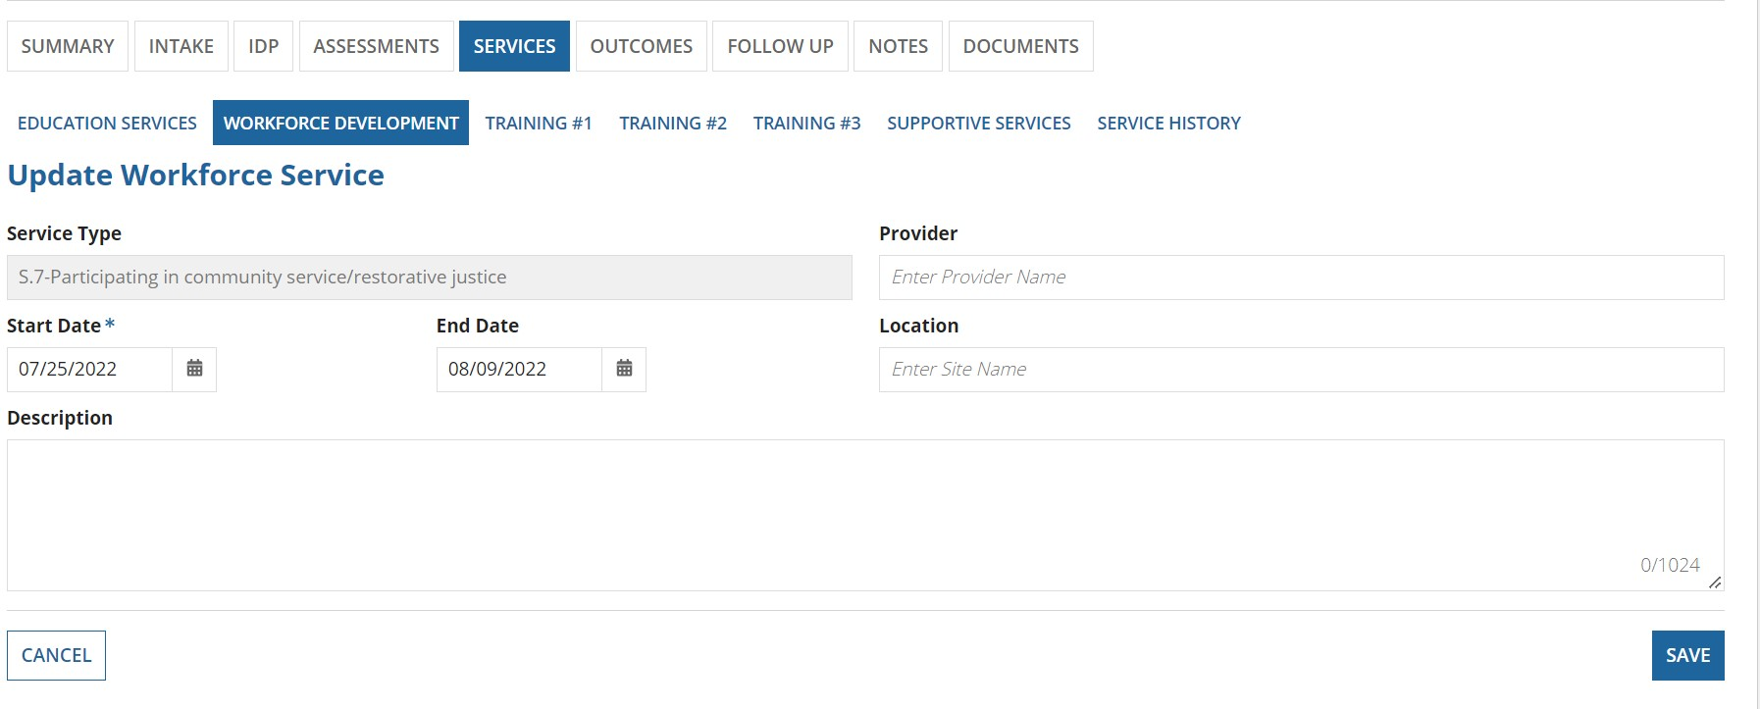
7. To delete a workforce development service record, click on Delete Education Service icon. A confirmation dialog box, with YES/NO options opens.
- If you click on NO, then you will simply stay on the same page.
- If you click YES, then the service record is deleted and will not be shown in the grid anymore.
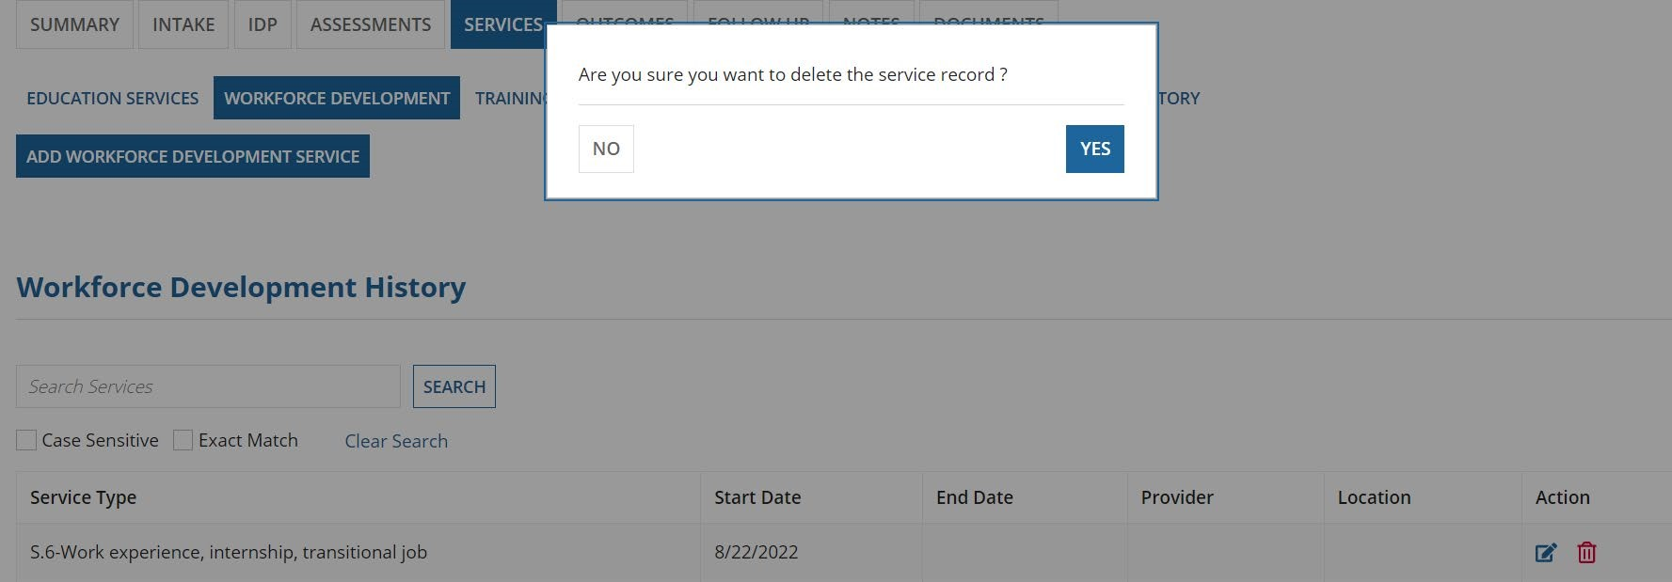
Training Services
There are three training services where the user can enter data. Training#1, Training #2, and Training#3.
The case manager or the user can enter data related to different training services received by the participant and can SAVE or UPDATE the data.
Training#1 (both adult and youth)
If S.16 is selected as “yes”, S.16a will appear below it and will be a required field. If S.17 is selected as a “yes” than S.18 will become a required field.
Note: The screenshots used for Training # 1, 2, 3 are for youth grant. The questions for adult grant will be numbered slightly different but the same behaviour will occur as described for youth grant.

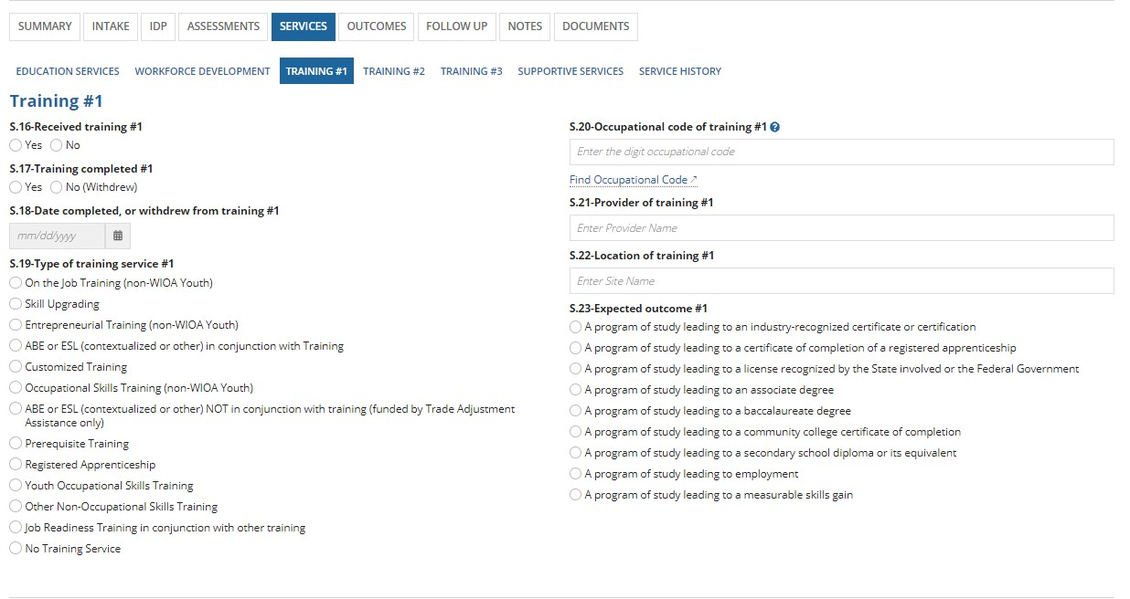

If the user selects that training was not received in S.14, then all the questions on the screen become disable as shown below:
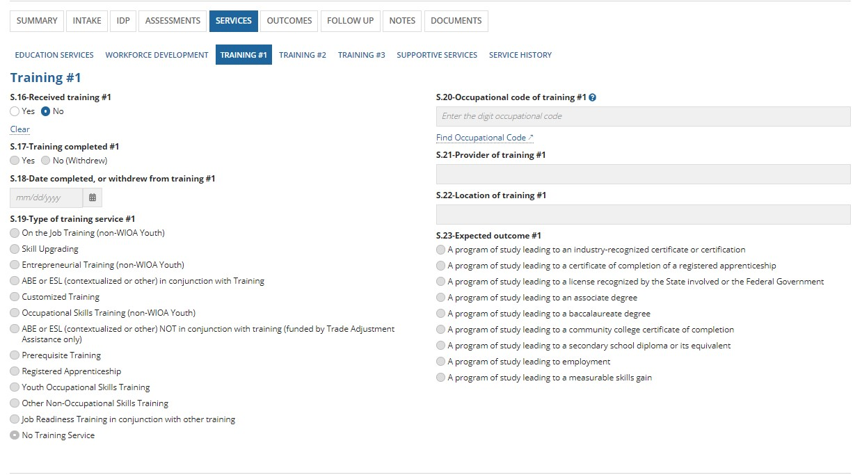

Training#2 (both adult and youth)
If S.24 is selected as “Yes” than S.24a becomes required. If S.25 is selected as “Yes”, S.26 becomes required.

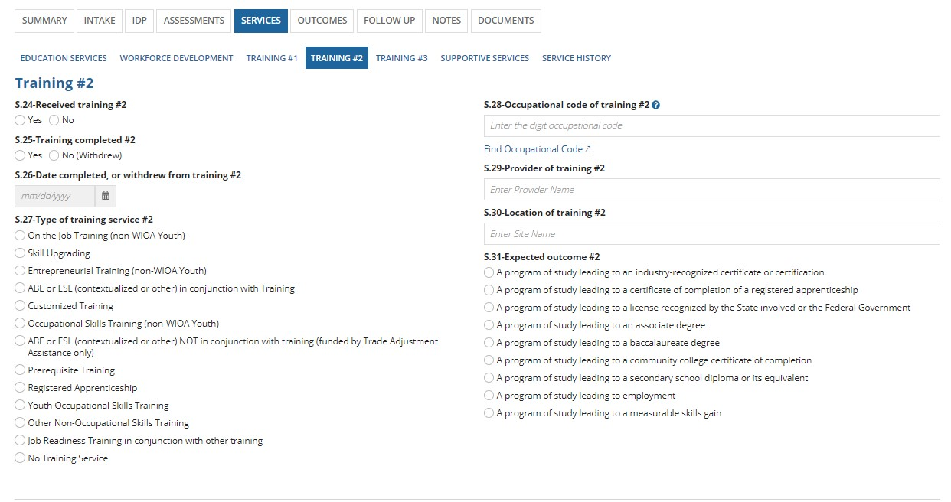
If S.24 is selected as “No”, than all the other questions becomes disabled as shown below.
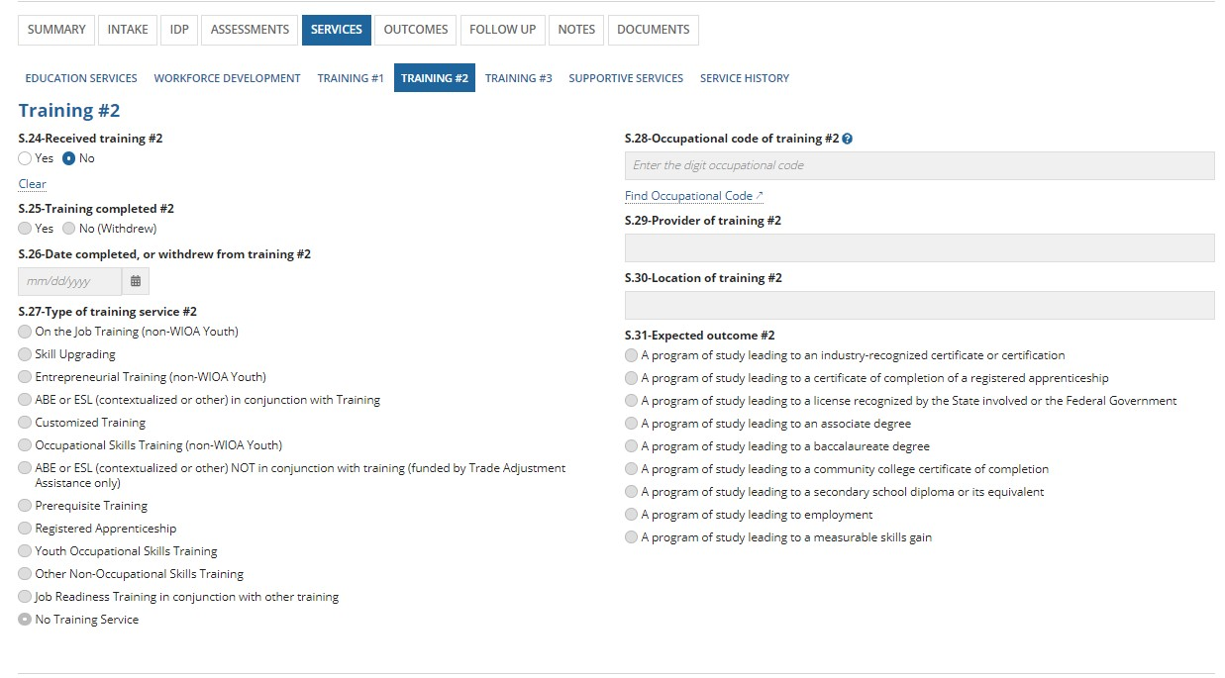
Training#3 (both adult and youth)
If S.32 is selected as “Yes” than S.32a becomes required. If S.33 is selected as “Yes” than S.34 becomes required.
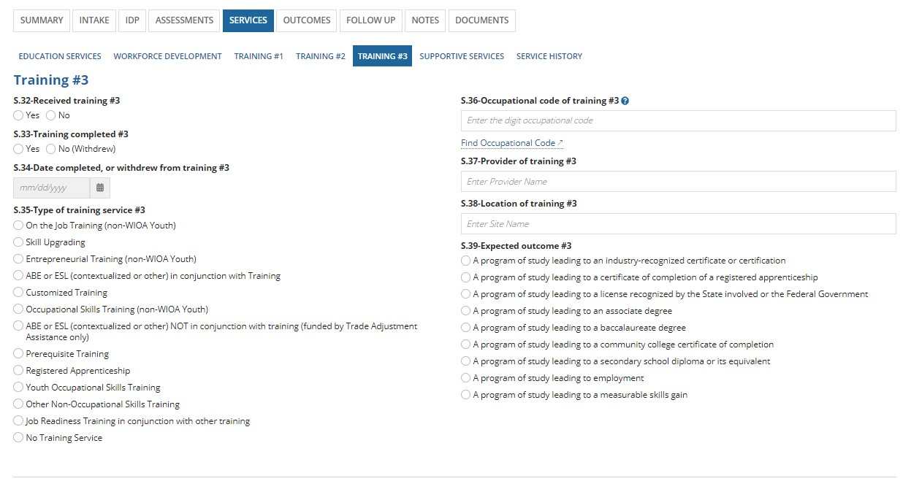
If the user selects that training was not received in S.30, then all the questions on the screen become disable as shown below:
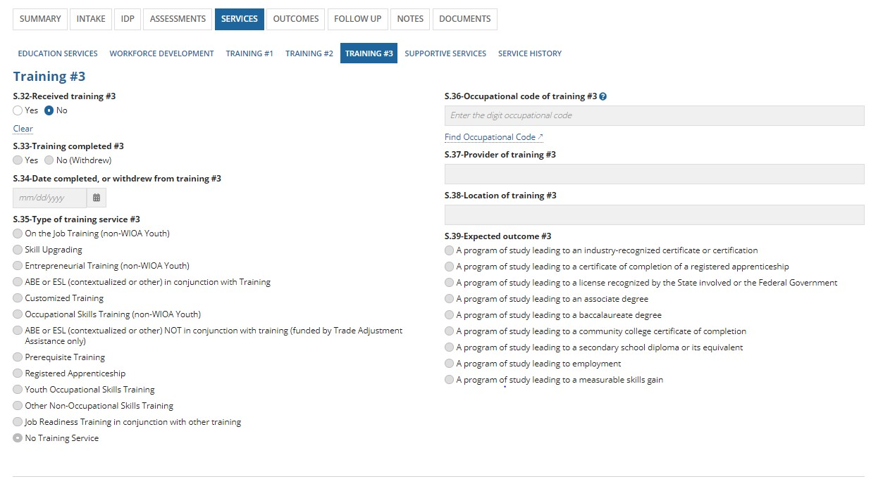

Supportive Services:
Supportive Services: (Youth)

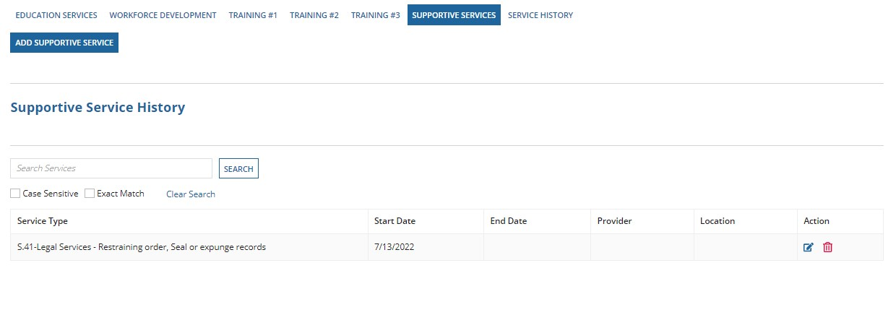
All the supportive services related information can be entered here. When user clicks on Supportive services, it will show “Add Supportive Service” button and supportive service history grid. All the supportive services we add will be shown in this grid. To add a supportive service, user must click on “Add Supportive Service” button. Once clicking on this button user will see “Service Date”, “Type” (Type of supportive service), “End Date”, “Description”, “Provider” and “Location”. The required fields here are “Service Date”, “Type” and “End Date”.
When the user selects type as “Received Legal Services” list of options
Outstanding warrants Child Support
Restraining order
Seal or expunger records
Other legal services. From these options user can select one or more applied options.
For the type “Received Housing Assistance, Substance Abuse Treatment or Mental Health Treatment” we have options like:
Non-emergency housing assistance
Non-emergency substance abuse treatment
Non-emergency mental health treatment
Emergency housing assistance Emergency substance abuse treatment Emergency mental health treatment.
User can select one or more applied options from the list.
For Family and Other Care Assistance type we have options like
Child Care
Family Care
Other Caregiver Assistance No.
User can select one or more applied options from the list.

Note1: while entering the service Date user must select a date which is same date or later date of program entry, or the case creation date and user cannot enter a future date.
Once the user enters all the details and clicking on “Save & CLOSE” will save the required service. All the saved or submitted services are shown in the supportive service history grid.

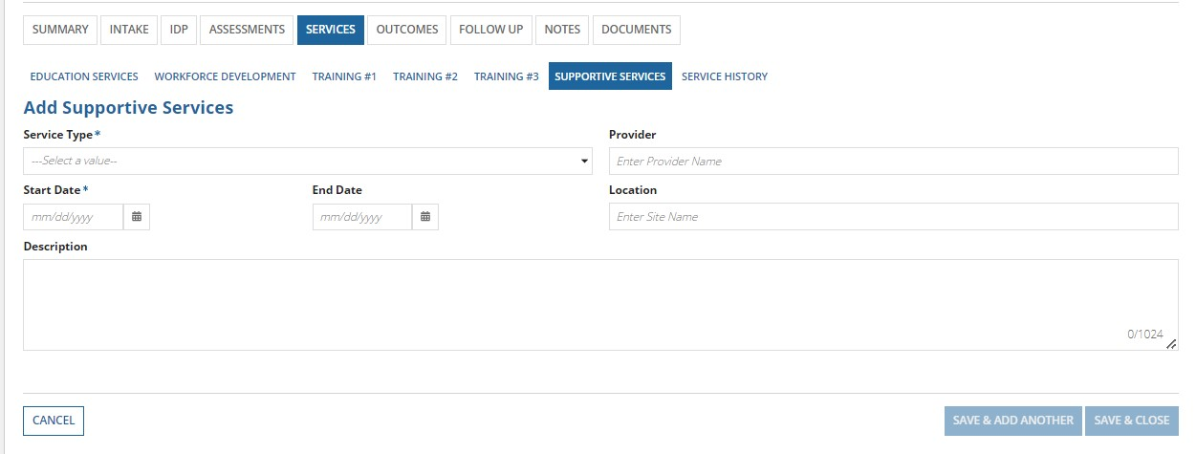

Supportive Services: (adult)
The functionality and the options of supportive services for adult & youth are the same.
Follow the step-by-step instructions mentioned below to add/navigate Supportive Services tab in Services section of the REO application.

- Services can be provided for participants that have successfully completed the intake process and are in “Active” case status
- Open participant case that is in “Active” status or “Intake (4/6)” or “Intake (5/6)” or “Intake (6/6)” and click on
“Services” tab. Then click on “Supportive Services” tab. You will see a screen as shown below
a. On this screen, you can add a supportive service by clicking on “Add Supportive Service”

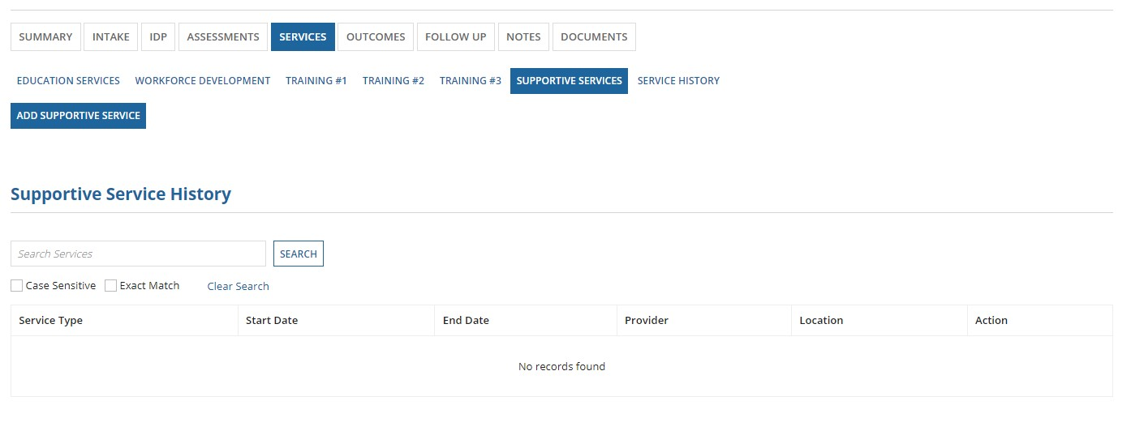
- Clicking on “Add Supportive Service” will open a new screen as shown below:
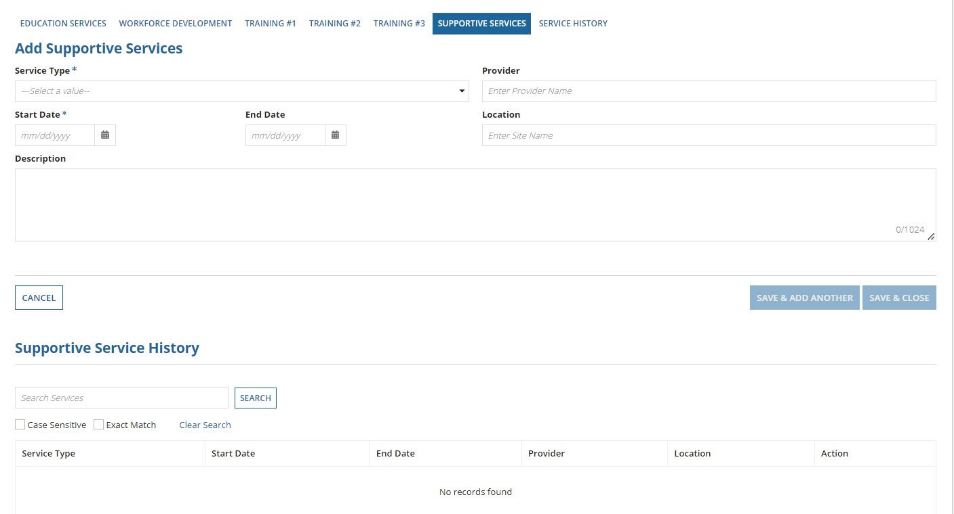 a. You can add the supportive service using this screen. ‘Service Type’ and ‘Start Date’ are required fields in this form as denoted by an asterisk (“*”) i. ‘Service Type’ is a dropdown field that will allow you to select the type from the options provided
- Optional details such as end date, provider, location, a brief description of the service can also be added
- A “Supportive Service History” grid is also displayed at the bottom of the page. This grid shows a list of all the supportive services that were received by the participant

- Once all required information is filled for the service, the “Save & Add Another” and “Save & Close” buttons enable at the bottom right as shown below
  - Clicking on “Save & Add Another” will save the existing service record and will directly open another form to add a new supportive service
  - Clicking on “Save & Close” will save the existing service record and take you back to the home screen for supportive services tab where this service record will be shown under the supportive service history grid
  - Clicking on the “Cancel” button on the left will cancel the action of adding this service for the participant
  - The image below shows adding a ‘Health Services’ supportive service for the participant

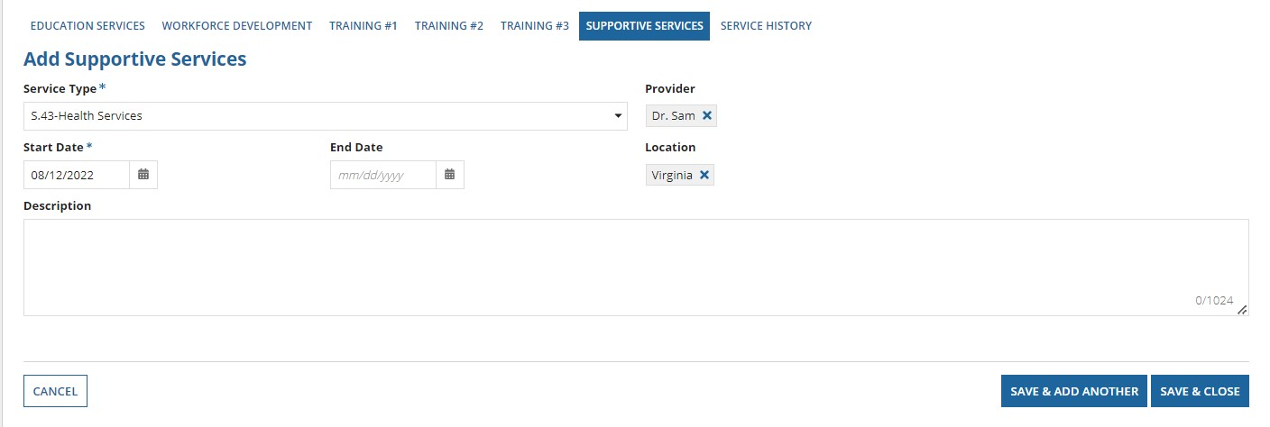
- The home screen of the supportive service tab now displays the ‘Health Services’ supportive service record in the “Supportive Service History” as shown below a. In the “Supportive Service History” grid, the service type and start date of the service will always be shown. If you add details such as end date, provider, and location, then those details will also be shown in the grid.
- The action column of this grid has both “edit” and “delete” icons to edit/delete the service record as needed
- A search functionality is also available to use to filter searches for “Supportive Service History” table. Instead of seeing all the records, you can use search functionality to search for information available in the table i. While searching, you can turn on/off for the search to be ‘case sensitive,’ or ‘exact match’ ii. Case sensitive searches will show results even for partial matches. Exact match searches will only give results that exactly match your search
iii. A ‘clear’ link is also available for you to clear the search data
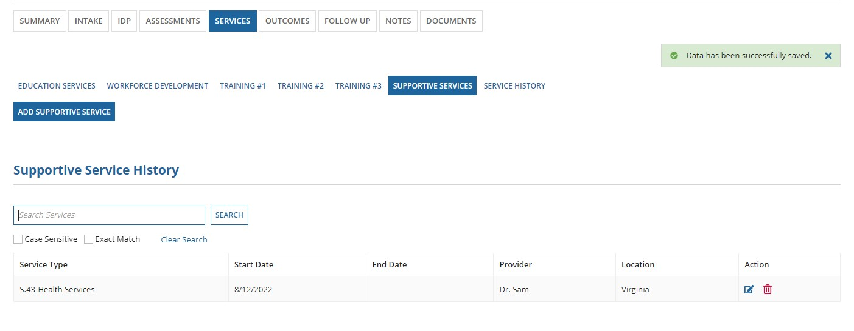

6. To edit a supportive service record, click on Update Supportive Service icon. New screen opens to display all the details of the record when it was created.
a. You are not allowed to change the service type, but you change the Start Date of the service, end date of the service, provider, location, and description of the service.
Once you are done with updating, click on SAVE button. You can see the updated data in the grid.
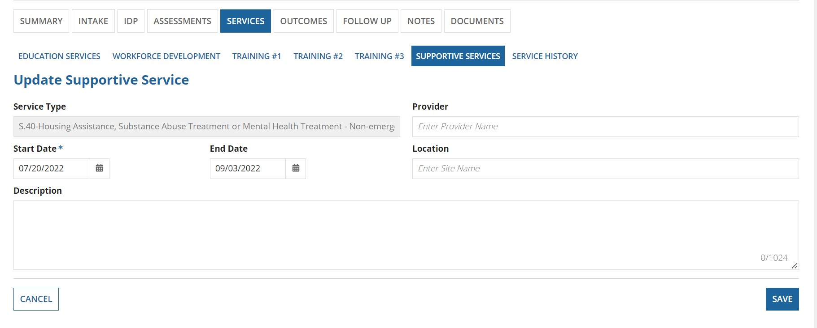
7. To delete a workforce development service record, click on Delete Education Service icon. A confirmation dialog box, with YES/NO options opens.
- If you click on NO, then you will simply stay on the same page.
- If you click YES, then the service record is deleted and will not be shown in the grid anymore.
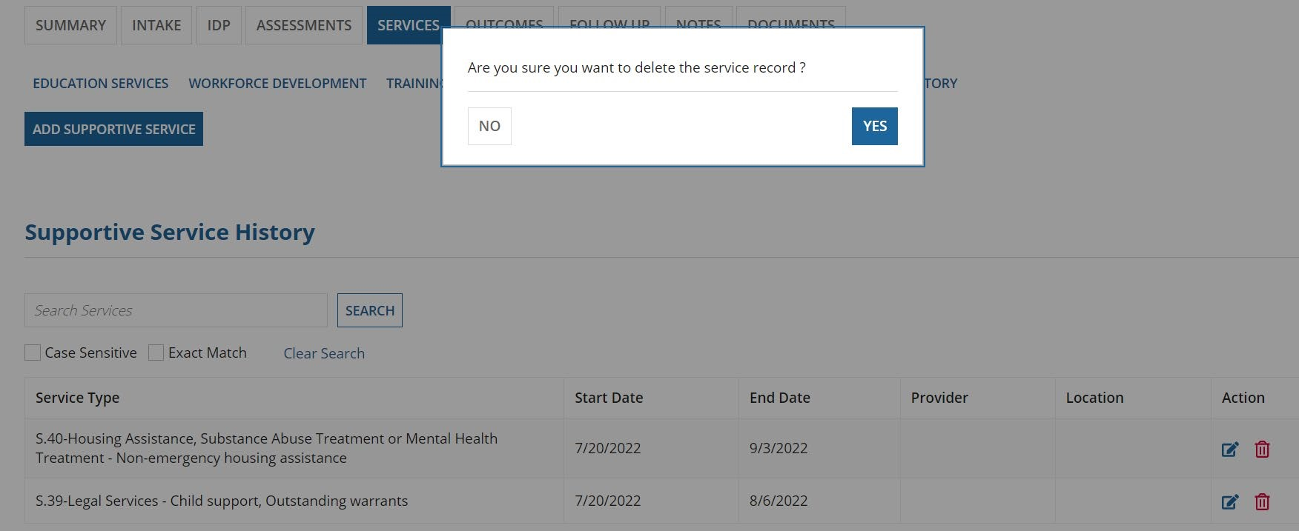

Service History:
All the services we added in Education Services, Workforce Development and Supportive Services are shown in the service history grid. This “Service History” grid will show all the services with Service Date, End Date, Provider and Location. User can select any service, by clicking on that service user will see the service history details (service name, service date, end date, provider, location/site, description) with all the information added for that service.
Note: Youth participant related services will be shown under youth service history grid and adult participant services under adult service history grid.

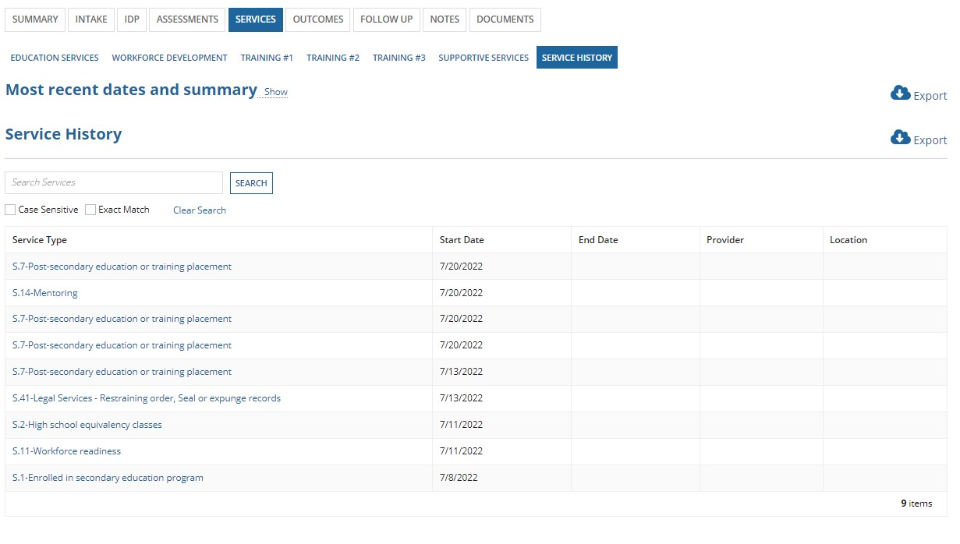
Follow the step-by-step instructions mentioned below to add/navigate Service History tab in Services section of the REO application.

- Services can be provided for participants that have successfully completed the intake process and are in “Active” case status
- Open participant case that is in “Active” status or “Intake (4/6)” or “Intake (5/6)” or “Intake (6/6)” and click on
“Services” tab. Then click on “Service History” tab. You will see a screen as shown below
  - The Service History tab is designed to serve as a repository of all the different types of services offered to the participant
  - There are two main sections on this page: “Most Recent Dates and Summary” and “Service History”
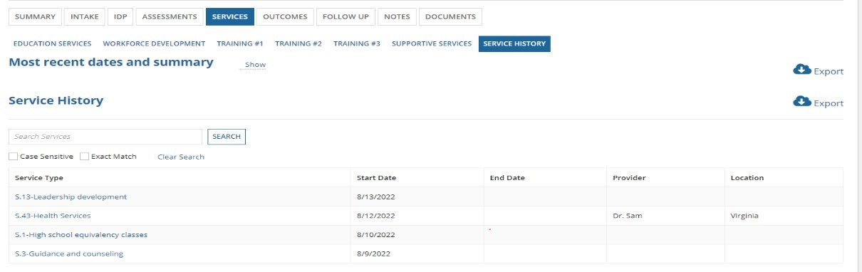
- Clicking on ‘show’ (in the above image) will expand the details of the most recent dates and summary section as shown in the image below. Clicking on ‘hide’ will minimize this section a. The ‘Most Recent Dates and Summary’ section will only show information related to date of service used from list of available workforce development and education services
- The ‘Service History’ section has a table of all the services used by the participant and the information related to those services.
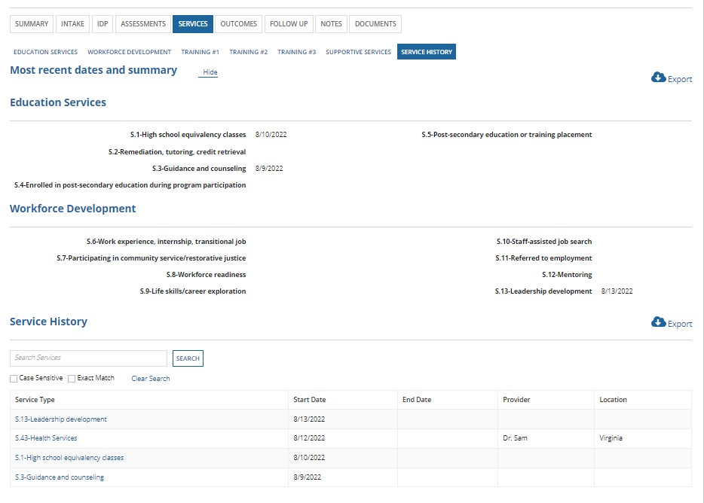

- A search functionality is shown for service history section to use. Instead of seeing all the service history records, you can use search functionality to search for types of service
i. While searching, you can turn on/off for the search to be ‘case sensitive,’ or ‘exact match’ ii. Case sensitive searches will show results even if you partially provide service type name. Exact match searches will only give results if you type the exact name of the service type in your search iii. A ‘clear’ link is also available for you to clear the search data

- There is also an export functionality on this page to download both most recent dates and summary and service history sections individually.
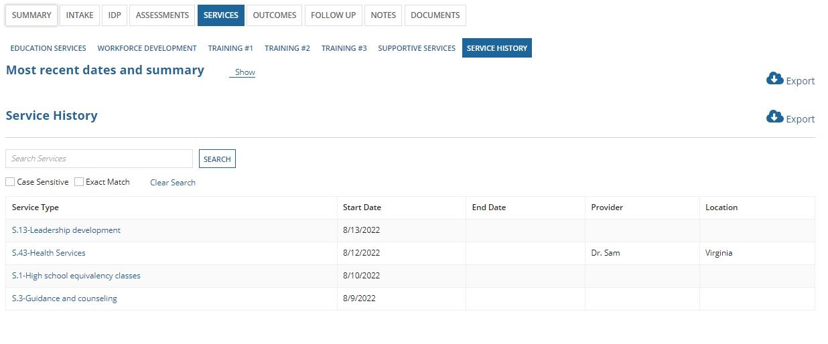
- Clicking on the export button (for service history section, for example) will provide ‘download’ & ‘clear’ links as shown below
- Clicking on ‘download’ link will download the service history table in an excel file onto the computer you are using
- Clicking on ‘clear’ will take you back to the home page of service history tab
- The same export functionality is implemented for most recent dates and summary section
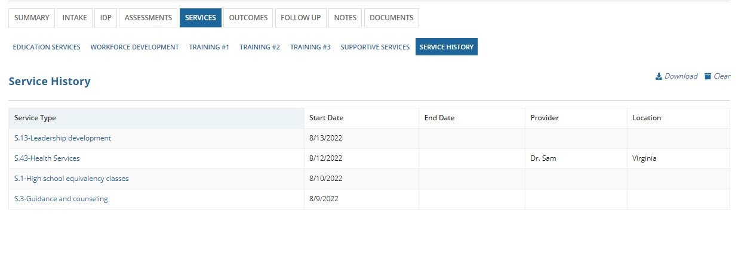

OUTCOMES
Outcomes section is used for managing the outcomes/benefits gained by the participants. The user can access the outcomes section tab to enter or update information related to:
- Employment
- Education
- Credentials
- Recidivism
- Measurable Skills Gain
- Exit
Each of these sections have a few required fields that the user must fill in before proceeding. Any date fields that are given in the outcomes section cannot be a future date.

Employment
In the Employment tab, the user can add employment or add apprenticeship outcomes via “Add Employment” and “Add Apprenticeship” buttons. Any records added for employment or apprenticeship outcomes will be shown in respective grids.
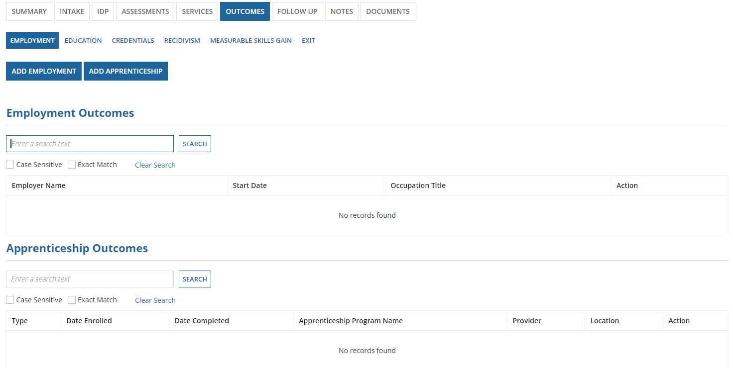
List of added education and apprenticeshop outcomes will be shown in “Education Outcomes” or “Apprenticeship Outcomes” Grid.

Add Employment
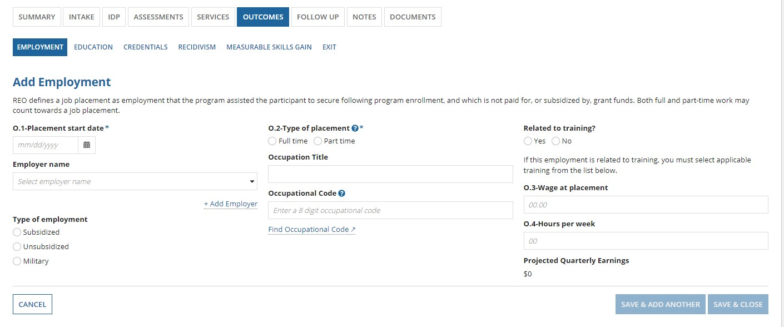
If an employer name is not available in the dropdown, the user can manually add employer by clicking on “Add
Employer”

Add Apprenticeship
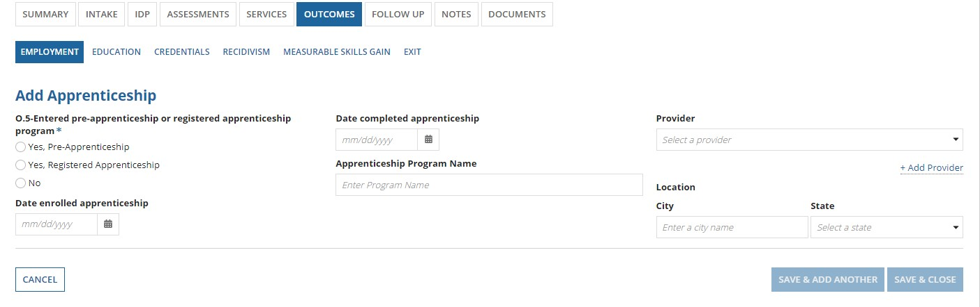

Education
In the Education tab, the user can add an education outcome record.
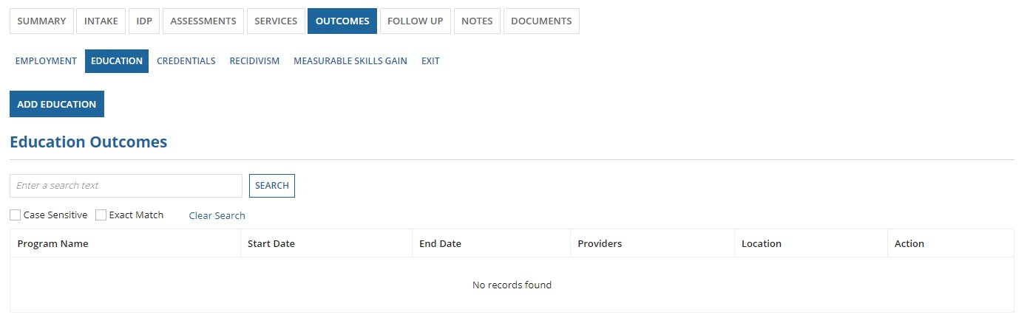
List of added education outcomes will be shown in “Education Outcomes” Grid. Add Education
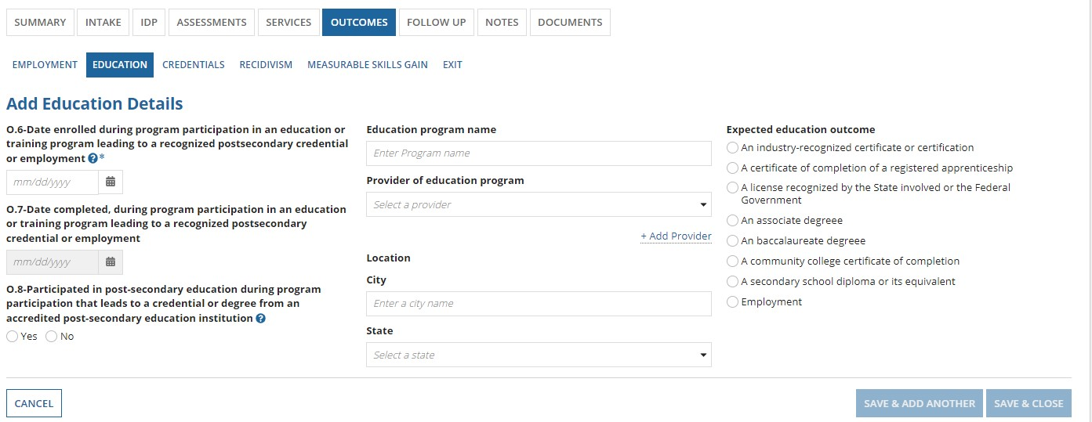
If provider of education program is not available in the dropdown, the user can manually add a provider by clicking on “Add Provider”

Credentials
In the Credential tab, the user can add outcome record related to credentials.
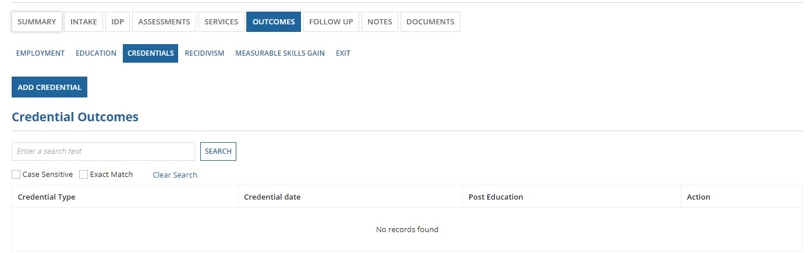
List of added credentials will be shown in “Credential Outcomes” Grid. Add Credential
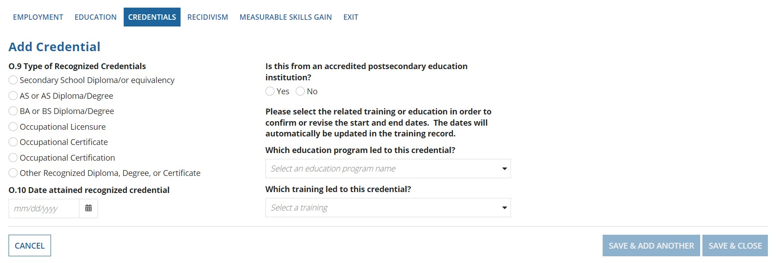
If the user adds any education programs in “Add Education” page, then those values will be available for the user to select for “Which education program led to this credential” dropdown. Similarly, if the user adds any training records under trainings tab in services section, then those values will be available for the user to select for “Which training led to this credential” dropdown.
If a particular education program or training is led to a credential and user selects that particular education program or training, then additional fields such as O.6 and O.7 will be displayed on the screen. O.6 is a required field and will be autopopulated from the previously entered information. The user can manually edit this information, if needed.
The user can only link a credential to either an education program or training.
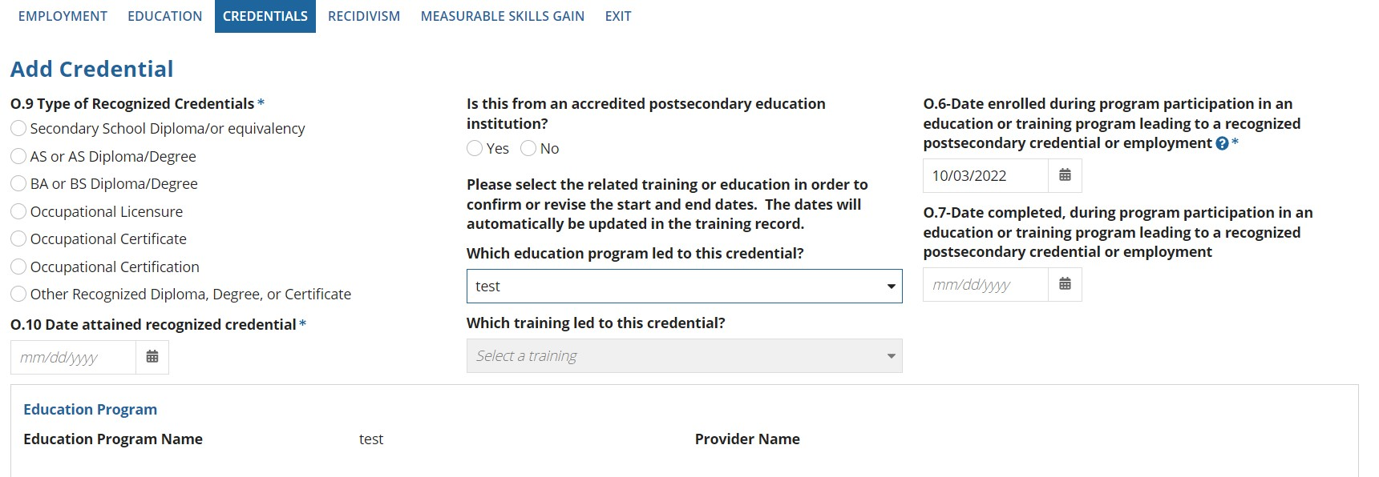

Recidivism

The Recidivism section has no required fields, but user should enter all the following information as applicable.
The date fields in this section (O.12 and O.17) cannot be a future date.
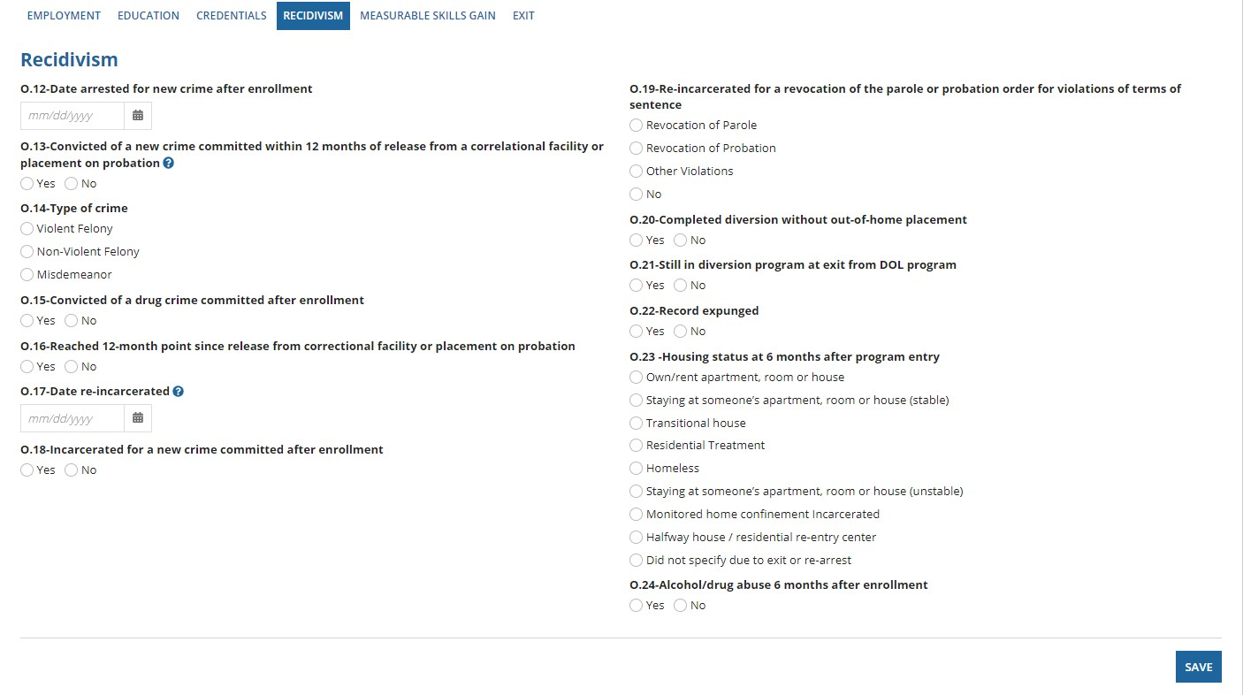

Measurable Skills Gain
the user can add a measurable skills gain record by clicking on “Add Measurable Skills Gain”

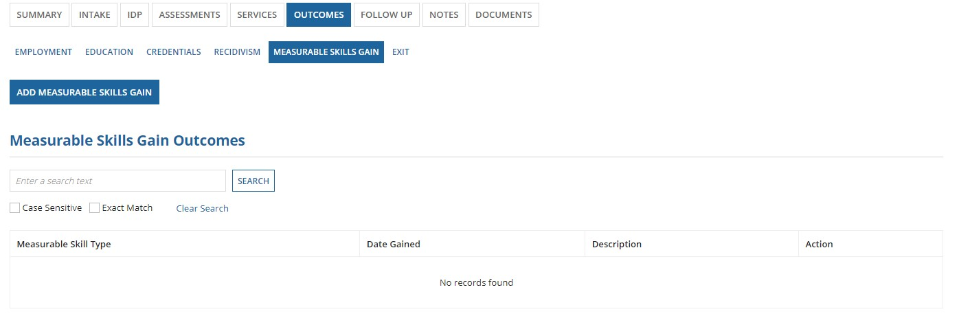
List of added measurable skills gain outcomes will be shown in “Measurable Skills Gain Outcomes” Grid.

Add Measurable Skills Gain
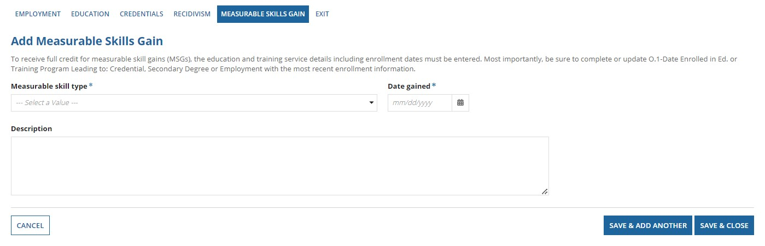

Exit
The exit tab allows the user to log information regarding manual exit or reactivation of the participant.
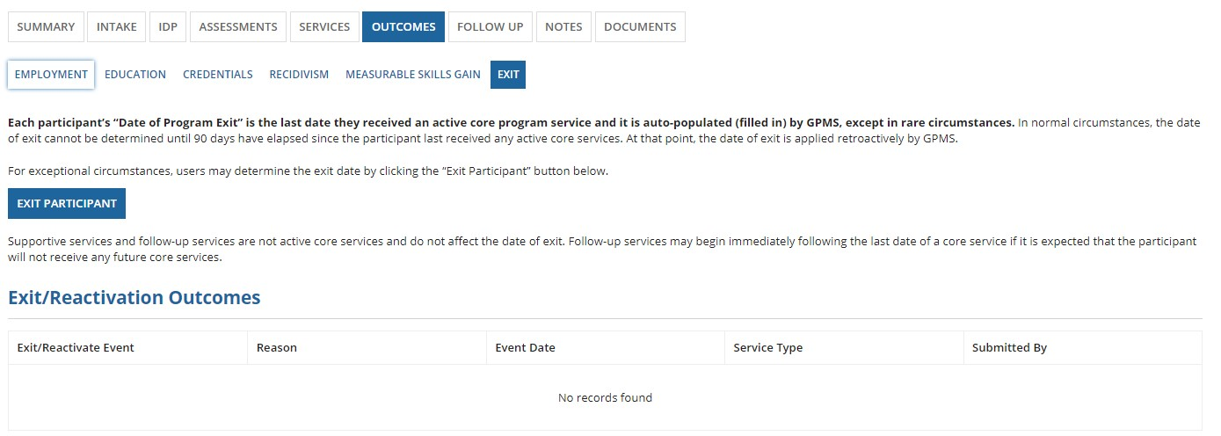
Any history of exits and reactivation will be shown in “Exit/Reactivation Outcomes” Grid.

Exit Participant
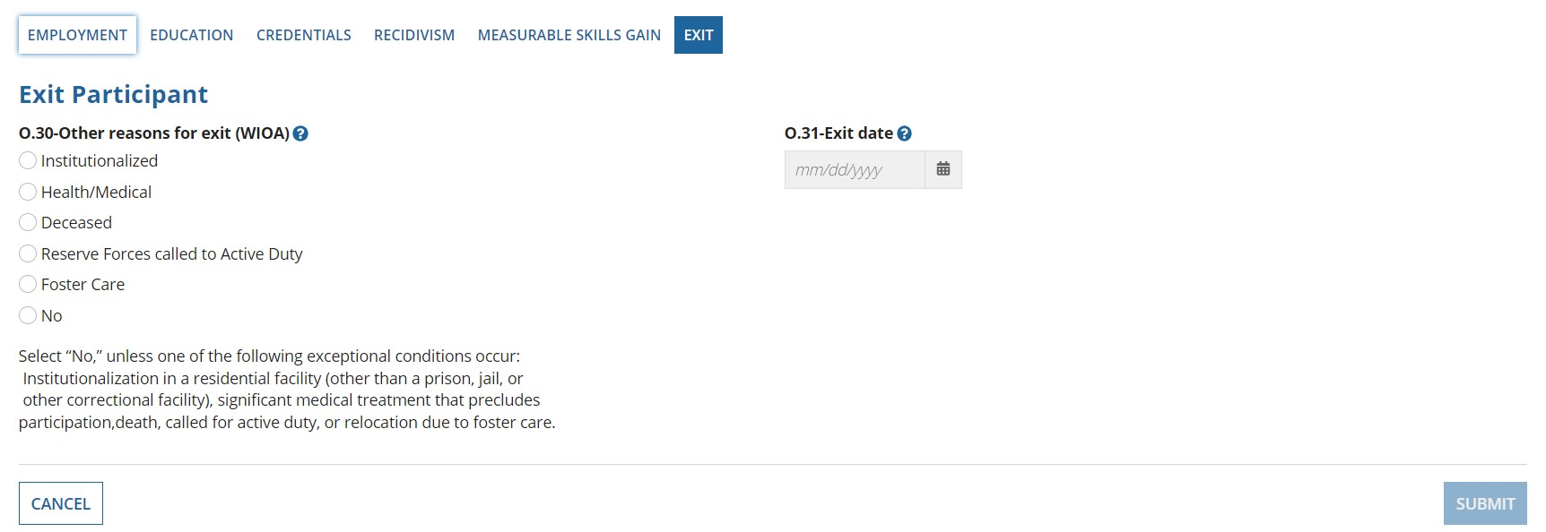
Once the user selects a value for O.30 (Other reasons for exit), O.31 is enabled and the user can enter the exit date.

FOLLOW-UP
The follow-up section records the status of participants who have exited the program. This section has two sub-tabs: Quarterly and Follow-up services.
Quarterly tab has information separated by quarter such as Q1, Q2, Q3, and Q4 as shown below. The same set of information and validations are presented in each quarter.
(Adult & Youth-grant Validations): Validations that are implemented on this page are explained below in the context of Quarter1. However, the same exact validation rules apply for all 4 quarters and for both adult and youth grants.
If user selects any option for O.33, then O.33a becomes a required field. If the user selects any of the options below for O.33:
“Yes,” or
“Yes, registered apprenticeship,” or
“Yes, Military,” then O.33a will have the options below:
UI wage Data
Federal Employment Records (OPM, USPS)
Military Employment Records (DOD)
Non-UI Verification
If the user selects “No” for O.33, then O.33a will have “Not employed” as the option
If the user selects “Information Not yet Available” for O.33, then O.33a will have “Information not yet available” as the option
When exit date is present in outcomes screen and O.33 is selected as
“Yes,” or

“Yes, registered apprenticeship,” or “Yes, Military,”
Then O.33c must be >0 AND (NOT=999999.99 or 9999999.99)
When exit date is present in outcomes screen and O.33 is selected as “No,” Then O.33c must be = 0
When exit date is present in outcomes screen and O.33 is selected as “Information Not yet Available,” Then O.33c will be 999999.99 or 9999999.99

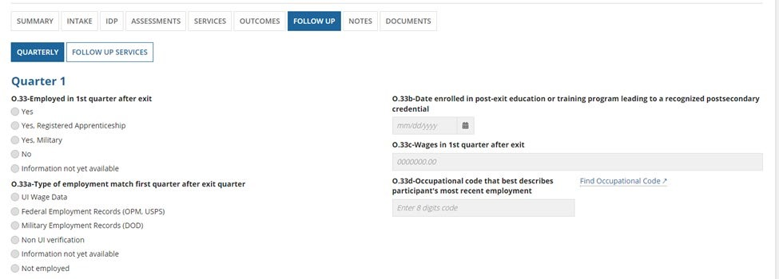
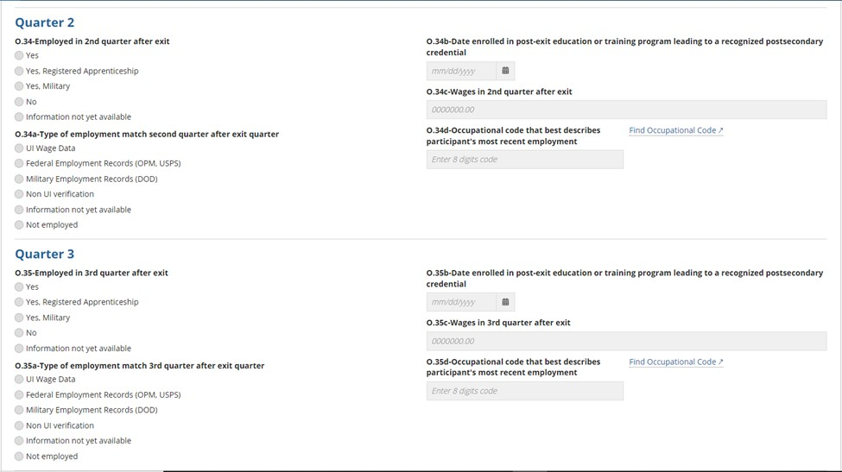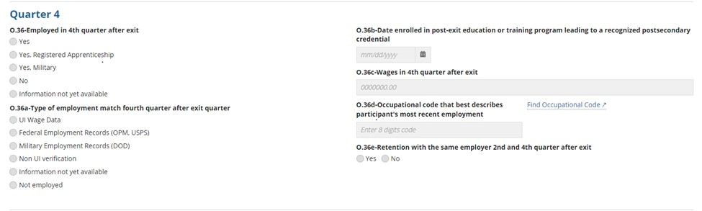
Youth-grant Validations: Below are list of validations that apply only for youth grants
If the options selected for “School status at program entry (from intake – employment education) is either:

In-school, postsecondary school or
Not attending school; secondary school graduate or has a recognized equivalent
then the Options for “In an education or training program in the second quarter after exit, and O.32c-In an education or training program in the fourth quarter after exit,” are:
Occupational Skills Training
Postsecondary Education No Placement
If the options selected for “School Status at Program Entry (from Intake – Employment Education) is either: In-school, secondary school or less

In-school, Alternative School
Not attending school or Secondary School Dropout
Not attending school; within age of compulsory school attendance
then the Options for “In an education or training program in the second quarter after exit, and O.32c-In an education or training program in the fourth quarter after exit,” are:
Occupational Skills Training
Postsecondary Education
Secondary Education
No Placement

Follow Up Services
Follow up services can be added to each particiupant by clicking on “Add Follow Up Service”

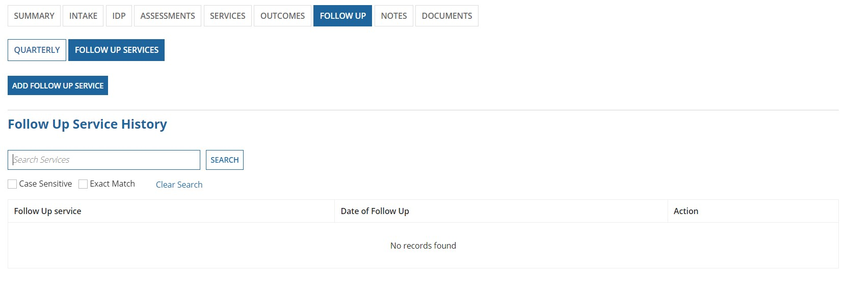

Add Follow Up Service

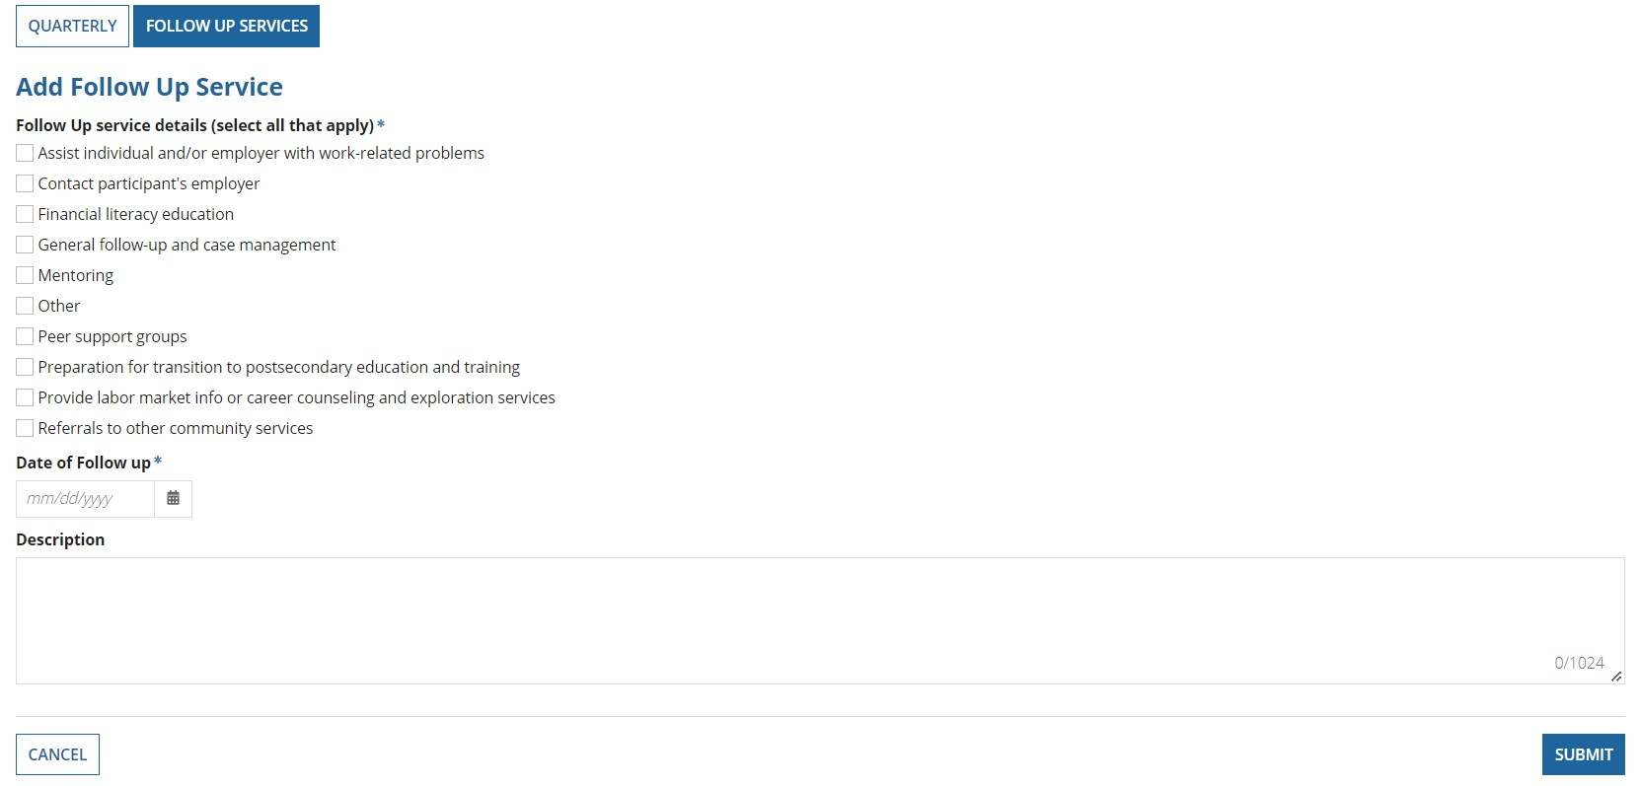
Follow up service detail and Date of follow up are both required fields.

Any follow up services that are added to the participant are shown in the “Follow Up Service History” table.
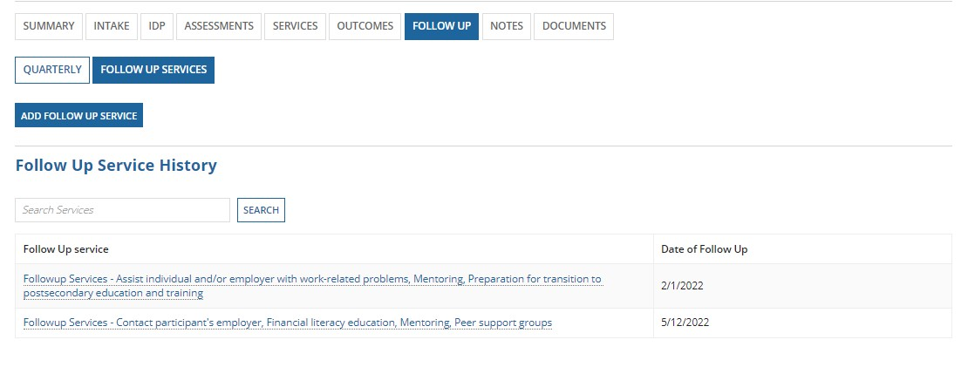
Note: Follow-up section functionality is the same for both adult and youth.

NOTES
External users can add or update notes to any active case. The Notes record displays User, Date and time of the update or creation of the notes, Category and Comments entered.
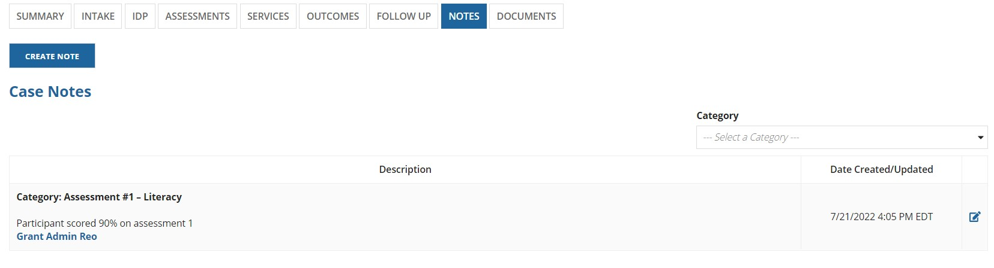
Create Note
Click “CREATE NOTE”, choose a category and enter the note and press “SAVE” button.
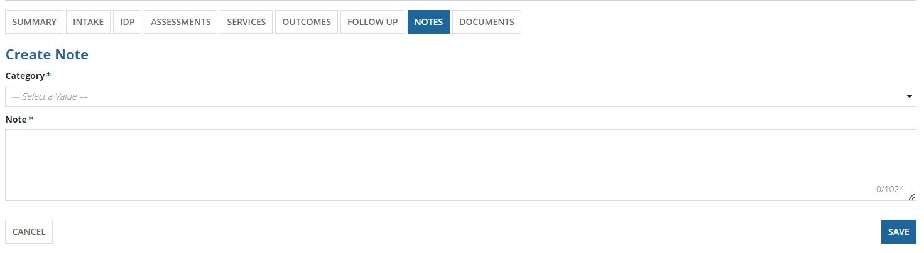
Editing an existing Note
For any existing note, the user can click on the edit icon (shown below) to make any changes. After making the necessary changes, the user can click update.
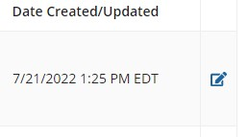

DOCUMENTS
The document section has a list of all the documents associated with the case. Below is the page that user sees when clicking on “Documents” tab.
On this page, the user can search for a specific document using the search function. The user can also upload a document by clicking on “upload document”
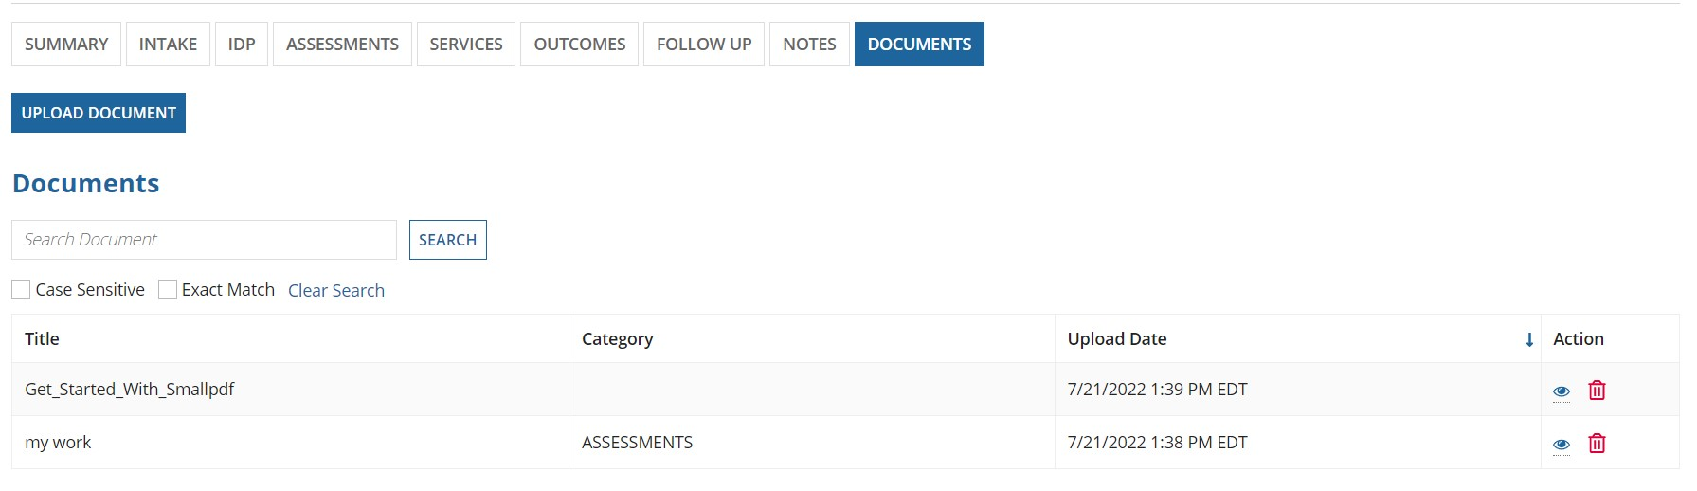
When the user clicks on “Upload Document” button, the below screen is shown:
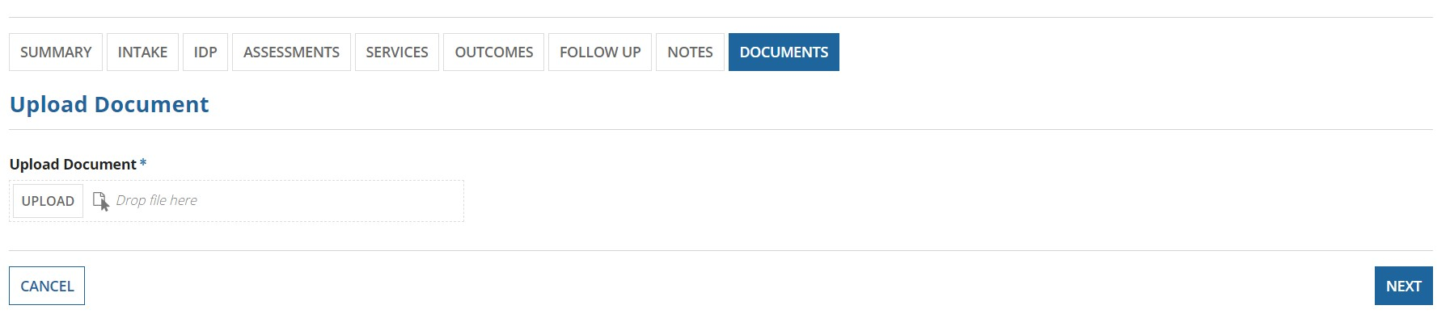
The User can only upload PDF and Docx file documents. If the user uploads any other file other than these documents, they will get an error.
After uploading a file, the user will click NEXT to proceed. When user clicks on NEXT, the page will be as shown below. In this page, the user enters details such as Title, Category and Description.
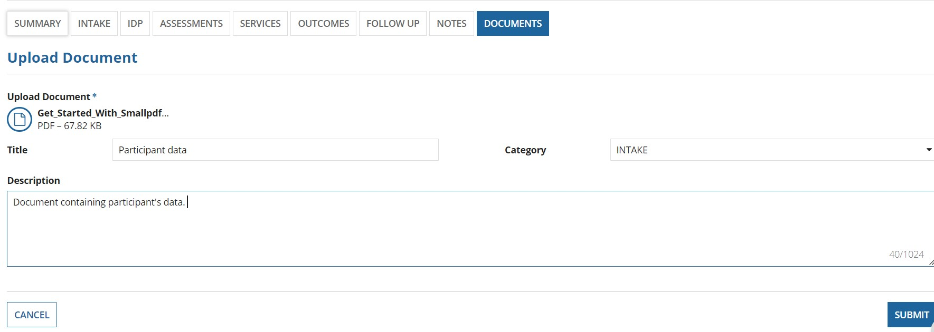
The user can enter a title, category, and description and submit to successfully upload the document.

