Youth Individual Service Strategy Webcast
6/25/2019
Slide # | Slide | Scripts
1 | Intro Slide | - The Employment and Training Administration (ETA) regularly surveys the field for training and technical assistance needs.  - One topic frequently discussed (through technical assistance requests, direct requests, and on webinars), is the need for more technical assistance on the Individual Service Strategy or an ISS.  - This webcast will review a sample ISS template developed by ETA from 39 ISS submissions from across the country.  - This template compiles key elements, common themes, and best practices and is not required but may be used and customized for WIOA Youth program case management.
2 | What is an ISS? | - WIOA section 129(c)((1)(B) requires that all eligible youth have an ISS that is directly linked to 1 or more WIOA indicators of performance as well as identifies career pathways that include education and employment goals, appropriate achievement objectives, and appropriate services for the participant.
3 | Components of an ISS | - WIOA outlines a vision for supporting youth and young adults through an integrated service delivery system.  - WIOA Youth funds must be used to deliver comprehensive youth services. Effective case management ensures youth receive relevant services and that programs document outcomes.  - While there is no one example of the perfect Individual Service Strategy (ISS), strong examples include the following components:
4 | Goals in an ISS | - The ISS is planned in conjunction with a young person and adopts a customized approach that addresses the unique strengths, challenges and needs of each participant.  - An ISS addresses key goal areas in education, training, employment and personal development; includes short and long-term goals; addresses potential barriers; shares objectives and action steps and includes timelines with start, end and review dates.  - Because it is youth driven and every young person who enters our doors is unique, no ISS should have the exact same outline for multiple participants.
5 | 14 Program Elements | - Youth are required to have access to all fourteen WIOA Youth program elements.  - The 14 program elements provide participants with academic, vocational & social support to help with advancement.  - An ISS ties the goals set by the young person to the 14 WIOA Youth program elements and includes referrals for services required to lift barriers to education and employment
6 | How should this template be used? | - AGAIN, this template is an optional tool and not mandatory in to use.  - This template is a guide to inform practitioners of essential components for developing an ISS and can be tailored for local areas use.  - Local areas are encouraged to adapt the form that aligns with their context.  - This means keeping sections that make sense, adding more where needed and even deleting what seems to be unrelated.  - It may be used as a paper version or tailored for electronic submissions.  - It is encouraged that staff and youth should have input on the final form.
7 | Key features of the template | - What are the key features of this template?
8 | Assessment | - The template includes a brief assessment section.  - This is not intended to replace the comprehensive assessment completed with the youth.  - Rather it should complement the assessment and provide a quick overview of the strengths, challenges and resources required to help a young person overcome a barrier.
9 | Goals | - The template includes a goals section to identify short- and long-term educational, employment and personal goals and benchmarks for those goals.
10 | Program Elements | - The law requires objective assessments with individualized service strategies drawn from the 14 program elements.  - The template includes all 14 WIOA Youth Program Elements and groups them into four sections:  - Improving Educational Achievement  - Preparing for and Succeeding in Employment  - Supporting Youth  - Developing the Potential of Young People as Citizens & Leaders  - Elements are selected based on needs identified on the participant’s objective assessment.
11 | Agreement | - The template includes an agreement for the youth and staff member to complete.  - This sets the dynamic of a partnership with equal responsibilities and expectations.
12 | Tips | - Whether you are creating a new ISS or using components of this template, here are some tips for having, and using, an effective ISS
13 | Staff Training | - All staff should receive training on the use and implementation of the form.  - Sound practice may be to pilot and revise as necessary.  - Periodic reviews of the form should be conducted to determine if updates or revisions are needed.
14 | SMART Goals | - Introduce the concept of and encourage youth to develop SMART goals for both short and long term so successes can be celebrated and learning opportunities from setbacks are created in a timely fashion.
15 | Dedicated time | - Since the ISS is youth driven, dedicate enough time to complete the ISS with the youth.  - Allow time to brainstorm and develop their “road map” and how they plan on accomplishing their goals.  - Develop a schedule for ISS review with the youth.  - Encourage the youth to lead and take ownership of the ISS process.
16 | Youth Case Management Toolkit | - Want more information on the ISS and Case Management?  - ETA has created a page on Youth Case Management on the Youth Connections Community  - Youth.workforcegps.org
17 | 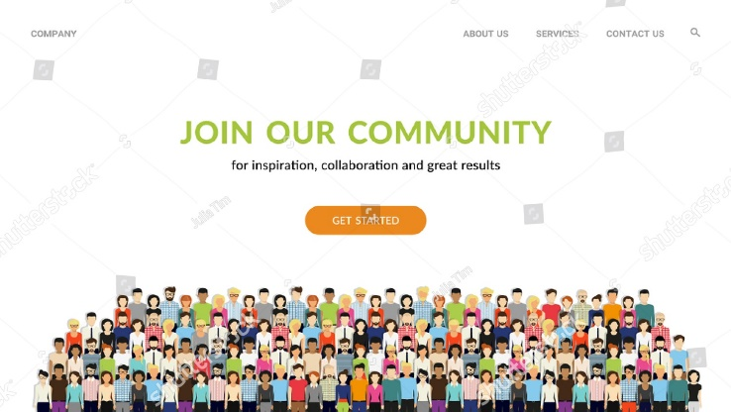 | - Sign up and be an active member of the Youth Connection Community through WorkforceGPS  - The Youth Connections Community offers a wealth of information and technical assistance.

