Framework for Monitoring and Oversight
  - A Technical Assistance Tool
June 2019
United States Department of Labor Employment and Training Administration

Table of Contents
Introduction 3
Background 3
Framework for Monitoring and Oversight: A Technical Assistance Tool 4
Element #1: Understanding the Goals and Value of Monitoring and Oversight 4
Element #2: Building Organizational Support and Capacity for Monitoring 7
Element #3: Establishing and Sustaining Effective Relationships 11
Element #4: Conducting Data-Driven Analysis 15
Element #5: Using Comprehensive and Current Monitoring Tools 19
Element #6: Conducting Effective On-site Monitoring 22
Element #7: Leveraging Monitoring as a Tool for Continuous Improvement 26
Conclusion 31
Appendix: Federal Requirements for Recipient and Subrecipient Monitoring 32

Introduction

Background
The need to understand the critical components of an effective monitoring approach has been consistently raised by states over the last several years. In 2013, after interviews with federal and state staff, the resource Ten Steps to Developing an Effective State Monitoring System, was developed and shared with the workforce system. This resource outlines those components and provides some supporting tools for states such as key questions to consider, a self-assessment, and best practices.
The Workforce Innovation and Opportunity Act (WIOA) requires accountability at all levels of the workforce investment system, and the President’s Management Agenda calls for accountability and transparency across the government. Funding and staff changes have impacted the size, depth, and capacity of some state monitoring units, while access to new technology may simultaneously streamline and improve the monitoring process. This Framework for an effective state monitoring system lays a foundation for training and capacity building on both the development and execution of a comprehensive monitoring approach. While this framework is focused on state WIOA-funded systems, it can also inform state efforts to monitor subrecipients of other grant types.
To address these ongoing needs, the United States Department of Labor’s Employment and Training Administration (USDOL/ETA) developed this Framework for Monitoring and Oversight: A Technical Assistance Tool (Framework). This framework was informed by state monitoring representatives who generously shared their time in conference calls on the essential elements, how each should be defined, what quality looks like, and their current successes and challenges around each.
This Framework builds off Ten Steps to Developing an Effective State Monitoring System, and adds key aspects of today’s workforce system such as evaluating implementation and outcomes; data driven analysis and continuous monitoring; and leveraging technology to streamline and advance the monitoring process with limited time and staff. The Framework provides essential elements for effective monitoring and oversight, and some suggested strategies for state consideration. In a subsequent phase of this project (outlined in Process and Next Steps below), ETA plans to develop complementary training to states to help ensure their monitoring approach reflects the quality baseline provided in the Framework.

Framework for Monitoring and Oversight: A Technical Assistance Tool
Monitoring can serve as a catalyst that improves future planning, and it identifies needs for funding of additional activities and programs. This is different than a checklist - it is looking for improvements and innovation, providing constituents with resources they need to be sustainable, and helping organizations to identify where there is opportunity.
~ Region 2 Monitoring Advisory Group Member

Element #1: Understanding the Goals and Value of Monitoring and Oversight
The goals of monitoring and oversight are numerous, and ETA has outlined their goals in the Core Monitoring Guide, and its value goes well beyond simply meeting a statutory requirement. Understanding what monitoring and oversight are intended to achieve is the critical first step in establishing an effective monitoring and oversight system. Monitoring is a process used to measure progress, identify areas of compliance, offer opportunities for technical assistance to help resolve non-compliance issues, and ensure that Federal funds are used responsibly. While some goals will be unique to a state, others are universal, and include ensuring:
- Compliance with statute, regulations, grant agreements, and policy
- Fiscal integrity
- Performance goals are achieved
- Effective and high-quality services are being provided
- Continuous improvement and innovation throughout the state and local systems, service design, and delivery
- Achievement of strategic priorities established at the federal, state and local levels
Additional detail regarding specific monitoring requirements and the primary goals of monitoring is provided below.

Monitoring to Meet Statutory and Regulatory Requirements
Clear requirements for the monitoring and oversight of workforce programs are included in both the Code of Federal Regulations (CFR) and Uniform Guidance. Oversight guidance is also included in WIOA Final Regulations. These provisions require that all recipients and subrecipients of federal funds must conduct regular oversight and monitoring and includes specific provisions regarding the timing and content of reviews as well as when on-site monitoring is required. Excerpts of those provisions are provided below and in their entirety in the Appendix: Federal Requirements for Recipient and Subrecipient Monitoring.
“Each Governor of a state shall conduct on an annual basis onsite monitoring of each local area within the state to ensure compliance with uniform administrative requirements.” - WIOA sec. 184(a)(4)
“The Non-Federal entity is responsible for oversight of the operations of the Federal award supported activities. The non-Federal entity must monitor its activities under Federal awards to assure compliance with applicable Federal requirements and performance expectations are being achieved. Monitoring by the non-Federal entity must cover each program, function or activity.”
~ 2 CFR 200.328(a), Monitoring by the non-Federal entity

Monitoring to Ensure Compliance and Effectiveness
Monitoring is critical to ensuring that grantees and subrecipients are administering and operating programs in a manner that is compliant with the intent outlined by statute, regulations, and/or policy. Therefore, it is imperative that states have a system and approach to monitoring that can effectively gauge compliance in key areas such as eligibility determination, appropriate and accurate documentation, and access to and delivery of required services.
However, high-quality monitoring goes beyond simply determining compliance with policy, documentation, and service delivery requirements and assesses the effectiveness of the local area/subrecipient structure and operations and alignment with the overall vision for the system as outlined by the State Board and/or Federal statute, regulations, and policy. Because monitoring should also provide key insight regarding local areas’ service design and delivery and whether it is effective, it is not sufficient to only look at compliance with process-related elements. Monitoring and oversight must also look at the quality of services delivered, and outcomes achieved. In other words, monitoring the effectiveness of the system is not optional – it is as required as monitoring eligibility determination, cost allocation, and other compliance indicators. As noted in the citation above from the Code of Federal Regulations, “The Non-Federal entity must monitor its activities under Federal awards to assure compliance with applicable Federal requirements and performance expectations are being achieved.” States must find a balanced approach to fulfill oversight responsibilities while also creating an environment which supports the vision of WIOA and encourages innovation.

Monitoring to Drive Continuous Improvement
Effective monitoring which results in corrective action, technical assistance, and training that supports the sharing of proven strategies and innovative practices can drive performance and continuous improvement within the system. If done effectively, monitoring can drive a continuous improvement cycle which is visually depicted below:
Figure 1: Monitoring Drives Continuous Improvement
Strategic analysis of monitoring results can also help to identify themes across the local system regarding challenges and needs that could be addressed through changes in state level management and/or policy, the provision of technical assistance, or the development and delivery of targeted training. This opportunity will be addressed further in Element #7: Leveraging Monitoring as a Tool for Continuous Improvement.

Monitoring to Advance Strategic Priorities
WIOA requires that State and Local Boards articulate a clear vision and strategic priorities for their workforce system. State policy and planning guidance typically conveys these priorities and requires Local Boards to define and develop strategies to advance those priorities locally. It is essential that states monitor both – whether the Local Boards have implemented the strategies they laid out in their local plan and the effectiveness of their efforts. Implementation of key WIOA strategies, such as sector strategies, regionalism, and career pathways development are required in the law and therefore must be implemented to achieve full compliance. States and locals can define how to implement these strategies which then must be monitored to ensure operationalization.
State planning guidance should include process and/or outcome measures for key WIOA strategies while also allowing local areas to establish additional process and/or outcome measures that may be unique to their local strategies. These measures can then be built into monitoring approaches and tools to ensure they are reviewed and evaluated. If issues are identified, states can address them through corrective action and/or technical assistance.

Element #2: Building Organizational Support and Capacity for Monitoring
Building organizational support and capacity for monitoring is critical to the quality and consistency that is required to achieve the goals of workforce systems. States need to have a sufficient number of well-trained monitors, working in accordance with clearly defined monitoring policies and procedures, to engage in deep oversight work that identifies issues and their conditions and causes. It is important to provide the support and staff development needed so that monitoring staff receive proper on-boarding and ongoing opportunities to grow and develop in their discipline.

Effective State Monitoring Structure
While there is no prescribed way to structure monitoring units, it is important for states to determine how they will set up their monitoring based on a number of factors, including: size and structure of the local system, monitoring requirements, grant portfolio to be monitored (discretionary and/or non-ETA funded grants), capacity, and efficiency. Existing structures of monitoring teams indicate a variety of models based on many factors. States should consider the following decision points when structuring their monitoring departments:
- Program and fiscal monitors as separate units or combined as a team
- Monitors with grant-specific expertise or who are generalists
- Monitors located independently or co-located with other units such as policy or program services
- Total number of monitoring positions developed
- Monitors that are full-time monitors and/or monitors that have additional responsibilities
It is important to note there is no right or wrong way to structure monitoring teams. What is critical is that staff roles and responsibilities are structured to allow for sufficient time to fully understand local area governance and operations to support the identification of issues and their conditions and causes.
Since every state has different needs, there is no set number of staff required or recommended as ideal. However, the unit should be large enough to meet the needs of the local areas and subrecipients and reassessed regularly as conditions change. Factors to consider in determining the size of the unit include the number of grantees to be served, the size of the geographic areas covered, and the need for ongoing technical assistance.
Hiring considerations should be carefully planned as well. Prior understanding of the workforce system is a valuable asset in a candidate but can also be taught. Consideration should include past experiences working in the workforce system for program monitors and/or a financial background for fiscal monitors. Hiring supervisors should look for attributes such as:
- Ability to think methodically
- Inquisitive nature
- Attention to detail
- Analytical skills
- Well-developed interpersonal skills
- Strong writing skills
- Accounting skills or understanding of budgets as required

Written Monitoring Policies and Procedures to Ensure Clear Understanding
States should have written policies and procedures that define the goals and value of monitoring, roles and responsibilities of monitors, the steps in the monitoring process, and what quality looks like for each oversight activity. Written policies and procedures ensure a clear understanding of expectations for monitors while ensuring consistent execution of oversight activities across local areas. This consistency is important to building trust and an overall perception of fairness with the local system.
Policies and procedures should be transparent to and shared with the local system. Below are ideal components for both a state monitoring policy and procedures governing the work of monitoring staff:

State Monitoring Policy Components:
- State objectives for monitoring
- Definitions of key monitoring terms
- State and local monitoring roles
- State and local required action, including issue resolution process
State Monitoring Procedures Components (note that some states provide procedures in conjunction with the policy):
- Monitoring areas of focus, including state identified priorities
- State monitoring activities
- State and local responsibilities regarding state monitoring of local areas/subrecipients
- Local responsibilities for monitoring of subrecipients
- State/local commitments and expectations regarding monitoring reports and issue resolution

Training to Ensure Skills and Capacity of Staff Performing Monitoring Functions
All monitors, program and fiscal, should have the knowledge, skills, and abilities necessary to ensure that local areas and subrecipients meet compliance and effectiveness requirements. Having a formal training plan in place ensures new team members are equipped for their roles and existing staff stay up to date on changes in the workforce system. A training plan also ensures consistency in how and what staff is trained on as well as accuracy in the information provided. Leadership buy-in to training is critical and includes allowing the time needed for proper and adequate on-boarding, resources for developing training, and support in its implementation.
Typically, there are four components in training models for monitors:
- Overview of Policies and Grant Requirements
  - New staff members learn the policies and requirements of the programs, grants, and priorities they are monitoring. Training during this phase typically occurs with a review of grant requirements, state policies, Training and Employment Guidance Letters (TEGLs), CFRs, Uniform Guidance, monitoring guides, flowcharts, timelines, or other materials that have been developed. It is important to remember that there are different learning styles and not everyone learns best just by reading the materials. Other training methods can include webinars, learning groups, visual tools, and/or audio recordings. Interviewing key staff members to hear about the policies as well as how those policies apply to programs can be helpful. Some states have also incorporated checkpoints or quizzes to reinforce and measure learning progress.
- Job Shadowing/Mentoring
  - Supervisors or seasoned monitors share their monitoring approaches with new staff by allowing them to “shadow” or join them during their own monitoring visits. New staff members can observe the monitoring processes and approaches veteran monitors take with local areas/subrecipients. New members also learn the mandatory protocols as well as different stylistic approaches. Note: It is important for the staff that are being shadowed to be properly prepared and trained on how best to guide new staff members. Ideally, a “train the trainer” approach has been incorporated into the departmental training plan.
- Supervised Monitoring
  - Once a new staff member is deemed ready to conduct their own on-site monitoring visits, a transitional process should occur. Initially, they should conduct the monitoring visit under supervision. Then they should be allowed to be responsible for planning, conducting the visit, and for follow-up—while having the support, guidance, and feedback of the supervisor/mentor as needed.
- Ongoing Learning
  - This component is for all staff, including seasoned monitors. It is important to offer training opportunities for all staff to stay abreast of policy changes, new regulations, new tools, and new approaches to monitoring.
One helpful approach we take is to provide an on-the-job training spreadsheet that lays out the first six months of trainings and tasks for new staff. We have a website where they can register for different classes and webinars. For each different type of program, we have a select set of curricula that is designed to help the new monitor.
~ Region 6 Advisory Group Member

Consistent and Comprehensive Communication Across Monitoring Staff and Other Staff Whose Roles Impact Monitoring
It is important to develop protocols to ensure ongoing communication between the monitoring staff and the staff of other related units/divisions such as policy, fiscal, and performance. This cross-discipline communication, which is discussed in more depth in Element #3: Establishing and Sustaining Effective Relationships.

Element #3: Establishing and Sustaining Effective Relationships
Monitoring is a shared responsibility across the federal, state, and local levels that comprise the workforce system. Although each level has distinct monitoring responsibilities, effective fulfillment of these responsibilities is essential to achieving the shared goals of program, financial, and administrative compliance, and performance excellence. Viewing the system as a partnership helps all involved to understand that quality monitoring and oversight is not intended to be punitive, but is, instead, a critical tool that drives the continuous improvement cycle through assessment, analysis, corrective action, peer sharing, and training. To build and maintain these partnerships, establishing and sustaining effective relationships is critical. Relationship building should begin at the onset, but continued efforts to maintain the partnership must also be part of effective monitoring.
Figure 2: Monitoring Partnership
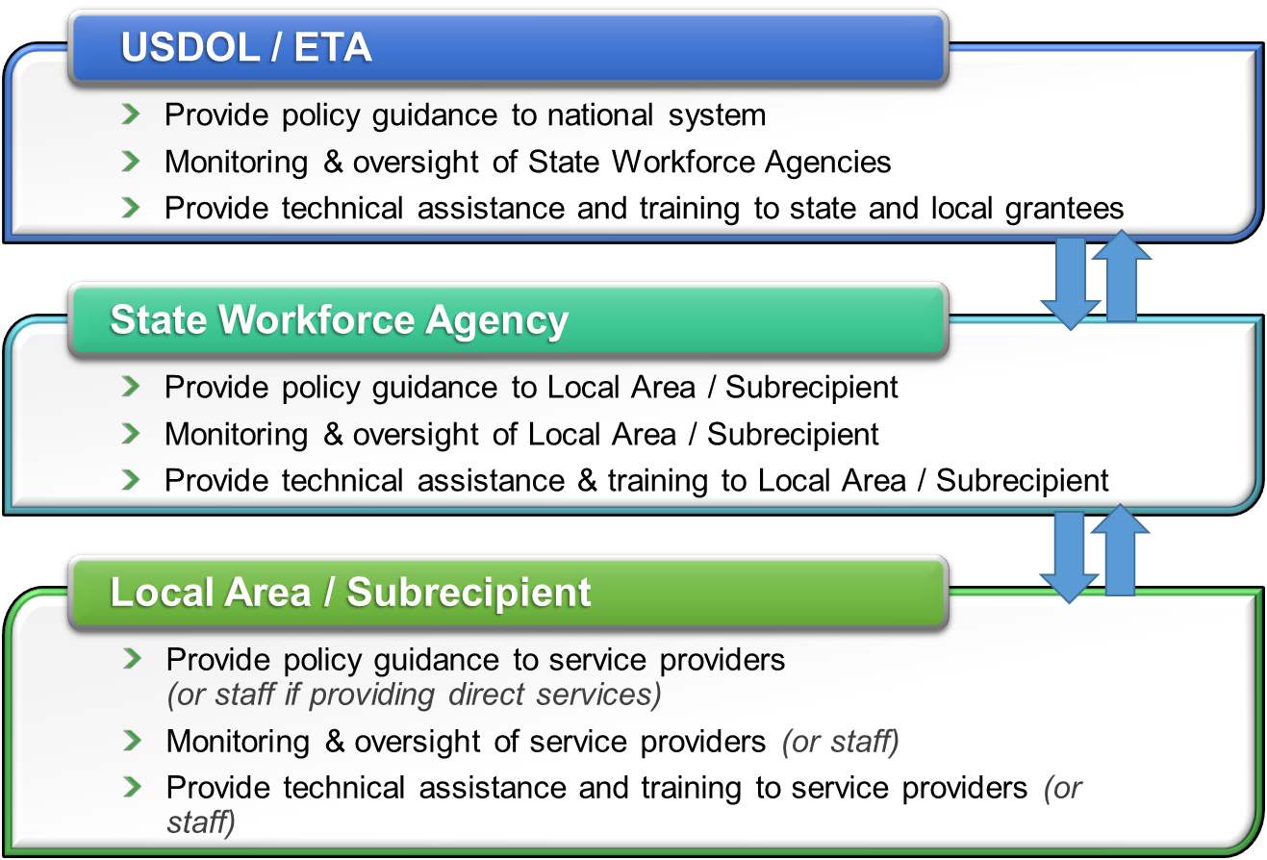

Monitoring as a Partnership Across Levels to Ensure Compliance and Effectiveness
Working with groups at all levels requires effort, finesse, and skill. Positive relationships go beyond a neutral, one-directional relationship and create a true partnership instead. It is important that states view monitoring as a vehicle to help their programmatic quality and success versus a “gotcha” moment or a risk of getting in trouble. True partnerships are one in which there are mutual benefits. For monitors, there is an opportunity to ensure effectiveness and compliance that strengthens local services and the workforce system. For local areas/subrecipients, there are benefits to monitoring that should be clearly articulated. In fact, articulating the benefits (even if they seem obvious), go a long way in developing partnerships. Some benefits of monitoring include:
- Early intervention of problems before it is too late
- Coaching and training opportunities
- Stronger/ better working relationships and partnerships
- Identification of problems grantees are unaware of
- Opportunity to go beyond the data, which alone can’t always tell the whole story – observations, conversation and analysis are needed
- Opportunity to provide resources
- Drives continuous improvement

Establishing and Maintaining Relationships Based on Trust and Understanding (which supports the early identification and resolution of issues)
Establishing and maintaining relationships requires monitors to examine their mindset and communication approaches. Monitors should consider the tones they set, how they will manage expectations, and how they will encourage a proactive versus reactive approach to program and fiscal management.
Communication is the foundation for effective monitoring and oversight.

Figure 3: Effective Communication Loop
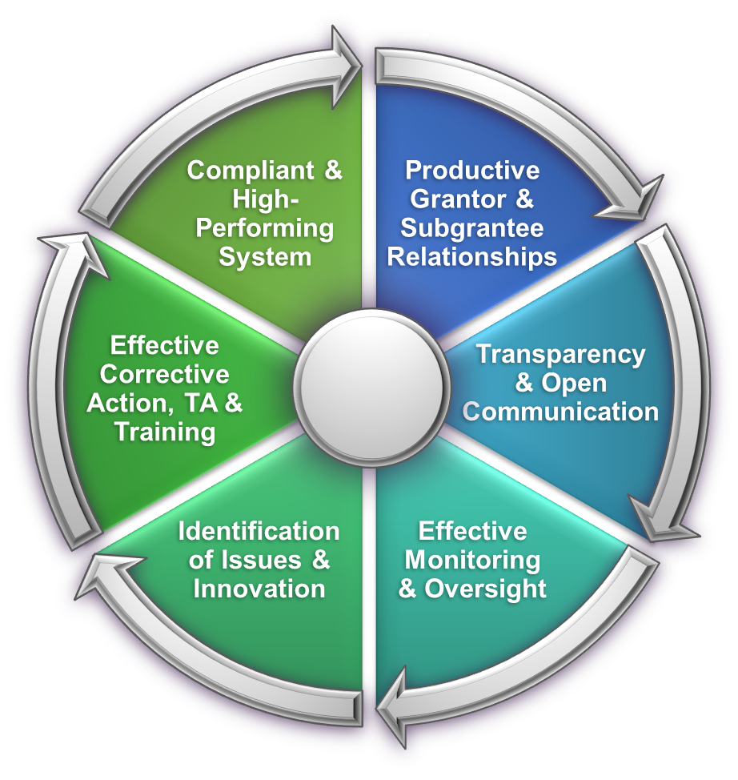
The process depicted above, which shows consistent and productive communication between monitors and grantees, is the foundation for effective monitoring and oversight. It lays the groundwork for establishing the positive relationships necessary to ensure that monitoring functions are productive. It is important to remember that monitoring is not a perfect science. It can be very difficult to gather complete information if the entity being reviewed is not inclined to be open and transparent. If subrecipients feel threatened or defensive, their instinct is to minimize the sharing of information or even conceal areas of weakness out of fear. Positive relationships lead to more open communication and transparency which leads to a more complete understanding of operations and the increased likelihood that problems will be identified and resolved.
Strategies that have been identified to increase effective communication include:
- Regular communication efforts, by phone or in-person to discuss progress, questions, and/or needs for interventions
- Monitors can join grantees on their visits to subrecipients to gain a better understanding of progress and challenges, as well as offer monitoring guidance, technical assistance and resources
- Tying monitoring efforts to the “end game” and the “why” as discussed above versus focusing merely on compliance
- Conduct comprehensive and thorough pre-visit planning which includes developing agendas that review what will be covered and who should be present
- Minimize surprises by having open and transparent communication
- On-site, initiate the visit by managing expectations. This includes a review of the purpose of the visit, the agenda to be covered, what the monitor is looking for (successes, challenges, and best practices), and next steps.

Monitors Have Key Communication Roles
Monitors have key communication roles when working with local areas/subrecipients including relationship builders, subject matter experts, and drivers of continuous improvement. Definitions of and expectations around these roles should be articulated in monitoring training and procedures. These roles are defined below:
- Relationship Builders are:
  - Professional by following protocol consistently and effectively, always being punctual, prepared, and courteous.
  - Respectful by acknowledging the complex challenges faced by staff in implementing programs and managing funding; and by acknowledging that management and staff also possess knowledge, skills, and competencies that are equally important to the process.
  - Responsive by meeting deadlines for planned activities with grantees and responding in a timely and thorough manner to their needs, concerns, and issues.
- Subject Matter Experts are well-versed in federal, state, and local requirements for innovative practices regarding governance, service delivery, performance measurement, and any other key area of effectiveness for workforce development programs.
- Drivers of Continuous Improvement use monitoring and oversight functions to identify risks and best practices and then feed that information back to the system through technical assistance and training. This role is discussed in more detail in Element #7: Leveraging Monitoring as a Tool for Continuous Improvement of this Framework.

It’s about transparency. If there is a finding, it’s not about the “gotcha” but how we can find a solution. When we see a need for a change in a tool or a shift in policy, we put out a call to the entities we are monitoring informing them of the change. We offer a discussion with them in how that change could possibly affect them. We provide them an opportunity to foresee the change and buy-in so they can prepare for the review.
~ Region 6 Monitoring Advisory Group Member

Element #4: Conducting Data-Driven Analysis
Conducting data-driven analysis is critical to maximizing the time and resources available for monitoring and oversight. Limited resources make it challenging to establish and implement a comprehensive monitoring approach based primarily on on-site reviews. In addition to limited state monitoring capacity, the time it takes to prepare and facilitate extensive on-site monitoring may also detract from the local areas’ ability to focus on service delivery and, therefore, should be limited.
Fortunately, advances in communication methods and management information systems (MIS) offer greater opportunity than ever before to use data to understand and assess system governance, operations, and outcomes. This Element outlines how states may use quantitative and qualitative data to conduct continuous monitoring as well as provides examples of the various data sources that should be reviewed to stay plugged in to conditions on the ground. This ongoing oversight work allows monitors to assess risk areas which should strategically drive the timing and focus of on-site monitoring.

Continuous Monitoring
Continuous monitoring means that monitoring staff are consistently engaged in various monitoring and oversight activities throughout the year in addition to scheduled on-site monitoring visits. This approach supports the early identification and rapid resolution of issues before they become entrenched or expand in scope.
With continuous monitoring, monitors use available information sources to assess risk for non-compliance or low performance as well as identify trends that may indicate a need to develop and deliver technical assistance and training to address challenges. Based on the results of that regular data analysis, monitors take appropriate next steps such as reaching out for additional information from the local area/subrecipient or moving up or strategically designing the focus of the next scheduled on-site review to look at the identified red flags. As risks are identified, monitors move through a process to oversight activities that require more in-depth review until issues are resolved.
The table below provides examples of key continuous monitoring activities (including the timing and data sources that could be analyzed). Much of this information is now available electronically and/or on-demand which supports regular access and review. Any of these activities might trigger additional steps if red flags or issues are identified:
Continuous Monitoring Activity | Examples of Data Sources | Timing
Information Collection and Review | Statement of Work (SOW), budget, cost allocation plans, policies and procedures, sub-grants or contracts, MOUs and other agreements, Local Plan, Board membership, etc. | When awarding new funding and updated at a specified time or when changes occur
Desk Reviews | Performance data such as enrollments, placements in training and employment, retention, etc.; fiscal data such as drawdowns, single audit report, etc.; qualitative data such as recent meeting minutes, local news, information provided from partners; may also include participant file review including case notes. | Ongoing (at designated points in the grant period)
Risk Assessment | Same sources as desk reviews but the number, type and significance of issues is applied to a set of criteria to assign a level of risk to the subrecipient. That risk category informs the timing and focus of additional monitoring activities. | Initially and at designated points in the grant period
Some states have developed questionnaires or other data request processes for local areas to provide information on an annual basis which the state can then use as the foundation for their monitoring and oversight. This approach typically includes responses to key questions regarding governance, administrative controls, service design, service delivery, and performance and requires submission of policies, Board membership, and other important documentation. The questionnaire or information request is usually completed in full when originally initiated and updated annually or as needed with changes at the local level.
This process not only provides the state with an efficient way to create a complete file for the local area/subrecipient and engage in more effective continuous and on-site monitoring, but it also builds local area/subrecipient understanding of what the state is reviewing and an oversight partnership with the state. Other states may want to consider this type of approach to realize monitoring efficiencies while expanding access to and storage of key oversight information.

Comprehensive Data Analysis Process and Tools
It is not simply the collection of data that determines how well an organization is administering a program, but rather the analysis of the information collected which allows for the identification of both simple deficiencies, such as a missing policy, or a large-scale problem, such as the underlying causes of consistent underperformance in enrollment, placement, or retention. Thoughtful analysis also will identify trends in performance, expenditures, or other areas which should trigger a monitor to delve further by doing additional information gathering and potentially more in-depth monitoring activities.
As depicted in the table above, analysis is strengthened using multiple data sources to further understand the heart of a problem. In some cases, it requires pulling pieces of information together from different sources to support a more comprehensive analysis which then provides a broader and deeper understanding of an issue. In many cases, this comprehensive analysis will require communication across units within the state agency such as programmatic, fiscal, performance, and policy staff to share data and work together to draw conclusions regarding what the data means and next steps. For example, low program enrollment alone may not provide much insight into what is happening locally, however combine that data with low expenditures and underachievement in key performance measures and you have a clear indication that the local area may be struggling. From a compliance perspective, low program enrollments, high expenditures, and low performance may also trigger a red flag which demands further investigation into how the local areas is investing its funding.
Some states are establishing processes and tools to support the cross-unit data analysis essential to a comprehensive understanding of local area compliance and effectiveness. The building of a team which includes staff that cover various programs, fiscal, performance, policy, etc. to bring their respective data to the table to collectively analyze and discuss their assigned local areas is one such approach. A potentially effective tool is the creation of a dashboard which allows for information across the key areas listed above to be displayed by local area to provide a snapshot that supports an integrated and comprehensive analysis of issues and their potential causes for further investigation and action.
In addition to helping to identify issues, analysis should also inform a strategy to resolve the identified deficiency. Steps to resolve may be as simple and straightforward as a phone call to the local area/subrecipient or as complex as an on-site monitoring review resulting in written corrective action and ongoing technical assistance. Monitoring staff should fully engage in each of these three steps of the process as well as ensure that issues and strong practices are fed into discussion regarding statewide and local training and technical assistance activities and potentially policy development or revisions.
Each monitoring activity can be envisioned as three steps: review, analyze, and resolve. The image below illustrates the type of organization, management, and critical thinking required for effective monitoring and oversight.
Figure 4: Monitoring Process
Review Analyze Resolve

Identifying the steps to resolve an issue requires an understanding of the condition and cause. If you don’t address the cause, it will be difficult to recommend appropriate corrective action and the issue will likely persist. The primary question is why did the condition occur? For example, a monitor may find missing eligibility documentation in participant files. They may cite it as a finding and outline corrective action of verifying the documentation, but that resolution does not address why the issue occurred in the first place. It may take interviews with staff asking how they determine eligibility to learn that a case manager was brought on board after training was delivered and there are no eligibility determination tools available for their use. Now that the cause has been identified, appropriate corrective action can be determined including, in this case, training and development of case management tools along with the verification of eligibility for all participants.

Qualitative vs. Quantitative Data
Most of the data sources already mentioned in this Element are quantitative rather than qualitative. However, as noted above, to fully understand a situation, monitors typically must move beyond just quantitative data, such as expenditure and performance figures, and integrate qualitative data, such as information gathered from grantee and customer interviews, into their analysis. Qualitative data stems from the word quality and characterizes attributes or properties of an object – or in this case – service design and delivery. It is essential to fully understanding what is happening in a local area/subrecipient and, therefore, essential to effective monitoring and oversight.
Monitors should collect and use qualitative data to inform their comprehensive analysis. In the world of monitoring workforce programs, there are a variety of qualitative data sources, including conversations with local area leadership and staff, meeting minutes, media reports, and observations and information gathered from time previously spent on-site. These sources provide insight into leadership style, partner collaboration, administrative entity and contractor relationships, customer flow, and other critical elements that can impact local area compliance and effectiveness. In fact, although quantitative data may provide the first red flag regarding a potential issue, it is often the qualitative data that helps identify the cause of the problem.
Quantitative data can point you in the right direction, but qualitative is necessary to give you a true understanding of the full picture. Quantitative data is the beginning of knowledge and data collection, not the end of knowledge.
~ Region 4 Advisory Group Member

Element #5: Using Comprehensive and Current Monitoring Tools
Monitoring tools support staff’s capacity to effectively execute monitoring and oversight activities by providing structure, organization and guidance that helps monitors collect, analyze, and make assessments regarding both the quantitative and qualitative data outlined in Element #4: Conducting Data-Driven Analysis. This Element discusses the essential monitoring tools that states should have in place and the need to ensure they are comprehensive, current, and provide maximum value.
The table below provides a listing of the types of tools (and their purpose) that states should have in their monitoring toolkits. This list is a baseline but not exhaustive. States may have developed or wish to develop additional tools to meet the specific needs of their staff and local system.
The right tools can be more important than knowledge, especially when we consider the intent and perception of monitoring.
~ Region 3 Advisory Group Member
Tool | General Purpose
Monitoring Schedule or Calendar | Lays out all monitoring activities over a specific period of performance, such as a program/fiscal year and helps to keep the monitoring unit on track.
Entrance Conference Agenda | Template that discusses the purpose of the on-site monitoring, what will be reviewed, timelines, processes, and expectations during the monitoring review period.
Exit Conference Agenda | Template that discusses the results of the monitoring in a standard and consistent order. It also discusses the definitions of monitoring terms, next steps, timelines for the receipt of a final report and resolution of any identified issues.
Requested Information Checklist | Includes a list of each required document and policy to be provided by a local area/subrecipient for review prior to the on-site review.
Risk Assessment | Evaluates the individual categories of a program and a local area. Standards and definitions for low, medium, and high risks are defined, along with information on how the risk relates to compliance findings.
Performance/Expenditures Trackers | Tracks performance and expenditures for the local area/subrecipient against planned performance and expenditures. These may also be part of a desk review guide (outlined below).
Desk Review Guide | Provides evaluative questions to consider when reviewing performance, expenditure and drawdown reports, as well as a participant file sample from the state MIS. Should include (or have separately defined) procedures for next steps if issues are identified.
On-site Review Guide | Provides details and information for the monitors and local areas to understand the programmatic and fiscal monitoring requirements, along with how and what will be monitored according to federal and state regulatory requirements. Ideally, it includes references to regulations, laws, and state policy. Should also include a tool to capture results of participant files reviews where issues and notes can be tracked by individual participant as well as a financial monitoring tool to help monitoring staff determine the adequacy of internal controls and reliability of subrecipient financial management systems.
Corrective Action Plan Template | Allows a local area to complete a standardized form to define their corrective action to resolve identified issues.
Corrective Action Tracker | Tracks issues and planned corrective action by the local area and technical assistance by the state, as well as status of issue resolution.
Monitoring Report Template | Used by monitors when compiling the final report. It contains standard language, formatting, and layout to ensure consistent communication of findings and best practices back to the local system.

Features of Strong Monitoring Tools
The best monitoring tools are easy to understand and to apply; they also ideally build the capacity of the monitors using them. For example, a strong review guide can also serve as a training resource for new monitors that need to learn both the program requirements and state-identified priorities that should be reflected in the tool. The inclusion of citations (ideally links if used electronically) back to regulations or policy also direct monitors to the authoritative source and encourages an understanding of the requirements in the broader context of the overall program. In addition to helping monitors gather and document information, tools should support analysis, typically with key questions and/or criteria for monitors to consider, such as what the information means in terms of compliance and effectiveness. The list below is not exhaustive, but provides some ideal features:
- Easy to use and understand by both monitors and grantees
- Provides monitors with the knowledge, intent, and understanding to effectively monitor programs
- Open-ended questions that encourage a full, meaningful answer and help discover the cause of an issue
- Refers to laws, regulations, and policies for a clear understanding of the program goals and requirements
- Reflects current state workforce system vision and priorities (as typically defined in state policy and planning guidance)
- Incorporates hyperlinks to regulatory source documents within electronic documents
- Easily modified to meet the program requirements of a specific grant
- Shared with grantees and subrecipients of funding and potentially improved with their ongoing input
- Addresses qualitative and quantitative aspects of program assessment
- Collaboratively developed with the program manager, monitoring team, and other relevant units
- Readily available online to improve transparency and accountability
- Adaptable to individual workstyle preferences, where appropriate
Monitoring tools need to be as helpful as possible to enhance training and understanding.
~ Region 3 Advisory Group Member

Keeping Monitoring Tools Current with Policy and Technology
Just as policies often require updating, monitoring tools must also be reviewed on a regular basis to ensure they align with current federal and state law, regulations, policy, and priorities. States should have a process in place for review and updating tools at least annually or within a defined period of time when changes occur. Keeping monitoring tools current is another reason to ensure consistent and effective communication between program, fiscal, performance, and policy staff within the state agency as changes in any of those areas may trigger a need to update monitoring tools.
States should also regularly evaluate tools to ensure they are leveraging current technology that could streamline the monitoring process. For example, tools that were once hard copy may now be better used in an electronic format. There may be options for tying tools to data systems to generate information needed during monitoring and some states have also developed tools that auto-populate report templates based on data entered during a review. Software to support monitoring and/or auditing is also available in the marketplace and in use by some state monitoring units. Leveraging new technology in a way that streamlines monitoring while supporting more sophisticated data analysis can support monitors’ understanding, identification, and collaborative resolution (with local areas/subrecipients) of issues before they become significant problems.

Element #6: Conducting Effective On-site Monitoring
Element #4: Conducting Data-Driven Analysis introduced the idea of continuous monitoring that is ongoing and not isolated to on-site reviews. That concept is critical to quickly identifying and addressing issues, and effectively driving continuous improvement throughout the year. That said, although on-site monitoring should not be the only oversight activity, it is a federal requirement and for a very good reason – it remains the best way to truly understand the full scope of what is happening on the ground level.
Effective on-site monitoring requires thoughtful planning and clear and consistent communication with the local area/subrecipient to be monitored. States should have an on-site monitoring plan (updated at least annually) that outlines which areas will be monitored when and the areas of focus for the review. Please note that this plan does not limit the state’s ability or responsibility to conduct on-site monitoring should an issue be identified through a continuous monitoring activity at another time throughout the year. An immediate need to resolve an issue before it grows should always be addressed in the most efficient and effective manner – which may be a targeted on-site review.
The scope of on-site monitoring is determined by federal requirements and the state based on analysis done through continuous monitoring activities. The table below depicts the primary areas of focus typically used by federal and state monitors and the types of documents, activities and services that are covered in an on-site review (although portions may be conducted off-site if feasible).
Categories | Documents, Activities, and Services to Monitor
Service Design & Delivery | Board membership, meeting minutes, state/local plan, policies, contracts with subrecipients, Memoranda of Understanding, one-stop operator agreements, past monitoring reports, staff interviews, programmatic policies and procedures, participant files and case notes, enrollments, eligibility documentation, intake process, employment plan, participant’s progress, client expenditures, training activities and documentation, allowable activities, service delivery, services received, follow-up activities, past TA requests, grant requirements, staff interviews, etc.
Grant Operations | Property management documents (rental/leasing agreements, insurance coverage, real property/equipment purchases, etc.), subrecipient management & oversight documents, records management documents, personnel documents, real-time performance data, real-time performance data, performance trends over time, performance indicators, expenditure levels, staff interviews, etc.
Financial Management | Financial and administrative policies and procedures, general ledgers, transactions, overall financial system, drawdowns and drawdown reconciliation, expenditure reports, monthly financial reporting, past monitoring reports, contractual agreements with financial commitments, subrecipient audits, single audit reports, cost allocation, cost sharing and infrastructure agreement, cash management, purchasing, contracting, equipment, property management, staff interviews, etc.

Preparation for On-site Monitoring
The on-site monitoring process begins long before the scheduled dates. The following steps are important to incorporate into your state’s process for preparing to conduct the on-site monitoring visit:
- Use the results of continuous monitoring (risk assessments, desk reviews, etc.) and communication across state units/staff to develop a strategy and focus for the on-site review. The data analysis may indicate a need to visit certain locations and providers, request additional documents, inform the file sample, and/or probe deeper into identified red flags.
- Notify the local area/subrecipient of the monitoring visit including the purpose, scope, documentation and interview requirements, and any planned activities while on-site to ensure they can properly prepare for the review. Advise of what will be reviewed off-site prior to the visit and what will be covered on-site. Note: If the state is a single local workforce area, notify the American Job Centers and service providers of the on-site visit.
- Work with the local area/subrecipient to establish and finalize a schedule that breaks down the time on-site by area of focus and activity (entrance meeting, tour(s), interviews, file reviews, etc.). Ensure that specific staff and times are identified and communicate that information to all involved parties.
- Complete portions of the review that can be done prior to traveling on-site such as reviewing governance structure, policies/procedures, performance, and expenditure reports, etc. In some states, this may include the full participant file review if files are completely electronic, although monitors should plan to follow-up on site regarding identified issues. Plan to further investigate any identified issues while conducting the on-site portion of the review.
It means being clear from the beginning on what we’re going to do before we do it. We lay that out in advance; including how we interact and with whom. We have a daily touchpoint [with the grantee] to inform them of our progress. Our goal is that there are no surprises [in the monitoring report].
~ Region 6 Advisory Group Member

On-site Monitoring Activities
The time allocated to an on-site monitoring review should be sufficient to allow for thorough completion of the essential on-site activities. Those include:
- Entrance meeting to review the purpose, scope, and schedule of the review as well as the resolution process for any identified issues.
- Tour of operations and customer flow.
- Interviews of executive, management, front-line staff, and customers.
- Participant file review (as noted above, portions of this may be completed off-site).
- Exit meeting to walk-through the outcomes of the review including identified issues and best practices as well as next steps regarding the report and resolution of any identified issues (this activity can be completed virtually post-review if travel schedules require early departure).

Effective interviewing and file review approaches
It is essential that monitoring staff have the opportunity to discuss governance, service design, and delivery with key personnel at the local area/-subrecipient. As outlined in Element #3: Establishing and Sustaining Effective Relationships, a state/local relationship built on trust, partnership and the common goals of compliance and effectiveness is essential to engaging in productive interviews. Local staff/subrecipients who view the monitoring as an opportunity to improve compliance and outcomes, rather than an effort to simply highlight deficiencies are more likely to be forthcoming with key details and context that support the monitor’s evaluation.
While it may seem like a monitor’s questions would vary dramatically depending upon the role of the staff being interviewed, that is not necessarily the case. Similar questions should be asked (although reframed if needed depending on the staff) across multiple respondent groups to understand where there is consistency in local staff’s understanding of policy and operations. For example, a monitor may ask a local workforce director if they have a particular policy in place and is told “yes” and provided a copy. The monitor may ask the AJC manager the same question and be told “yes, I think so, and I believe it is somewhere on our internal portal.” Finally, the same question may be posed to a case manager who responds they are “not aware of such a policy.” Without verifying the response at all levels, the monitor would have never learned the policy has not been effectively communicated across local operations. This “identify and verify” approach becomes even more critical as states move to collecting all available documentation, such as policies, in advance to support the desk and pre-onsite review process.
The purpose of the participant file review is to observe and assess the compliance and effectiveness of service design and delivery for each participant as they move from enrollment through follow-up. The file review shows key compliance elements, such as appropriate eligibility determination, along with the participant’s “story” which might include answers to the following questions:
- Was the individual employment plan and services provided appropriate based on the participant’s situation and identified barriers?
- Did the participant remain engaged? If not, what effort was made to determine why not and to reengage the participant?
- Was the participant placed in training or other services that align with the local area’s sector strategies and result in advancement along a career pathway? If not, why not?
The monitoring sample size may include many variables, including time allowed on-site, number of participants, and risk factors. The file sample should be selected by the state monitor. Local areas should not know who is in the file sample until the moment they help the monitor pull the files or questions/issues are raised post review (if completed off-site).
To identify issues and identify their causes, it’s important to select a diverse file sample that includes variety in terms of service provider, case management staff, AJC, programs (if reviewing multiple), services delivered, and outcomes. Not only does this support the monitor’s ability to pinpoint causes, it also helps to identify cross-cutting themes that may point to significant issues across programs and staff.
To access additional information, resources, and strategies regarding effective interviewing and observation techniques while conducting an on-site monitoring review, please read Appendix D of Ten Steps to Developing an Effective State Monitoring System.

Exiting the Review
The exit meeting is typically the final activity in an on-site monitoring review. State monitoring staff conducting the on-site review should communicate prior to the exit meeting to discuss issues and best practices they’ve identified on the review. Typically, the exit meeting is not the first time the local area/subrecipient has heard of concerns as monitors often need to raise the issue to probe deeper during the review to identify the cause. This is usually appropriate as the local area/subrecipient staff do not feel blindsided and may even come to the exit meeting with strategies in mind to resolve the issue. Many states have established a daily check-in meeting during on-site reviews to keep those being monitored abreast of how the review is proceeding; including any issues, strong practices and outstanding needs for documentation or discussion.
Leadership of the entity being monitored should be invited to the exit meeting and it is up to them to determine the participation of other staff. The meeting should include the following key components:
- Thank you to the local area/subrecipient for their time and engagement in the review.
- Reminder of the scope and activities conducted during the review.
- Sharing of issues and concerns and strong practices as identified.
- Discussion of potential corrective action, and the impact unresolved issues could have in the system if not addressed, and provision of technical assistance (if needed).
- Reminder of the process for issue resolution and report issuance.
If findings are resolved on-site or prior to report issuance, many states will include the finding in the monitoring report but note it as “resolved” and document the corrective action taken. This approach is appreciated by local areas/subrecipients and further strengthens the trust between the two parties.

Element #7: Leveraging Monitoring as a Tool for Continuous Improvement
A high-value outcome of monitoring is the identification of issues and the understanding of the underlying causes, which can then inform the development and delivery of effective technical assistance. This process is critical to driving continuous improvement across the workforce system. Unfortunately, many people do not understand the role that effective monitoring can play and see it only as a mundane requirement separate from the opportunity to be strategic and innovative. They are missing the link between the roll-out of priorities through policy and program development and the role of monitoring to ensure those priorities are effectively implemented.
To drive continuous improvement, however, monitoring staff must proactively identify risks and how these risks will impact the workforce system if not addressed. Also, identify best practices and feed that information back to the state and local system in a way that supports continuous improvement through the delivery of technical assistance and training and potential refinements or changes in policy or procedures. It is a cycle of continuous improvement that is depicted in the graphic below, and while the process for doing this can be unique to each state, it should be clearly defined.
Figure 5: Communication = Continuous Monitoring
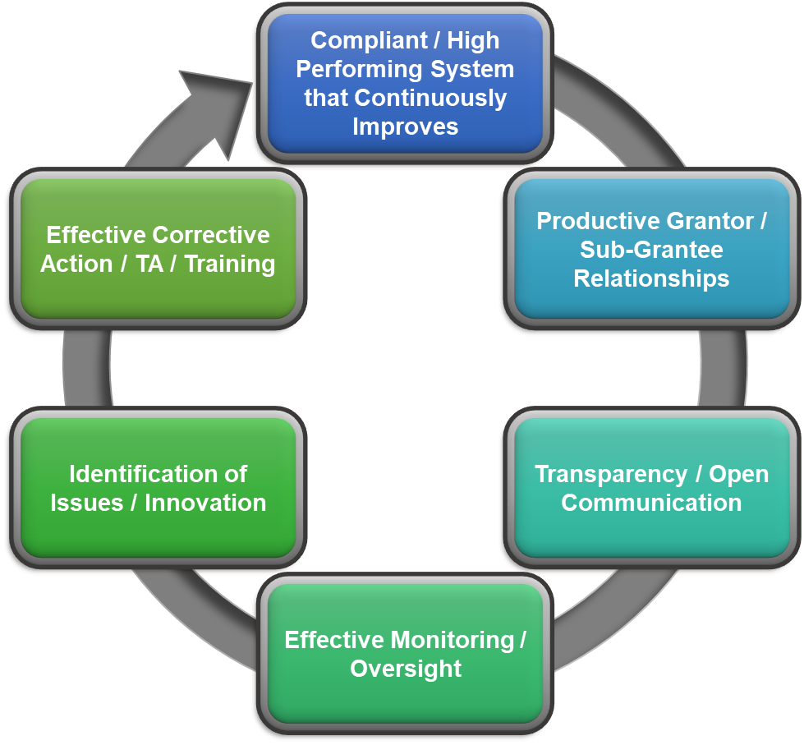

Communicating Findings, Corrective Action, Areas of Concern, and Effective Practices
The first step in resolving issues is effectively communicating them to the local area/subrecipient. This is done both verbally and in writing through monitoring reports and potentially also in email or other correspondence. Below are some basic guidelines to follow when communicating monitoring results:
- Follow a transparent, consistent, clearly defined, and documented process for report writing and any other official transmission of monitoring results (e.g. some states’ continuous monitoring process allows for reports to be generated through activities other than on-site monitoring; many states also issue quarterly letters to local areas outlining performance to date around a variety of key areas).
- Establish templates for monitors to use when writing monitoring reports and letters.
- Establish clear procedures for all monitors to follow when writing, vetting, submitting and following-up on all official communication. Those procedures should clearly outline definitions for state and local areas around key monitoring terms used by your state to represent “finding”, “areas of concern”, and “effective” or “best practice” (please see definitions below used by ETA Federal Project Monitors).
- Provide training to monitors on how to craft clear and well-written reports.

Findings, Areas of Concern, and Effective Practices Definitions
The following are definitions for the key terms typically used in monitoring reports. These definitions should be fully understood by state monitors and the local areas/subrecipients.
- A finding is a violation of a specific compliance requirement contained in law; regulations; national policies; FOA; Uniform Guidance or OMB Circulars; the grant terms and conditions; ETA policy guidance, including Training and Employment Guidance Letters (TEGLs); and/or the grant agreement. A citation is readily available from one of those sources outlining the requirement and corrective action is required to resolve the finding.
- An area of concern (or some states may use the term observation) is used when there is a potential issue, challenge, or situation identified that does not yet violate one of the sources listed above, but left unchecked, could elevate to a finding or, at a minimum, negatively impact outcomes. Reports typically include a recommendation to address the situation at hand.
- An effective or best practice is a strategy, approach, process, or product in one or more key areas of implementation: governance, administration, service design and delivery, etc. that is sufficiently effective and/or innovative to warrant highlighting in the report.

Managing Corrective Action
State monitors should take an active role in helping local areas/subrecipients identify appropriate corrective action and tracking progress through issue resolution. A finding is not just the local area/subrecipient’s problem, but, as the grant recipient (in the case of federal funds) is also “owned” by the state. The state needs to confirm that the identified action has been completed and has truly resolved the issue which may require follow-up on-site monitoring and ongoing tracking.
As noted in Element #5: Using Comprehensive and Current Monitoring Tools, a corrective action plan template and/or tracking tool is essential to managing the process and ensuring that all parties are carrying out their responsibilities within the time defined by state monitoring procedure. This could be a simple spreadsheet that tracks the issue, local area/subrecipient, dates of identification and response, progress to date, notes, etc. or something more sophisticated developed to meet a particular state’s unique needs.
For additional information on how to craft findings and areas of concern and a sample corrective action tracking tool , please visit Step 8 of the Ten Steps to Developing an Effective State Monitoring System.

Developing and Delivering Technical Assistance
The state has a role beyond identifying and tracking corrective action. It is also a primary source for technical assistance and training to provide potential strategies, support, and solutions to help local areas resolve issues and effectively implement strategies. As noted in Element #3: Establishing and Sustaining Effective Relationships, monitoring is a partnership where each party supports the achievement of common goals – compliance and effectiveness. Through technical assistance and training, the state plays a significant role in ensuring issue resolution and continuous improvement at the service delivery level.
What exactly is technical assistance? The term appears throughout federal legislation, and, although it is not officially defined, it is typically clarified with terms such as:
- Training
- Assistance with developing improvement plans
- Sharing of effective practices
- Coordination and support
It is important to note that the identification of effective or best practices through monitoring becomes especially important when delivering technical assistance. Those effective practices become strong technical assistance tools to benefit other local areas/subrecipients who may be able to apply and replicate (sometimes with some tweaking) to improve their own outcomes. States should have a process to ensure staff at both the state and local levels learn about identified best practices and have the ability to access in-depth information about those strategies through write-ups, peer sharing or other effective methods.

Targeted Technical Assistance
The resolution of issues specific to local boards and subrecipients should be supported by the state through consultation, provision of subject matter expertise, sharing of strong practices/peer matching and/or other approaches customized to meet the grantee’s need. The local area should not feel they are “going it alone” but rather have state monitoring staff working collaboratively with them to identify the causes of the problem, understand the impact of the problem if not addressed, strategize potential solutions, and, where possible, provide technical assistance to the local area/subrecipient until the issue is resolved. This technical assistance plan should be integrated with, or at least align with, the corrective action plan.

Technical Assistance to Address Themes
As noted throughout this Framework, effective monitoring can identify issues and challenges that are impacting several local areas/subgrantees at the same time. This could be the result of many things, such as new policies or policy provisions that are proving difficult to implement, changes in economic conditions, shifts in national or state priorities that require adjustments locally, or even confusion regarding accurate reporting in the MIS. In these situations, the state has a valuable opportunity to use monitoring results to develop and deliver technical assistance to improve compliance and outcomes across the state. To capitalize on this opportunity, the state should have a defined technical assistance process that includes the following steps:
- Staff communication to share common findings and understand the impact of the finding if not resolved, to support identification of themes.
- Determination of the cause(s) of the issue and if that cause is shared across local areas/subrecipients.
- Based on cause, determine if issue should be addressed through state-level action, such as a policy change or clarification, or through technical assistance. If technical assistance, then:
  - Defined technical assistance options and a communication protocol for discussing the most appropriate and potentially effective strategy. Potential options might include:
    - In-person or virtual training
    - Peer learning and/or mentoring
    - Research and consultation
    - Tapping into subject matter expertise through Federal Project Officers and national or state experts
    - Development of resources (desk aid, toolkit, checklist, etc.)
  - Development, delivery, and evaluation of technical assistance through issue resolution.

Continuous Improvement Strategies
In addition to technical assistance in response to specific findings, states should strategically engage in proactive and ongoing efforts to drive continuous improvement across their workforce system. This effort is most effective when done collaboratively with local areas/subrecipients with a stated objective of achieving the shared goals of high-quality outcomes for businesses and workers across the state.
It is up to the state to identify the best way(s) to engage in this collaborative continuous improvement work for their system and there are many possible approaches. Many states do some or all of the following:
- Use risk assessment results and trend analyses to identify patterns and themes to address through technical assistance.
- Conduct regular professional development for both state and local staff to review expectations for compliance and effectiveness (including priorities outlined in state planning guidance when appropriate), common compliance and effectiveness findings, and discuss causes of challenges and potential solutions. These discussions could happen through a conference, face-to-face meetings, virtual discussions, etc.
- Encourage local leaders to self-monitor and reach out for help with resolving identified issues at any point in the year, not just during on-site monitoring.
- Provide a virtual platform for the sharing of common findings and effective practices. (Many states have developed online monitoring and oversight interactive portals to house both monitoring requirements, policies and procedures as well as findings and effective practices.)
- Engage local areas/subrecipients with performance, policy and other relevant staff beyond monitors to ensure holistic solutions to issues.

Conclusion
This Framework seeks to support states in their effort to establish and implement effective monitoring approaches by outlining the elements essential to achieving both compliance and high quality. It does not ensure that local systems will always be in compliance or achieve effectiveness, but rather that a state monitoring approach that reflects the essential elements will be well positioned to not only identify and help resolve issues, but also to provide the support and assistance needed to continuously improve.
The Framework is intended to serve as a guide for discussion and strategizing as states seek to strengthen their monitoring and oversight systems. States are encouraged to work collaboratively with their leadership and Federal Project Officers (FPOs) to assess and identify ways to advance their efforts to build or refine a high-quality monitoring approach that meets the needs of their state and local workforce system.

Appendix: Federal Requirements for Recipient and Subrecipient Monitoring
20 CFR 683.410
(a) Each recipient and subrecipient of funds under title I of WIOA and under the Wagner-Peyser Act must conduct regular oversight and monitoring of its WIOA and Wagner-Peyser Act program(s) and those of its subrecipients and contractors as required under title I of WIOA and the Wagner-Peyser Act, as well as under 2 CFR part 200, including 2 CFR 200.327, 200.328, 200.330, 200.331, and Department exceptions at 2 CFR part 2900, in order to:
(1) Determine that expenditures have been made against the proper cost categories and within the cost limitations specified in WIOA and the regulations in this part;
(2) Determine whether there is compliance with other provisions of WIOA and the WIOA regulations and other applicable laws and regulations;
(3) Assure compliance with 2 CFR part 200; and
(4) Determine compliance with the nondiscrimination, disability, and equal opportunity requirements of sec. 188 of WIOA, including the Assistive Technology Act of 1998 (29 U.S.C. 3003).
(b) State roles and responsibilities for grants under secs. 128 and 133 of WIOA:
(1) The Governor is responsible for the development of the state monitoring system. The Governor must be able to demonstrate, through a monitoring plan or otherwise, that the state monitoring system meets the requirements of paragraph (b)(2) of this section.
(2) The state monitoring system must:
(i) Provide for annual on-site monitoring reviews of local areas' compliance with 2 CFR part 200, as required by sec. 184(a)(3) of WIOA;
(ii) Ensure that established policies to achieve program performance and outcomes meet the objectives of WIOA and the WIOA regulations;
(iii) Enable the Governor to determine if subrecipients and contractors have demonstrated substantial compliance with WIOA and Wagner-Peyser Act requirements;
(iv) Enable the Governor to determine whether a local plan will be disapproved for failure to make acceptable progress in addressing deficiencies, as required in sec. 108(e) of WIOA; and
(v) Enable the Governor to ensure compliance with the nondiscrimination, disability, and equal opportunity requirements of sec. 188 of WIOA, including the Assistive Technology Act of 1998 (29 U.S.C. 3003).
(3) The state must conduct an annual on-site monitoring review of each local area's compliance with 2 CFR part 200, as required by sec. 184(a)(4) of WIOA.
(4) The Governor must require that prompt corrective action be taken if any substantial violation of standards identified in paragraph (b)(2) or (3) of this section is found.
(5) The Governor must impose the sanctions provided in secs. 184(b)-(c) of WIOA in the event of a subrecipient's failure to take required corrective action required under paragraph (b)(4) of this section.
(6) The Governor may issue additional requirements and instructions to subrecipients on monitoring activities.
(7) The Governor must certify to the Secretary every 2 years that:
(i) The state has implemented 2 CFR part 200;
(ii) The state has monitored local areas to ensure compliance with 2 CFR part 200, including annual certifications and disclosures as outlined in 2 CFR 200.113, Mandatory Disclosures. Failure to do so may result in remedies described under 2 CFR 200.338, including suspension and debarment; and
(iii) The state has taken appropriate corrective action to secure such compliance.

Maher & Maher, an IMPAQ Company, completed this project with federal funds, under contract number 1630DC-17-U0009 ORM 2017, from the U.S. Department of Labor, Employment and Training Administration. The contents of this publication do not necessarily reflect the views or policies of the Department of Labor, nor does mention of trade names, commercial products, or organizations imply endorsement by the U.S. Government.

Maher & Maher is a specialized change management and talent‐development consulting firm focused on advancing the collaboration between workforce, education, and economic development.

