Participant Support Lifecycle
Resources & Tool

Overview

The Participant Support Lifecycle (PSL) model for DOL Nursing Expansion Track 1 and 2 grants (Tables 1 and 2) is a framework that grantees can use to gain a comprehensive awareness of their participants’ training journeys and help identify critical moments where participants disengage (i.e., loss points). Understanding your program’s participant loss points can open up new opportunities for participant support.
Informed by evidence and rooted in proven practices, the PSL provides a method for organizing and evaluating participant data and training milestones. It includes planning steps meant to empower you and your program to assess your current program delivery; identify areas of risk; and plan for targeted interventions at each lifecycle phase.
Loss points are critical moments where participants may drop off or disengage.
Using the PSL to Design Participant-Centered Supports
- Step 1 - Define/Refine Key Components and Milestones invites grantees to identify their own program’s components and milestones and adapt the lifecycle to reflect their specific program goals.
- Step 2 - Align with Metrics, Identify Potential Loss Points, and Brainstorm Strategies assists grantees to identify loss points and the potential barriers participants experience in each phase.
- Step 3 - Explore Resources and Promising Practices offers resources to grantees that may be valuable for addressing loss points and strategizing for improvement in each phase of the lifecycle.
- Step 4 – Plan for Action provides a tool to assist grantees with creating an action plan to mitigate the impact of loss points, maximize the success of participants, and achieve success toward grant performance goals.
The four steps in this model can help you analyze your program and design targeted participant-centered supports that are based on identification of your program’s unique training milestones, alignment with program metrics, and a recognition of your program’s specific participant loss points. The model is applicable to both a “traditional” training-to-employment program and programs built around work-based learning experiences (including apprenticeship).

Table 1. Nursing Expansion Track 1 PSL
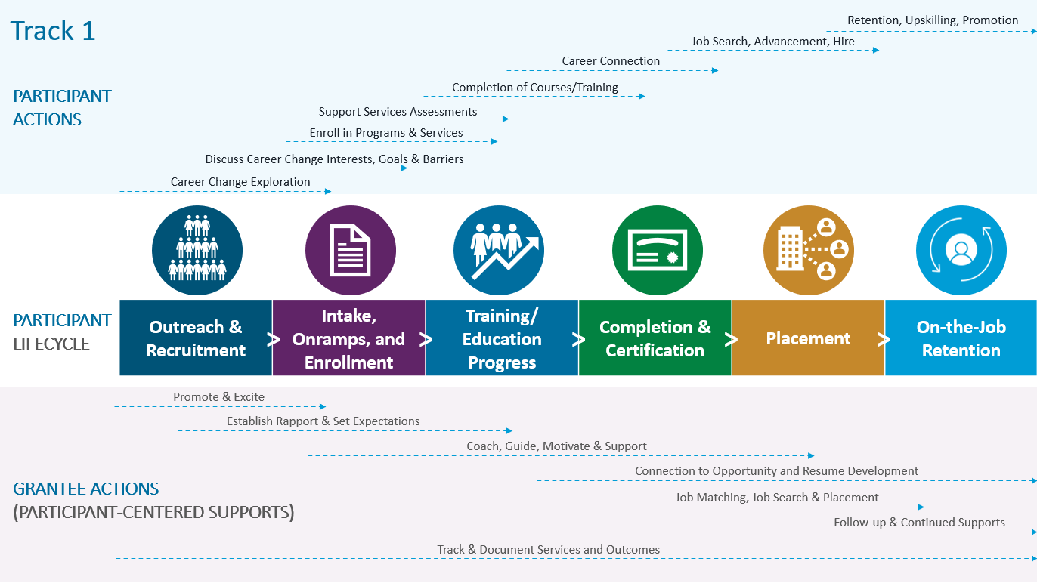

Table 2. Nursing Expansion Track 2 PSL
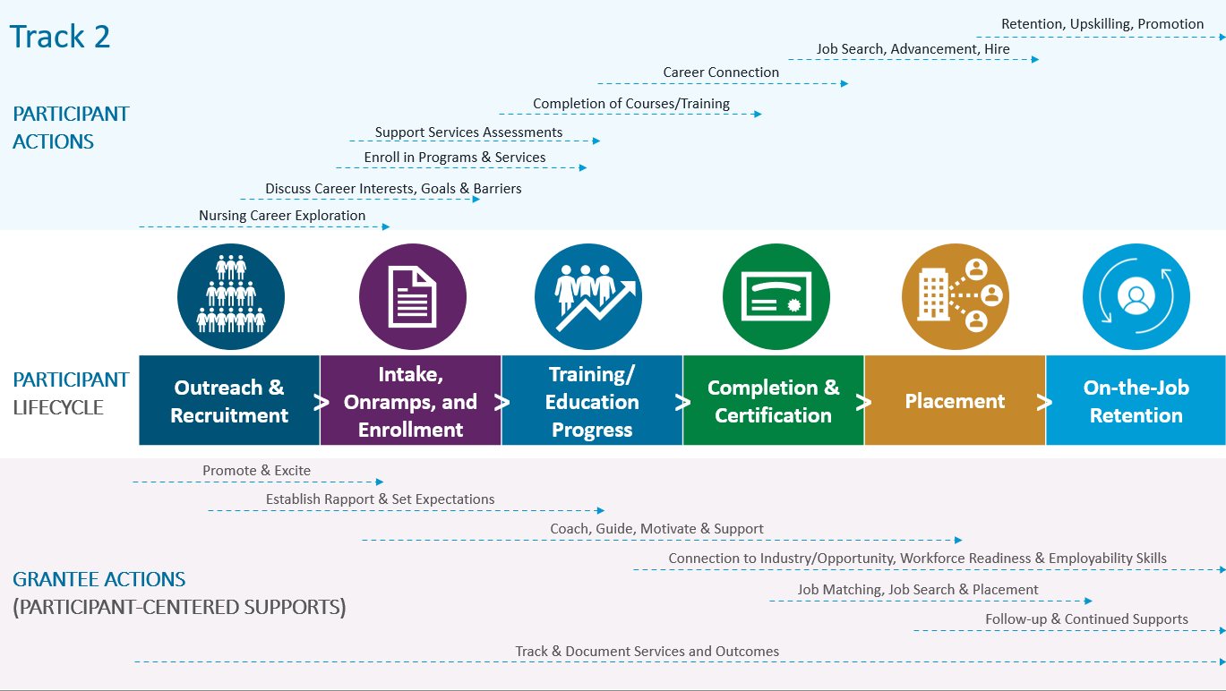

Using the PSL to Design Participant-Centered Supports

Step 1: Define/Refine Key Components and Milestones

In Step 1, grantees begin to align their own unique program design with the lifecycle model by identifying applicable participant activities for their programs that occur in each lifecycle phase. The purpose of this step is to assist grantees with understanding the strengths and challenges your grant is experiencing at each phase in the PSL.
Steps 1 and 2 below provide an example for each track of potential activities that may occur in each phase of the PSL. They may not exactly match your program design but are intended to give you an idea of the types of activities that may be involved in each phase. You may use this table as a jumping off point to design your own table that reflects your specific program.
Using the blank Step 1 table in this resource, add, delete, or rearrange activities under each phase of the PSL, as appropriate. As you look at the examples, ask yourself:
• Do these activities and milestones reflect our grant program/approach?
• Are there components missing? If so, add them. If the components already listed are not relevant, remove them from each phase/column.
• Are there components that should be shifted to different phases in the lifecycle? If so, shift them to the relevant phases.
When complete, the Step 1 table should reflect the realities of your specific program.

Step 1: Nursing Expansion Track 1 - Key Considerations & Components (SAMPLE)

Outreach & Recruitment | Intake, Onramps, and Enrollment | Training/Education Program Progress | Completion & Certification | Placement | On-the-Job Retention
- Outreach to promote opportunities  - Community connections and recruitment strategies  - Program/opportunity overviews and promotion  - Strategic recruitment targets and events | - Various onramps to programming  - Equity of access  - Intake processes  - Career Guidance  - Eligibility determinations  - Initial case management  - Assessment tools  - Info/data collection and expectations  - Assessment of barriers and supportive services  - Transition to training  - Tracking progress/ conversion to trainee/ student  - Enrollment, documentation of participant | - Required training/ education through 75% completion  - Learning progression  - Supportive services for retention/success  - Ongoing career and guidance counseling  - Identification of needed academic and resource interventions  - Tracking of process toward graduation  - Networking and peer connections | - Last 25% of courses  - Academic and career advising  - Career trajectory discussions – to employment or additional training/ education  - Connection to career opportunities  - Course completion  - Required exams and assessments  - Credential application and attainment  - Tracking and reporting of milestones and outcomes | - Connections to employers  - Resume prep  - Interview prep  - Job search  - Job acquisition  - Tracking of placement outcomes | - Retention for 3-, 6-, 9-, and 12-months  - Retention supports (career and supportive services)  - Upskilling  - Promotion along or across career pathways

Step 1: Nursing Expansion Track 1 -Key Considerations & Components (fillable TOOL)

Outreach & Recruitment | Intake, Onramps, and Enrollment | Training/Education Progress | Completion & Certification | Placement | On-the-Job Retention

Step 1: Nursing Expansion Track 2 - Key Considerations & Components (SAMPLE)

Outreach & Recruitment | Intake, Onramps, and Enrollment | Training/Education Progress | Completion & Certification | Placement | On-the-Job Retention
- Outreach to promote opportunities  - Community connections and recruitment strategies  - Program/opportunity overviews and promotion  - Strategic recruitment targets and events | - Various onramps to programming  - Equity of access  - Intake processes  - Career Guidance  - Eligibility determinations  - Initial case management  - Assessment tools  - Info/data collection and expectations  - Assessment of barriers and supportive services  - Transition to training  - Tracking progress/ conversion to trainee/ student  - Enrollment, documentation of participant | - Required training/ education through 75% completion  - Learning progression  - Supportive services for retention/success  - Practical application, work-based learning  - Ongoing career and guidance counseling  - Identification of needed academic and resource interventions  - Tracking of process toward graduation  - Networking and peer connections | - Last 25% of courses  - Academic and career advising  - Career trajectory discussions – to employment or additional training/ education  - Connection to career opportunities  - Course completion  - Required exams and assessments  - Credential application and attainment  - Tracking and reporting of milestones and outcomes | - Connections to employers  - Resume prep  - Interview prep  - Job search  - Job acquisition  - Tracking of placement outcomes | - Retention for 3-, 6-, 9-, and 12-months  - Retention supports (career and supportive services)  - Upskilling  - Promotion along or across career pathways

Step 1: Nursing Expansion Track 2 - Key Considerations & Components (fillable TOOL)

Outreach & Recruitment | Intake, Onramps, and Enrollment | Training/Education Progress | Completion & Certification | Placement | On-the-Job Retention

Step 2: Align with Metrics, Identify Potential Loss Points, and Brainstorm Strategies

In Step 2, grantees will use their own data to identify which lifecycle phases have current or potential loss points (places in your process and interactions where potential participants or participants drop out). You will record the actual numbers of potential participants/participants you are currently capturing at each phase to help you determine how many you are “losing” between each phase and strategize about how to address the challenges in each phase where you have loss points. Please note that data on potential participants is used only in phase one, Outreach and Recruitment.
The Step 2 table below provides an example of the process for completing this step in four columns: Data, Loss Rate/Risk, Challenges & Loss Points, and Potential Supports & Strategies. Use the blank Step 2 table in this resource to complete your own.
Column A: Data – Choose a time period (e.g., the last twelve months) and identify the number of potential participants and participants your program served in each phase using data on progress metrics you are collecting on your participants. You may have to estimate for the Outreach and Recruitment phase; just do your best. Enter that number in the box for each phase under “Column A: Data.” Note that based on the time period you select the data may not align with your Quarterly Performance Report (QPR) which shows data from the previous quarter and cumulatively. If you choose a time period other than cumulative, you will do the aggregating.
Column B: Loss Rate/Risk – Calculate the percentage of participants who continue to the next phase to determine the loss rate. You can determine this by dividing the number of participants in each phase by the number of participants in the previous phase. To determine the percentage that you lose in a phase, you can simply subtract that percentage from 100 percent (%).
- For example, if you have 100 people enrolled, but you only start 20 people in a training program, you’ll divide 20/100, which equals 20%. To get your loss percentage, you’ll simply subtract 20% from 100%. The equation looks like this: 100% - (20/100) = 80%. In this scenario, your loss rate would be 80%.
After calculating your loss rate percentages for each phase in the lifecycle, determine where your greatest risk is by looking at the highest percentages. These are the phases in which you have the greatest risk of losing participants. These phases may be where you would have the highest impact with improvement and interventions.
Column C: Challenges & Loss Points – Use the table you completed in Step 1 to identify the activities that take place in your program during the phases in which you have the greatest risk of losing them. Ask yourself the following questions to help identify potential challenges participants face as they receive these activities.
- Are there specific barriers to starting or continuing training/education activities during this phase?
- Are there processes that are confusing?
- Do participants in the previous phase understand what comes next and how to prepare for it?
- Do they know who to ask for help?
- Is help available?
Do not just guess; ask them! Ask both participants who are still in your program and those who have dropped out, if you can find them. Spend some time here to really understand the root cause of the problem. Enter these challenges in the box in Column C that corresponds to the correct lifecycle phase.
Column D: Potential Supports & Strategies – Knowing what you now know about your loss points, what are some potential strategies that can better support your participants and minimize loss points? Consider using the provided resources in Step 3 (and others), but also talk directly to your participants to find out what might aid in their success. Note: Checking in with staff who have contact with participants in a phase, including education and training partners or employers relevant to each phase in the lifecycle, might illuminate additional participant barriers and challenges.

Step 2: Capture Potential Participant Loss Points, Challenges, and Brainstorm Strategies (SAMPLE)
 | Column A: Data | Column B: Loss Rate/Risk | Column C: Challenges & Loss Points | Column D: Potential Supports & Strategies
Outreach & Recruitment | 350 | N/A | Not enough people know about the opportunity | Use social media, partner with community-based organizations
Intake, Onramps & Enrollment | 100 | Loss Rate: 71%  100% minus (Intake, Onramps & Enrollment/Outreach & Recruitment) | People have to work while in training so are not interested | Note: While this number seems high, it is common for this to be your highest number. There may be strategies you can implement to engage more participants
Training & Education Program Progress | 80 | Loss Rate: 20%  100% minus (Training & Education Program Progress/ Intake, Onramps & Enrollment) | People do not come back after initial appointment | Implement a follow-up call procedure to check in on potential participants
Completion & Certification | 40 | Loss Rate: 50%  100% minus (Completion & Certification/Training & Education Program Progress) | Participants are dropping out after week two | Have case manager in classroom in weeks one and two to understand participant barriers and provide support
Placement | 30 | Loss Rate: 25%  100% minus (Placement/ Completion & Certification) | Participants are not telling us if they are working | Offer incentives for successful placement, encouraging participants to contact with employment information
On-the-Job Retention | 25 | Loss Rate: 17%  100% minus (On-the-Job Retention/Placement) | Some participants are being terminated during their probationary period | Implement employability skills training into program

Step 2: Capture Potential Participant Loss Points, Challenges, and Brainstorm Strategies (fillable TOOL)
 | Column A: Data | Column B: Loss Rate/Risk | Column C: Challenges & Loss Points | Column D: Potential Supports & Strategies
Outreach & Recruitment | # | /A
Intake, Onramps & Enrollment | # | Loss Rate: %  100% minus (Intake, Onramps & Enrollment/Outreach & Recruitment)
Training & Education Program Progress | # | Loss Rate: %  100% minus (Training & Education Program Progress/Intake, Onramps & Enrollment)
Completion & Certification | # | Loss Rate: %  100% minus (Completion & Certification/Training & Education Program Progress)
Placement | # | Loss Rate: %  100% minus (Placement/ Completion & Certification)
On-the-Job Retention | # | Loss Rate: %  100% minus (On-the-Job Retention/Placement)

Step 3: Explore Resources and Promising Practices

Now that you have identified your greatest loss points, it is essential to develop your team’s knowledge, capacity, and toolbox to better address participant challenges.
In Step 3, you will continue to build on the strategies you identified in Column D of the Step 2 table. The table below provides resources across the PSL. Review this table to identify resources that may assist your strategy development during the targeted phases of the PSL in which you are experiencing high loss points. Identifying resources and tools will assist your team as you transition to Step 4: Plan for Action.
It is important to note that the lifecycle is a continuum, and resources may have impact across multiple phases.
Resources & Tools
Outreach & Recruitment | WorkforceGPS Resources:  - H-1B Rural Healthcare Success Stories & Promising Practices  - H-1B Rural Healthcare – Recruitment, Enrollment and Retention Strategies for Training Participants  - Maximizing the Power of Social Media for Recruitment and Engagement from the H-1B TechHire Community of Practice  Other Resources:  - Rural Healthcare Provider Retention Strategies from the Veteran’s Administration
Intake, Onramps & Enrollment | Community College Research Center at Teachers College, Columbia University Resources:  - Unpacking Program Enrollments and Completions with Equity in Mind  - Ask-Connect-Inspire-Plan: Reimagining Onboarding Framework  - Investing in Student Success at Community Colleges: Lessons from Research on Guided Pathways  College Completion Network Resources:  - Five Lessons to Consider When Supporting Returning Students  - Advising for College Success: Policies, Practices, and Programs That Support Students on the Path to College Completion  WorkforceGPS Resources:  - Nursing Expansion PSL Resources  - H-1B Rural Healthcare – Recruitment, Enrollment and Retention Strategies for Training Participants  - H-1B Rural Healthcare Grant Activities & Service Delivery
Training/  Education Program Progress | What We Are Learning About Guided Pathways from Community College Research Center, Teachers College, Columbia University  Implementing Healthcare Career Pathway Training Programs in Rural Settings from the Tribal Health Profession Opportunity Grants (HPOG) 2.0 evaluation team
Completion & Certification | Advising for College Success: Next Steps for Policymakers, Practitioners, and Researchers from the College Completion Network  Eight State Policy Recommendations That Support Postsecondary Credential Completion for Underserved Populations from Jobs for the Future  Four Ways to Increase the Value of Short-Term Credentials: A Guide for Community Colleges from Jobs for the Future
Placement | The Next Phase of Placement Reform: Moving Toward Equity-Centered Practice from Center for the Analysis of Postsecondary Readiness, Teachers College, Columbia University  WorkforceGPS Resources:  - H-1B Rural Healthcare – Participant Employment and Placement Resources  - Promising Practices for Participant Retention and Job Placement from the H-1B America’s Promise Community of Practice
Retention Resources | WorkforceGPS Resources:  - H-1B Rural Healthcare – Recruitment, Enrollment and Retention Strategies for Training Participants  - H-1B Rural Healthcare – Strategies and Resources to Improve Participant Retention

Step 4: Plan for Action

In Step 4, you will review the strategies you identified in Column D in Step 2 and, based on your research or additional review conducted in Step 3, you will determine which of the potential solutions your team would like to implement.
Below is a template you can use to begin planning for those identified solutions by mapping out the action steps needed to achieve them, who is responsible for implementing them, the time period during which the steps will be implemented, the expected result, and other resources or supports needed to complete the steps.
When identifying action steps, note that most solutions will have more than one step, so you will want to identify each step and how you will accomplish each one. In the “Expected Outcome and Impact” column, consider how this solution will affect your grant’s overall goals, performance, or specific metrics and other outcomes. Finally, in the “Additional Supports Needed to Achieve Success” column, identify any support the team might need to ensure the success of this intervention. This may include communication with or support from partners or internal leaders, training for your team, increased capacity/staffing, or various external resources or funding sources.
Add additional rows to the table for additional solutions and steps as needed.

ACTION PLANNING TEMPLATE
SOLUTION  Enter proposed solution | ACTION STEPS TO ACHIEVE  Identify each step needed | RESPONSIBLE PARTY(IES)  Identify who is responsible for each step | TIMELINE  Identify important milestones and the date by which the step will be accomplished | EXPECTED OUTCOME AND IMPACT  What will the overall impact be on your grant? | ADDITIONAL SUPPORTS NEEDED TO ACHIEVE SUCCESS  What else do you need to ensure this solution is successful?
Example:  Plan periodic case management onsite visits at training site to check in on participant barriers | Coordinate with training provider | Program Manager | By the end of next week | Help participants where they are before they drop out of class. Will impact training completion. Will enhance outcomes by building stronger relationships. | Need support of training institution and leadership buy-in to allow for offsite visits.
 | Rearrange schedule to be available during class every Tuesday | Case Manager | By the end of next week
 | Ensure equipment (laptop, Wi-Fi, etc.) to handle needs onsite | Case Manager & IT | Within the next two weeks

The Participant Support Lifecycle is loosely inspired by other evidenced-based research and tools, including Effective Case Management and Counseling- The Role of Triage and Documentation and the Understanding the Student Experience Through The Loss/Momentum Framework: Clearing The Path To Completion

