CURRENT AND LONG-TERM WORK TRENDS AMONG OLDER AMERICANS

A year ago I examined labor market trends among older Americans (55 and older) in some detail, including employment and unemployment. I have updated all these data through 2023, and added charts and several tables to make the trends easier to understand. Supporting data are attached above. The most important points appear in boldface purple. The Social Security section isn’t highlighted in this manner, but it should be read by those unfamiliar with the program.

The existing Current Population Survey (CPS) data (the best source) for some age brackets do not extend far enough back in time to be certain about long-term trends. However, these data can be supplemented using decennial census data, and I’ve taken advantage of IPUMS to examine employment trends from the mid-19th century to the time when the CPS series begins.

Work trends among older individuals vary the most depending upon age bracket and gender. Therefore, to separate out the impact of these factors, I examined narrow 5-year age brackets (except for those 75 and older), and the differences between women and men (which have narrowed considerably over time). Because I examined the detailed labor force and unemployment patterns not that long ago, and not enough time and change has occurred to alter conclusions about these topics, this narrative focuses exclusively on the employment-to-population ratio (referred to as the employment rate, for convenience). However, the attached spreadsheet above updates all the unemployment and labor force participation rate data through 2023, and includes age groups not discussed below (such as all those 55 and older, and 65 and older).

Summary. Historical changes in work behavior among older individuals have been as dramatic as the more widely known changes in paid work among women. In the mid-19th century, about 70 percent of men older than 75 worked. By the 1990s the rate was only about one-tenth of this, although it has subsequently risen to slightly more than 10 percent. For the elderly, overall employment rates (for both genders) fell from 1900 through the mid-1980s, then climbed until the 2020 pandemic, where they have stalled, likely temporarily. Some of the most important factors influencing work among older individuals are as follows.

Rising affluence reduced employment rates among older individuals for decades before the first Social Security Old Age Insurance payments began in the 1940s.

The increasing number and coverage of a wide variety of programs under the Social Security system – including disability income support – made retirement more likely, and employment rates lower, for older individuals through the 1980s.

The 1983 enactment of an increase in the age of full Social Security retirement benefits from 65 to 67 had an almost immediate impact on employment rates among the elderly, although this increase did not even begin to be implemented until 2003, and won’t be completed until 2027. By the mid-1980s, employment rates began to rise among all subgroups of individuals aged 55 and older. This was the first major reduction in the Social Security system, after decades of expansion and liberalization.

Improvements in public health measures and medical care lengthened U.S. life expectancy for at least a century and a half, which almost certainly meant that older individuals were in better health and therefore better able to work at older ages than their predecessors. More recent data on disability rates indicate a general decline in disability among older individuals until the pandemic. However, even a decade before the pandemic began, U.S. life expectancy had basically plateaued.

Within an international context, employment rates among older individuals have been increasing since about 2000, especially among 55 to 69 year-olds. Some of these countries have also raised their social security retirement age, but the median age for comparable countries is 65, two years less than the U.S. level. In fact, employment rates in many other countries for 55 to 64 year-olds now exceed U.S. levels. Therefore the U.S. increase in the Social Security normal retirement age cannot fully explain increased employment among older individuals. Average U.S. life expectancy is below the levels of dozens of countries, and the U.S. disadvantage widened as a result of the pandemic. Despite this, U.S. employment levels for the elderly are among the highest among advanced economies, only exceeded by Japan and Korea, and the relative U.S. position rises in the older age brackets.

The coronavirus pandemic in the U.S. has had the greatest impact in lowering employment rates among the elderly, as rates for individuals aged 55 to 64 had by 2023 reached historic peaks in the post-World War II period. For older individuals, among women except those 75 and older the pandemic diminution of employment is clearly a passing phase, although elderly men’s employment rates remain stalled. The pandemic impact for both men and women is clearest for those 75 and older, despite disability rates not continuing to increase for this age bracket in 2023. The U.S. is unusual among advanced economies in the pandemic reducing employment rates for the elderly, almost certainly because ineffective U.S. public health and vaccination pandemic strategies have made employment for the elderly much riskier in America than in otherwise comparable nations.

Throughout history women have worked, as have men, although the type of work they performed was typically strictly limited. When the Industrial Revolution dramatically increased the proportion of workers who were employees, traditional attitudes in most countries strictly limited the type of work thought appropriate for women, which significantly reduced their paid employment during the 19th century. When women’s overall paid employment rates began to steeply rise in the post-World War II period, this in turn had a persistent and significant impact upon overall employment rates among older individuals.

Disability income support programs (primarily Social Security Disability Insurance and Supplemental Security Income) have made it possible for some older individuals to effectively retire before they become eligible for Old Age Insurance benefits. However, the proportion of older individuals who receive such benefits has always been relatively low, and has diminished in recent years. Therefore it is unlikely that they reduced employment among older individuals, especially as employment rates for 55 to 64 year-olds continue to rise.

The post-World War II baby boom initially significantly lowered the average age of Americans, but has in recent decades dramatically increased it (aided by falling birth rates since the baby boom). This has nearly doubled the proportion of total employment constituted by those 55 and older, from 12 percent in the early 1990s to nearly 24 percent since 2019. This large share has made the U.S. economy much more dependent on older workers, and made it more difficult for employers to avoid hiring them, or to discriminate against them, although such discrimination remains a serious problem for older individuals. As the baby boom generation ages, retires and then dies off, the share of older workers in the workforce will decline, presenting some new challenges for the economy.

Peak employment rates for prime working-age 25 to 54 year-olds slightly exceeded 80 percent in 2000, and again in 2023. In comparison, the historic peak for 55 to 59 year-olds was about 7 percentage points lower, at 71.9 percent in 2023, falling much further to 56.7 percent for 60 to 64 year-olds in 2023 (also a historic peak). Unless coronavirus resurges, employment rates among such older individuals are likely to continue to rise, but are unlikely to match rates for prime-age individuals. The proportions fall much further for 65 to 69 and 70 to 74 year-olds, which haven’t returned to their pre-pandemic 2019 peaks of 33.3 and 19.1 percent, respectively (these peaks are lower than the 1950 levels). Fewer than 10 percent of those 75 and older work, with again a failure to return to the recent peak in 2019 of 8.8 percent (also below the 1950 level).

Contents | Page Number
PANDEMIC AND POST-PANDEMIC TRENDS | 3
Social Security overview | 3
Coronavirus Pandemic and Later | 4
LONG-TERM TREND BACKGROUND FACTORS | 8
Longevity (life expectancy) | 9
Share of the workforce comprised of older workers | 11
Health and disability among older individuals | 12
Old Age Insurance and disability income support programs | 14
Trends in receiving various types of income among older individuals | 15
EMPLOYMENT RATE LONG-TERM TRENDS | 18
Work among prime-age individuals | 18
Employment rates for older Americans | 19
Men’s employment | 21
Women’s employment | 22
Comparing male and female trends for older individuals | 24
INTERNATIONAL COMPARISONS | 27
Employment rates for the prime working-age population | 27
Employment in the approximate pre-retirement years of 55 to 64 | 28
Employment rates among the elderly | 29

PANDEMIC AND POST-PANDEMIC TRENDS

Because the pandemic impact is probably of the greatest importance to observers, I begin with the recent rather than the long-term trends. Work among older individuals is strongly influenced by the availability of Social Security, so we begin below with a basic explanation of some Social Security programs and policies.

Social Security is the most extensive social program in America, including the size of the beneficiary population. When people refer to Social Security, they generally mean Old Age Insurance, which is the primary retirement program. However, there are many other Social Security programs, including Disability Insurance and Supplemental Security Income (SSI), which some individuals effectively use as retirement programs until they become available for Old Age Insurance. In fact, some Social Security beneficiaries are children, as the program also provides benefits to orphans.

Currently, age 62 is the youngest that one can obtain Old Age Insurance through one’s own employment history. However, it should be kept in mind that many people retire before 62, typically because they believe that they cannot continue to work due to health or disability problems. Therefore some individuals who believe they can’t continue to work before reaching age 62 use Disability Insurance or SSI for income support: SSI includes a disability component. There are generally no age eligibility restrictions for Disability Insurance and SSI, although the former generally requires some work history, and a determination that the individual is generally no longer capable of working.

Old Age Insurance establishes age 67 as the “normal” retirement age -- normal only in the sense that retirement before that age reduces the benefit payment. The normal retirement age was formerly 65, but in 1983 Congress raised the retirement age to 67, although implementation didn’t begin until two decades later, is being phased in over nearly a quarter century, and won’t be complete until 2027. The raising of the retirement age is an important reason why individuals in their sixties began to work later in life, beginning in the 1990s.

Conversely, individuals who retire after age 67 (retire in the sense of applying for Old Age Insurance) obtain a higher benefit payment, although no additional bonus is given for those who retire after age 72.

The Coronavirus Pandemic and Later

The pandemic, which was widely recognized as a worldwide disaster by the public in March 2020, has had some major effects on work behavior among older as well as younger individuals. Except among those who could telework, working typically meant interacting with others, which was the major means by which the disease spread. Moreover, coronavirus was much more disabling and deadly among older individuals, which meant that those who continued to work took some risks about their health and even their life, and these risks increased with age.

Unsurprisingly, this caused some older individuals who economically didn’t need to work to withdraw from the labor force, although it was unclear at the time whether such a withdrawal was temporary or permanent. By 2024 we have a clearer picture of the longer-term impact of work. However, it should be kept in mind that isn’t always easy for individuals to stop working and then later find a job, and it is much more difficult for elderly individuals to do so.

For older individuals who were working, their later course from 2020 onward could follow one or more of the following developments.
- They left the labor force and then remained out of it, and essentially retired.
- They continued to work, but may have retired sooner than they otherwise would have because of concerns about coronavirus.
- They withdrew from the labor force for a time, then returned to work once coronavirus subsided (it continues to be a threat).
- They withdrew from the labor force, but then were unable to find a job despite desiring one, and therefore retired involuntarily.
- COVID-related disability caused a cessation of work (since 2021, disability rates have generally been rising among the elderly).
- They continued to work.

The charts in later sections show the pandemic and post-pandemic impact upon employment rates in the context of long-term patterns, but the tables below compare 2023 levels compared to the pre-pandemic 2019 averages, and the narrative on the right side of the tables explains the general patterns between 2019 and later. The pattern is somewhat complicated, and to make it easier to follow the detailed age cohorts are separated into three basic categories:
- pre-retirement (64 and younger, although as noted previously many of these individuals have already retired),
- typical retirement years (65 to 69), and
- post-retirement years (70 and older).

This classification scheme shows that some age groups follow clear patterns, while for others the impact differs for women versus men. The first table below shows the totals, and the following two show the gender-specific trends.

General patterns. The pandemic recession laid off a greater proportion of the labor force than any downturn since the Great Depression, but fortunately the recovery took much less time to begin. Therefore employment rates fell among individuals of all ages, not just the elderly.

Note that the age brackets used by BLS and the Census Bureau don’t coincide with the Old Age Insurance age brackets (which, as noted above, have themselves changed over time). Social Security isn’t mandatory, although its rules provide strong economic incentives to either continue to work or to retire, depending upon individuals’ specific age. Consequently there remains some element of personal choice in whether individuals continue to work or not, irrespective of their age.

One recent element not involving complete discretion is coronavirus-related disability. This is difficult to accurately measure. Because the disease was much more deadly among those with a pre-existing disability, and for the elderly in general, it decreased the number of persons with disabilities by killing them. However, coronavirus also increased the number of persons with disabilities, especially via persistent coronavirus symptoms (commonly called “long COVID”). The CPS data show that among the elderly – unlike for younger cohorts – disability rates continued to rise significantly in 2023, albeit at a lesser pace than in 2022 (a .4 percentage point rise, compared to .9 points in 2022). The rise in disability rates has been concentrated among 65 to 69 year-olds (and female 70 to 74 year-olds), as by 2023 disability rates were stable or declining among those 75 and older.

A special CPS disability supplement will be conducted in July 2024 that includes a specific question about persistent disability caused by coronavirus, which will hopefully enable us to have a better understanding of the impact of this disease upon disability.

One of the simplest patterns occurred among older individuals of typically pre-retirement ages, 55 to 64 (the first two groups shown in the tables). By 2023, their employment rates had at least returned to 2019 averages, and in most cases surpassed the 2019 levels. This pattern also occurred among the 25 to 54 year-old individuals generally considered to be of prime working age. To summarize, the pandemic has not persistently reduced the employment rate among older individuals who are in the immediate typical pre-retirement years.

A relatively simple but opposite pattern occurred among individuals of the typical retirement ages of 65 to 69 (recalling that the “normal” Old Age Insurance age is 67, at which age an applicant suffers no reduction in their benefit amount). For both men and women, the 2023 employment rate remained below the 2019 level. However, as the rate for women continued to vigorously rise through 2023, it is likely that the pandemic impact in reducing work is a temporary one. In contrast, there was no rise in men’s employment for this age bracket, suggesting that the pandemic impact may be more persistent among men.

The pandemic impact is more complicated for individuals of typical post-retirement ages, varying both by gender and by the age sub-categories. For 70 to 74 year-olds, women’s employment rates had by 2023 exceeded the 2019 level, and continue to vigorously rise. By contrast, men’s 2023 level remained well below that of 2019, and there was no increase between 2022 and 2023. The effect of the pandemic seems most clear among both women and men for those 75 and older, as employment rates remain below 2019 levels through 2023, and only for women in 2023 did a tiny increase occur. Through 2022 for women, and 2023 for men, employment rates for this age group continued to drop. As is shown by the colored table below, disability rates for both men and women appear to no longer be increasing in 2023 for this age group. This perhaps means that fear of coronavirus, rather than actual disability or deaths (which have been declining), is driving the reduction in employment at this point. If both death and disability rates remain stable or decline, this may prompt a return to the previous pattern of rising employment rates for this group of the oldest of the elderly.

Age group (men and women) | Employment to population ratio (%) |  |  | Conclusions |  |  | Trends
 | 2019 | 2023
Generally pre-retirement ages |  |  |  | The earliest SS retirement age is 62, although there’s a financial penalty for early retirement. Individuals can also effectively retire via receipt of one of the SS disability benefit problems (Disability Insurance or Supplemental Security Income). Note that many individuals retire at these ages, usually because of ill health or disability.
55 to 59 | 71.0 | 71.9 |  | 2019 level slightly surpassed by 2022 |  |  | Continuing to vigorously rise
60 to 64 | 56.0 | 56.7 |  | 2019 level matched by 2022 |  |  | Continuing to vigorously rise
Typical Social Security retirement ages |  |  |  | The SS retirement age with no penalty is now 67 for new retirees, and after that age individuals receive a bonus for delaying their retirement for ages 68 through 72, but no bonus for retiring later than age 72.
65 to 69 | 33.3 | 32.4 |  | Apparently clear pandemic effect of withdrawing from the labor force |  |  | 2022 and 2023 levels were identical (i.e., no trend)
Typical post-retirement ages
70 to 74 | 19.1 | 18.6 |  | Still significantly below pre-pandemic level, but effect may be temporary |  |  | Continuing to vigorously rise
75 and older | 8.8 | 8.0 |  | Apparently clear pandemic effect of withdrawing from the labor force |  |  | 2022 and 2023 levels were almost identical (.1% point rise, i.e., no trend)
Age group (men) | Employment to population ratio (%) |  |  |  | Conclusions | Trends
 | 2019 |  | 2023
Generally pre-retirement ages
55 to 59 | 77.0 |  | 77.0 |  | 2019 level matched by 2022 | Continuing to vigorously rise
60 to 64 | 62.0 |  | 62.6 |  | 2019 level almost matched by 2022 | Continuing to vigorously rise
Typical Social Security retirement ages
65 to 69 | 38.3 |  | 37.0 |  | Apparently clear pandemic effect of withdrawing from the labor force | .6% point drop between 2022 and 2023
Typical post-retirement ages
70 to 74 | 23.4 |  | 21.7 |  | Apparently clear pandemic effect of withdrawing from the labor force | 2022 and 2023 levels were identical (i.e., no trend)
75 and older | 11.8 |  | 10.7 |  | Apparently clear pandemic effect of withdrawing from the labor force | Small drop each year between 2021 and 2023

Age group (women) | Employment to population ratio (%) |  | Conclusions | Trends
 | 2019 | 2023
Generally pre-retirement ages
55 to 59 | 65.3 | 66.8 | 2019 level well surpassed by 2022 | Continuing to vigorously rise
60 to 64 | 50.5 | 51.2 | 2019 level almost matched by 2022 | Continuing to vigorously rise
Typical Social Security retirement ages
65 to 69 | 29.0 | 28.3 | Still significantly below pre-pandemic level, but effect may be temporary | Continuing to vigorously rise
Typical post-retirement ages
70 to 74 | 15.5 | 15.9 | 2019 level not surpassed until 2023 | Continuing to vigorously rise
75 and older | 6.6 | 6.0 | Apparently clear pandemic effect of withdrawing from the labor force | Fell between 2021 and 2022, then rose by .2% points in 2023
Source for all three of the above tables: BLS, annual averages of monthly Current Population Survey (CPS) data

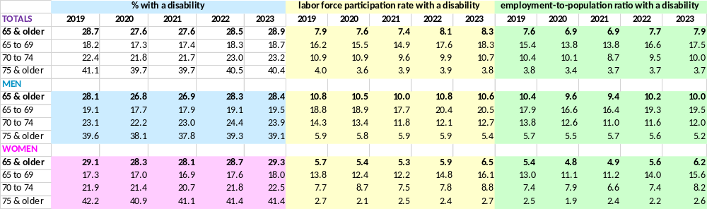
Source: BLS unpublished tables

LONG-TERM TREND BACKGROUND FACTORS

Although many people obtain satisfaction from paid work, certainly for the income and also often from psychological rewards, very few people wish to work until they die. Moreover, most people wish to pursue their own desires and sometimes even whims, and not those of their employer or boss. These are basic human traits that can be taken as a given.

However, other influences governing work among older individuals are much more variable, especially over history. The most important of these are

- longevity – obviously people cannot work if they don’t remain alive into old age;
- reasonably good health, and the extent to which individuals have disabilities, especially severe ones (health and disability don’t always coincide);
- whether individuals can continue to pursue the kind of work they performed when younger;
- societal attitudes toward work, especially those involving age and gender;
- how remunerative work is, especially compared to other sources of income such as private sector pensions, government assistance, and personal savings;
- employer policies and practices governing work for older employees, including hiring them; and
- relatively rare situations, such as major wars and pandemics, that can temporarily have tremendous influence on whether older individuals work.

Historically, some of the major influences upon work among the elderly include

- the end of slavery, allowing for the first time such freed older individuals some ability to choose to work or not;
- rising affluence, which allowed individuals to retire, or for their families to support their retirement;
- the introduction of governmental Social Security, especially Old Age Insurance and multiple disability income support programs;
- the rise – and subsequent decline – of private sector pension benefits;
- changing societal attitudes toward work among the elderly, first a widespread belief that they were entitled to retire, and more recently a growing belief that elderly individuals should continue to work;
- radical changes in general views about women and work, which also affected their tendency to work at older ages;
- government support for care of infirm older individuals (apart from income support), as many individuals otherwise capable of paid work must assist infirm family members (a task that disproportionately falls upon women, in part because of their greater longevity); and
- sufficiently adequate health insurance such that individuals’ income aren’t drained through medical costs.

People tend to take the relative generosity of some of the above factors for granted, assuming that they will necessarily continue, but this is unwarranted. There has been a movement for decades to privatize Old Age Insurance, and continuing efforts to raise the retirement age (despite U.S. life expectancy first plateauing, and then declining). Many elderly individuals can retire and live apart from their families, but this only occurred because of affluence and more generous government programs. Without these supports, elderly individuals would be dependent on their families. Prior to social security benefits, families often resented the burden of their non-working elders, and sometimes severely neglected and even gradually starved them to death to reduce or eliminate that burden (this has been documented in France, but presumably occurred in America as well). The continuing aging of the U.S. population will almost certainly breed greater resentments toward them in the future, and such attitudes have already been emerging for some time.

Similarly, the attitudes of employers and other individuals in power are not necessarily kindly toward the elderly, and their proclivity to take advantage of their weakness is only restrained by active enforcement of legislation, which often necessitates private legal action by older individuals themselves. It is noteworthy that as long ago as the sixth century, the saint Symeon Stylites the Younger highlighted older individuals as special targets for oppression, identifying the basic attitudes of the powerful as, “I will oppress the pauper, I will not spare widows, nor will I respect the grey hair of the old man…for weakness is exposed as useless.”

The following analysis will consider only the most important of the above factors. We will first review some of the most important background trends, then present employment rates by age, and attempt some explanations for these trends.

Longevity. The prevalence of old age itself should not be taken for granted, and was an anomaly throughout most of human history. Average U.S. life expectancy at birth was only 38 years in 1850 (see the chart below), not radically greater than the approximately 30 years estimated at the upper range for the ancient Roman empire. Wars, diseases, and economic depressions can significantly reduce life expectancy, as shown in the chart below for the post-Civil War Period, the 1918-1920 flu pandemic, the Great Depression, and to a lesser extent the coronavirus pandemic.

The chart also shows the potential impact of Social Security’s Old Age Insurance program (which is what most people mean when referring to “Social Security”) on longevity itself, as life expectancy became much less erratic once Social Security benefits began to be paid in the 1940s.

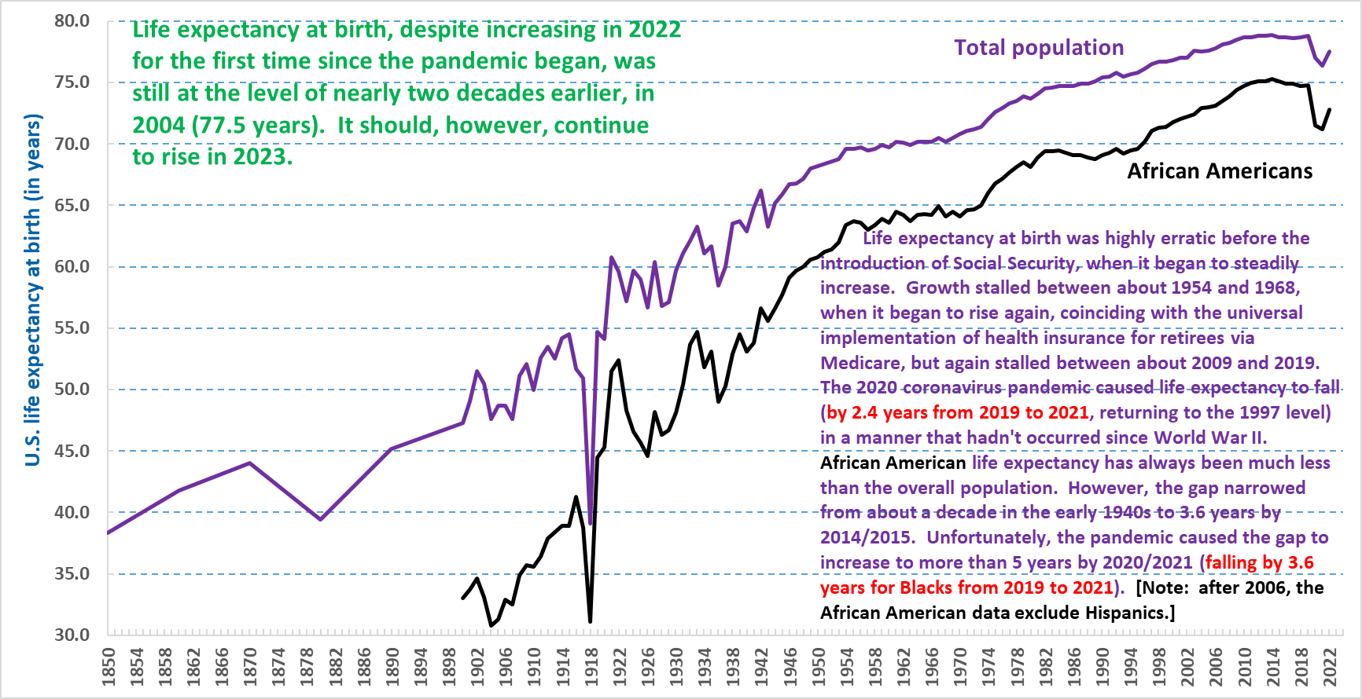
Sources: U.S. National Center for Health Statistics (NCHS) and Historical Statistics of the United States, Millennial Edition (2006)

The deadliest mass death events in U.S. history are shown below, led by the Civil War and the 1918 pandemic, followed by the coronavirus pandemic – adjusted for population size. Mass deaths can have greatly varying impacts upon different age groups, with wars often much more deadly for young men (except for modern total wars, which can kill huge numbers of civilians), and diseases sometimes most deadly for differing age groups. For example, the coronavirus pandemic was most dangerous for older individuals, whereas the 1918 flu pandemic tended to strike young adults.

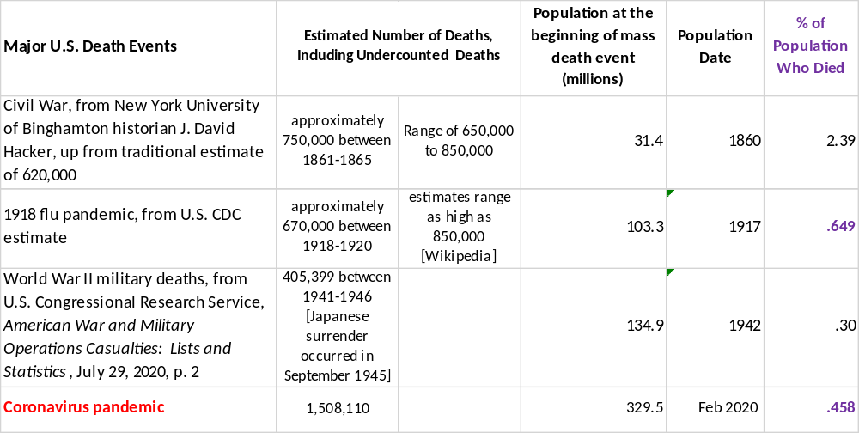
Various sources, including U.S. Census Bureau, U.S. Center for Disease Control and Prevention (CDC), and academic studies

Throughout most of history women have lived shorter lives than men, and only began to live longer in approximately the first half of the 20th century. Their advantage improved significantly in the post-World War II period, as shown in the chart below. Once women became more likely to enter the paid workforce, this greater longevity attained greater significance in influencing employment rates among older individuals.

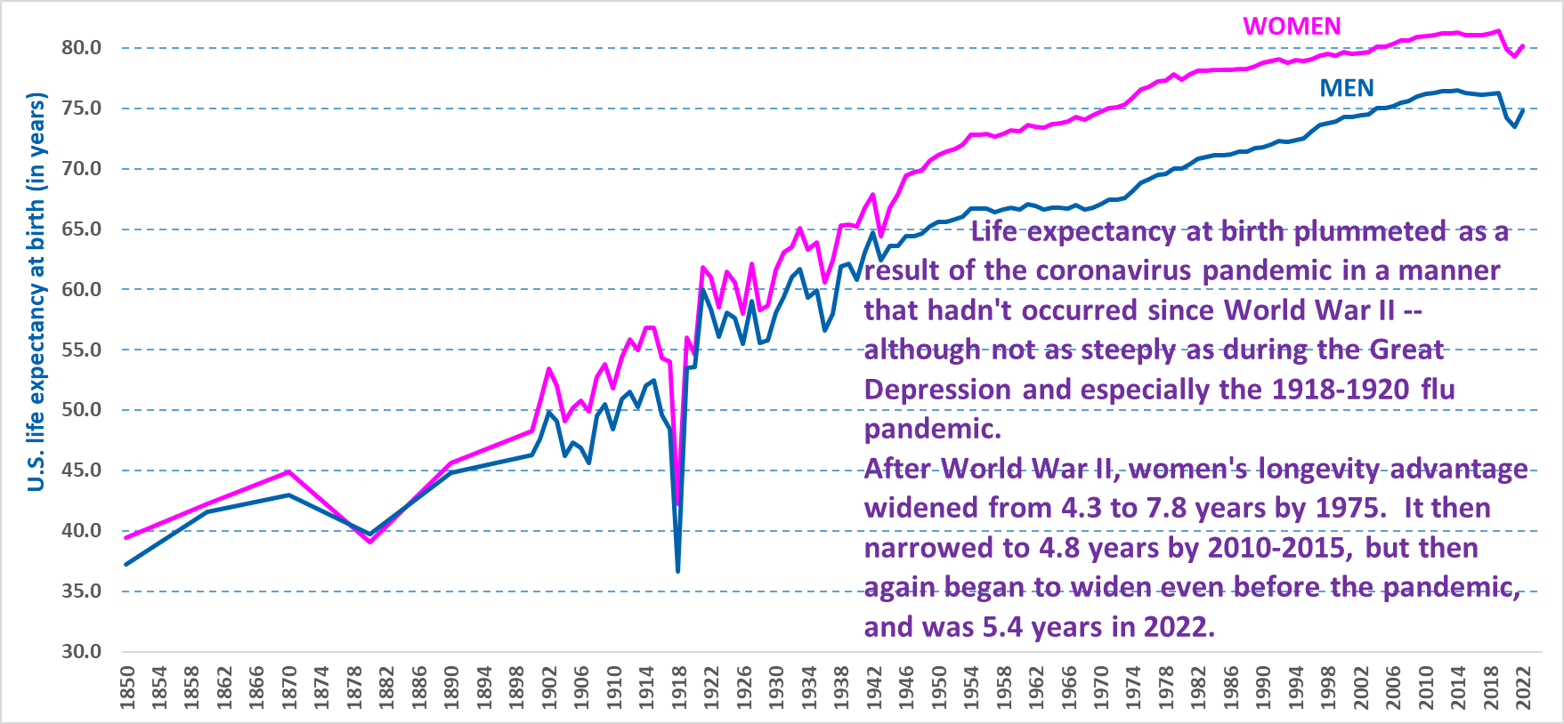
Sources: U.S. National Center for Health Statistics (NCHS) and Historical Statistics of the United States, Millennial Edition (2006)

In the U.S., life expectancy plateaued for a decade prior to the pandemic, a trend that is characteristic even of the most advantaged group – non-Hispanic Whites. The pandemic then caused life expectancy to drop to the levels of about two decades previously. Longevity levels began to recover in 2022, but it seems unlikely that they will ascend in the manner that occurred for most of the 19th and 20th centuries. Therefore, this factor alone will limit the growth of the older workforce.

The share of the workforce comprised of older workers. Most observers focus on employment rates among older individuals, but the sheer size of the older workforce has important implications alone. For example, if older workers constituted a relatively tiny share of the total workforce, this would allow employers greater scope to ignore and even discriminate against them. However, as the share of older workers rises, employers have much less discretion to avoid hiring them, or to lay them off. The chart below focuses on the post-World War II period, when longevity began to significantly increase the size of the elderly population.

The share of the workforce comprised of older individuals depends upon both the age distribution of the overall population, and the propensity of older individuals to work. The Great Depression and World War II led to significantly lower birth rates, which resulted in a large U.S. birth spurt following the war (although this didn’t occur in many other countries), popularly referred to as the baby boom. This huge population has moved through the workforce in a wave-like manner, first significantly lowering the age of the workforce, then increasingly aging the workforce beginning in the mid-1990s, when the youngest of the baby boom generation entered their fifties. The pandemic temporarily interrupted this expansion, but as discussed above, its effect is likely to be temporary if no further resurgence of coronavirus occurs.

The impact of the baby boom generation nearly doubled the proportion of total employment constituted by those 55 and older, from 12 percent in the early 1990s to nearly 24 percent since 2019. This large share has made the U.S. economy much more dependent on older workers, and made it more difficult for employers to avoid hiring them, or to discriminate against them, although such discrimination remains a serious problem for older individuals.

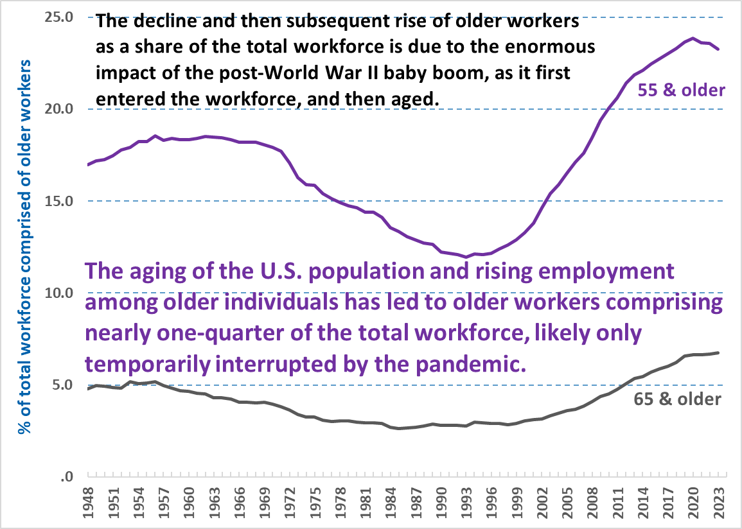
Source: U.S. BLS, annual averages of the monthly Current Population Survey (CPS)
A good example of the changes associated with the aging of the workforce is the evolving changes in hiring patterns in the very large retail trade industry. In the post-World War II period, retail trade employers at first moved toward reliance upon part-time, disproportionately teenage workers. However, over time employers became increasingly prone to hiring older individuals for such jobs, an occurrence that had formerly been a rarity. When many older individuals withdrew from the workforce during the pandemic, this again allowed younger workers greater opportunity to work in retail trade jobs, which was an important reason why they had one of the best labor market experiences during the pandemic.

The baby boom generation will of course become a diminishing and then disappearing factor in the workforce, and even the youngest of this generation are now older workers. This will have the effect of reducing the proportion of older individuals in the workforce. Moreover, even if employment rates continue to rise among older individuals, as long as Old Age Insurance persists, they will continue to have much lower employer rates than prime-age individuals.

Health and disability among older individuals. Another factor limiting work is the fact that health and disability problems increase with age, a pattern that begins as early as individuals’ mid-thirties. The best source on this point is the BLS National Longitudinal Surveys: the most relevant and up-to-date one followed individuals born between 1957 and 1964 (the younger half of the baby boom generation) as they aged.

The basic patterns as these individuals aged are shown in the table and chart below. Given the questions asked by this survey, it is likely to encompass both health and disability impediments that limit the kind of work individuals can perform (bearing in mind that limitations don’t necessarily mean that individuals could not perform some types of work).

Generally, with each decade of aging after age 34, the likelihood of health limitations upon work roughly double. African Americans and high school dropouts are by far the most likely to experience health limitations on work, especially the latter. These effects are so extreme that high school dropouts are more likely to experience such limitations at age 44 than are Whites and men in general who are a dozen years older. By age 56, nearly half of high school dropouts have experienced a limitation upon the work that they can perform. Less educated individuals are much more likely to perform manual labor, and are much less likely to be hired for the kind of white collar jobs that wouldn't necessitate manual labor – therefore work limitations for this group make it much less likely that they can find suitable work at all. The increasingly widening disparity is most easily visualized in the chart below the table.

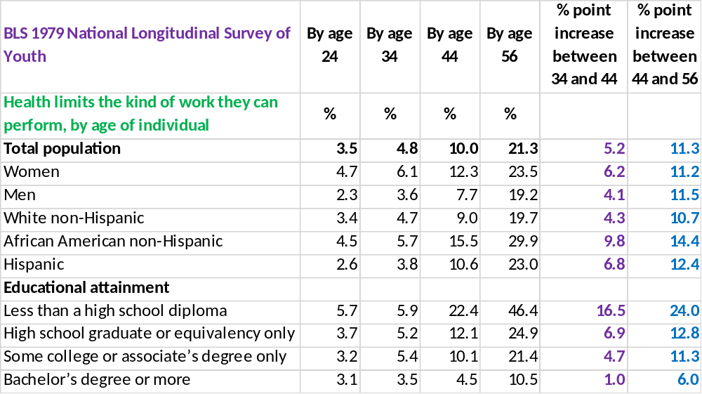
Source: BLS National Longitudinal Survey of Youth, 1979
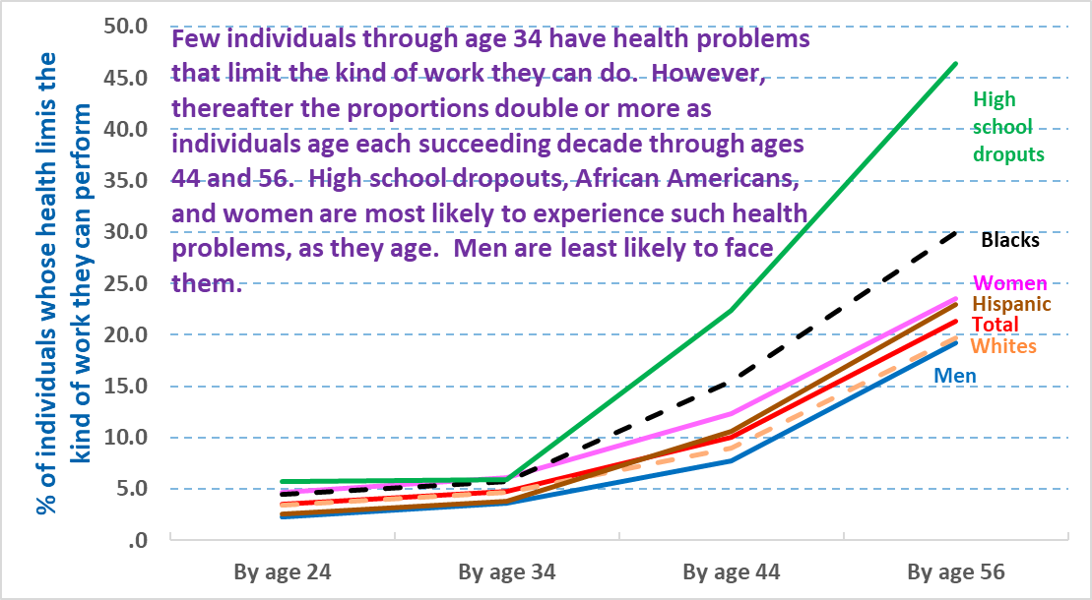
Source: BLS National Longitudinal Survey of Youth, 1979

However, a notable countervailing trend is that disability rates prior to the pandemic had been falling within each age subgroup of older Americans, suggesting that older Americans were relatively healthier than their past cohorts.

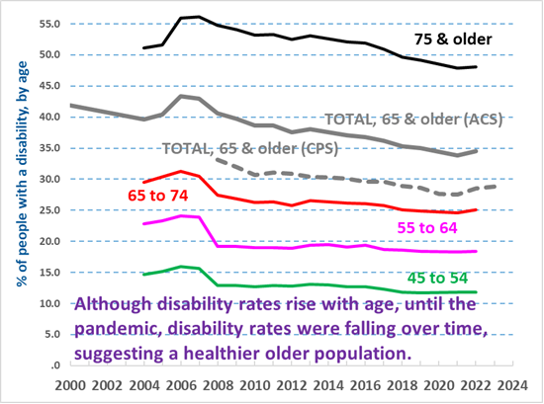
Sources: U.S. Census Bureau, American Community Survey (ACS) and annual monthly averages of the Current Population Survey (CPS) for 65 and older only
Old Age Insurance and disability income support programs. The enactment of the Social Security Act of 1935 made it possible in the U.S. for former workers to retire and not risk economic catastrophe. The United States was a latecomer to governmental old age insurance, pioneered in Germany in the late 1880s, and only the Great Depression supplied the necessary support to inaugurate this program in America.

As shown in a chart below, elderly employment rates had been declining since about 1900, some four decades before Old Age Insurance payments were first made (not until the 1940s, despite the 1935 enactment, and Social Security taxes were implemented before any benefits were paid). Moreover, even after the full implementation of Old Age Insurance, employment rates rose among 55 to 64 year-olds (some of which were eligible for early retirement at age 62, beginning in the early 1960s) in the immediate post-World War II period. Nonetheless, Old Age Insurance made it possible for employment rates to continue to decline among the elderly through the mid-1980s, and even among 55 to 64 year-olds from about 1970 through the mid-1980s.

Concern about the solvency of the Old Age Insurance program led to the Social Security Amendments of 1983, which raised the age of full retirement benefits from 65 to 67. This marked the first major retrenchment in the Social Security program, which had until then expanded over many decades. However, in likely the most delayed legislative implementation in American history, the retirement age only began to be raised two decades later, in 2003, and won’t fully rise to age 67 for nearly another quarter century after that, in 2027. It is extremely unlikely that most Americans were fully aware of these details, although general understanding of the increase was widely known. The eligibility year for early retirement remained at 62. The benefit amounts are structured in such a way that the precise age of retirement affects the permanent benefit of the retiree, so that individuals who retire between 62 and 66 received a reduced pension, and individuals who retire at 67 received the full pension, whereas individuals who delay their retirement until the ages of 68 through 72 receive an amount higher than the full pension. Thus older individuals have an incentive to delay their retirement until 67, and an even greater incentive to delay retirement until age 72 – although after 72 no additional bonus is paid.

The increase in the age of full retirement Old Age Insurance benefits, combined with a radical diminution of private sector employer pensions, has had a major impact on enhancing employment among older individuals, as detailed below.

Several other income support programs play a potentially important role in the labor market behavior of older individuals. All arose after the creation of Social Security, and the most important are two disability income support programs that are part of the Social Security system.

Although early retirement under the Old Age Insurance component of Social Security is only possible at age 62, surveys indicate that those who have retired gave a median age of retirement of 59. Thus although older Americans through age 64 have increased their employment rate (see the attachment above), a significant proportion do not work, including some who consider themselves retired.

One means of in-effect retiring prior to age 62 is to obtain disability benefits through the Social Security Disability Insurance (DI) or Supplemental Security Income (SSI). The Disability Insurance program began making payments in 1958, and SSI in 1974. Both were intended to fill gaps in the Social Security system. Disability Insurance provides assistance to those who have a history of working (similar to the design of Social Security Old Age Insurance), but could no longer work and were too young to retire: the initial eligibility ages were 50 to 64 (later lowered). SSI assists those who are disabled but lack the work history necessary to receive Disability Insurance. SSI also provides income support to all individuals 65 and older who either aren’t eligible or don’t receive sufficient income via the Old Age Insurance component, but in this analysis the focus is restricted to non-elderly adult SSI recipients (the program also provides some support to those younger than 18, also not included here except in the first chart below).

Trends in receiving various types of income among older individuals. Older Americans generally have access to more varied types of income than their younger adult counterparts, due to both their age and greater likelihood of infirmity. The most significant and generous social programs are part of the Social Security system. It should be kept in mind that this system encompasses numerous programs and types of benefits, and that individuals can obtain Social Security benefits not only via their own work history, but because they are spouses (or former spouses) of beneficiaries, widows or widowers, or survivors of beneficiaries. Therefore although the age of early retirement is 62, individuals well below that age – even young children – can obtain Social Security benefits under qualifying circumstances. This explains why a small proportion of the 55 to 59 year-olds in the chart below receive Social Security income.

Using the Census Bureau’s annual supplement to the Current Population Survey (CPS, the same survey used to report national income and poverty statistics) allows a consistent examination of Social Security receipt over more than three decades. As shown below, for all individuals 60 and older, receipt of Social Security benefits tended to drop during the 1990s, and the decline accelerated beginning in the early 2000s, especially among the 60-64 and 65-69 year-olds who were most affected by the gradual rise in the full retirement age from 65 to 67 (a process not yet completed). This suggests that raising the age of full retirement benefits has had and presumably will continue to have a major impact on employment rates among older individuals. In fact, as explained in the next section, the higher full retirement age seems to have influenced employment rates among older individuals well before the Old Age Insurance changes began to take effect.

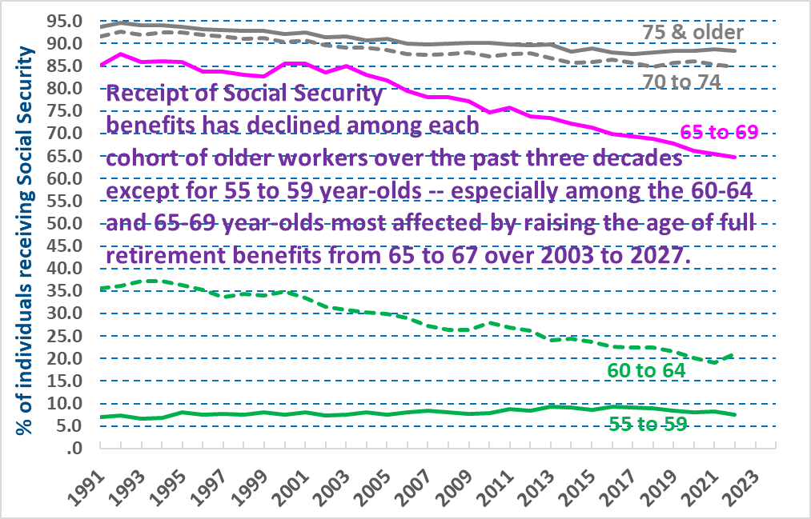
Source: U.S. Census Bureau, Current Population Survey (CPS), Annual Social and Economic Supplement

Recipient trends for total Disability Insurance recipients who formerly worked, and for SSI blind and disabled recipients, are shown below. During a relatively brief period in the first half of the 1990s, both programs served nearly the same number of persons with disabilities, although the Disability Insurance program has always served more persons with disabilities, and the gap significantly widened after the mid-1990s. However, as shown, both programs peaked in about 2013/2014, and have significantly diminished since then.

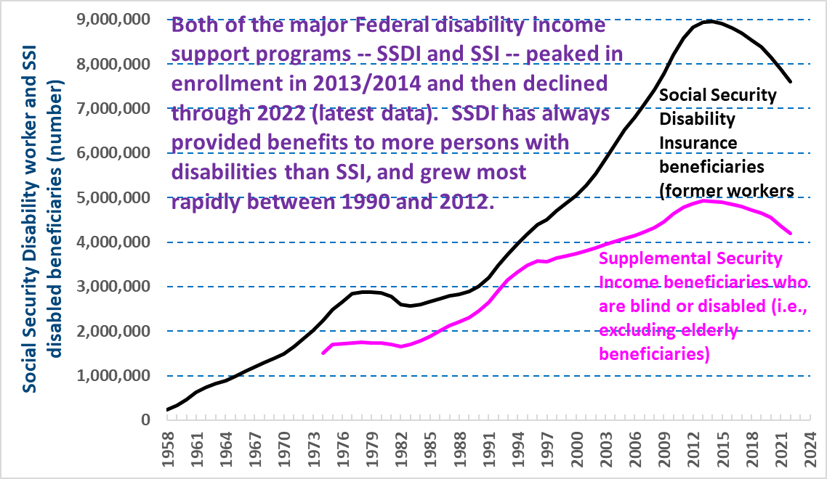
Source: U.S. Social Security Administration

Both disability income support programs have tended to serve an older population over time. This trend, combined with a rising number of beneficiaries, increased recipiency in the latter half of the 1990s through roughly 2012. However, thereafter recipiency rates declined for all age groups younger than 65, beginning somewhere between 2013 and 2018, depending upon the age bracket. The increase among those 65 and 66 occurred for the obvious reason of raising the full retirement age from 65 to 67 (over the 2003 to 2027 timeframe): prior to 2003, such individuals weren’t eligible for Disability Insurance, and would instead have been covered by Old Age Insurance.

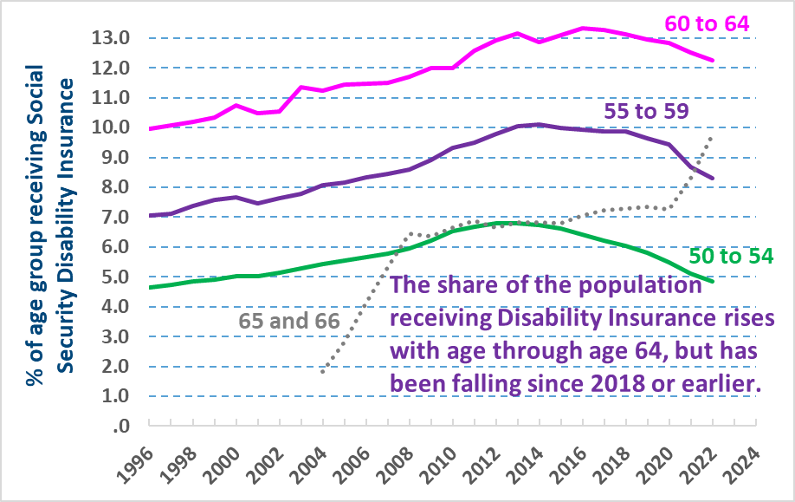
Sources: Social Security Administration administrative data, and Census Bureau Current Population Survey (CPS) Annual Social and Economic Supplement population data
The available recipiency rates (covering a shorter timeframe) for SSI appear in the chart below. They show very little change since the early 2000s, and no consistent trend over time, although recipiency rates have recently declined for 60 to 64 year-olds, and have leveled off for beneficiaries in their fifties.

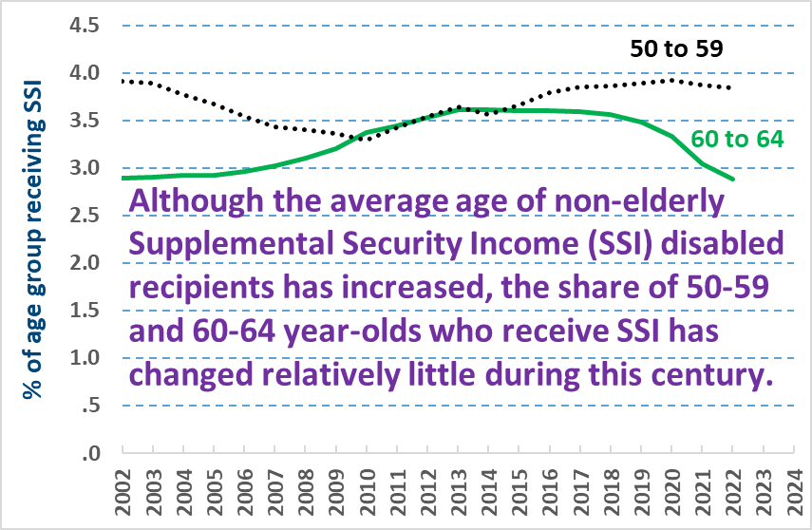
Sources: Social Security Administration administrative data, and Census Bureau Current Population Survey (CPS) Annual Social and Economic Supplement population data

To summarize, both of the major income support programs for non-elderly persons with disabilities (DI and SSI) peaked in their number of recipients about a decade ago, and neither are received by more than a relatively small share of older Americans younger than 65/67. Thus it is unlikely that the disability income support programs have been an important factor among older individuals in creating disincentives for employment, and whatever disincentives existed must now be waning. The recipiency rate among older individuals with disabilities would of course be higher, although it is well known that employment rates for persons with disabilities have historically been so low that disability income support programs cannot be the primary cause of this pattern.

A different Census Bureau survey (the Survey of Income and Program Participation, or SIPP) allows us to examine assistance from several other major government programs, including the Supplemental Nutrition Assistance Program (SNAP, formerly called Food Stamps) and the two major governmental health insurance programs, Medicare and Medicaid. SNAP provides quasi-income, although certainly not in amounts that could support retirement. Moreover, older individuals are less likely to receive SNAP than younger adults, and recipiency rates among older individuals are too low to have likely influenced employment behavior (nor is there any consistent trend in recent years).

The age of eligibility for Medicare is 65 (unaffected by the increase in the full retirement benefit age). Recipiency rates for Medicaid have significantly increased among older individuals younger than 65, as shown in the first panel below.
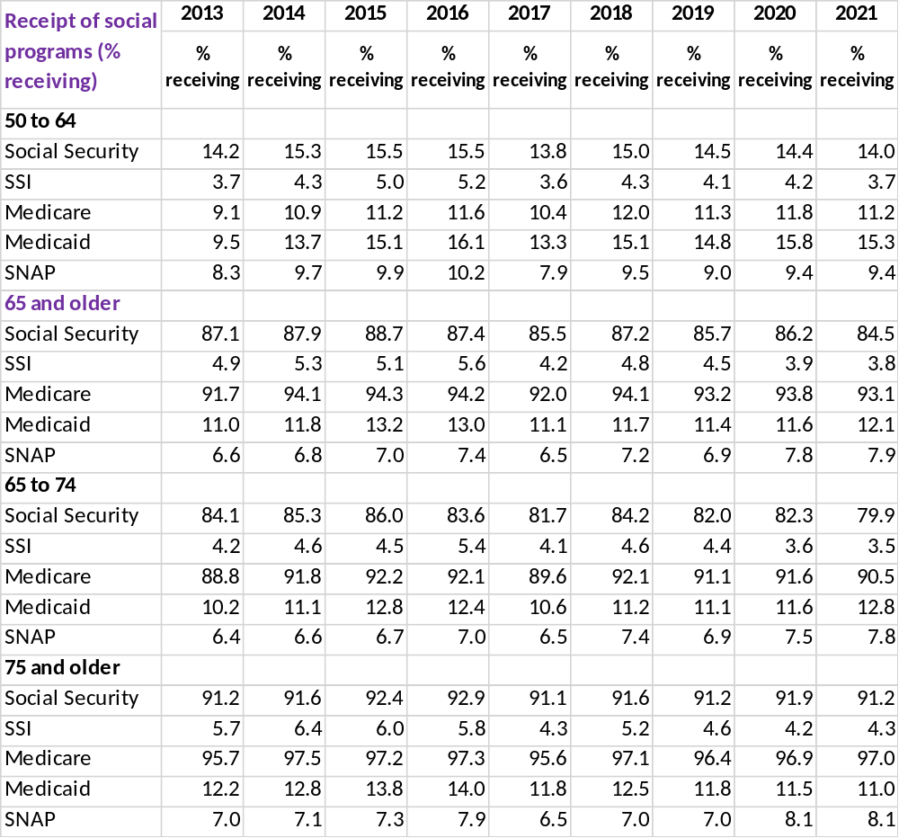
Source: U.S. Census Bureau, Survey of Income and Program Participation

EMPLOYMENT RATE LONG-TERM TRENDS

Using decennial census and Current Population Survey data, employment-to-population ratios (employment rates, using shorthand) can be tracked over about a century and three quarters. This section summarizes the changes, and incorporates the factors described above and others to explain trends and potential future implications. The final section below compares U.S. to international trends, using countries that are similar to America and selected others tracked by the Organisation for Economic Co-operation and Development (OECD) or the European Union (via EuroStat).

Work among prime-age individuals. We first describe work patterns for younger Americans, which enhances our understanding of labor market behavior among older Americans. By age 24 most individuals have completed their schooling, and therefore the 25 to 54 year-old age group is commonly used to track patterns among what are usually referred to as the prime employment years. The major change over time has been increased paid employment among women, a historical convergence with men which reached its current status by about 2000, as shown in the chart below. Peak employment rates for this age group slightly exceeded 80 percent in 2000, and again in 2023. In comparison, the historical peak for 55 to 59 year-olds was about 7 percentage points lower, at 71.9 percent in 2023, falling much further to 56.7 percent for 60 to 64 year-olds in 2023 (also a historic peak). Unless coronavirus resurges, employment rates among older individuals are likely to continue to rise, but are unlikely to match rates for prime-age individuals.

As discussed in the final section below, U.S. employment rates for prime working-age individuals are now below those of many other countries, in contrast to the pre-eminent position of the U.S. circa 2000.

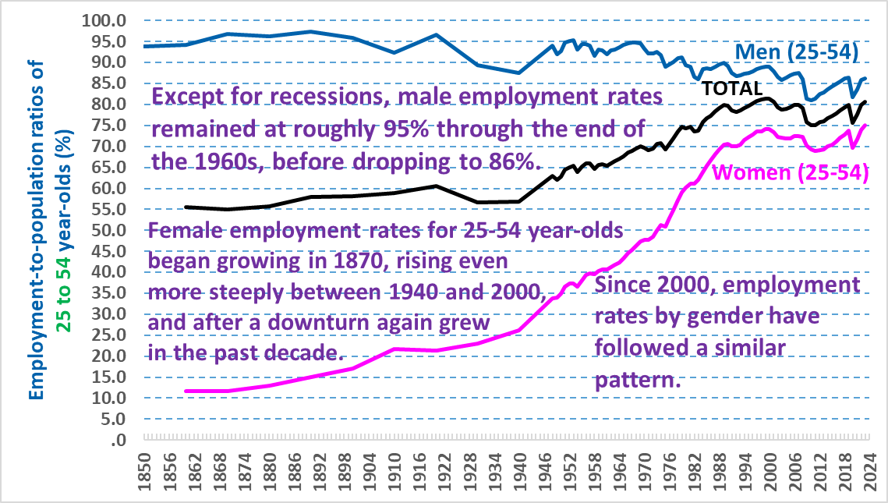
Sources: U.S. Census Bureau, decennial censuses, 1850 through 1940; BLS, annual monthly average from the Current Population Survey (CPS) for 1948 forward

Employment rates for older Americans. We first describe overall trends among older individuals, then track patterns separately for men and women within narrower age cohorts.

Employment rates among the elderly have changed much more over time than for those aged 55 to 64. In the immediate post-Civil War period, nearly half of 65 to 74 year-olds worked, but from about 1900 onward the proportion of elderly individuals in both cohorts more or less steadily dropped, as shown in the chart below. As Social Security Old Age Payments didn’t begin until the 1940s, the most likely cause of the decline in the first four decades of the 20th century is rising affluence.

The implementation of Old Age Insurance undoubtedly facilitated the decline from 1940 forward, aided by liberalized benefit rules, and the later additions of Disability Insurance and SSI.

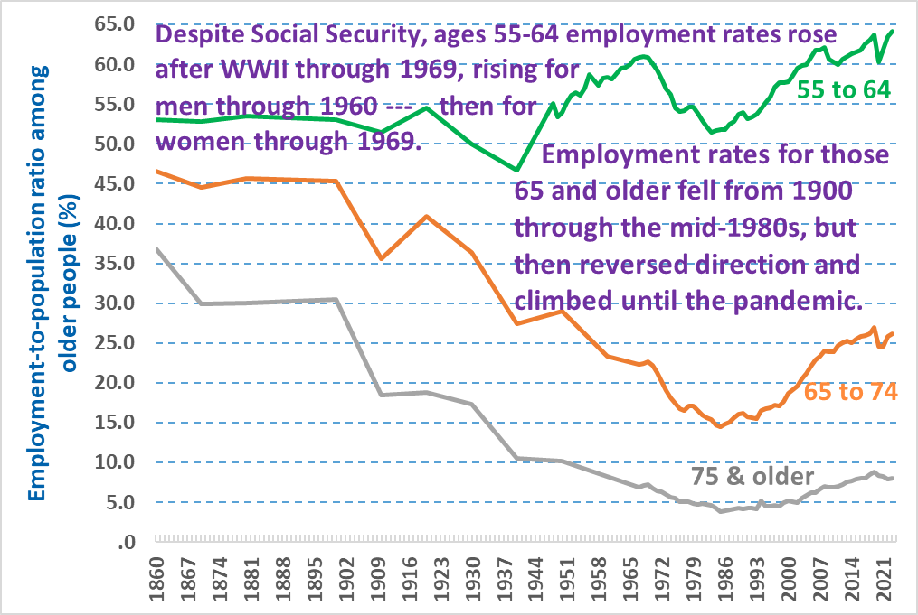
Sources: U.S. Census Bureau, decennial censuses, 1860 through 1960; BLS, annual monthly average from the Current Population Survey (CPS) for 1948 forward for ages 55 to 64, and for 1967 forward for ages 65 to 74, and 75 and older

The situation for 55 to 64 year-olds is more complex, with generally stable employment rates for decades longer – approximately through 1920, then falling rates during the 1920s -- presumably attributable to this being a decade of rising affluence until the Great Depression. Employment rates then continued to drop during the Great Depression, and the subsequent rise after the Depression suggests that this further decline wasn’t voluntary.

Thereafter the employment pattern for 55 to 64 year-olds radically diverged from lessening employment rates among their elderly counterparts. For this generally pre-retirement age bracket, employment rates not only recovered to their pre-Depression level, but continued to rise through the end of the 1960s to levels not seen since the 19th century. This initially seems puzzling given Old Age Insurance, but the explanation is due to the absence of an early retirement benefit at age 62, not introduced until the early 1960s, and the mass entrance of women into the paid workforce. Men’s employment for the relevant 60 to 64 year-olds began to plummet at this point, but the continued rising employment among women especially in their late fifties, and to a lesser extent in their early sixties, sustained an overall rising employment trend for 55 to 64 year-olds through the end of the 1960s. Thereafter employment rates for both female cohorts dropped, causing an overall decline among both genders until the mid-1980s.

A historically major reversal began in the mid-1980s, when employment rates again rose for those aged 55 to 64, and more significantly among the elderly -- the first time such an increase had occurred in American history. Although as discussed below increases in employment among older individuals later occurred in most advanced economies, the most likely explanation for the earlier U.S. rise is widespread public knowledge of the increase in the normal Social Security retirement age, enacted in 1983. As explained above, this increase didn’t even begin to be implemented until the early 2000s, most Americans were likely unfamiliar with these details, but instead simply understood that they were going to need to delay their retirement or risk lower Social Security payments.

Employment rates continued to increase among older individuals, albeit with interruptions for 55 to 64 year-olds during the so-called Great Recession that began in 2007, until a more pervasive interruption of this trend during the pandemic, as discussed above.

Men’s employment. Apart from recessions, employment rates tended to remain relatively stable among older men during the late 19th century, but then began to decline around 1900, four decades before the first Old Age Insurance occurred, even apart from the impact of the Great Depression.

As shown in the chart below, in the mid-19th century, virtually all men – about 95 percent – worked through the age of about 64, and even through 69 more than 90 percent worked. Even at 75 and older, about 70 percent of men worked. Because men either had to or were expected to work until old age, their declining employment rates for the half century between 1870 and 1920 – decades before the introduction of Social Security – strongly suggest that rising American affluence enabled a growing number of elderly men to retire than had previously been possible. Occasional declines were likely involuntary, caused by severe economic depressions in the early 1900s, a pattern more obviously revealed later during the Great Depression, but occasional recessions cannot explain a clear pattern over so many decades.

Post-World War II employment rate declines among elderly men – in contrast to the opposite pattern for men aged 55 to 64 – highlights the likely cause of Old Age Insurance, as early retirement at age 62 wasn’t introduced until the early 1960s. The increase of employment rates among elderly men that began to occur in the mid-1980s is likely part of the general pattern discussed above. The rise in rates among men in their early sixties didn’t begin until about a decade later, in the mid-1990s (men in this age bracket were perhaps more keenly aware that the increase in the retirement age hadn’t yet taken effect).

The pattern for men in their late fifties strikingly differs from that of older men, showing considerable stability – apart from recessions – from the mid-1980s through the present. Men in this cohort exhibit roughly a similar pattern to prime-age working men, who also show reasonably stable patterns over the same interval, apart from economic downturns.

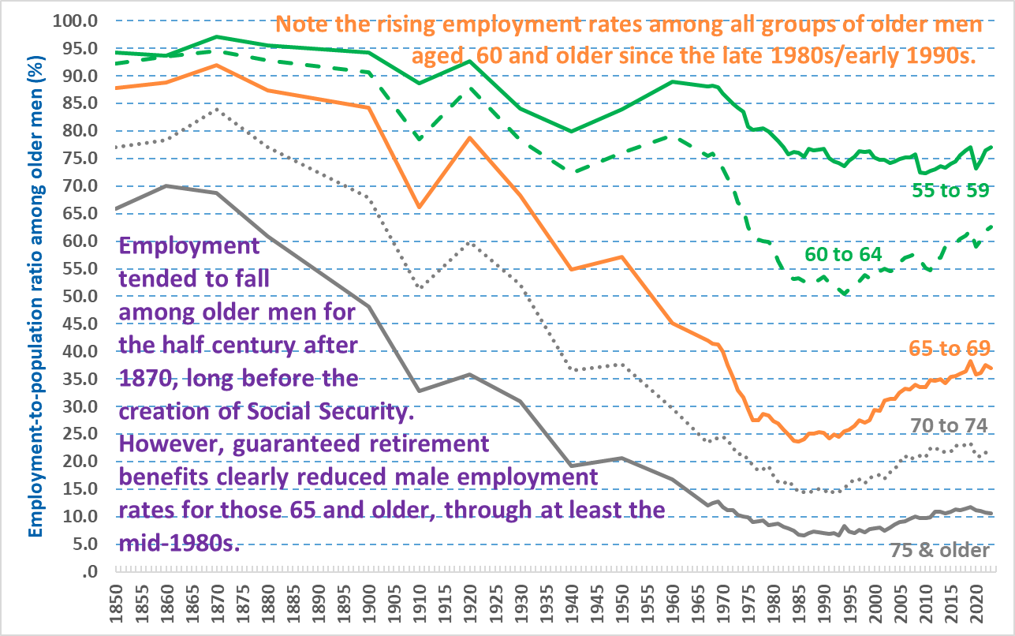
Sources: U.S. Census Bureau, decennial censuses, 1850 through 1960; BLS, annual monthly average from the Current Population Survey (CPS) for 1967 forward

Women’s employment. In stark contrast to men, very few women held paid employment during the mid-19th century – typically 10 percent or less. This began to change in the last two decades of the century, rising to nearly 20 percent for women in their late fifties by the century’s end.

Thereafter from about 1900 employment rates among older women either stagnated or fell, a trend that preceded the Great Depression.

The pattern differed for prime working-age women, whose employment rates rose from about 1870 onward, even between 1930 and 1940 (while the rate for men fell -- see the chart above). However, as through 1940 no more than about one-quarter of such women held paid jobs, they were much less likely than men to obtain Old Age Insurance payments when these began in the 1940s, and they were much more likely to receive Social Security payments as the spouses or widows of men.

This situation began to radically change during World War II, when a large number of women held paid employment to support the war effort, at a time when 16 million men and 380,000 women were in the military. Female civilian labor force participation rates rose from 20 percent in 1940 to about one-third in each of 1943, 1944, and 1945. The war’s impact was not as great for older women, whose labor force participation rate rose from 16.3 to 21.3 for women 45 and older between 1940 and March 1944 (the closest age bracket available for older women in 1944).

Rising paid employment rates continued after the war’s end, and the impact was especially dramatic among women in their late fifties, whose rates steeply rose from 18 percent in 1940 to nearly half of all women in this cohort by the end of the 1960s. The trend was less steep for women in their early sixties, but it rose sharply as well through 1970, as shown in the chart below. Employment rates then stalled and for some cohorts dropped for about the next two decades (repeating the same pattern of the early 20th century), before again rising significantly for all age groups except those 75 and older.

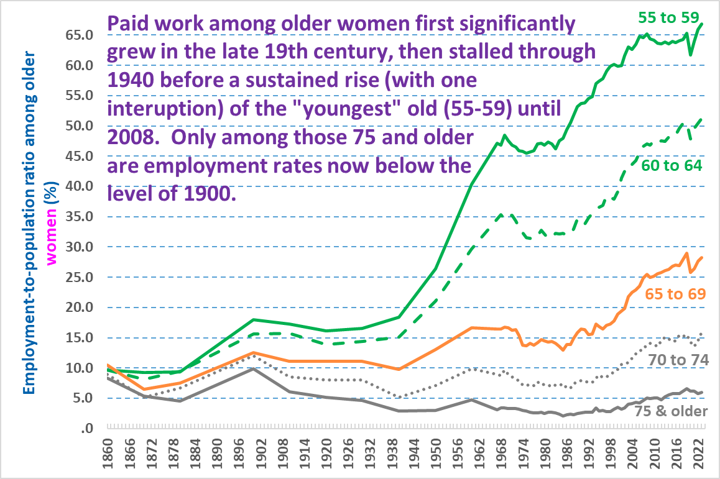
Sources: U.S. Census Bureau, decennial censuses, 1860 through 1960; BLS, annual monthly average from the Current Population Survey (CPS) for 1967 forward

Given their rapidly expanding paid employment rates, which made a much larger proportion of women eligible for Old Age Insurance based upon their own employment history than had previously been the case, it is possible that some proportion of the stalled/declining employment rate pattern after 1970 was due to their eligibility for Social Security. This would of course not explain the drop for women in their late fifties, however.

Comparing male and female trends for older individuals. Because employment patterns among older women reflect the countervailing impacts of more pervasive feminist attitudes toward paid work (which raised employment rates) and eligibility for Old Age Insurance (which lowered employment rates) -- in contrast to the simpler societal trends behind older men’s employment rates -- directly comparing female/male trends for each age cohort can be revealing. It should also be kept in mind that because many women and men live in married-couple households, their individual labor market decisions are often determined with the experiences and income of their partner in mind. Once women became much more likely to have employment careers, it isn’t surprising that some couples reconfigured general roles in which women were sometimes more likely to work than men. In general, men are likely to be somewhat older than their female partners (and also more likely to die sooner, based upon both their older age and lesser life expectancy), and such factors also influence decisions about whether to remain employed later in life.

The series of five charts below tracks female/male differences for each age cohort. In general, the patterns reflect falling male employment rates for every cohort, although the pattern differs for women. Through roughly age 74, women’s employment rates rose during the post World War II period – although to a much lesser degree for 70 to 74 year-old women, whose increase also occurred much more recently. For women 75 and older, there has been relatively little change in employment rates over the past century.

The trends for each cohort are summarized in the heading in each chart below.

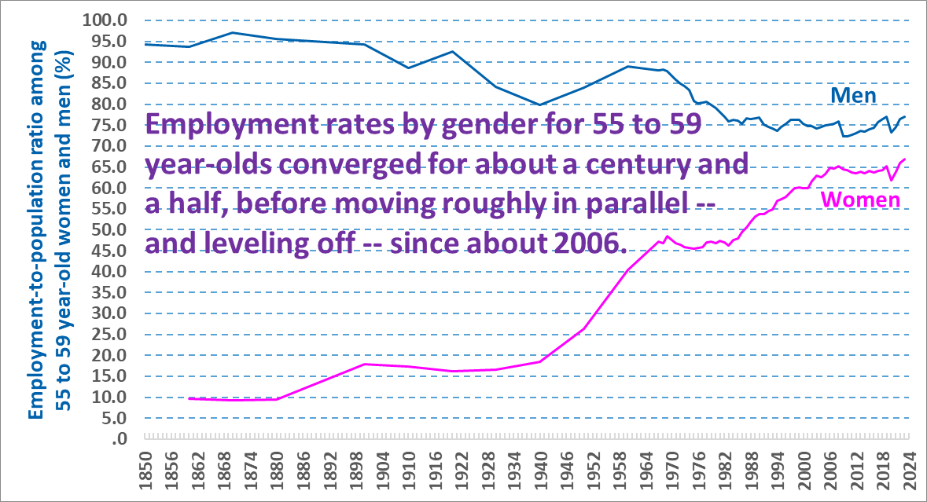
Sources: U.S. Census Bureau, decennial censuses, 1850 through 1960; BLS, annual monthly average from the Current Population Survey (CPS) for 1967 forward

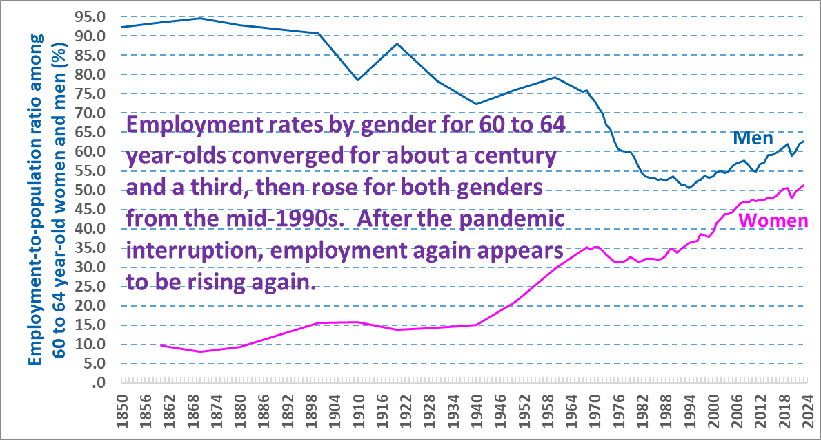
Sources: U.S. Census Bureau, decennial censuses, 1850 through 1960; BLS, annual monthly average from the Current Population Survey (CPS) for 1967 forward

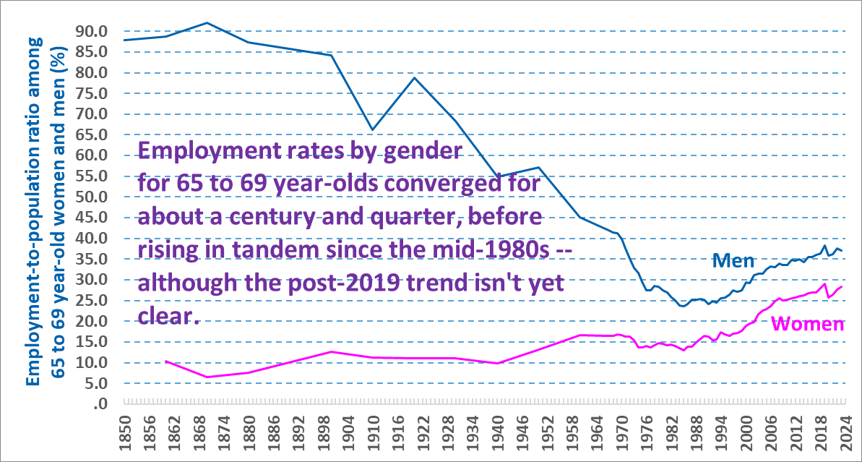
Sources: U.S. Census Bureau, decennial censuses, 1850 through 1960; BLS, annual monthly average from the Current Population Survey (CPS) for 1967 forward

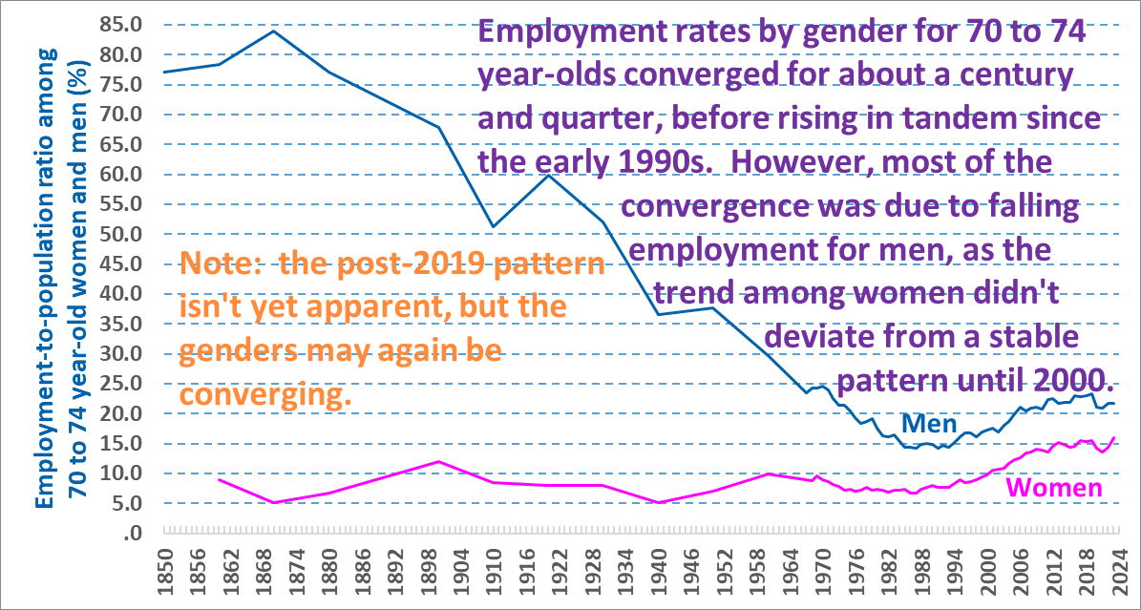
Sources: U.S. Census Bureau, decennial censuses, 1850 through 1960; BLS, annual monthly average from the Current Population Survey (CPS) for 1967 forward

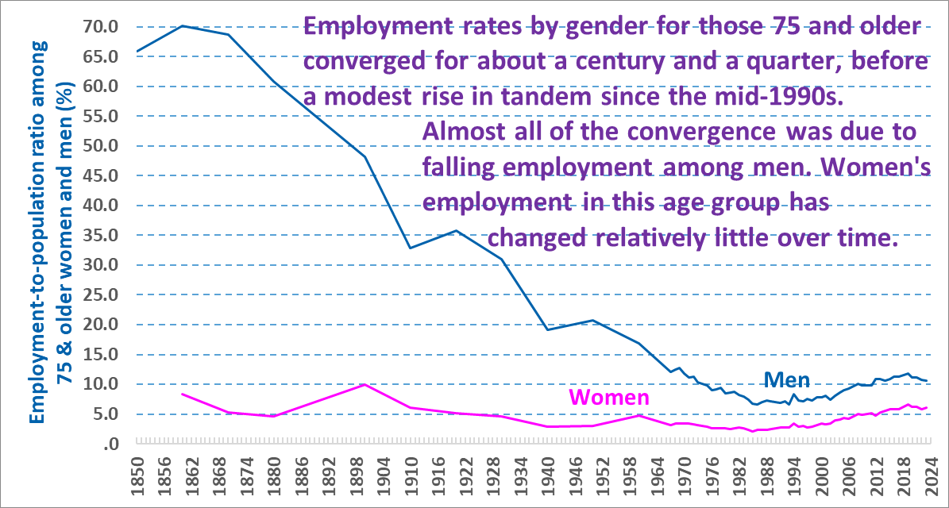
Sources: U.S. Census Bureau, decennial censuses, 1850 through 1960; BLS, annual monthly average from the Current Population Survey (CPS) for 1967 forward

INTERNATIONAL COMPARISONS

In an international context, the U.S. performance is poor in terms of life expectancy at birth, its relatively high normal age of retirement, and the difference between the retirement age and life expectancy. The “International” tab of the first attachment above shows basic background and selected trends for several dozen countries, including the world’s advanced economies. We first review international trends in several key areas, placing the U.S. patterns within that context, and then present more detailed findings by age group.

Better public health policies and improved medical care have raised life expectancy at birth throughout the entire world. Unfortunately, the U.S. average is significantly below the average for the several dozen countries tracked (3.7 years below the median for 2021/2022), and the U.S. position deteriorated as a result of its poor public health policies during the pandemic. As noted above, even for the decade prior to the pandemic, U.S. life expectancy had stagnated for about a decade.

The median normal Social Security retirement age for the countries tracked is 65, with a median early retirement age of 62. Several countries have raised their normal retirement age because of growing longevity, with Denmark’s age 74 at the high end. Somewhat surprisingly, the two most prosperous East Asian countries with extremely high employment rates for the oldest of the elderly – Japan and Korea – have a relatively low normal retirement age of 65. The future normal U.S. retirement age of 67 is two years above the median country.

By comparing life expectancy with the normal retirement age, we can estimate the relative generosity of various countries in terms of the expected duration of Social Security benefits for individuals: median life expectancy at birth is nearly 15 years higher than the median Social Security retirement age. This is significantly greater than the 10.5 years in the U.S., 4.3 years less than the median country. Moreover, this U.S. disadvantage exists despite the relative wealth of the U.S., which has a per capita GDP more than double that of the median country.

Employment rates for the prime working-age population. Several decades ago the U.S. had one of the highest employment rates among the major advanced economies for 25 to 54 year-olds. For the last half of the 1990s (when we begin to have relatively complete data for the countries tracked), the U.S. employment rate was about three percentage points above the median country for the prime working-age population. However, beginning in 2001 the U.S. superiority significantly diminished, so that in the immediate pre-pandemic years the U.S. level was roughly 2 percentage points below the median country, and its position dropped further as a result of the pandemic, to 4.0 percentage points lower in 2022. This relative decline is depicted more clearly in the chart below against selected countries whose economy and government are similar to the U.S.

This trend is somewhat surprising, given the prevalent misconception in the U.S. that the generosity of government benefits in many other countries has discouraged employment there.

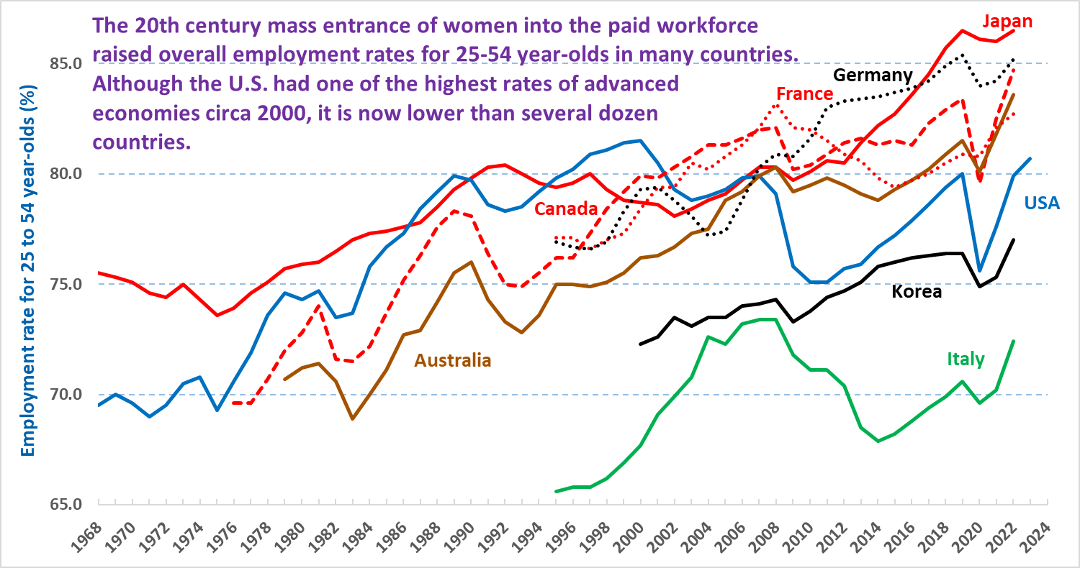
Sources: Eurostat, OECD and BLS customized data tools; and country-specific sources

Employment in the approximate pre-retirement years of 55 to 64. Another common misconception in the U.S. is that America is one of the world’s leaders in employment among older individuals. This was generally true several decades ago, and as late as 2004 the U.S. employment level for this age bracket was 15 percentage points above the median country, but this superiority then began to rapidly diminish. The U.S. level remained slightly above the median in 2019, on the eve of the pandemic, but by 2023 (for which we have mostly complete data) its average was 2.8 percentage points below the country median. This relative decline is more clearly depicted in the chart below, showing the U.S. moving from second place (behind Japan) in the early 2000s to near the bottom of similar countries by 2023 (albeit still well above France and Italy).

For the U.S. and several other countries, employment rates declined for this age bracket through the 1980s (and through the mid-1990s for Canada and Australia, although note that we have data for relatively few countries prior to the mid-1990s). However, from about 2000 forward there is a relatively steep rise in the employment rate for 55 to 64 year-olds across many countries. This trend has been so vigorous that the median employment rate rose by more than 25 percentage points between 2000 and 2023 (from 41.2 to 67.0 percent), despite a common (albeit not universal) dip during the pandemic. This is a dramatic change in the propensity of older individuals to work since the reductions facilitated by Social Security benefits throughout the world, and marks a major employment change only exceeded by the earlier mass entrance of women into the paid workforce.
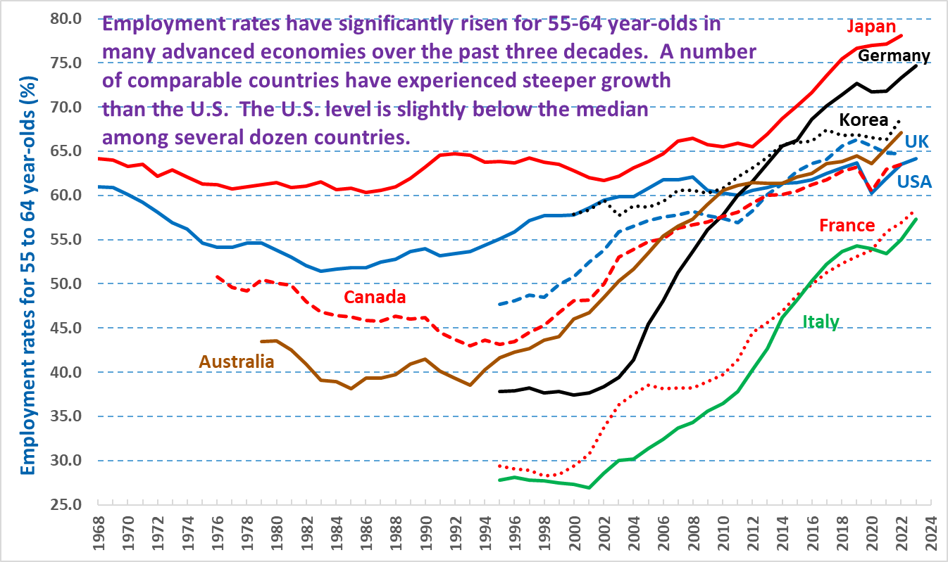
Sources: Eurostat, OECD and BLS customized data tools; and country-specific sources

Employment rates among the elderly. In contrast to the pattern described above for the non-elderly, for each of the elderly age brackets the U.S. is among the leading countries, and the U.S. averages become relatively higher with age, in the international context.

In general, the U.S. employment average for these three age brackets – 65 to 69, 70 to 74, and 75 and older – is only exceeded by Japan and Korea (we lack Korean data for those 75 and older, but the average is presumably high given their rate for 70-74 year-olds). The high employment rates for these two East Asian countries occurs despite a normal retirement age that is lower than that for many other countries, including the U.S. (although perhaps relatively low benefits might explain the persistence of their work at advanced ages).

For 65 to 69 year-olds – who are at or just above the normal retirement age in many countries – employment has also risen over time, although by much less than the increase for 55 to 64 year-olds. From 1996 through 2006 the median country level remained at about 10 percent, but then rose to 16.8 percent in 2019 on the eve of the pandemic, and then rose further to 21.0 percent by 2022 (note that our data for this age bracket is available for most countries only through 2022). This reflects an approximate doubling of the circa 2000 level, certainly a significant trend, but of course this approximately 10 percentage point rise pales against the nearly 25 percentage point increase for 55 to 64 year-olds.

It should also be noted that the pandemic employment rate decline in the U.S. is by no means characteristic of several other major countries, as shown in the chart below. The labor market withdrawal of some elderly individuals in the U.S. was likely caused by the relatively higher coronavirus death rates in America, in turn attributable to much lower coronavirus vaccination rates and less effective public health measures in the U.S. Therefore, the elderly in other countries were more likely to continue their pre-pandemic employment patterns than occurred in America.
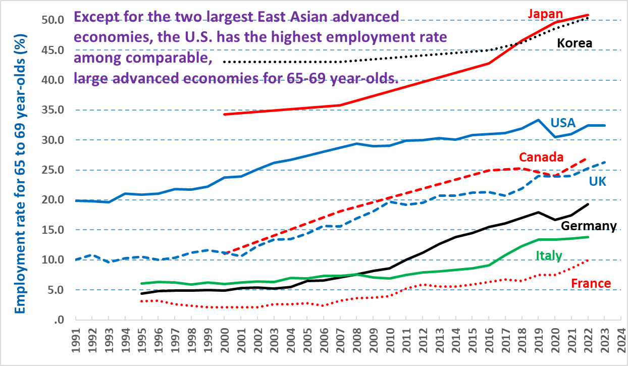
Sources: Eurostat, OECD and BLS customized data tools; and country-specific sources

For the next oldest cohort of 70 to 74 year-olds -- above the Social Security retirement ages for all but a few countries -- the likelihood of employment is generally rare, although there has been a modest increase in a number of countries. The median country level rose from roughly a 4.5 percent level in the 1997 to 2001 period to 8 percent on the eve of the pandemic, but then receded slightly to slightly over 7 percent in 2021/2022.

Bearing in mind that our data become less comprehensive and less up to date beginning with this age bracket, the most notable increase has occurred in Japan, although as the chart below shows, this rise is clearly exceptional. The increases that occurred among several other major economies appear to have leveled off even before the pandemic – including in the U.S., United Kingdom, France, and Italy.

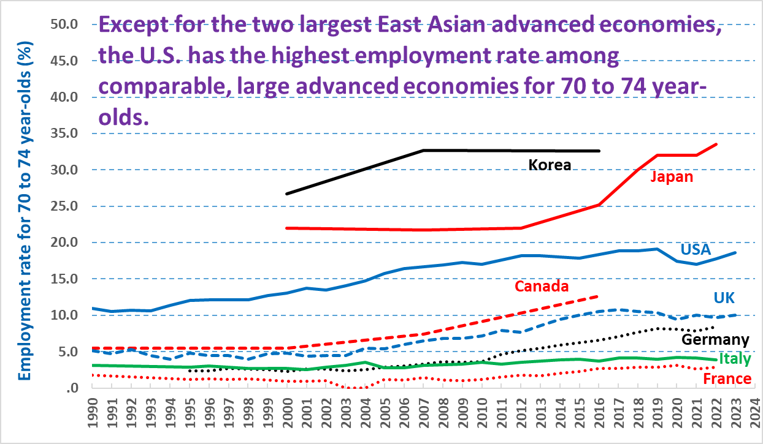
Sources: Eurostat, OECD and BLS customized data tools; and country-specific sources

The available data become sparser for the oldest individuals aged 75 and older (and as noted, don’t include Korea). Employment at this age is relatively rare, at most about 10 percent of this cohort, and has changed less than employment among younger individuals. That said, there is a definite increase in several countries – as shown in the chart below -- although the pandemic appears to have reduced employment in this cohort more consistently than occurred for the relatively younger elderly population. The decline is most notable in America and the UK, two of the major advanced economies with extremely high coronavirus death rates.
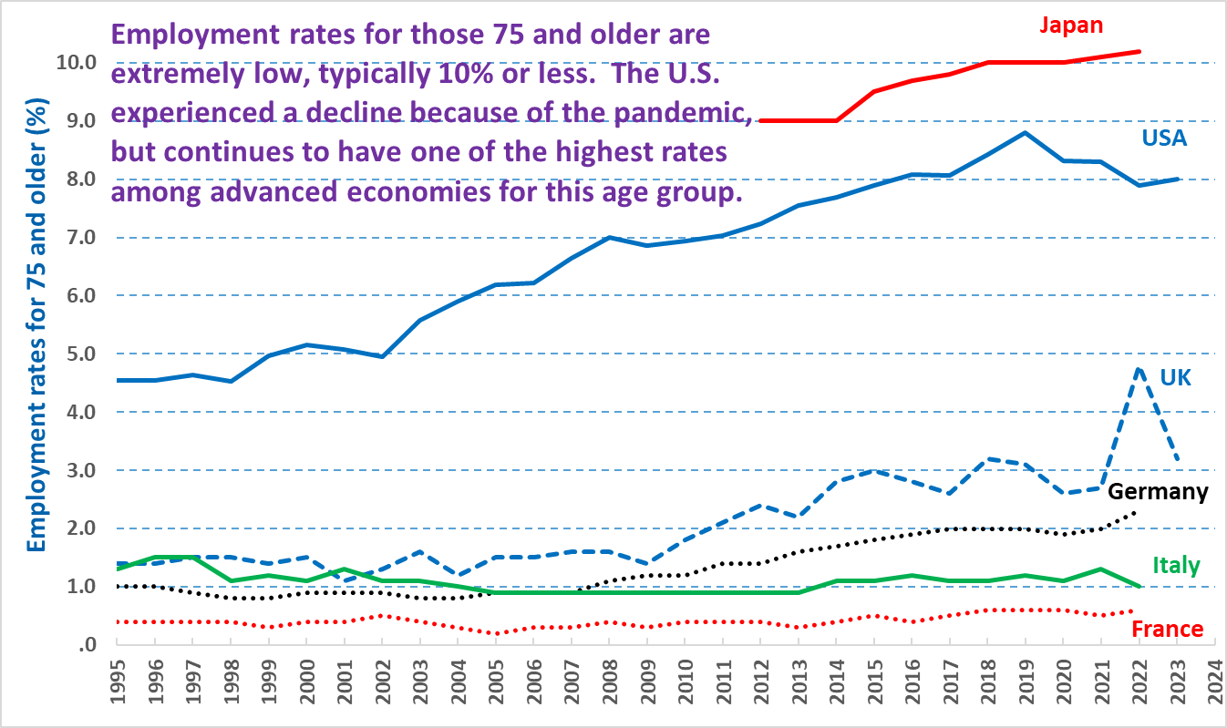
Sources: Eurostat, OECD and BLS customized data tools; and country-specific sources

[3-27-2024, by Frank Gallo, at Gallo.Frank@DOL.gov]

IPUMS is an excellent private sector source that provides much more data than do the Census Bureau’s microdata tools, including all available decennial censuses from 1850 forward (the 1890 census records were destroyed in a fire, and for this year I used the available 1890 Census Bureau reports), and the pre-2004 American Community Survey (ACS) data (not used here).
The employment-to-population ratio measures the proportion of the population that works, and the labor force participation rate measures the proportion of the population that is either working, or unemployed and looking for work.
We don’t know the precise retirement ages, and I’m also working on a separate examination of the interaction between retirement and work among the elderly. However, it is certain that a large proportion of retirees retired prior to age 62 – almost certainly more than half, as in 2019 42 percent of retirees reported that they had retired by age 59.
It should be possible to follow single-year ages over time (available from BLS unpublished tables), and examine their employment patterns in 2019 and later years, to try to understand the numbered alternatives shown above, but I haven’t analyzed the data in this degree of detail.
For men, the 2023 level was only .1 percentage point below that of 2019, but because it has continued to rise between 2021 and 2023, the 2024 level will almost certainly surpass the 2019 average.
I have used 67 as the current retirement age for full benefits, although we are still a few months short of 67, which will be completely implemented by 2027.
Quoted in Lucy Parker, Symeon Stylites the Younger and Late Antique Antioch, Oxford University Press, 2022, p. 96. Stylites were holy men who spent years and sometimes decades living atop of columns.
Note that male employment data are available from the 1850 decennial census, but female employment data aren’t available until the 1860 census.
Acemoglu, Autor, and Lyle, Women, War and Wages: The Effect of Female Labor Supply on the Wage Structure at Mid-Century, NBER Working Paper 9013, June 2002, Figure 2, p. 65 of pdf, www.nber.org/system/files/working_papers/w9013/w9013.pdf
March 1944 data calculated from U.S. Department of Labor, Women's Bureau, Changes in Women's Employment During the War, June 1944, Special Bulletin Number 20, Tables 1 and 11, pp. 24, 29, https://fraser.stlouisfed.org/files/docs/publications/women/sb020_dolwb_194406.pdf. See also Doris Weatherford, American Women During World War II: An Encyclopedia, 2010, Routledge, pp. 146-150

